Best Practices for Descriptive Metadata

May 2008 Version 0.5

Yale University

Part 1

Creating and Using Descriptive Metadata

Metadata is the structured knowledge that we have about things we collect.
To make a collection usable, we need to record what we know about the things in the collection and make that knowledge available to others. The record of our knowledge about our collections is metadata. We use that knowledge, that metadata, to manage our collections of things, to reveal them to others and to make them usable.

Anything—digital, tangible or imaginary--can be described by metadata. We use metadata to describe: rocks, bones, persons, events, films, books, archives, drawings, buildings, protein sequences, dresses, online journal articles, psychological disorders, cities, etc. What we need to know about them varies in part on what things we are describing. Persons have names in a way that rocks do not. Books and articles have titles in a way that bones and viruses do not.

Given the variety of things that can be collected, metadata may take many forms and may contain many particular bits of information about the things it describes. A library catalog records one particular sub-set of knowledge about a collection of books; a museum registry records another; a census database records a third; a dictionary records a fourth. Use of any collection depends on such sub-sets of knowledge about things in a collection. There is some common ground, some overlap between sub-sets. This document mainly addresses that common ground and points to some particular differences.

To manage collections, reveal them to others, and make them usable, we need to systematically record our knowledge of

- The scope of the collection. What things are in the collection: natural objects, data, texts, photographs, sculptures or sounds?
- The uses the collection supports. Does the collection provide materials for research, teaching, publication or entertainment?
- The allowed use of the collection: Who may use the collection: Yale faculty, graduate students, undergraduates or anyone?
- The means by which the collection is described and discovered. How are the descriptions structured? How is the content of the descriptions standardized? How is the database indexed? How is the database designed to be used?

Although metadata is only one aspect of the creation and management of a collection, that information and its structure determine how the collection will be managed, searched and used. The collection user’s success in discovering and retrieving things from the collection affects how that collection as a whole is valued by you and other scholars, students, colleagues and administrators.

Since metadata may be everything we can know about the things in our collections, we have to be selective about what we chose to explicitly record. We need to ask what knowledge about the things in our collections it is most important to record. The answers depend on what we want to do with the things in our collections.

At the least, we must know what we call the items in our collection and where we keep them. The Name (which could be a title or identifying number) and the location are the two most basic elements in a description and may be usefully represented in two distinct fields in a database record.

Beyond the minimum, we need enough descriptive metadata to provide citations for the things we have. Citations identify things uniquely and give us a sub-set of information about them that allows their subsequent retrieval. Citations for books and journal articles are familiar to students and scholars. For other things citation metadata may include: what kind of things they are (rocks, people, films) their names, their locations and their date of origin. For some things, who found or who made them, their size and shape may be needed to identify them.

Generally, more metadata makes things easier to find, sort through, arrange, compare with similar items and evaluate. What are they about? How are they related to other things? Who may use them? How and when did we get them? The more we know about some thing, the more we can do with it or let others do.

Metadata is a record of the answers to a set of questions we may have about things. This set of answers—the metadata—is what we know about the things: what they are, what they are called, where they are, what they are made of, how big they are, whether they are wholes things themselves or parts of another larger thing, what they are about, who made them, their histories, who owns them, who knows about them, etc. When we know these answers clearly and consistently, we can best manage them, find them and use them.

Common questions about the things we collect

There are more questions one may have to answer about an object, but these are some of the most commonly useful questions to be asked of a thing and answered in the metadata about it. These answers or elements used together can provide metadata that support the user in identifying, discovering, using, and managing some thing in a collection.

1. What is it?
We need to know what kind of thing it is: it is a rock, a sound, an image, a text, etc. We may need to know this more specifically, too. Is it granite, a song, a photograph, a diary, etc. This knowledge may range from broad category to
specific type: image, photograph, Gelatin silver print.

2. What is it called?
We need to know what this particular thing is called. We need to know its name: London Calling, Citizen Kane, etc. It may not have a name per se, but to manage it and use it, it has to be called some unique thing: Hillary Clinton’s 2007 1040, YPM 62696A (Taxon Name Algae).

3. Who made it?
If someone made it, who? Clash (Musical group), Orson Wells, William Hogarth, etc. If we don’t know, what do we know about the people or culture that produced it? Hopi Indians. If it is not a made thing, ignore this question.

4. What is it about?
If it isn’t about anything, ignore this question, but for many made things we want to know what it is about or what it depicts or what it represents. Recording aboutness can be complicated. For instance, the book, Oasis vasco : el nacimiento de Euskadi en la república y la guerra civil by José Luis de la Granja Sainz. (Madrid: Tecnos, 2007) is about the Spanish Civil War. Picasso’s painting of the bombing of Guernica is not about that war in the same way, but one may in some cases want to record that subject for that painting.

5. When it was made, or, how old is it?
Dating the things in collections is of widespread if not universal importance. Putting something into a timeframe helps one to identify it and helps one to understand it in its context. Was it made in 1939 or 20,000 BCE? Is it 1 million years old or 300 hundred million?

6. Who may use it?
Rights need to be respected and maintained. Metadata is essential for rights management as a producer or user. Is it In the public domain, under copyright or licensed use only?

7. What language it is in?
If it is a language thing, is it in Latin, English, Hebrew, Russian, Chinese, Arabic or French, etc.

8. Who published it or produced it?
If it is not a published or manufactured thing, ignore this question. If it is who published it or produced it may matter to users and managers of the collection.

9. Where is it?
If a tangible thing, where is it kept? At Yale University Art Gallery, the Peabody Museum of Natural History, Yale University Library? Are there digital surrogates or versions of it available online? What is the URL? If it is a digital thing online, what is the URL, the DOI or other persistent link?

10. How big is it?
Is the thing one wants to find a 30 second audio file or 30 hours of audio? Is a sculpture 10 feet high or 10 inches high? It is often important to know and record the size of a thing, its dimensions, its duration, etc. Knowing this may be vital to identifying it or using it.

11. What is it made of?
Is the painting oil on canvas or acrylic on wood?

Some considerations regarding the level of effort and expense

The level of effort and expense needed to create metadata varies according to many factors. One of these is the amount of information one records about each thing or the fullness of the description one makes. Generally, for a fuller description more time and skill must be applied, and that equals more expense. However, tools for automatically capturing data such as those in digital cameras or judicious re-use of existing metadata can greatly lower costs and speed production. A simple scale for levels of fullness is helpful in determining how much metadata and which metadata to create for which things. We suggest the following 3 level scale.

1) Minimum: users can perform basic searches and filtering
This minimum level should allow things to be incorporated meaningfully into a collection. Descriptions that meet this level can be discovered and used more readily than those things that are barely citable. A minimum description would tell
- what kind of thing it is
- what it is called
- where it is
- who may use it

2) Medium: users have more advanced functionality such as browse and group search results
This medium level allows the user more advanced options for discovery, browsing, sorting, etc. Elements in this level represent a level of detail some might not have for legacy collections. A medium description would tell more by adding to the minimum such information as
- more specifics about what kind of thing it is
- some description of it
- what it is about (if applicable)
- what language it is in (if applicable)
- links to images of it or recordings of it (if applicable)
- a unique machine-operable identifier

3) Full: users can perform precise searches, sorting, etc.
This full level allows users more functionality. Meeting this level allows the introduction of very precise searching capabilities across a wide variety of resources and allows a user to make a final evaluation as to whether the resource is relevant to his or her needs. A full description would tell more by adding to the medium such information as
- what roles various people may have had with making it
- a detailed description of it
- an abstract or summary
- its relationships with other things
- precise terms or codes regarding what it is about
- it history
Some Descriptive Metadata Examples

From a library catalog

Author: Cicero, Marcus Tullius.
Uniform title: [Academica. English]
Title: On academic scepticism / Marcus Tullius Cicero ; translated, with introduction and notes, by Charles Brittain.
ISBN: 0872207757 (cloth) 0872207749 (pbk.)
Published: Indianapolis, IN : Hackett Pub. Co., c2006.
Description: lviii, 161 p. ; 22 cm.
Table of contents [a hyperlink to a web page showing this book’s table of contents]
Bibliography: Includes bibliographical references (p. xlvi-liii) and index.
Contents: Select topical bibliography -- Analytical table of contents -- On academic scepticism -- Fragments from the Academici libri -- Textual appendix -- Biographical index -- Select English-Latin-Greek glossary.
Subjects (Library of Congress):
Knowledge, Theory of --Early works to 1800.
Skepticism --Early works to 1800.
Also listed under: Brittain, Charles.
Location: CLASSICS (Non-Circulating)
Call Number: PA6308.A2 B75X 2006
Status: Not Checked Out
Location: SML, Stacks, LC Classification
Call Number: PA6308.A2 B75X 2006
Status: Not Checked Out

From a database of digital images

Accession Number 2312-046  Title Side chair from Raymond Evans House  Artist/Creator Wright, Frank Lloyd, 1867-1959  Alternate Title  Object Date  Object Type chairs (AAT)  Nationality-Culture-Style  Medium  Subject Heading Furniture -- 20th century -- United States (YVRC)  Original Location  Source R: YVRC  Content Type Image  Collection Name  Description  Relation  Format  Contributor Niedecken-Walbridge Company, 1907-  Dimensions  Format (digital) Image (TIFF)  Rights Management  Context  Requestor 003  Faculty Use | 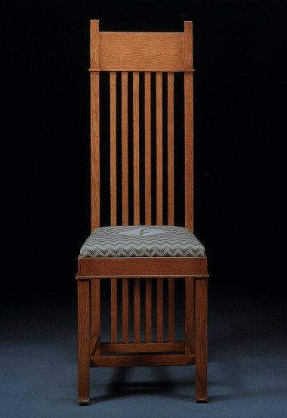

Another from a database of digital images

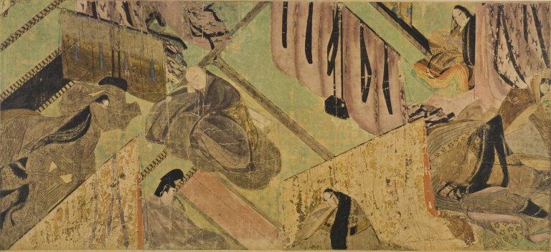
Accession Number: 3074-009
Title: Tale of Genji: The Oak Tree (1)
Artist/Creator:
Alternate Title: Genji monogatari emaki: Kashiwagi (1) | 源氏物語絵巻 第三十六帖「柏木]（１）
Object Date: ca. 1120-1140
Object Type: paintings: narrative handscrolls (emakimono, 絵巻物) (YVRC)
Nationality-Culture-Style:
Medium: ink and color on paper
Subject Heading: Painting Japan Heian period, 784-1185 (YVRC) | Genji-e, (pictorial representations inspired by the Tale of Genji) (YVRC)
Original Location:
Source: Genji monogatari emaki: kokuho, 1971 (Kodansha)
Content Type: Image
Collection Name: Tokyo, Japan: Tokugawa Reimeikai Foundation
Description: National Treasure.
Relation:
Format:
Contributor:
Dimensions: 21.8 x 48.3 cm
Format (digital): Image (TIFF)
Rights Management:
Context: Murasaki Shikibu, Tale of Genji: Chapter 36, The Oak Tree (Tyler, trans.; 2001)
Requestor: 021 | 054
Faculty Use: JAPN002b/HUMS082b: Genji's World: Japan's Culture ca. 1000

From a natural history museum

YPM 98037
Taxon Name.......... | Accipiter cooperii (Bonaparte, 1828)
Locality............ | North America. USA. Massachusetts. Barnstable County. West Falmouth.
LatLon.............. | 41.604 -70.635
Collected...........
Higher Ranks........ | Falconiformes; Accipitridae
Other Attributes.... | female; skin, round; Other numbers: 37-83-1368
n=1

From an art museum
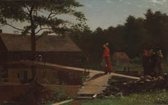 Winslow Homer (American, 1836–1910)
Old Mill (The Morning Bell), 1871
Oil on canvas, 24 x 38 1/8 x 1 in. (61 x 96.8 x 2.5 cm)
Bequest of Stephen Carlton Clark, B.A. 1903
1961.18.26
The social role of women was profoundly changed by the Civil War, and economic necessity forced many to leave their homes to work in factories. Homer shows several of these young women, lunch pails in hand, on their way to work in a New England mill, possibly in Lowell, Massachusetts. While the focus of the painting is on the young women, underlying the whole scene is the uneasy sense of a young nation in transition between an agricultural and an industrial society. To earn extra money, many school teachers came from the city to work in factories during the summer months. The sense of shared community evoked by the circle of three rural women in aprons and earth-colored, homespun dresses chatting at the right is in striking contrast to the solitary central figure, inappropriately dressed for factory work in a straw bonnet and scarlet jacket. While the country women seem comfortably rooted in the fertile landscape, she hesitatingly turns from the ramp onto the makeshift bridge over a stagnant stream. Situated at the crossroads in the painting, she may be seen as symbolically poised between the rural values of the past and the increasingly isolated and depersonalized culture of American life after the Civil War.
From a biology database

1OEH DOI 10.2210/pdb1oeh/pdb Images and Visualization Asymmetric Unit
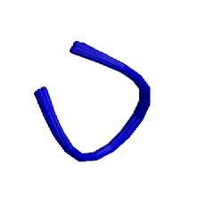 Red - Derived Information
Title HUMAN PRION PROTEIN 61-68
Authors Zahn, R.
Primary Citation Zahn, R. (2003) The octapeptide repeats in mammalian prion protein constitute a pH-dependent folding and aggregation site. J.Mol.Biol. 334: 477-488
[ Abstract ] History Deposition 2003-03-27 Release 2004-04-23 Experimental Method Type NMR, 20 STRUCTURES Data N/A NMR Ensemble Conformers Calculated 100 Conformers Submitted 20 Selection Criteria LEAST RESTRAINT VIOLATION NMR Refine Method NMR, 20 STRUCTURES Molecular Description Asymmetric Unit
Polymer: 1 Molecule: MAJOR PRION PROTEIN Fragment: RESIDUES 61-68 Chains: A
Classification Prion Protein Source
Polymer: 1 Scientific Name: Homo sapiens Common Name: Human Expression system: Escherichia coli SCOP Classification (version 1.71)
Domain Info | Class | Fold | Superfamily | Family | Domain | Species
d1oeha_ | Peptides | Prion protein fragments | Prion protein fragments | Prion protein fragments | Prion protein fragments | Human (Homo sapiens)
PFAM Classification
Chain | PFAM Accession | PFAM ID | Description | Type | Clan ID
A | PF03991 | Prion_octapep | Copper binding octapeptide repeat | Repeat | n/a
GO Terms
Polymer | Molecular Function | Biological Process | Cellular Component
MAJOR PRION PROTEIN (1OEH:A) | - none | - protein homooligomerization | - membrane

