Sudoku game
The project aims to code a Sudoku game on terminal using Python. The following points explain how it has been approached.
- Get a general idea on the game’s rules and user interface
- Sketch a flow chart of the program
- Create a class that describes each block in the flow chart
- Develop a finite state machine that defines the interactions of each block
- Handle user’s input exceptions

Flow Chart:
- Update and display grid:
  - Clear the terminal and display the matrix.
  - Display any exceptions or information.
- Get user input:
  - Prompt the user to input the row and column of the cell to edit.
  - Allow the user to input the desired digit.
- Check user input:
  - Validate the user input for character validity.
  - Verify if the selected cell is editable (initial digits in the grid cannot be edited).
- Update matrix:
  - Copy the user input into a 9x9 matrix.
- Check if all cells are full:
  - Determine if there is a digit in each cell of the matrix.
  - Indicate that the game is nearing completion.
- Check solution:
  - Examine the matrix to ensure it adheres to the game's rules.

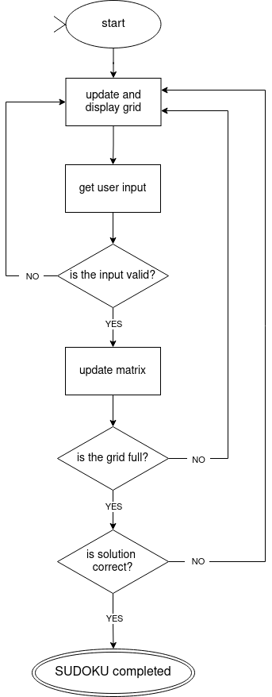
Image 1.1 flow chart

The code is designed to perform a singular task according to its current state, returning to the initial display block without employing nested functions. This architecture guarantees enhanced scalability for larger projects.
Object-oriented programming serves as a potent tool in the design process by enabling the initial specification of an object's properties at a lower level. Subsequently, from a higher-level perspective, it facilitates the design of interactions between individual blocks.

Git-hub
The project’s repository can be found here.

Sources
Chat-GPT has been used for displaying formatted text on the terminal and implementing the logic to verify the correctness of a Sudoku solution.

