LAB-5

TRY IT OUT-1:
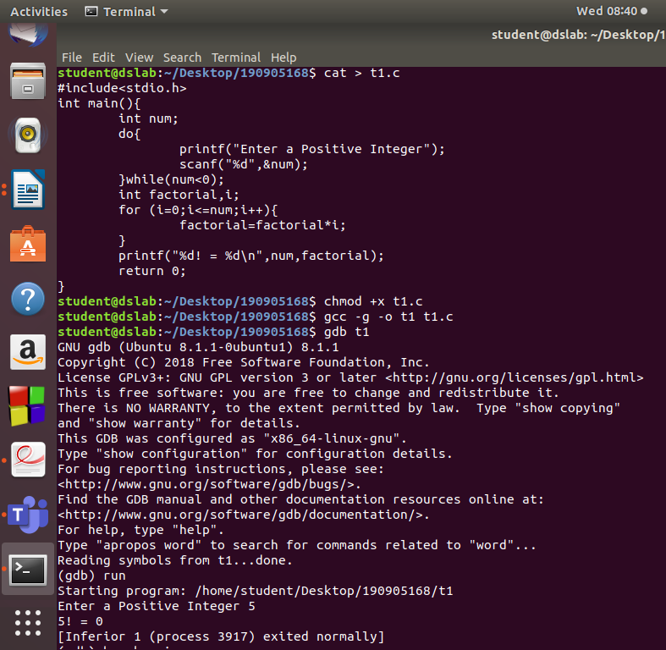

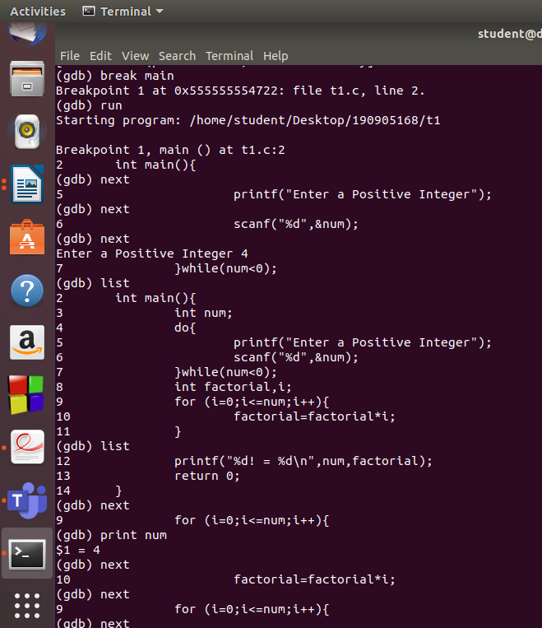

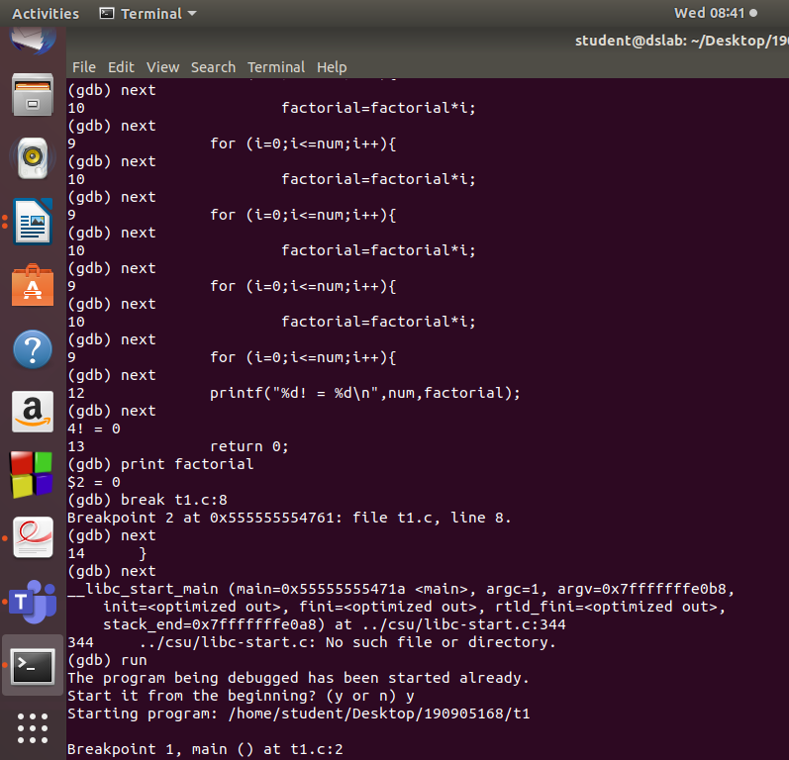

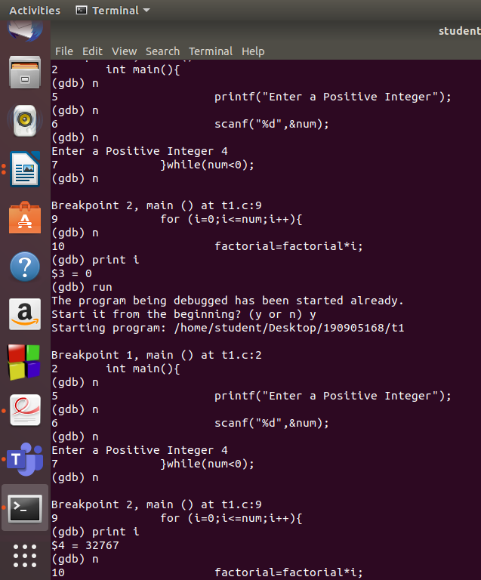

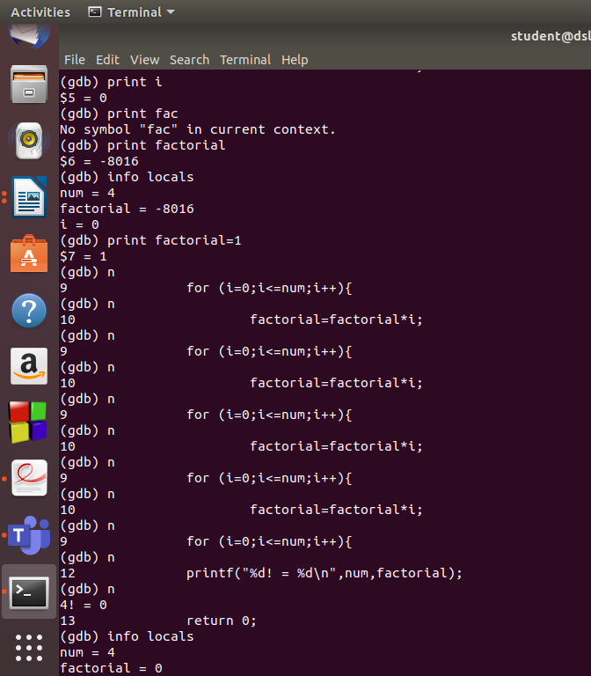
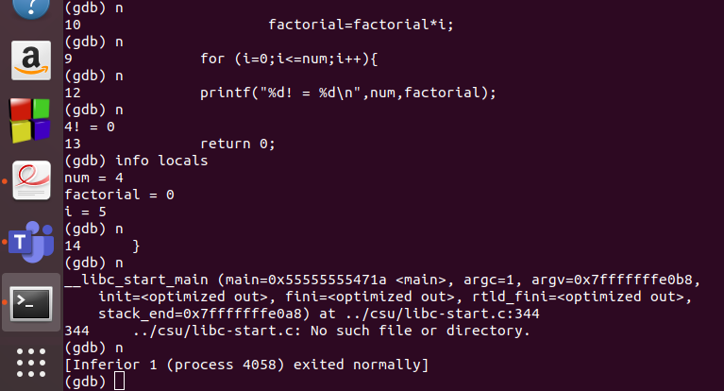

Q-1)
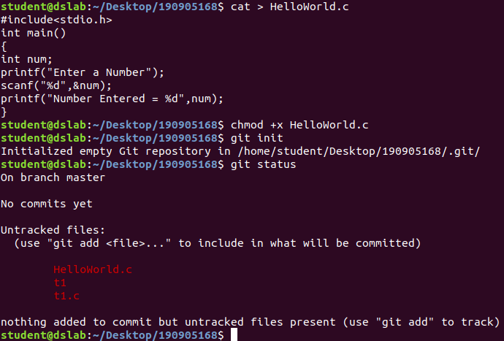
Q-2)

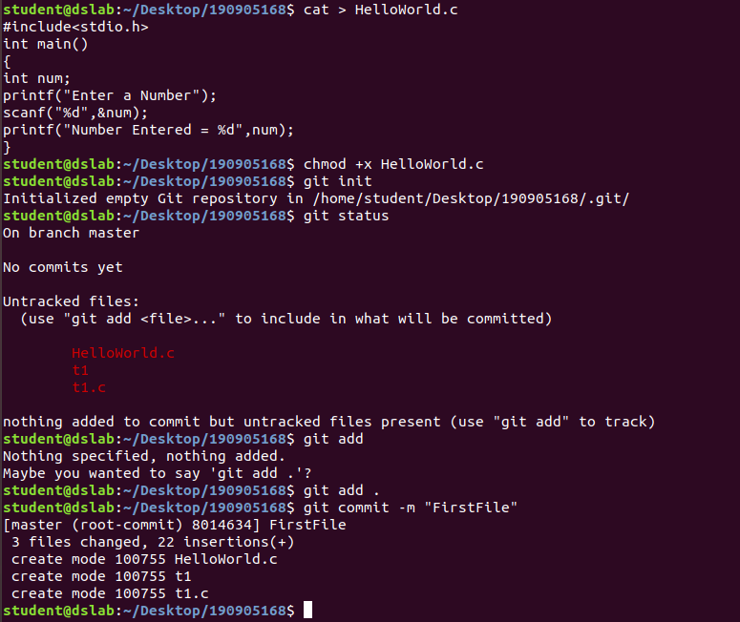
Q-3)
#include<stdio.h>
int main()
{
int num;
printf("Enter a Number");
scanf("%d",&num);
num=num+1;
printf("Number Entered = %d",num);
}
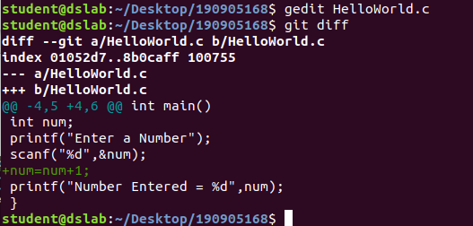

Q-4)
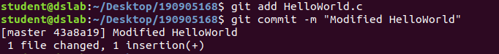
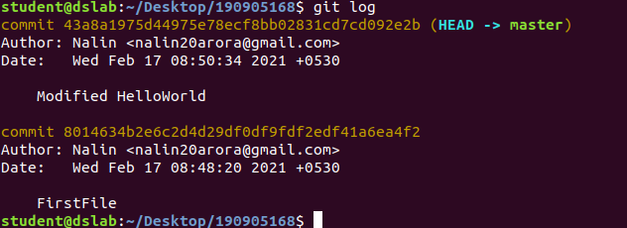
Q-5)
#include<stdio.h>
int main()
{
int num;
printf("Enter a Number");
scanf("%d",&num);
num=num+2;
printf("Number Entered = %d",num);
}
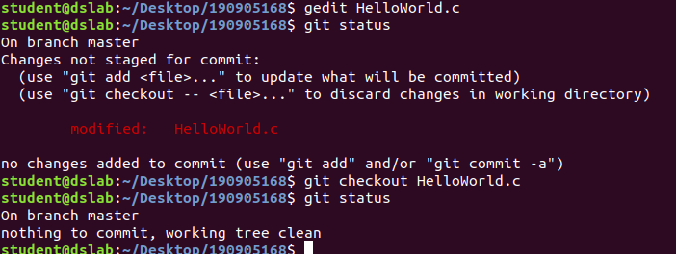
Q-6)
