LAB-6

Q-1)
<!DOCTYPE html>
<html>
<head>
<title>Week 6 Q 1</title>
</head>
<body>
<h1>Heading</h1>
<h2 dir="rtl">Heading</h2>
<h3>Heading</h3>
<h4>Heading</h4>
<h5>Heading</h5>
<p style="color:RED">This is a paragraph of 2 lines<br>line changed</p>
<div style="border:1px solid black">This is a div tag</div>
<p>This is a inline span <span style="border:1px solid black">This is a span tag</span> after this this paragraph will continue</p>
<pre>This a pre tag</pre>
<p>This is a paragraph about <del>blue</del> and
<ins>black color</ins></p>
</body>
</html>
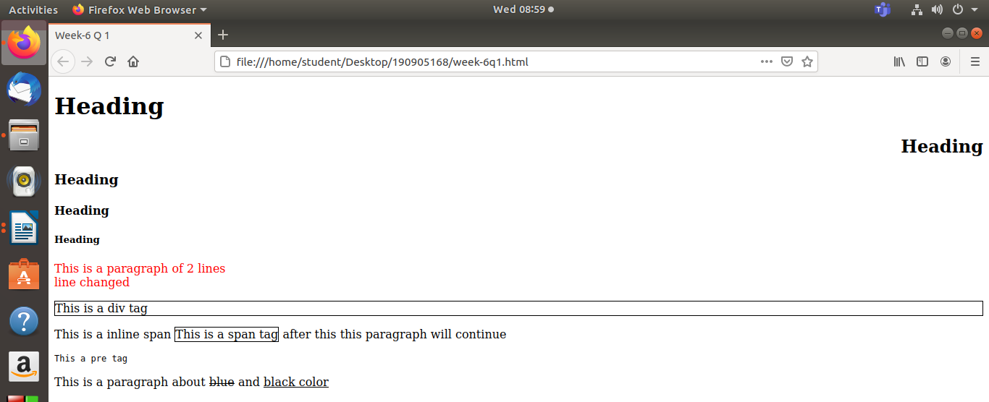

Q-2)
<!DOCTYPE html>
<!DOCTYPE html>
<html>
<head>
<title>Week 6 Q 2</title>
</head>
<body>
<a href="https://www.google.com/">Google</a>
<br>
<a href="https://www.google.com/"><img src="https://www.psdstack.com/wp-content/uploads/2016/10/pixabay-1.jpg"</a>
<br>
<a href="https://www.microsoft.com/en-in/microsoft-teams/group-chat-software" target="blank">Ms Teams</a>
</body>
</html>
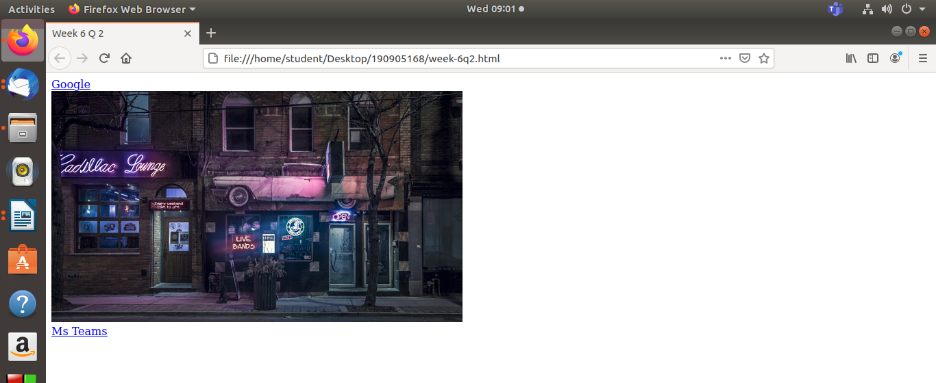

Q-3)
<!DOCTYPE html>
<!DOCTYPE html>
<html>
<head>
<title>Week 6 Q 3</title>
</head>
<body>
<a href="https://www.google.com/">
<img src="https://www.psdstack.com/wp-content/uploads/2016/10/pixabay-1.jpg" width="250px" height="200px" align="left" alt="Shop" usemap="#myMap">
<map name="myMap">
<area shape="rect" coords="0,50,65,60" href="https://www.google.com/search?safe=strict&source=hp&ei=BZwnYM28E5vZz7sP1ZyZmAI&iflsig=AINFCbYAAAAAYCeqFczKmCUH_dT0buqaM-QsGymOZdtM&q=sign+board&oq=sign+board&gs_lcp=Cgdnd3Mtd2l6EAMyBQgAELEDMgUIABDJAzICCAAyAggAMgIIADICCAAyAggAMgIIADICCAAyAggAOggIABCxAxCDAToLCC4QsQMQxwEQowI6AgguOgUILhCxAzoICC4QsQMQgwE6DgguELEDEIMBEMcBEK8BUPwPWIYsYNIwaABwAHgAgAH-AYgBywuSAQUwLjkuMZgBAKABAaoBB2d3cy13aXo&sclient=gws-wiz&ved=0ahUKEwiN08CjxubuAhWb7HMBHVVOBiMQ4dUDCAY&uact=5">
</map>
</a>
<br>
</body>
</html>
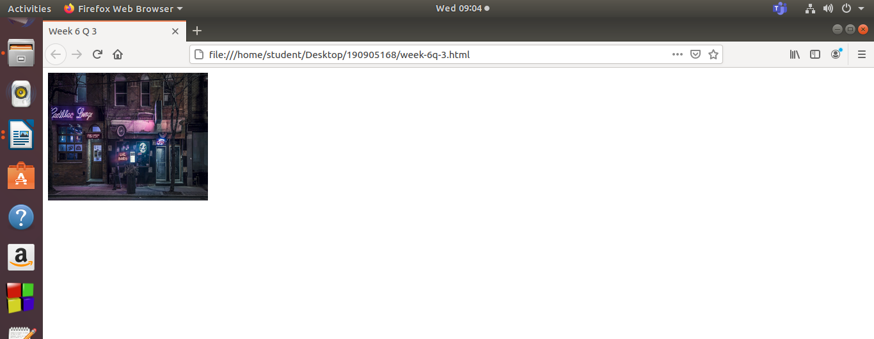

Q-4)
<!DOCTYPE html>
<!DOCTYPE html>
<html>
<head>
<style>
table,th,tr{
border: 1px solid black;
}
</style>t
<title>Week 6 Q 4</title>
</head>
<body>
<table width="100%" cellpadding="10px" cellspacing="10px" rowspan="10px" columnspan="10px">
<caption>Information of the Students</caption>
<tr>
<th>Name</th>
<th>Club</th>
<th>Number of Ballon 'dor</th>
</tr>
<tr>
<th>Messi</th>
<th>Barcelona</th>
<th>6</th>
</tr>
<tr>
<th>Ronaldo</th>
<th>Juventus</th>
<th>5</th>
</tr>
</table>
</body>
</html>
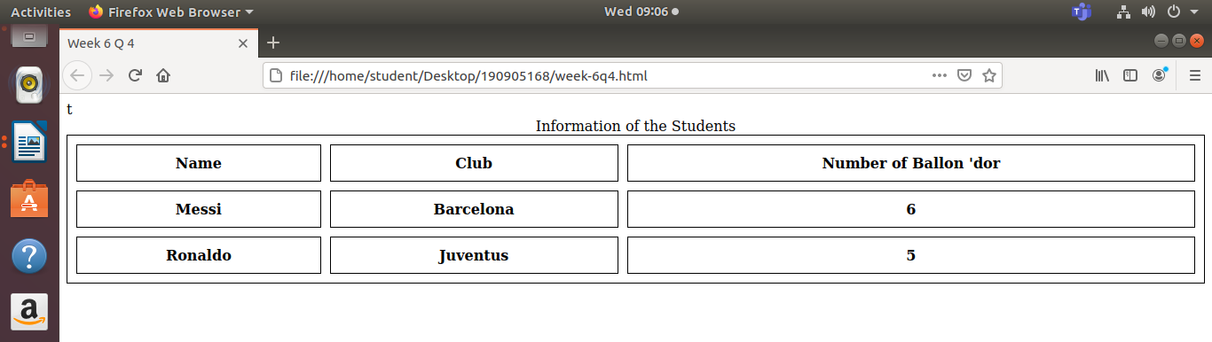

Q-5)
<!DOCTYPE html>
<!DOCTYPE html>
<html>
<head>
<title>Week 6 Q 5</title>
</head>
<body>
<ol>
<li>Laptop</li>
<li>Tab</li>
<li>Phone</li>
<li>PC</li>
</ol>
<ul>
<li>Laptop</li>
<li>Tab</li>
<li>Phone</li>
<li>PC</li>
</ul>
<dl>
<dt>Laptop</dt>
<dd>HP</dd>
<dd>DELL</dd>
<dd>Macintosh</dd>
<dt>Phone</dt>
<dd>Samsung</dd>
<dd>Apple</dd>
<dd>OnePlus</dd>
</dl>

</body>
</html>

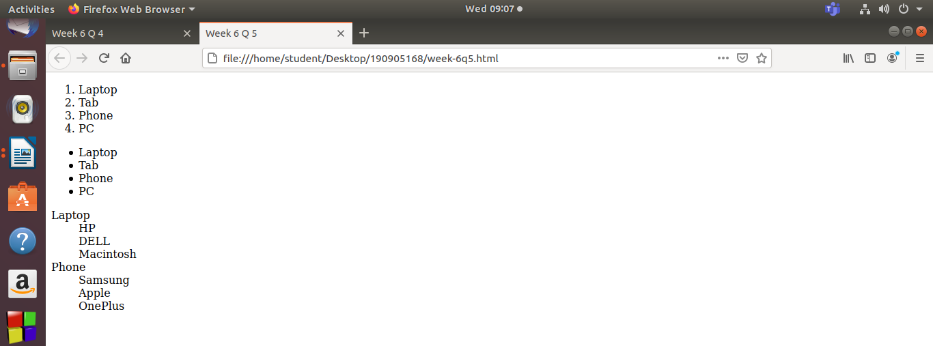

Q-6)
<!DOCTYPE html>
<!DOCTYPE html>
<html>
<head>
<title>Week 6 Q 6</title>
</head>
<body>
<label>Name:</label>
<input type="text" name="nm">
<br>
<label>Password:</label>
<input type="Password" name="pwd">
<br>
<label>What all devices you own</label>
<br>
<input type="checkbox" name="device1" value="Laptop" id="1">
<label>Laptop</label>
<br>
<input type="checkbox" name="device2" value="Phone" id="2">
<label>Phone</label>
<br>
<input type="checkbox" name="device3" value="Tab" id"2>
<label>Tablet</label>
<br>
<input type="submit" name="Submit">
<br>
<label>Choose a device:</label>
<select >
<option>Tab</option>
<option>Phone</option>
<option>PC</option>
<option selected>Laptop</option>
</select>
<br>
<label>Enter your reviews:</label>
<input type="text" name="reviews">
<br>
<label>Lets play a game</label>
<button onclick="alert('You won')">Click here</button>
<button onclick="alert('Sorry')">Click here</button>
<button onclick="alert('Sorry')">Click here</button>
</body>
</html>
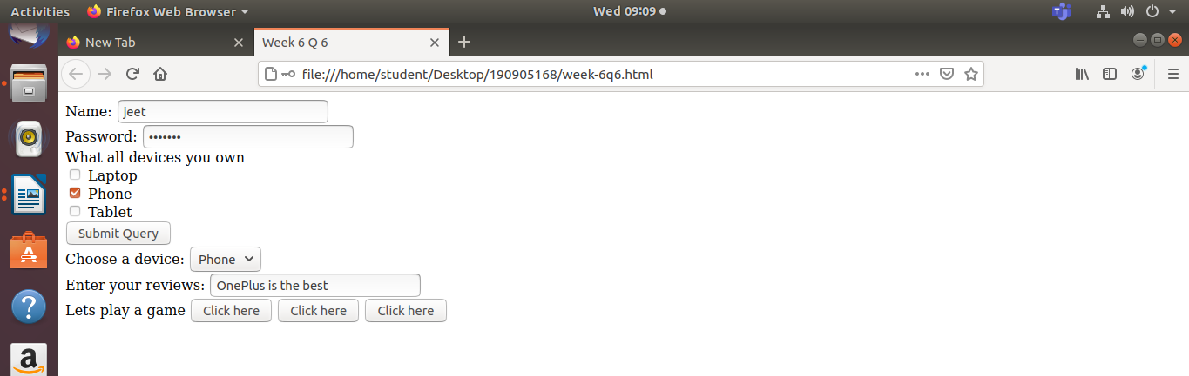

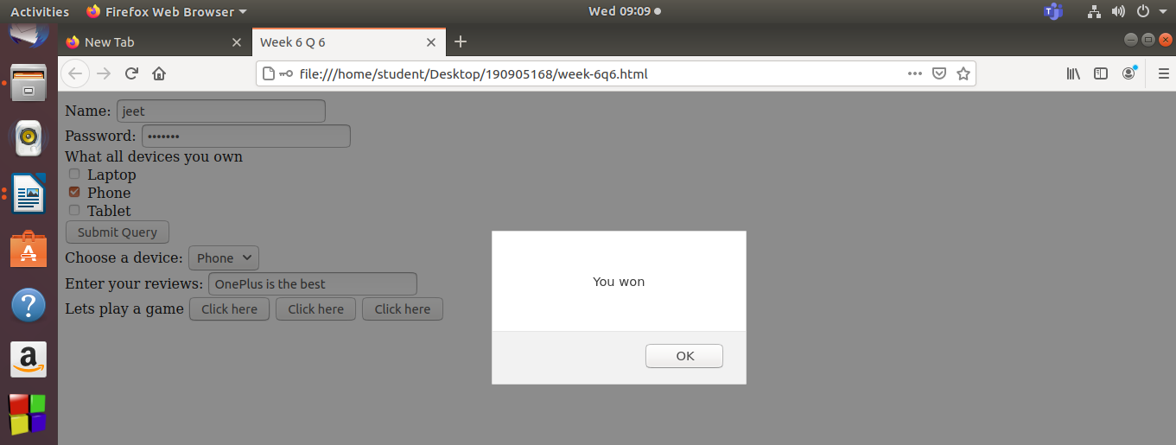

Q-7)
i)

<!DOCTYPE html>
<!DOCTYPE html>
<html>
<head>
<style>
h3{
background: rgb(250,100,250);
}
</style>
<title>Week 6 Q 7</title>
</head>
<body>
<h1 style="color:red" >This is a Heading</h1>
<h2 style="border:1px">This is a Heading</h2>
<h3>This is a heading</h3>
</body>
</html>

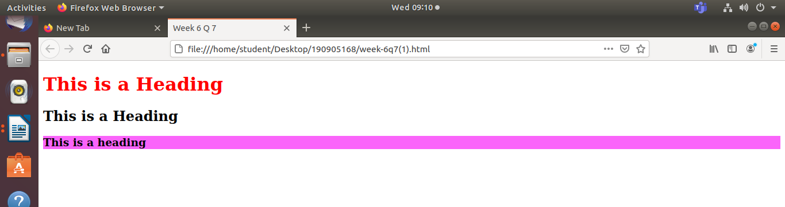

ii)

<!DOCTYPE html>
<!DOCTYPE html>
<html>
<head>
<style>
h3{
background: rgb(350,70,350);
}
</style>
<title>Week 6 Q 7</title>
</head>
<body>
<h1 style="color:red" >This is a Heading</h1>
<h2 style="border:1px">This is a Heading</h2>
<h3>This is a heading</h3>
</body>
</html>

<!DOCTYPE html>
<!DOCTYPE html>
<html>
<head>
<link href="/home/student/Desktop/HTML/week6q7">
<title>Week 6 Q 7</title>
</head>
<body>
<h1>This is a Heading</h1>
<h2>This is a Heading</h2>
<h3>This is a heading</h3>
</body>
</html>

CSS file:
body{
border: 2px;
}
h1,h2,h3{
background: rgb(350,70,350);
}

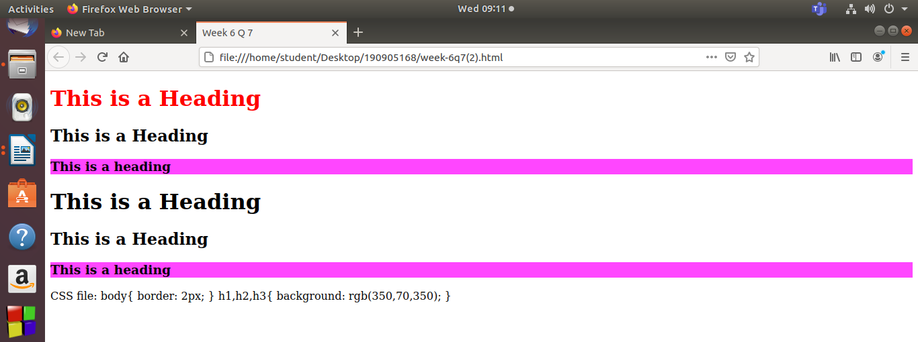

Q-8)
i)
<html>
<body>
<canvas id="myCanvas" width="300" height="150" style="border:1px solid #d3d3d3;">
Your browser does not support the HTML5 canvas tag.</canvas>
<script>
var c = document.getElementById("myCanvas");
var ctx = c.getContext("2d");
ctx.beginPath();
ctx.rect(20, 20, 150, 100);
ctx.stroke();</script>
</body>
</html>

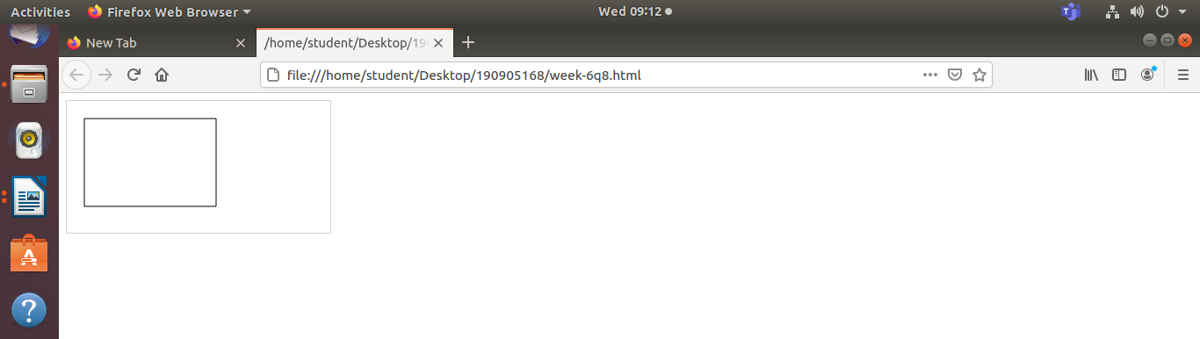

ii)
<html>
<body>
<canvas id="myCanvas" width="200" height="100" style="border:1px solid #d3d3d3;">
Your browser does not support the HTML canvas tag.</canvas>
<script>
var c = document.getElementById("myCanvas");
var ctx = c.getContext("2d");
ctx.moveTo(0,0);
ctx.lineTo(200,100);
ctx.stroke();
</script></body>
</html>

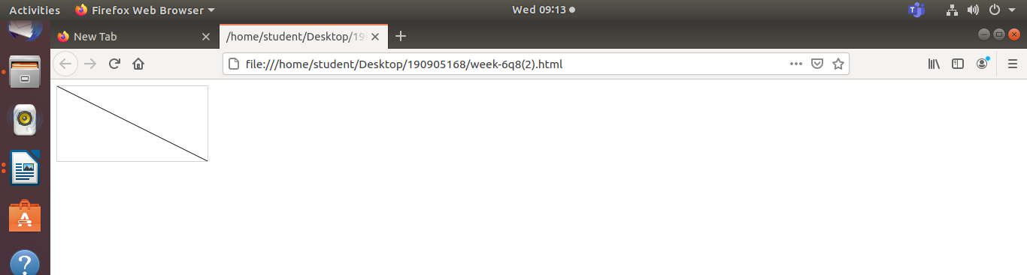

iii)
<html>
<body>
<canvas id="myCanvas" width="200" height="100" style="border:1px solid #d3d3d3;">
Your browser does not support the HTML canvas tag.</canvas>
<script>
var c = document.getElementById("myCanvas");
var ctx = c.getContext("2d");
ctx.beginPath();
ctx.arc(95,50,40,0,2*Math.PI);
ctx.stroke();
</script>
</body>
</html>

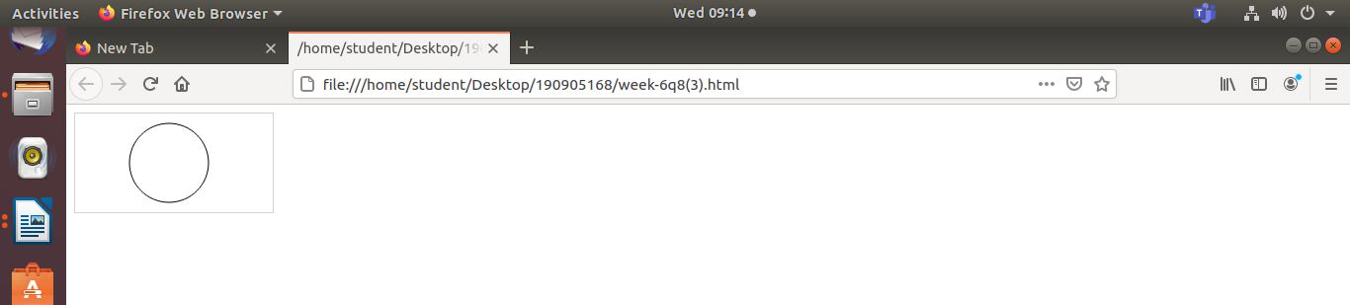

iv)
<html>
<body>
<canvas id="myCanvas" width="300" height="150" style="border:1px solid #d3d3d3;">
Your browser does not support the HTML5 canvas tag.</canvas>
<script>
var c = document.getElementById("myCanvas");
var ctx = c.getContext("2d");
ctx.beginPath();
ctx.arc(100, 75, 50, 0, 0.5 * Math.PI);
ctx.stroke();
</script>
</body>
</html>

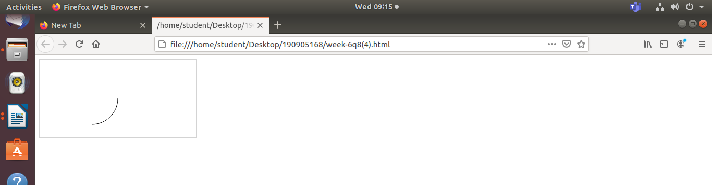

v)
<html>
<body>
<canvas id="myCanvas" width="200" height="100" style="border:1px solid #d3d3d3;">
Your browser does not support the HTML canvas tag.</canvas>
<script>
var c = document.getElementById("myCanvas");
var ctx = c.getContext("2d");
var grd = ctx.createLinearGradient(0,0,200,0);
grd.addColorStop(0,"red");
grd.addColorStop(1,"white");
ctx.fillStyle = grd;
ctx.fillRect(10,10,150,80);
</script>
</body>
</html>

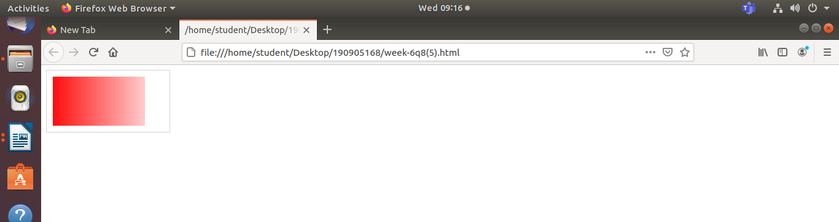

vi)
<html>
<body>
<canvas id="myCanvas" width="200" height="100" style="border:1px solid #d3d3d3;">
Your browser does not support the HTML canvas tag.</canvas>
<script>
var c = document.getElementById("myCanvas");
var ctx = c.getContext("2d");
var grd = ctx.createRadialGradient(75,50,5,90,60,100);
grd.addColorStop(0,"red");
grd.addColorStop(1,"white");
ctx.fillStyle = grd;
ctx.fillRect(10,10,150,80);
</script></body>
</html>

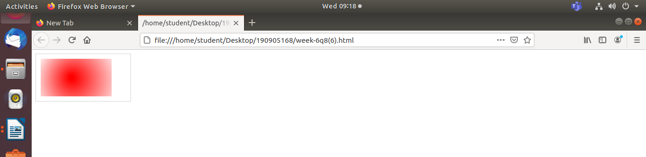

vii)
<html>
<body>
<canvas id="myCanvas" width="300" height="150" style="border:1px solid #d3d3d3;">
canvas.</canvas>
<script>
var c = document.getElementById("myCanvas");
var ctx = c.getContext("2d");
ctx.lineWidth = 10;
ctx.strokeRect(20, 20, 80, 100);
</script>
</body>
</html>
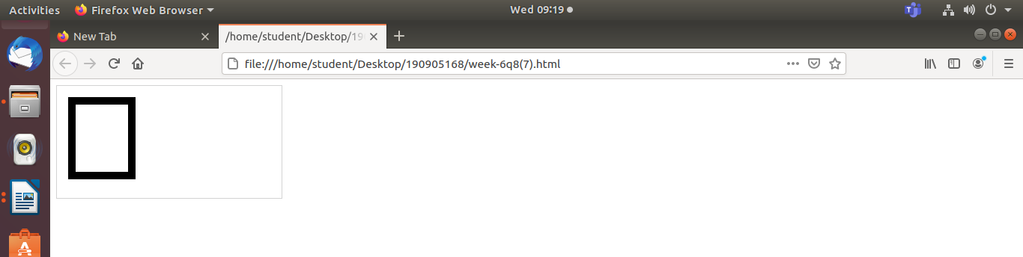
viii)
<html>
<body>
<canvas id="myCanvas" width="300" height="150" style="border:1px solid #d3d3d3;">
Your browser does not support the HTML5 canvas.</canvas>
<script>
var c = document.getElementById("myCanvas");
var ctx = c.getContext("2d");
ctx.strokeStyle = "#239505";
ctx.strokeRect(20, 20, 150, 100);
</script>
</body>
</html>

