Adventure locations searching application

Oleksandra Ostra

s13073

# Contents

2. Project description 3

3. Requirements 4

4. Chosen technologies 5

5. Entity diagram 6

6. Use-case diagram 7

# Project description

People travelling and doing extreme sports. In the process, they are making photos and videos which can describe locations visited by person. They share content on Instagram, Facebook, YouTube. And then somebody else looking for adventures can use their content to choose the best place to go. Application gives opportunity to make it real.

Not just locations could help users to get the most from but also events such as competitions of different levels, from region to world. And for sure they are going to added.

Not forgetting about such huge changes occurred due to social networks growth and popularity in application is going to be functionalities of such portals. Application will support communication between users in private conversation and groups, will provide opportunity to follow users, such as sportsman or photographers to stay up to date, will give possibility to rank locations, and events, and posts, and even other users.

Program is going to support such a list of activities: photography, video making, backpacking, hiking, climbing, rock climbing, mountaineering, caving, cycling, downhill, caving, canoeing, skiing/snowboarding, slope park, big air, freeriding, diving, technical diving, freediving, water skiing, wakeboarding, surfing, windsurfing, kitesurfing, bungee jumping, paragliding, skydiving, hang-gliding, wingsuit.

Except location people also need equipment and other services which are supported by commercial organisations from shops to sport schools so search for them also might be found in application.

On website, also will be provided information of more commercial type such as locations of equipment rentals, repair centres and other places where people can get needed for their trip equipment and all other services.

# Requirements

Functional requirements:

* Administrator who is responsible for user’s accounts;
* Other administrator responsible for content;
* Preferred users responsible for providing content;
* Travelers using system.

Nonfunctional requirements:

* Project will include web application which can be opened by: Google Chrome, Internet Explorer, Mozilla Firefox or another browser;
* Also, users could work with a system by 2 mobile application for devices working on Android and on iOS;
* Application should provide access for 2.000-3.000 of users at the same time;
* Database should be accessible 0:00-24:00 and 7 days per week;
* All applications should be easily understandable and fast working;
* Users data should be secured;
* Content should be checked on correspondence and appropriateness.

# Chosen technologies

Such technologies will be used for different part of system:

* Server side: C# MV parts of MVC and C# Xamarin;
* Data exchange: JSON;
* Frontend: HTML5, CSS3, JavaScript programming languages;
* Android application: Java programming language;
* iOS application: Swift, ObjectiveC programming languages.

# Entity diagram

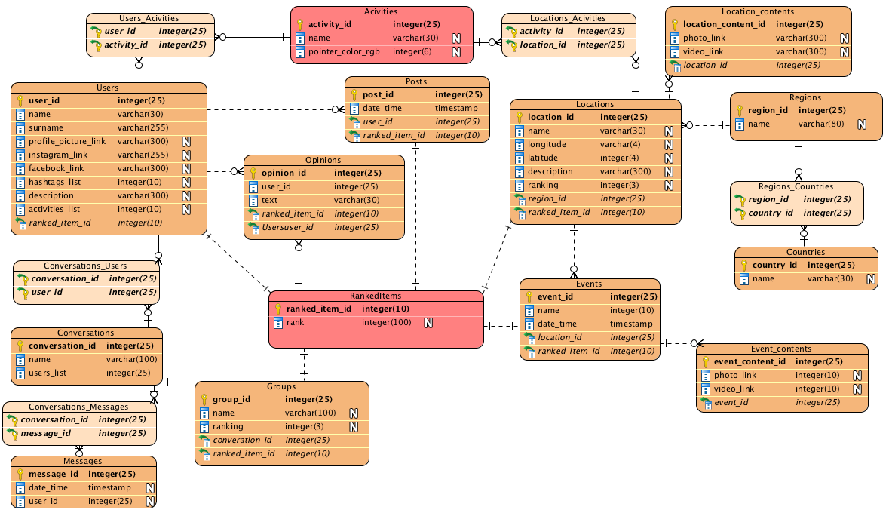

# Use-case diagram

