NON-PEER REVIEWED PREPRINT SUBMITTED TO EARTHARXIV

Built on the High Bank
Does a 440-year-old decision still decide who floods in a Siberian city?
A Sentinel-2 and terrain analysis of the 2026 Tura river flood in Tyumen, Russia
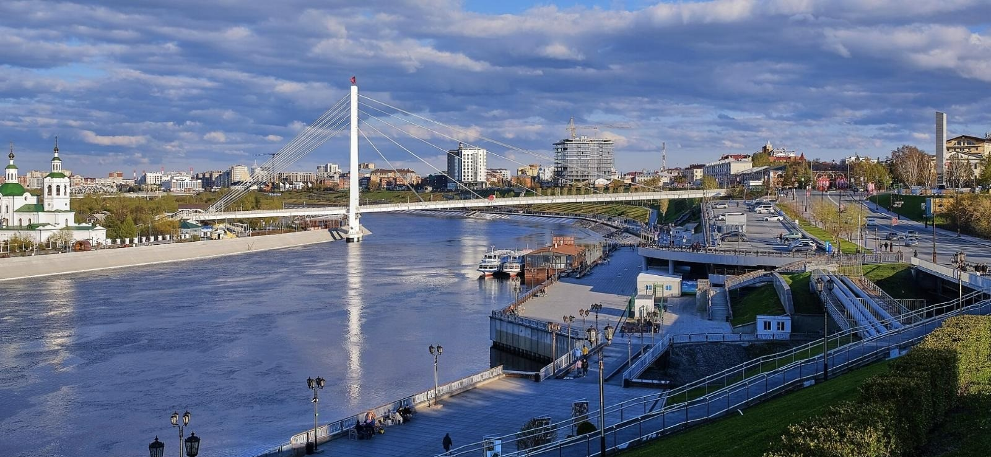
The Tura river at Tyumen in May 2026, three months before the flood. The photograph is taken from the high south bank, looking across to the low north bank. Photo: Vyacheslav Bukharov, Wikimedia Commons, CC BY-SA 4.0.
Sasha Ostriagin
Bromsgrove School, United Kingdom
ORCID: https://orcid.org/0009-0004-2671-3970
Correspondence: aostriagin@gmail.com
This manuscript is a non-peer reviewed preprint submitted to EarthArXiv. It has not been submitted to a journal. Subsequent versions may differ.
Contents
Abstract 3
1. Introduction 4
2. Study Area: Tyumen and the Tura River 5
2.1 Two banks at different heights 5
2.2 The flood of July–August 2026 7
3. Data and Methods 9
3.1 Satellite imagery 9
3.2 Detecting water 9
3.3 Separating flood water from shadow 10
3.4 Terrain cross-section 11
3.5 Measuring who was affected 11
4. Results 12
4.1 Flood extent 12
4.2 Terrain 13
4.3 Who was affected 14
4.4 Why part of the low bank stayed dry 15
5. Limitations 16
6. Conclusions 16
6.1 History or geography? 16
6.2 A threshold, not a boundary 17
7. Data and Code Availability 18
8. Declarations 18
9. References 19

Abstract
Tyumen was founded in 1586 as a Russian fort on the high, steep southern bank of the Tura river, leaving the low northern bank undeveloped.
This study tests whether that siting decision still governs flood exposure in the city, using the record summer flood of July–August 2026, which peaked at 897 cm (57.49 m above sea level) on the city gauge on 2 August.
Flood extent was mapped from Sentinel-2 satellite imagery for 18 June 2026 (before the flood) and 29 July 2026 (near the peak), and compared with buildings, roads and population on each bank.

Key findings
- The mapped flood covered 415.0 ha, of which 280.8 ha was newly inundated land.
- On the low north bank 120 of 716 buildings were flooded (1 in 6). On the high south bank it was 18 of 4,437 (1 in 250).
- About 5,080 residents were exposed on the north bank against about 560 on the south bank: nine times as many.
- The south bank rises to roughly 90 m within 400 m of the river. The north bank reaches only 59–63 m, and at several points lies 1–3 m above the flood line.
- The 1586 siting logic therefore persists, but as a threshold rather than a boundary: an event of this size was sufficient to cross onto terrace ground that ordinary floods do not reach.

Keywords: flood mapping; remote sensing; Sentinel-2; MNDWI; digital elevation model; flood exposure; path dependence; Tura river; Tyumen

1. Introduction
The present study investigates whether the historical choice of Tyumen's siting in 1586 still governs which bank is exposed to flood water. The settlement was placed on the high, steep southern bank of the Tura river, while the low, broad northern bank was left undeveloped.
The record summer flood of July–August 2026 offers a test. Specifically, the paper examines whether the defensible-position reasoning established four centuries ago holds under the conditions of an extreme hydrological event, or whether the exceptional flood reveals a threshold above which the historical pattern of exposure ceases to operate.
The question belongs to a broader literature on persistence and path dependence in economic geography, which asks how far the present spatial distribution of activity is determined by history rather than by geographic fundamentals, and how long the effects of a historical decision endure (Allen and Donaldson, 2022).
Using Sentinel-2 optical imagery, a global digital elevation model (DEM) and OpenStreetMap data, the study does three things:
- maps the flood extent;
- measures exposure on each bank;
- tests the historical premise against the catastrophic event.

Terms used in this report
North bank / south bank. The two sides of the Tura at Tyumen. The south bank is high and holds the historic city; the north bank is low.
Gauge level. The height of the river in centimetres above a fixed zero point on the city's measuring post. At Tyumen the zero is 48.52 m above sea level, so 897 cm is 57.49 m.
Sentinel-2. A pair of European Space Agency satellites that photograph the same place every five days in visible and infrared light.
MNDWI. The Modified Normalised Difference Water Index: a number calculated for every pixel of a satellite image, high over water and low over land.
DEM. A digital elevation model: a map in which every pixel records the height of the ground.
River terrace. A flat step of land beside a river, left behind when the river cut down to a lower level.

2. Study Area: Tyumen and the Tura River
Tyumen (57.15°N, 65.53°E) is the oldest Russian city in Siberia. It lies about 4,100 km east of London, just beyond the Ural Mountains (Figure 1).
The city stands on the banks of the Tura river, a tributary of the Tobol, which flows into the Irtysh, then into the Ob, and finally empties into the Kara Sea in the Arctic.
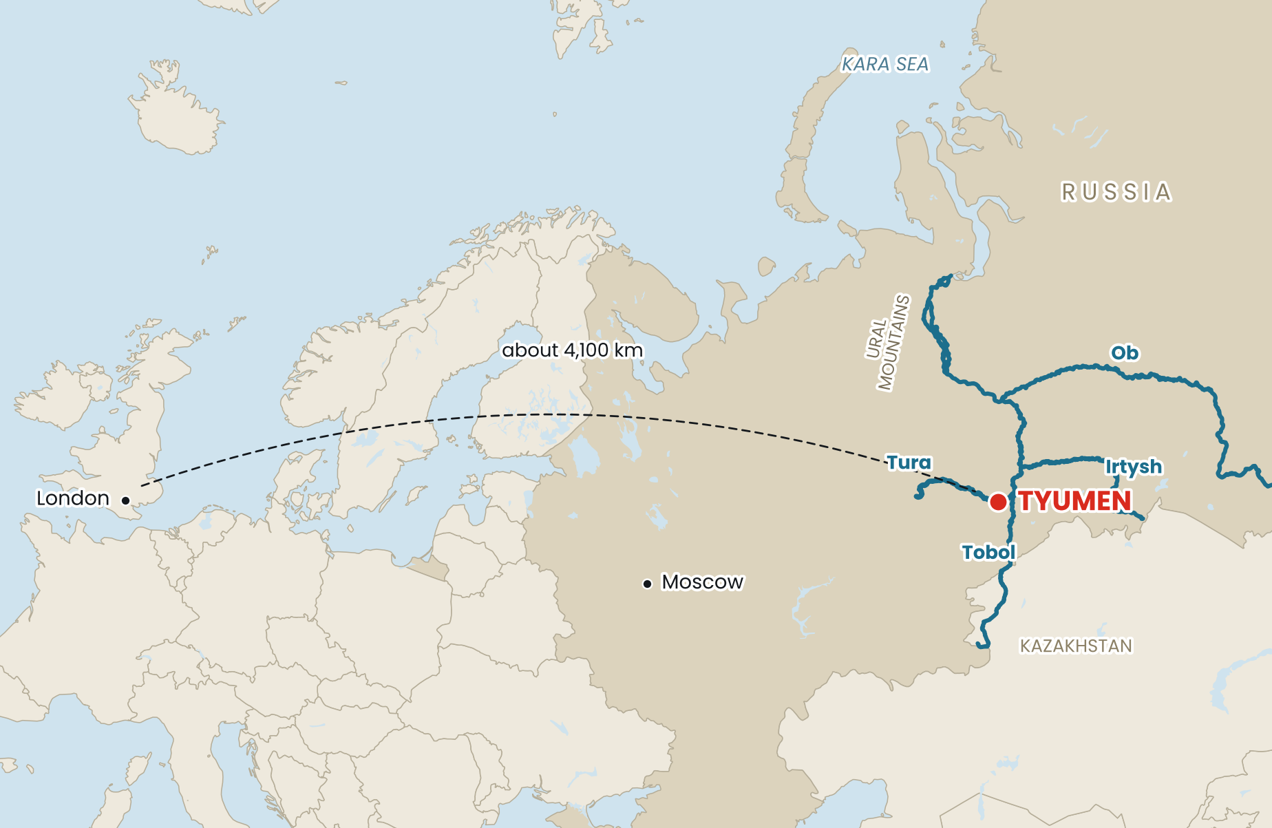
Figure 1. Location of Tyumen. The four rivers that carry its water north to the Arctic are shown in blue. Source: author's map; country outlines, lakes and rivers from Natural Earth (public domain).

2.1 Two banks at different heights
The historical centre and the kremlin are located on the high, steep bluff of the south bank, which rises approximately 30–40 metres above the river within a few hundred metres of the channel.
The northern bank, by contrast, is a more moderate terrace hosting docks, industry and, latterly, landscaped embankments. Part of it is the upper river terrace (in Russian, вторая надпойменная терраса, the “second terrace above the floodplain”). Historically, this area was built up above the first, lower terrace and is traditionally considered to lie outside the ordinary flood extent.
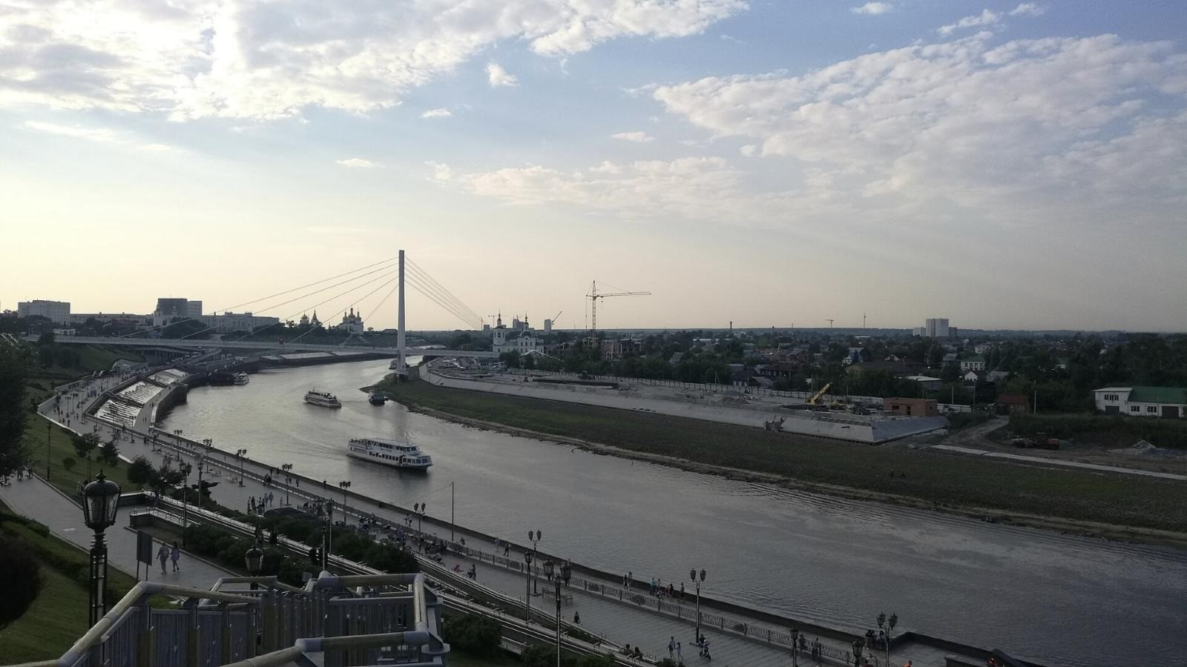
Figure 2. The view from the high south bank across the Tura to the low north bank, August 2020. The embankment on the far side was then under construction. Photo: RG72, Wikimedia Commons, CC BY-SA 4.0.
Figure 3 sets out this asymmetry directly. Panel (a) is a satellite image of the study reach, locating the historic centre, the city gauge and the line of the cross-section discussed below. Panel (b) maps the same area by height: the colour ramp alone distinguishes the high southern bluff from the low northern terrace.
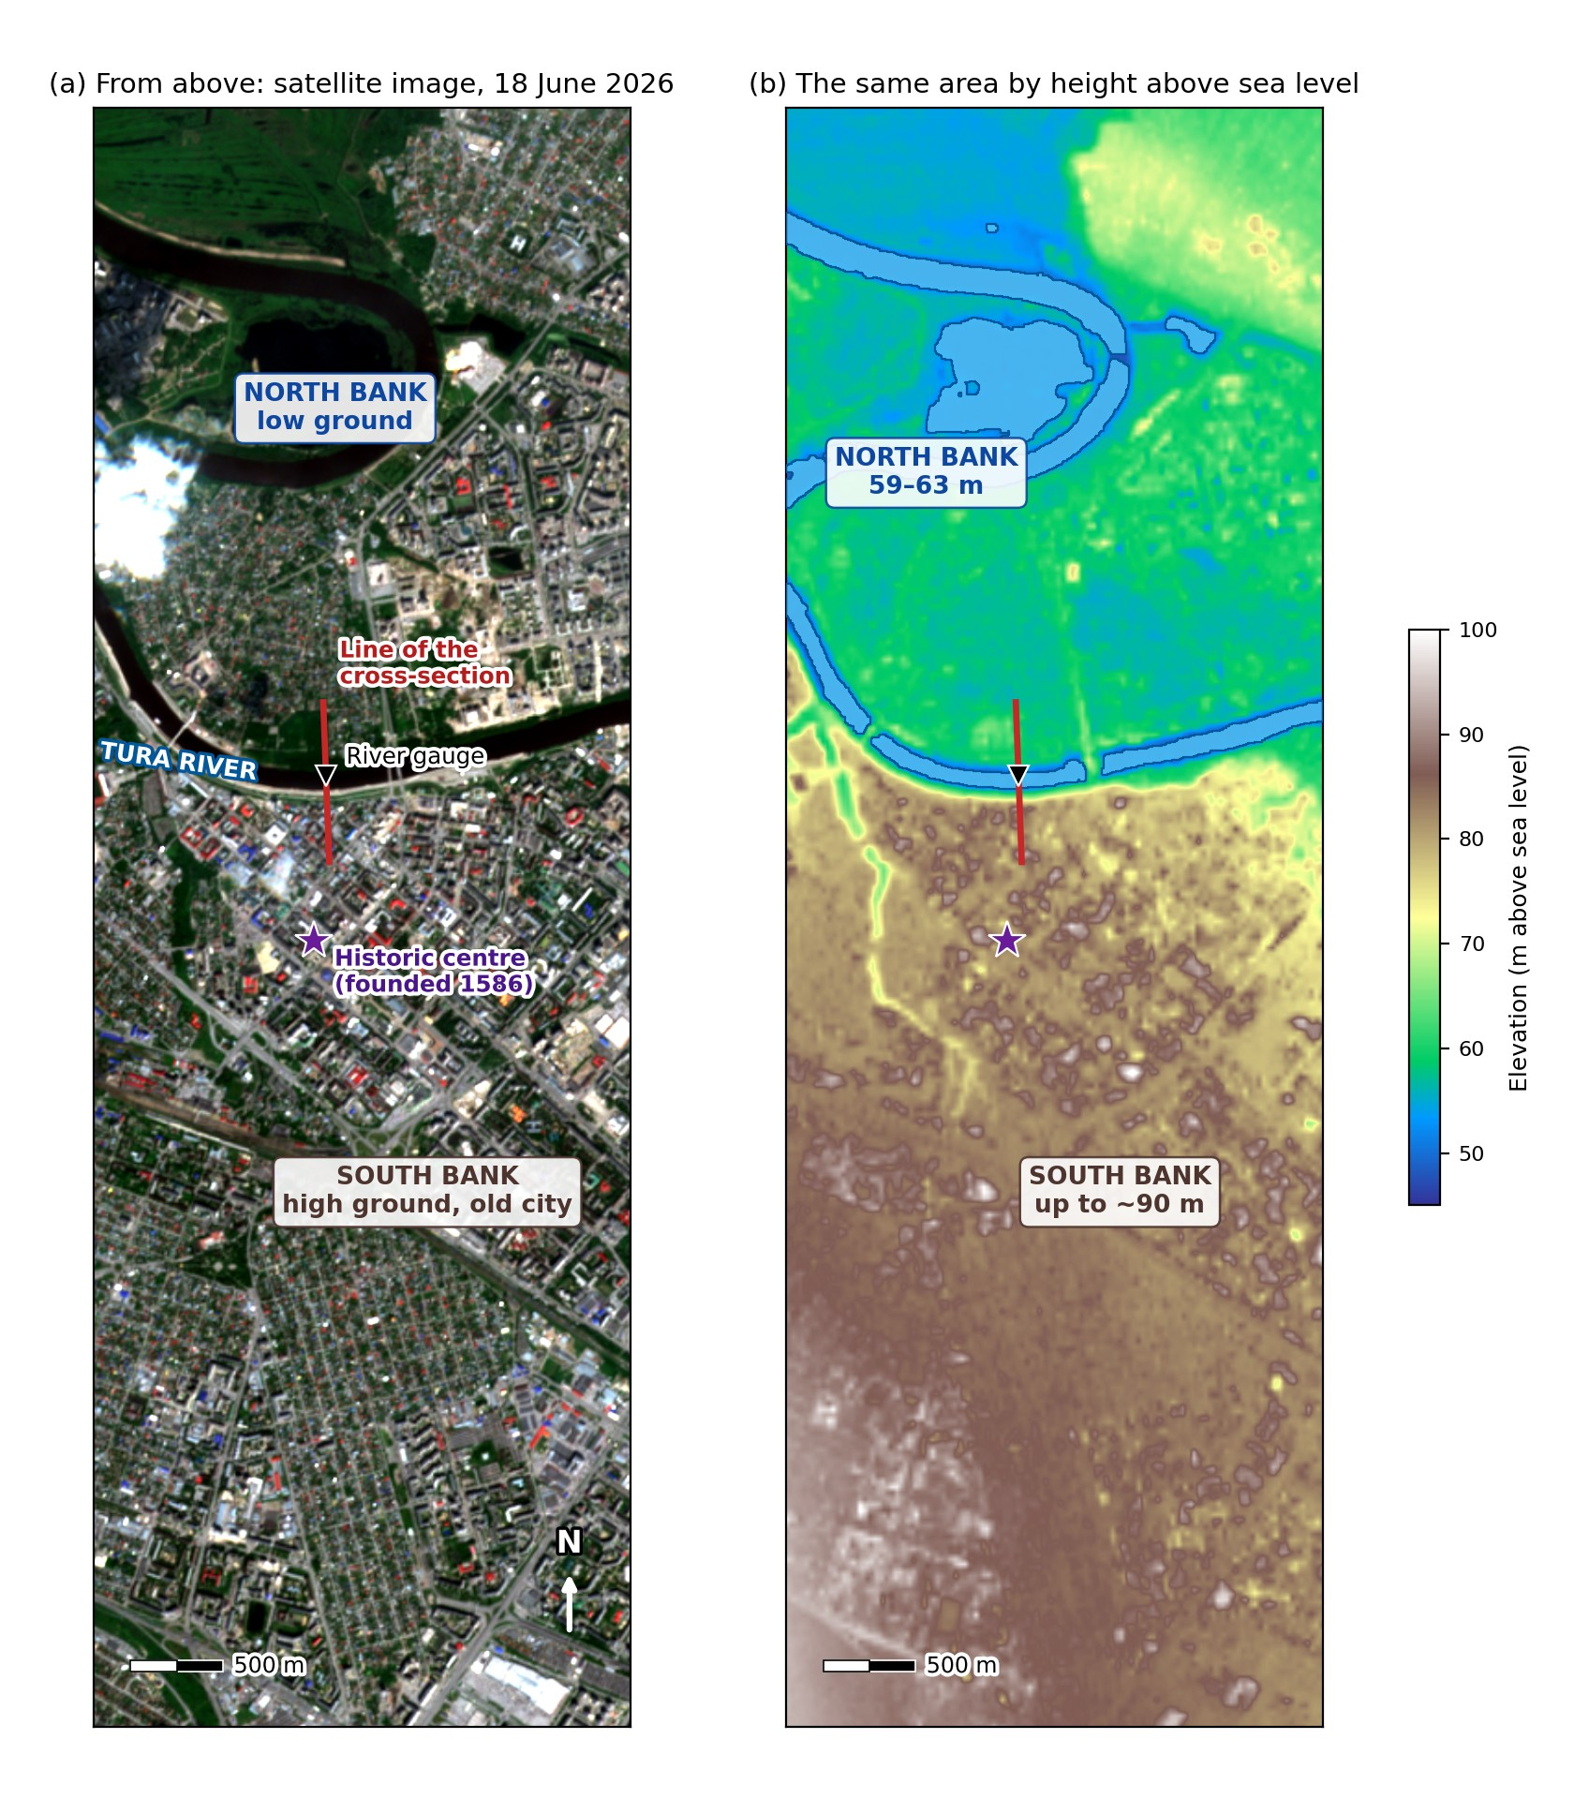
Figure 3. The study area shown twice at the same scale. (a) Sentinel-2 true-colour image, 18 June 2026. (b) Terrain from the Copernicus DEM GLO-30. Sources: Sentinel-2 L2A, Copernicus Data Space Ecosystem; Copernicus DEM GLO-30; author's analysis.

2.2 The flood of July–August 2026
In July 2026, prolonged heavy rainfall over the Tura's headwaters on the eastern slope of the Middle Urals produced a rapid rise several hundred kilometres downstream at Tyumen. This was a rain-generated summer flood rather than the spring snowmelt event that ordinarily sets the annual maximum.
The level on the city gauge reached 891 cm on 31 July and peaked at 897 cm (57.49 metres above sea level) on 2 August 2026 (Kommersant, 2026; RuNews24, 2026).
This was an absolute record for a summer flood at Tyumen, far above the previous summer maximum of 665 cm set in 1947. It remained below the all-time maximum of 915 cm recorded during the spring snowmelt flood of May 1979 (RuNews24, 2026).
Date | Gauge level | What happened
18 June 2026 | normal | Satellite image used as the pre-flood baseline
28 July 2026 | 877 cm | State of emergency declared from midday (The Moscow Times, 2026)
29 July 2026 | 886 cm | Satellite image used to map the flood
31 July 2026 | 891 cm | Water still rising
2 August 2026 | 897 cm | Peak: a record for a summer flood
Table 1. Timeline of the flood at the Tyumen gauge. Sources: Kommersant (2026); RuNews24 (2026); The Moscow Times (2026).
The lower tiers of the city embankment were submerged, and volunteers, including the author of this paper, filled sandbags on the north bank over two days as the water spread into residential areas beyond the normal floodplain.
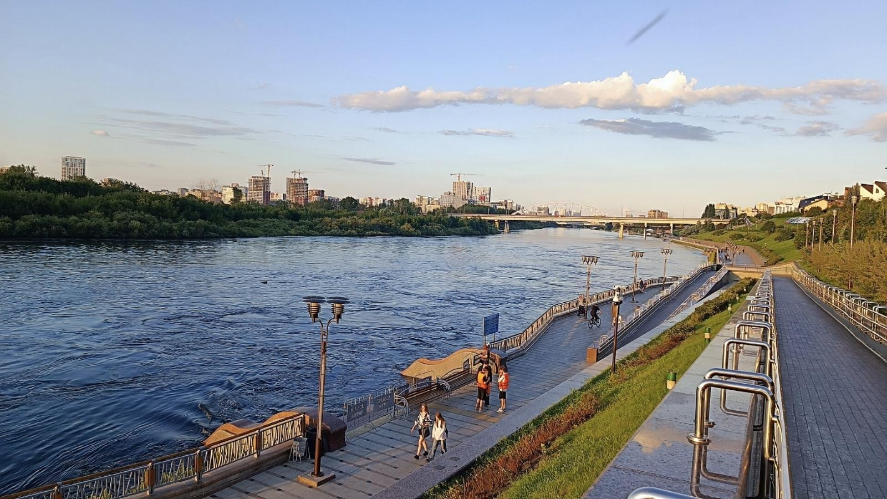
Figure 4. The Tura in high water on 1 August 2026, the day before the peak, seen from the city embankment. Photo: RG72, Wikimedia Commons, CC BY 4.0.

3. Data and Methods
The analysis uses four open datasets (Table 2). All processing was performed in Python and is documented in the accompanying repository, so the entire analysis can be re-run from the raw data.
Dataset | Used for | Detail
Sentinel-2 L2A | Mapping water | Two images, 18 June and 29 July 2026; 10–20 m bands
Copernicus DEM GLO-30 | Ground height | 30 m resolution
OpenStreetMap | Buildings and roads | 5,153 building polygons; full road network
WorldPop (2020) | Population | 100 m resolution, unconstrained
Table 2. Data sources.

3.1 Satellite imagery
Two Sentinel-2 L2A (surface reflectance) images covering the tile T41VPD (UTM zone 41N, EPSG:32641) were used. The mission's multispectral instrument provides 10–20 m visible, near-infrared and shortwave-infrared bands on a five-day revisit with two satellites (Drusch et al., 2012).
The images were obtained from the Copernicus Data Space Ecosystem using the Copernicus Browser:
- a cloud-free pre-flood image of 18 June 2026;
- a flood image of 29 July 2026, four days before the 2 August peak, when the gauge stood at 886 cm. This was the closest cloud-free Sentinel-2 pass to the peak.
Bands B02 (blue), B03 (green), B04 (red) and B11 (shortwave infrared, resampled to 10 m) were exported for both dates and co-registered on an identical grid (535 × 1599 pixels, approximately 5 m pixel spacing after the browser's resampling).

3.2 Detecting water
For each date, the Modified Normalised Difference Water Index (Xu, 2006) was computed as:
MNDWI = (B3 − B11) / (B3 + B11)
Water has high reflectance in the green band and strong absorption in the shortwave-infrared band, giving MNDWI values that are strongly positive over open water and negative over vegetation, soil and impervious surfaces.
MNDWI was developed as a modification of the earlier NDWI, which used the near-infrared band (McFeeters, 1996). Substituting shortwave infrared was specifically intended to suppress built-up land, which NDWI tends to misclassify as water. MNDWI is therefore the more appropriate index for an urban scene such as Tyumen (Xu, 2006).

3.3 Separating flood water from shadow
A fixed MNDWI threshold of 0, the default proposed by Xu (2006), correctly delineated the river channel in the pre-flood image. On the flood image it grossly underestimated the flooded area: the initial pass showed flooded pixels only 4.5% above the pre-flood baseline, contradicting the obvious widening of the river visible in the true-colour image.
Sampling band values along the cross-section revealed the reason. Reflectance in the visible bands decreased 4–5× between the two dates while shortwave-infrared reflectance remained comparable. This is the signature of cloud shadow, not open water, suppressing MNDWI in the flood image.
Two conventional approaches were tried and rejected:
- Otsu's automatic thresholding (Otsu, 1979) misclassified a large proportion of the built-up city as water, since the method assumes two clear groups of values that an urban scene does not provide.
- Simple region growing on a relaxed threshold leaked through shadowed streets and dark rooftops across the whole city, while still failing to delineate the true flooded area near the gauge.
This failure is well documented: shadow, dark roads and certain artificial surfaces return index values closely similar to those of water (Yang et al., 2018).
The final method therefore constrains the spectral water mask with a topographic one. A pixel is classified as water only if it passes three tests (Figure 5):
- It looks like water. Its MNDWI value exceeds a permissive threshold (−0.15 for the pre-flood date; −0.35 for the flood date, to account for shadow).
- It is low enough. Its DEM elevation lies below a plausible cut-off (53 m above sea level for the pre-flood channel; 58.9 m for the flood date, which is 1.5 m above the 891 cm level of 31 July).
- It joins the river. It is connected, through other qualifying pixels, to a strict high-confidence water seed (MNDWI > 0.05 pre-flood; > −0.05 flood).
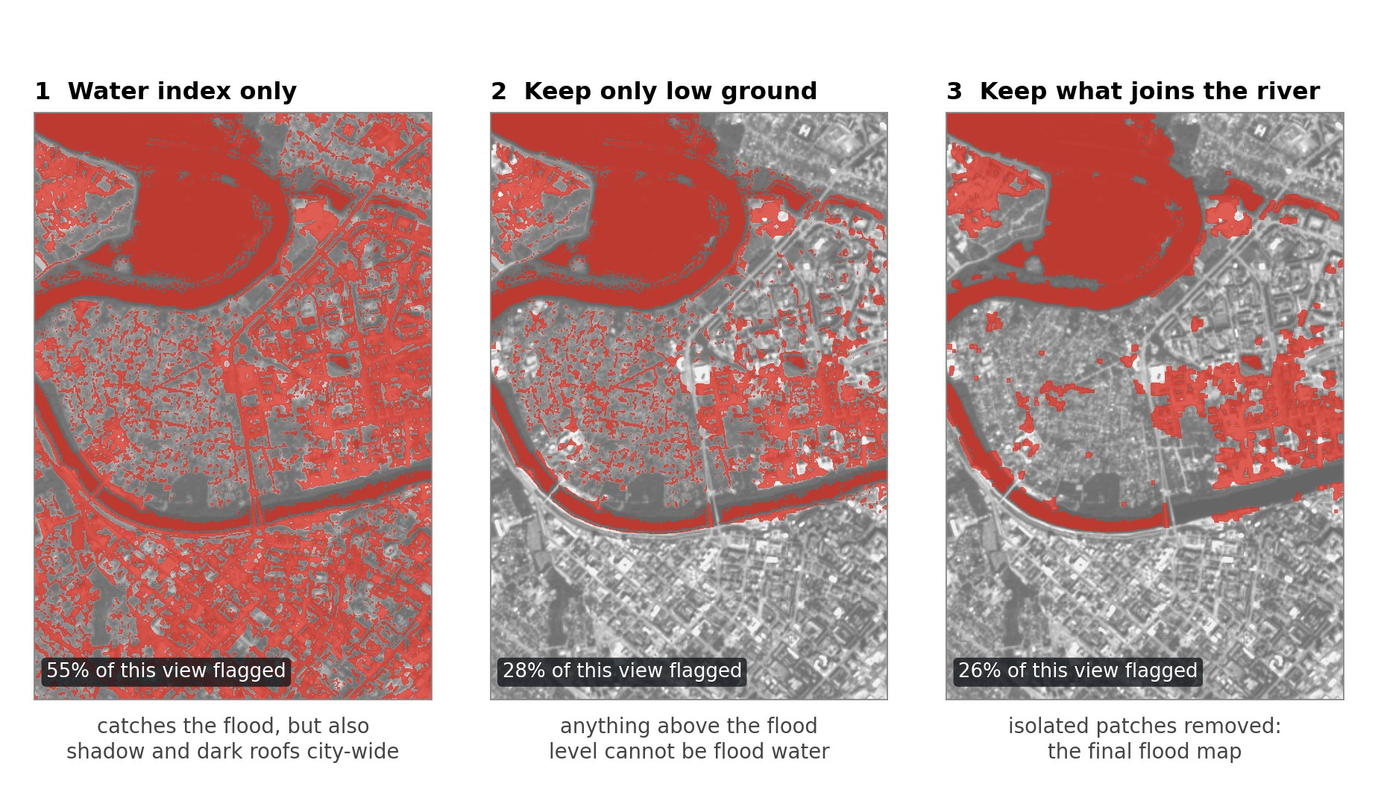
Figure 5. The three tests applied to the 29 July 2026 image. Each step removes false water: first shadow on high ground, then low patches that do not connect to the river. One short reach of the channel east of the bridge is also lost at step 3, so the method errs on the side of mapping too little water. Source: author's analysis.
The underlying principle is that a pixel's plausibility as flood water depends on its height relative to the adjacent drainage, not on its spectral signature alone. This follows the logic of the Height Above Nearest Drainage terrain model (Nobre et al., 2011). Refining a satellite flood map with elevation and connectivity has been applied to radar flood mapping in comparable settings (Hansen et al., 2025); the approach here is a simplified variant suited to a single optical scene.
Connectivity is implemented as 3×3 morphological opening followed by connected-component labelling in scipy.ndimage. The resulting masks were converted to polygons in Python (rasterio, geopandas); the QGIS project accompanying this report reproduces the same layers for inspection.

3.4 Terrain cross-section
A 900 m cross-section (450 m on each side of the river centreline) was extracted from the DEM at 5 m intervals. It runs perpendicular to the river and passes through the point on the channel nearest the gauge (57.1619°N, 65.5349°E).

3.5 Measuring who was affected
- Buildings and roads were extracted from OpenStreetMap via the Overpass API (bounding box 65.50–65.56°E, 57.14–57.17°N). Buildings and road segments intersecting the flood polygon were counted on each side.
- The dividing line between north and south was defined from the local direction of the river centreline at the gauge point, checked against the known south-bank location of the Tyumen kremlin.
- Population was obtained from the WorldPop Global Project Population Data (Tatem, 2017) for the flooded area on each bank.

4. Results

4.1 Flood extent
Figure 6 shows the pre-flood and flood scenes with the derived water masks overlaid.
- The pre-flood channel occupies 137.4 ha, including the meander lake north of the historic centre.
- The flood extent covers 415.0 ha.
- Of this, 280.8 ha (68%) is newly inundated territory beyond the permanent channel.
The flood extends markedly further north of the river, and into more densely built fabric, than it does to the south.
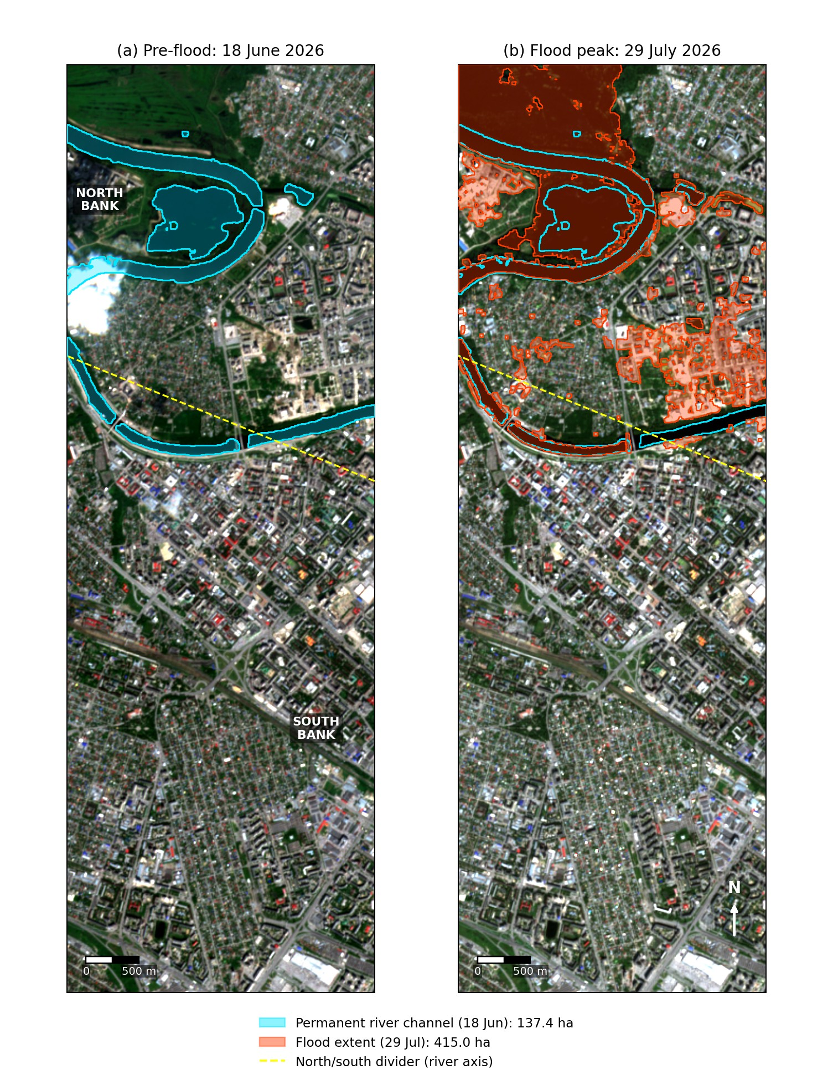
Figure 6. Sentinel-2 true-colour images of Tyumen on 18 June 2026 (pre-flood, left) and 29 July 2026 (flood, right). The permanent river channel is outlined in cyan and the 29 July flood extent is shown in orange. The dividing line used for the exposure counts is also shown. Source: Sentinel-2 L2A, Copernicus Data Space Ecosystem; author's analysis.

4.2 Terrain
Figure 7 shows the DEM cross-section through the historic centre, with the 897 cm gauge peak (57.49 m above sea level) drawn as a reference line.
- The channel bed lies at approximately 48–50 m, consistent with the gauge zero of 48.52 m.
- The south bank rises sharply, reaching approximately 90 m within about 400 m of the channel. This is a genuine bluff, and the site occupied by the 1586 fortress.
- The north bank is considerably more moderate, rising to only 59–63 m over the same distance. At several points along the broader terrace it lies only 1–3 m above the flood line.
The flood line crosses approximately 515 m of the cross-section, almost all of it on the low north-bank side.
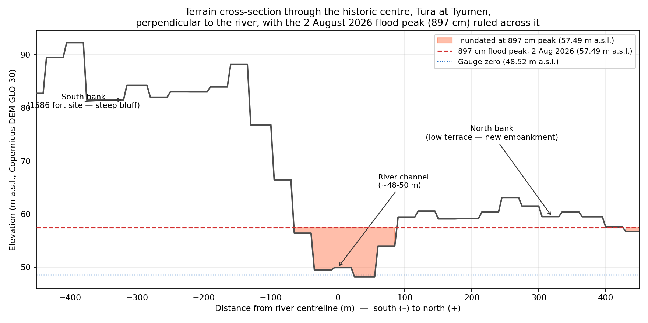
Figure 7. Terrain cross-section perpendicular to the Tura through the historic centre, with the flood peak of 2 August 2026 (897 cm = 57.49 m above sea level) ruled across it. Source: Copernicus DEM GLO-30; author's analysis.

4.3 Who was affected
Table 3 and Figure 8 summarise exposure by bank.
 | North bank | South bank
Flood extent | 391.2 ha | 23.9 ha
Buildings (total, OpenStreetMap) | 716 | 4,437
Buildings flooded | 120 (16.8%) | 18 (0.4%)
Roads flooded | 39.8 km | 11.4 km
Population exposed (WorldPop 2020) | ≈5,080 | ≈560
Table 3. Flood exposure by bank, 29 July 2026. Sources: buildings and roads, OpenStreetMap contributors; population, WorldPop (unconstrained, 2020, 100 m); flood extent, author's analysis.
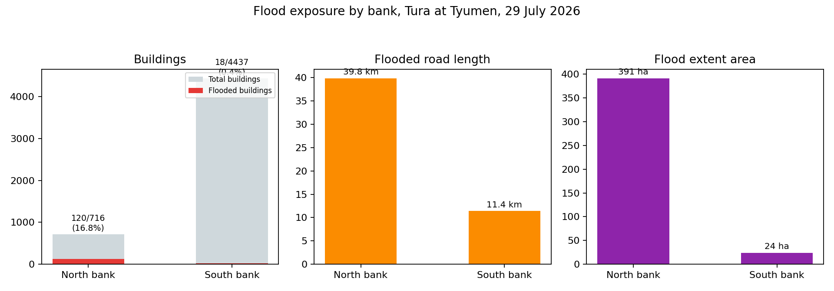
Figure 8. Flood exposure by bank: buildings flooded (of total), flooded road length, and flood-extent area. Source: author's analysis; OpenStreetMap contributors; WorldPop.
The south bank contains six times more buildings in total, including the historic centre and the majority of the contemporary city. Despite this:
- the flooded area on the north bank is sixteen times larger;
- its proportion of flooded buildings is approximately forty times higher;
- the estimated exposed population is roughly nine times greater.
This is a clear and consistent result across every exposure metric. It corresponds directly to the 1586 siting decision, to build the city on the high south bank while leaving the low north bank as floodplain. The observations in this paper are a retrospective validation of that decision, 440 years later.

4.4 Why part of the low bank stayed dry
The cross-section explains why the result cannot be reduced to a simple binary of “north floods, south does not.”
Along most of the cross-section the north-bank terrace remains several metres above the flood line and stayed dry. Although the proportion of flooded buildings on the north bank is relatively high (16.8%), the majority of the terrace was not inundated.
But wherever the terrace elevation comes within 1–3 m of the flood line, the 897 cm event was sufficient to cross it. At the peak, national reporting recorded 121 flooded homes and 53 people evacuated in the city (Kommersant, 2026).
The reasoning of the 1586 siting (south = safe, north = exposed) is therefore not a binary but a threshold relation. The north bank has always lain closer to the flood line. An exceptionally large flood, the largest summer event in the Tyumen record and within 18 cm of the all-time spring maximum, pushed parts of the terrace that had previously stood just above the threshold below it.

5. Limitations
Several limitations affect the accuracy of these results, although they do not change their overall direction.
- One image, four days before the peak. This is the most important limitation. The 29 July image was taken when the gauge stood at 886 cm against the eventual 897 cm. The mapped extent is therefore likely to be conservative, and the exposure figures should be read as a lower bound for the peak.
- The masking method. It may still underestimate water beneath dense tree canopy or in deep shadow, and may overestimate very shallow wet patches detected by the permissive threshold. The geometric simplification used for the population query changes the area by a further 3–4%.
- Pixel size. The Sentinel-2 bands used have a native resolution of 10–20 m. A single pixel can straddle the true flood boundary, so small buildings or short road segments at the edge may be misclassified.
- A straight dividing line. The north–south divide is a straight line derived from the local river direction, a simplification of the Tura's meandering course. Buildings and roads very close to the river may be assigned to the wrong bank.
Cloud cover prevented a cloud-free Sentinel-2 image closer to the peak. Sentinel-1 radar, which is unaffected by cloud and is routinely used for flood mapping with the kind of topographic refinement applied here (Hansen et al., 2025), could provide a near-peak map in future work.

6. Conclusions
The results confirm the premise of the research question directly. Four hundred and forty years after the founding of Tyumen, the same asymmetry, a steep, high southern bank and a gentle, low northern bank, still determines the bulk of flood exposure in the city. It is seen in the DEM cross-section, in the satellite-derived flood extent, and in every exposure metric calculated in this paper.

6.1 History or geography?
This is a striking example of historical-geographical path dependence: sixteenth-century military reasoning in choosing a defensive position continues to sort flood risk in the twenty-first century.
It is, however, a particular variety of persistence. Allen and Donaldson (2022) distinguish between spatial patterns that are path-dependent, sustained by history and by the accumulated investment that follows it, and those determined by geographic fundamentals that would reassert themselves regardless.
Tyumen's case leans towards the latter. The asymmetry is anchored in terrain that has not moved, so the 1586 decision is better read as an accurate early reading of a durable physical constraint than as a self-reinforcing historical accident. The built environment that grew up around that reading is what converts the constraint into present-day exposure.

6.2 A threshold, not a boundary
The 2026 event complicates that interpretation. The upper terrace on the north bank, built up and occupied under the presumption of safety from ordinary flooding, was inundated. The geography had not changed; a flood of exceptional size for the season was large enough to cross a threshold that ordinary floods do not reach.
That this was a summer, rain-generated event rather than a spring snowmelt one matters. The terrace's safety margin had been established against a flood regime in which the annual maximum arrives with the melt, and the 2026 event arrived outside it.
The 1586 siting logic should therefore be interpreted as a gradient of exposure keyed to elevation above the channel, one that held reliably through four centuries of ordinary floods and failed only in the face of a single exceptional event.
As climate and hydrological conditions change the frequency of such record events, the safety margin historically provided by the north-bank terrace may require revision rather than assumption.

7. Data and Code Availability
All processing scripts, the derived flood-extent and exposure layers, the QGIS project and the figure files are available in the accompanying repository:
https://github.com/ostriagin/tura-flood-tyumen-2026
- Sentinel-2 L2A imagery: Copernicus Data Space Ecosystem (dataspace.copernicus.eu).
- Copernicus DEM GLO-30: the public copernicus-dem-30m archive.
- OpenStreetMap data: retrieved via the Overpass API.
- WorldPop population data: retrieved via the WorldPop REST API.
Exact retrieval parameters are documented in the repository README.

8. Declarations
Funding. This research received no funding.
Competing interests. The author declares no competing interests.
Use of AI tools. AI tools assisted with parts of this work, including locating sources and the processing code.
Field observations. The author was present in Tyumen during the flood and took part in the volunteer sandbagging on the north bank.

9. References
Allen, T. and Donaldson, D. (2022) ‘Persistence and path dependence: A primer’, Regional Science and Urban Economics, 94, 103724. doi: 10.1016/j.regsciurbeco.2021.103724
Drusch, M., Del Bello, U., Carlier, S., Colin, O., Fernandez, V., Gascon, F., Hoersch, B., Isola, C., Laberinti, P., Martimort, P., Meygret, A., Spoto, F., Sy, O., Marchese, F. and Bargellini, P. (2012) ‘Sentinel-2: ESA's Optical High-Resolution Mission for GMES Operational Services’, Remote Sensing of Environment, 120, pp. 25–36. doi: 10.1016/j.rse.2011.11.026
Hansen, M., Vejby, J. and Koch, J. (2025) ‘Flood mapping using Sentinel-1 imagery with topographical and hydrological contextualization: Case study from Ribe, Denmark’, International Journal of Applied Earth Observation and Geoinformation, 143, 104816. doi: 10.1016/j.jag.2025.104816
Kommersant (2026) ‘Паводок в Тюмени: уровень воды на Туре достиг 896 см’ [‘Flood in Tyumen: the water level on the Tura has reached 896 cm’], 2 August. Available at: https://www.kommersant.ru/doc/8860971 (Accessed: 24 September 2026).
McFeeters, S.K. (1996) ‘The use of the Normalized Difference Water Index (NDWI) in the delineation of open water features’, International Journal of Remote Sensing, 17(7), pp. 1425–1432. doi: 10.1080/01431169608948714
Nobre, A.D., Cuartas, L.A., Hodnett, M., Rennó, C.D., Rodrigues, G., Silveira, A., Waterloo, M. and Saleska, S. (2011) ‘Height Above the Nearest Drainage – a hydrologically relevant new terrain model’, Journal of Hydrology, 404(1–2), pp. 13–29. doi: 10.1016/j.jhydrol.2011.03.051
Otsu, N. (1979) ‘A Threshold Selection Method from Gray-Level Histograms’, IEEE Transactions on Systems, Man, and Cybernetics, 9(1), pp. 62–66. doi: 10.1109/TSMC.1979.4310076
RuNews24 (2026) ‘Губернатор Моор назвал летний паводок в Тюмени рекордным’ [‘Governor Moor calls the summer flood in Tyumen a record’], 14 August. Available at: https://runews24.ru/tumen/14/08/2026/gubernator-moor-nazval-letnij-pavodok-v-tyumeni-rekordnyim-za-vsyu-istoriyu-nablyudenij (Accessed: 24 September 2026).
Tatem, A.J. (2017) ‘WorldPop, open data for spatial demography’, Scientific Data, 4, 170004. doi: 10.1038/sdata.2017.4
The Moscow Times (2026) ‘Tyumen Region Declares State of Emergency as It Braces for Major Flooding’, 28 July. Available at: https://www.themoscowtimes.com/2026/07/28/tyumen-region-declares-state-of-emergency-as-it-braces-for-major-flooding-a93347 (Accessed: 24 September 2026).
Xu, H. (2006) ‘Modification of normalised difference water index (NDWI) to enhance open water features in remotely sensed imagery’, International Journal of Remote Sensing, 27(14), pp. 3025–3033. doi: 10.1080/01431160600589179
Yang, X., Qin, Q., Grussenmeyer, P. and Koehl, M. (2018) ‘Urban surface water body detection with suppressed built-up noise based on water indices from Sentinel-2 MSI imagery’, Remote Sensing of Environment, 219, pp. 259–270. doi: 10.1016/j.rse.2018.09.016

