Meeting with Thang: 11/14/2017

Participants: Scott Russell

Andrew Ekstedt

Thang Hoang

Main Points:

- review individual Technology Reviews

- Discuss suggestions for implementation.

**Action Items:**

**-Work on Technology Review (ALL)**

**-Delete SFTP From Requirements Doc and Resubmit for Approval. (SR)**

**-Meeting with Andrew (TA) Tomorrow to Discuss Progress. (ALL)**

**-Technology Review on Github By Friday for peer review. (ALL)**

- **Send out Notes (SR)**

Image of Process (Email, Local Server, Database, Client)

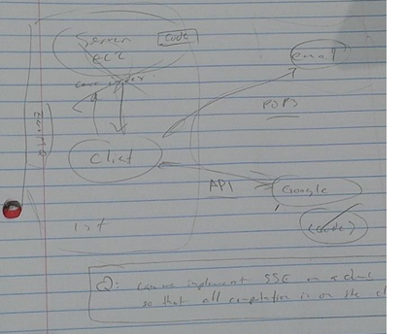

Personal Technology Review Notes

Server Protocol:

POP3

MAPI

IMAP

Cloud Server:

Amazon EC2

Google CE

Microsoft Azure VM

Benchmarks:

Clusion (David Cash Java)

DSSE Bit Matrix (C++)

?sophos by raphael bost (public key opperations)

Comparison Tests:

-End-To-End Delay

-Size Comparison

-Server Computation Preformance

-Client Computation Delay

-Transmission Speed

-I/O Access (Hard Drive and Ram)

Discuss Proposted Solutions for Project

Thang gave individual suggestions for choices of Server/Cloud/Benchmarks

-Download Email

-Upload Encrypted Index to Google Drive