MIDTERM ASSIGNMENT:

Date of Birth Analyzer loaded from db table

In this assignment, you need to create 3 dropdown menus: MONTH | DAY | YEAR.

When user selects the date and clicks the submit button, the feedback will report which date is selected, general information about the generation belonging to the specific year span and the short bio about the famous persons born within that year span ( at least 2 persons per year span ).

All of the information has to be selected from the database.

Use "calendar.php" that we created in class ( week 8 ). This file is inside your midterm-head-start.zip

Start with your database.

Open *phpMyAdmin* and create the database and tables.

DATABASE ---> TABLES ---> COLUMNS

Here is the example:

database name: dob

name of the first table: gen_table

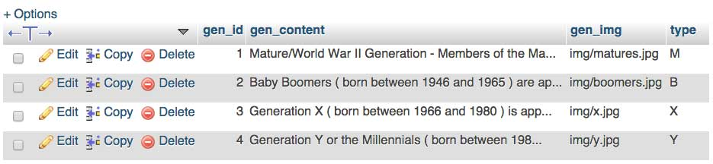

gen_id column would be primary key – auto increment.

gen_content column would have TEXT datatype (no length restriction). Here is the place for general information about generations.

gen_img column would have VARCHAR datatype. It stores the relative path to your image.

type column stores the code for each generation, for example M stands for Matures.

Name of the second table: spec_table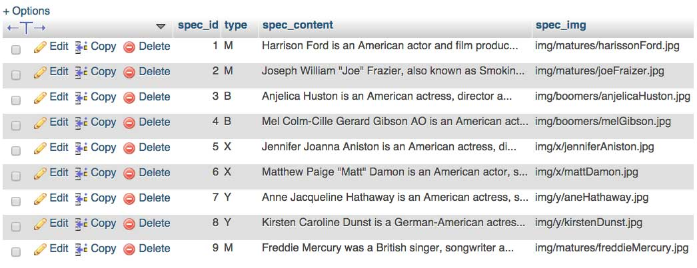

spec_id column is primary key – auto increment.

spec_content column has TEXT datatype (no length restriction).

spec_img column would have VARCHAR datatype. It stores the relative path to your image.

type column stores the code for each generation, for example M stands for Matures.

For each year-span, you will do 2 queries:

* The first query will select gen_content and gen_img based on type
* The second query will select spec_content and spec_img based on type

GENERAL INFORMATION ABOUT GENERATIONS

Mature/World War II Generation - Members of the Mature/WWII Generation ( born before 1946 ) are 67 years or older. Although most members have retired from the labor force, they comprise a wealth of valuable knowledge and experience. Many believe this generation views work as an obligation: they respect authority, take rational approaches, and produce quality work.

Baby Boomers ( born between 1946 and 1965 ) are approximately between the ages of 47 and 66. The older members have begun to retire from the labor force. This generation occupies most of the senior-level management roles. They are often stereotyped as extremely focused on work, and they possess a strong work ethic and desire recognition for their efforts.

Generation X ( born between 1966 and 1980 ) is approximately between the ages of 32 and 46. The oldest members could be entering senior-level management roles while the younger members entering/approaching mid-career and senior-level supervisory roles. Many members of Generation X embrace diversity9 and entrepreneurship.

Generation Y or the Millennials ( born between 1981 and 2000 ) are approximately between the ages of 12 and 31. The older members are in the labor force while the younger members are still completing their formal education. This generation is known for being optimistic and goal-oriented: they are known for enjoying collaboration and multitasking, are comfortable embracing emerging technologies, and appreciate meaningful work.

*Zip your files including exported database file and submit it to Canvas.*

*Fully completed assignment will be marked 100/100.*

*50% - Functionality*

*35% - Style*

*15% - Code formatting*