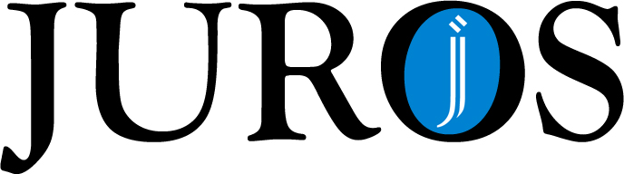

License Agreement: Part 1

By submitting this agreement, the authors grant the Journal of Undergraduate Research at The Ohio State University (JUROS) the non-exclusive right to reproduce, translate, and distribute the submission (including the abstract) in print, electronic format, and any other media, including but not limited to audio or visual for the purpose of inclusion in JUROS. Authors also agree that JUROS may make and retain more than one copy for the purposes of preservation, security, and backup. Authors represent that they have the authority to grant the rights contained in this agreement. Authors also represent that their submission does not, to the best of their knowledge, infringe upon existing copyright. If the submission contains material for which authors do not hold copyright, they represent that they have obtained the unrestricted permission of the copyright owner to grant JUROS the rights by this agreement, and that such third-party material is clearly identified and acknowledged within the submission. Acceptance of this agreement gives JUROS permission to publish the submission on behalf of the authors.

Submission Title:

______________________________________________________________________________

______________________________________________________________________________

Names of All Authors (Please Print): Signatures of All Authors:

____________________________________ ____________________________________

____________________________________ ____________________________________

____________________________________ ____________________________________

____________________________________ ____________________________________

____________________________________ ____________________________________

____________________________________ ____________________________________

Advisor’s Signature: ________________________________ Date: _____________________

License Agreement: Part 2
Creative Commons License
(Optional)

Creative Commons licenses are web-based agreements designed by the author/creator, to share his/her work while retaining copyright. As an author or creator, you can specify conditions under which others can copy and distribute your work. For instance, most authors/creators insist that others give the author/creator credit for their work.
Should you want to offer your work with no conditions and make it freely available via JUROS, you may simply choose the first option, the “public domain” license by entering your initials on the blank line. If you wish to exercise your copyright by alerting others to specific conditions of use, choose one of the additional options by entering your initials on the blank line and we will link your work to a Creative Commons license based on your responses.
(REMEMBER: To license a work, you must be its copyright holder or have express authorization from its copyright holder to do so. Neither The Ohio State University nor Creative Commons provide legal advice or services).

- _________ Public Domain: The work may be freely reproduced, distributed, transmitted, used, modified, built upon, or otherwise exploited by anyone for any purpose, commercial or non-commercial, and in any way, including by methods that have not yet been invented or conceived. (No license is assigned.)
- _________ Use and distribution license: As long as they credit you for the original creation and license their new creations under the identical terms, you permit others to copy, distribute, display, perform, translate, make remixes, and produce new creations based on your work. (This license lets others distribute, remix, tweak, and build upon your work, even commercially, as long as they credit you for the original creation and use the same license.)
- _________ Non-commercial use and distribution license: As long as they credit you for the original creation and license their new creations under the identical terms, you permit others to copy, distribute, display, perform, translate, make remixes, and produce new creations based on your work only for non-commercial purposes. (This license lets others distribute, remix, tweak, and build upon your work non-commercially, as long as they credit you for the original creation.)
- _________ No changes use and distribution license: As long as they credit you for the original creation, you permit others to copy, distribute, display, and perform your work. (This license lets others distribute your work, even commercially, as long as they credit you for the original creation.)
- _________ Non-commercial / No changes use and distribution license: As long as they credit you for the original creation, you permit others to copy, distribute, display, and perform your work only for non-commercial purposes. (This license lets others distribute your work for non-commercial purposes, as long as they credit you for the original creation.)
For more information on Creative Commons licenses visit http://www.creativecommons.org

