Predictions for Tides at Yaquina Coast Guard Station in Newport for May 2020

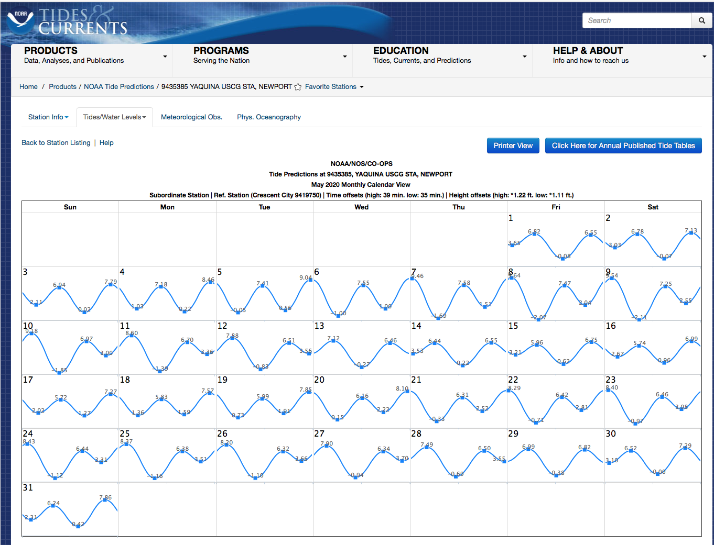

<https://tidesandcurrents.noaa.gov/noaatidepredictions.html?id=9435385&units=standard&bdate=20200501&edate=20200531&timezone=LST/LDT&clock=12hour&datum=MLLW&interval=hilo&action=monthlychart>