***What effect does the gravitational force by the Moon have on the Earth?***

|  |  |  |  |
| --- | --- | --- | --- |
| Table V.15  Average predicted high and low tides during the predicted new, 1st quarter, full, and third quarter phases of the Moon during May 2020 at the Yaquina Coast Guard Station, in Newport, Oregon | | | |
| Moon Phase | Average predicted high tide in feet | Average predicted low tide in feet | Difference between average predicted high and low tides |
| Full Moon on May 7 | |  | | --- | | 8.52 | | -0.09 | 8.61 |
| 3rd Quarter on May 14 | 6.50 | 1.71 | 4.76 |
| New Moon on May 22 | 7.36 | 1.05 | 6.31 |
| 1st Quarter on May 29 | 6.91 | 1.36 | 5.55 |

Data predicted by [National Oceanic and Atmospheric Administration (NOAA) Tides and Currents : https://tidesandcurrents.noaa.gov/noaatidepredictions.html?id=9435385&units=standard&bdate=20200501&edate=20200531&timezone=LST/LDT&clock=12hour&datum=MLLW&interval=hilo&action=monthlychart](National%20%20Oceanic%20and%20Atmospheric%20Administration%20(NOAA)%20Tides%20and%20Currents%20https://tidesandcurrents.noaa.gov/noaatidepredictions.html?id=9435385&units=standard&bdate=20200501&edate=20200531&timezone=LST/LDT&clock=12hour&datum=MLLW&interval=hilo&action=monthlychart)

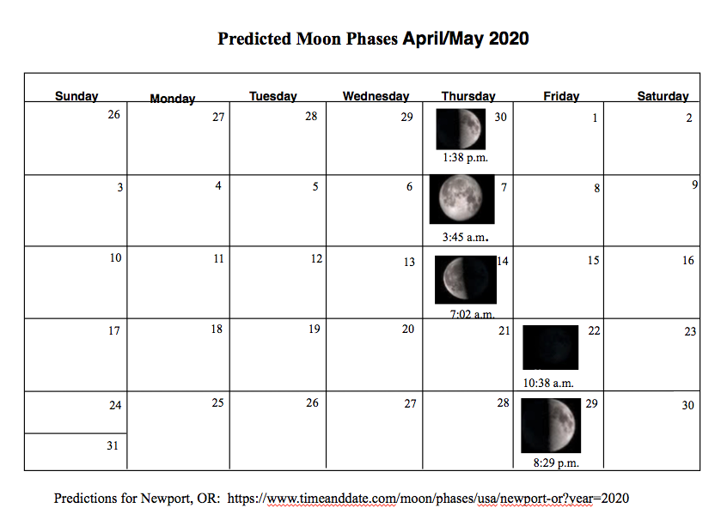

What is the connection between phases of the Moon and the occurrence of spring and neap tides?