Using Pinhole Phenomena to Estimate the Diameter of the Sun

Some students go outside on a sunny day. As shown below, they hold up an aluminum foil frame with a pinhole so that a projection of the Sun falls on a screen:

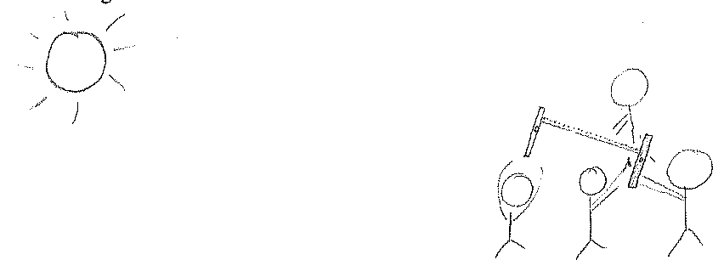
They hold the frame with the pinhole about one meter (100 centimeters) away from the screen. After they trace the projection on the screen, they measure its diameter and find it to be about 1 centimeter.
Assume that the Sun is about 100 million miles away.
Follow the guidelines for solving pinhole phenomena problems to estimate the diameter of the Sun.

