Analogy between Moving and Melting Phenomena:

TABLE IV.4a Analogy between moving and melting phenomena
Falling Ball Observations |  |  | Melting Ice Observation and Predictions
Graph | Height | Slope | Graph | Height | Slope
Position vs time |  |  | Mass of ice vs time*  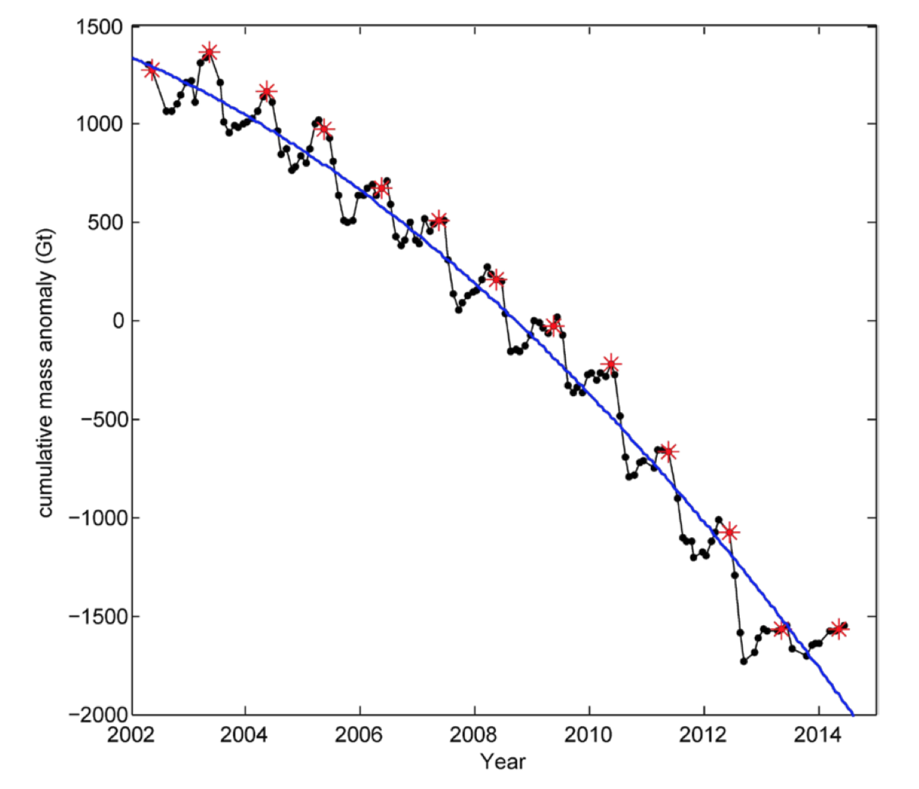
Velocity vs time |  |  | Velocity of melting vs time
Acceleration vs time |  |  | Acceleration of melting vs time
• Khan et al., “Greenland Ice sheet balance: a review.,” Reports on Progress in Physics 78(4), 046801 (2015).
* See also: http://wgms.ch/latest-glacier-mass-balance-data/

