Summary of Analogy Between Moving and Melting Phenomena
TABLE IV.4b Summary of analogy between moving and melting phenomena
Falling Ball Observations |  |  | Melting Ice Observation and Projections
Graph | Height | Slope | Graph | Height | Slope
Position versus time  t  x | Position, a number on a number line, where the ball is at a particular instant | Velocity, how much the position of the ball changes in one unit of time  A number, what the velocity of the moving ball is at a particular instant | Mass of ice vs time*  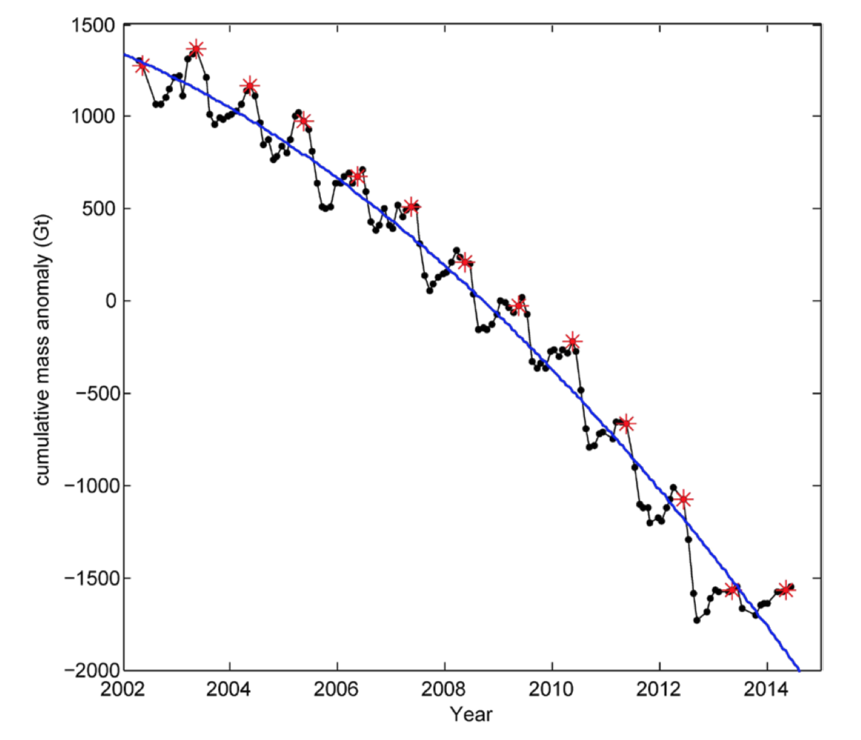 | Mass, a number,  how much ice there is at a particular instant | Velocity of melting, how much the mass of ice changes in one unit of time  A number, what the velocity of melting is at a particular instant
Velocity versus time  t  v  aa | Velocity, how much the position of the moving ball changes in one unit of time,  A number, what the velocity of the moving ball is at a particular instant | Acceleration, how much the velocity of the moving ball changes in one unit of time  A number, what the acceleration of the moving ball is at a particular instant | Velocity of ice melting vs time  t  v | Velocity of melting, how much the mass of melting ice changes in one unit of time  A number, what the velocity of melting is at a particular instant | Acceleration, how much the velocity of melting changes in one unit of time  A number, what the acceleration of melting is at a particular instant
Acceleration vs time  t  a  t | Acceleration, how much velocity of the moving ball changes in one unit of time  A number, what the acceleration of the moving ball is at a particular instant | How much acceleration changes in one unit of time (no special name)  Is this a natural process with constant acceleration? | Acceleration of melting vs time  t  a | Acceleration, how much the velocity of melting changes in one unit of time  A number, what the acceleration of melting is at a particular instant | How much acceleration of melting changes in one unit of time  (no special name)  Is this a natural process with constant acceleration?  Or can it be modified by human action?

• Khan et al., “Greenland Ice sheet balance: a review.,” Reports on Progress in Physics 78(4), 046801 (2015).
* See also: http://wgms.ch/latest-glacier-mass-balance-data/

