<https://developer.mozilla.org/en-US/docs/Learn/Getting_started_with_the_web>

<https://developer.mozilla.org/en-US/docs/Learn/Getting_started_with_the_web/What_will_your_website_look_like>

The Colour Picher tool

<https://developer.mozilla.org/en-US/docs/Web/CSS/CSS_Colors/Color_picker_tool>

#C3C3FC

<https://developer.mozilla.org/en-US/docs/Learn/Getting_started_with_the_web/Dealing_with_files>

<!DOCTYPE html>

<html>

<head>

<meta charset="utf-8">

<title>My test page</title>

</head>

<body>

<img src="" alt="My test image">

</body>

</html

=====================================================================================

<!DOCTYPE html>

<html>

<head>

<meta charset="utf-8">

<title>My First Web page</title>

</head>

<body>

<img src="IndexFiles\OneWheel.jpg" alt="My test image">

</body>

</html>

Organise your Web Site Folder like this: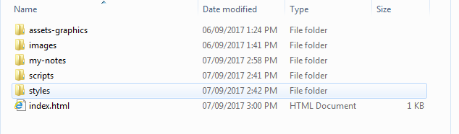

**Assignment:**

Do: What will your site look like

Do: Dealing With Files

Do: HTML basics

Create a site in a folder called MySiteYourName:

https://developer.mozilla.org/en-US/docs/Learn/Getting_started_with_the_web/HTML_basics

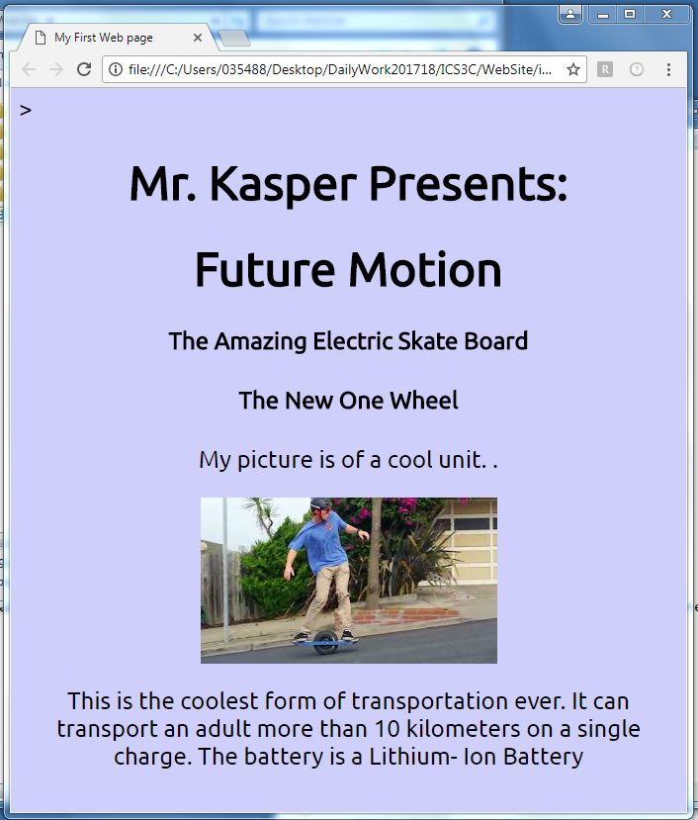

Introduction to Computer Programming

Basic HTML coding

**ICS3C – WEB site assignment**

**Name:_________________________________ Date:_____________**

**References:**

[**https://developer.mozilla.org/en-US/docs/Learn/Getting_started_with_the_web**](https://developer.mozilla.org/en-US/docs/Learn/Getting_started_with_the_web)

[**https://developer.mozilla.org/en-US/docs/Learn/Getting_started_with_the_web/What_will_your_website_look_like**](https://developer.mozilla.org/en-US/docs/Learn/Getting_started_with_the_web/What_will_your_website_look_like)

[**https://developer.mozilla.org/en-US/docs/Learn/Getting_started_with_the_web/Dealing_with_files**](https://developer.mozilla.org/en-US/docs/Learn/Getting_started_with_the_web/Dealing_with_files)

[**https://developer.mozilla.org/en-US/docs/Learn/Getting_started_with_the_web/HTML_basics**](https://developer.mozilla.org/en-US/docs/Learn/Getting_started_with_the_web/HTML_basics)

Levels of Achievement

**Communications:** 1 2 3 4

File Structure

Name of Document

**Knowledge Understanding** 1 2 3 4

Source code correct

**Thinking** 1 2 3 4

Use of extra HTML tags not

Given during the lesson

**Application** 1 2 3 4

Application of details from the

Web site resource

Change document name to student name.

Cascading Style Sheets:

<https://developer.mozilla.org/en-US/docs/Learn/Getting_started_with_the_web/CSS_basics>

<https://www.w3schools.com/js/default.asp>