<https://developer.mozilla.org/en-US/docs/Learn/Getting_started_with_the_web>

<https://developer.mozilla.org/en-US/docs/Learn/Getting_started_with_the_web/What_will_your_website_look_like>

The Colour Picher tool

<https://developer.mozilla.org/en-US/docs/Web/CSS/CSS_Colors/Color_picker_tool>

#C3C3FC

<https://developer.mozilla.org/en-US/docs/Learn/Getting_started_with_the_web/Dealing_with_files>

<!DOCTYPE html>

<html>

<head>

<meta charset="utf-8">

<title>My test page</title>

</head>

<body>

<img src="" alt="My test image">

</body>

</html

=====================================================================================

<!DOCTYPE html>

<html>

<head>

<meta charset="utf-8">

<title>My First Web page</title>

</head>

<body>

<img src="IndexFiles\OneWheel.jpg" alt="My test image">

</body>

</html>

Organise your Web Site Folder like this:

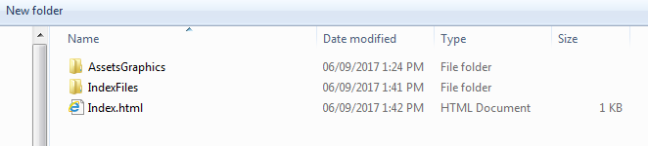

<http://www2.tdsb.on.ca/wifiuserguide/>

<https://www.w3schools.com/js/default.asp>