Shared-memory programming using OpenMP
Oscar Vargas Pabon
All codes where uploaded to the following repository under the 2_submit folder https://github.com/osvarp/paralelComputing_week3

1 OpenMP Model
When I run it without the ‘-fopenmp’ flag it only prints ‘hello’ once. When I run it with the flag it prints ‘Hello’ 8 times.
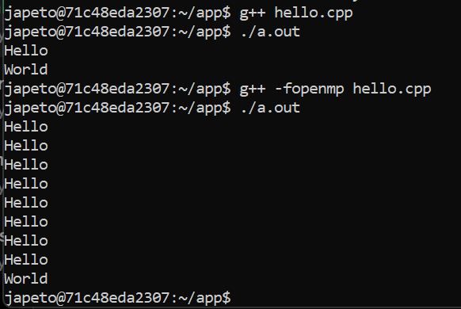
2 The team
It’s possible to create odd number of threads and more threads than cores (apparently my machine has 8 threads and I tried creating >10).
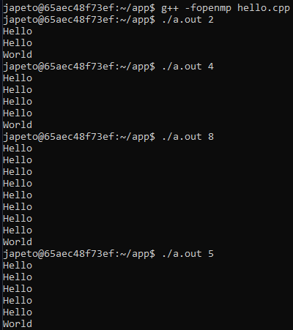
3 Thread identifier
Done
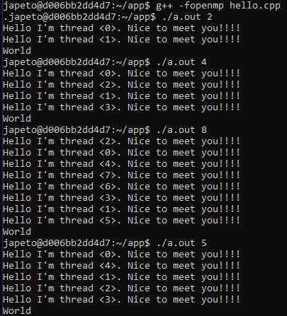
4 Identifier + pragma omp parallelize for
If it’s not evenly divisible, then some threads may end with more or less iterations to execute.
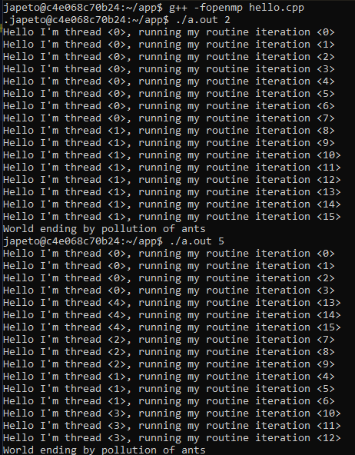
5 Degree of parallelization
The reason behind the errors are race conditions involving the variable where I add in each iteration.
As the COUNT amount increases, the mistakes it makes seems to increase too. For some reason, having 4 and 8 threads tend to generate a bigger error than 2, 32 or 64 in my experiments.
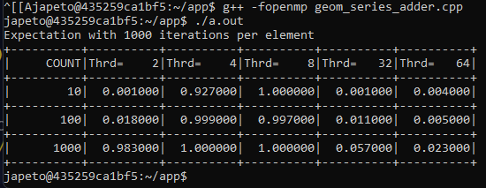
6 Private Vs global scope
Changing it to private makes it always give wrong answers. The reason is that by making it private, then each thread calculates with it’s own version of ‘sum’, meaning that the result among all threads is never calculated.
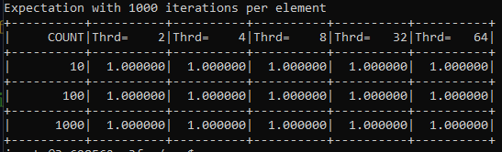
7 Reduction
Reduction tells omp that the variable ‘sum’ of each thread will be subject to a reduction (all will be added into a single one).
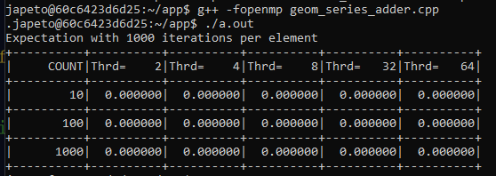
8 Compute PI
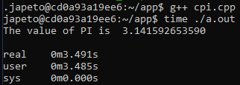
9 Parallelize PI
The program is not only noticeable slower, it also computes an incorrect answer to PI. My hypothesis to the second downfall is that the stability of the previous algorithm depends on the order of the summands (addition is not commutative over floating point-_-).
