**Graded Assignment 4 Screenshots**

1. **Add roles in the database**

POST - http://localhost:8080/role 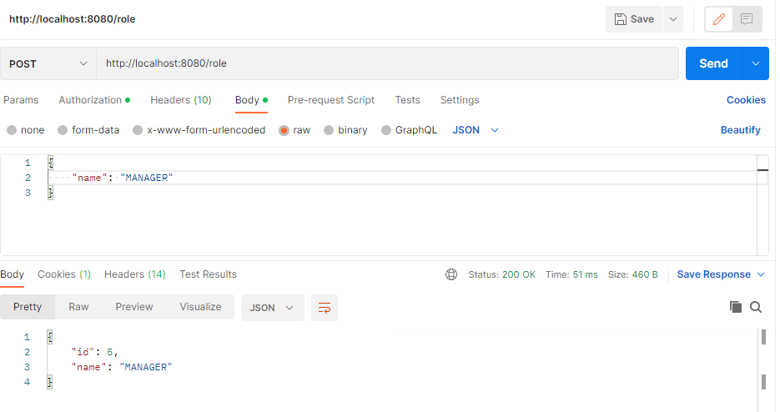

Screenshot from DB-

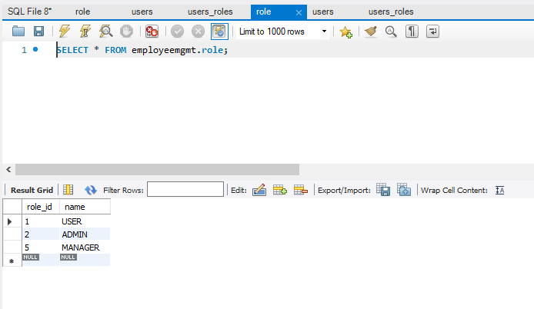

1. **Add Users in the db which can be used for authentication purposes.**

POST - http://localhost:8080/user

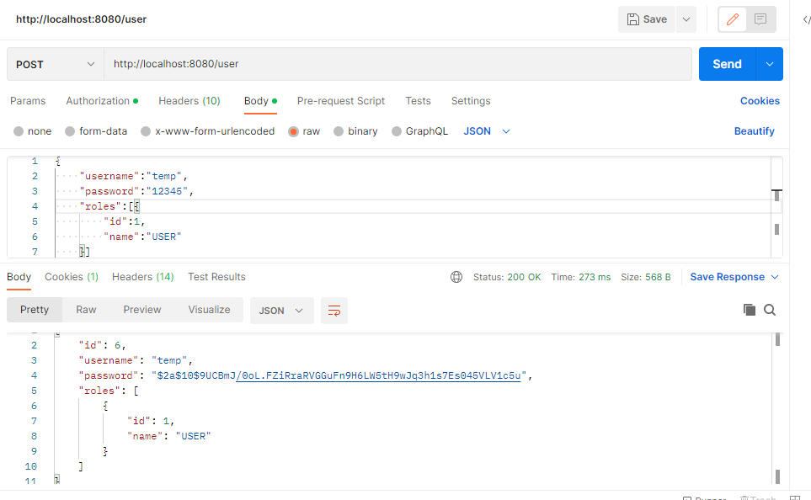

Screenshot from DB –

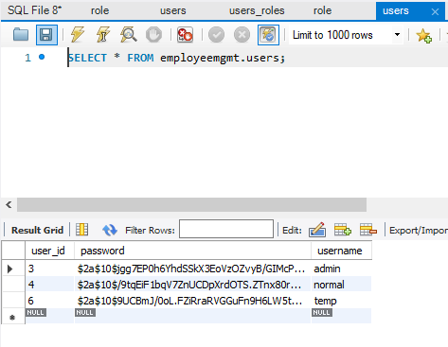

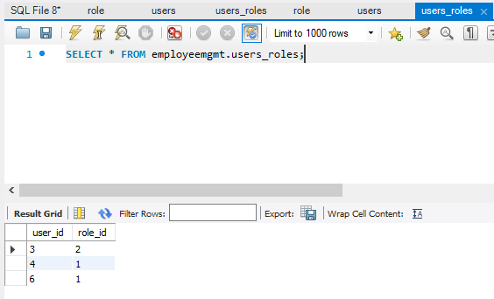

1. **Add employees data in the db if and only if the authenticated user is ADMIN-**

POST - <http://localhost:8080/employees>

Using admin user authentication-

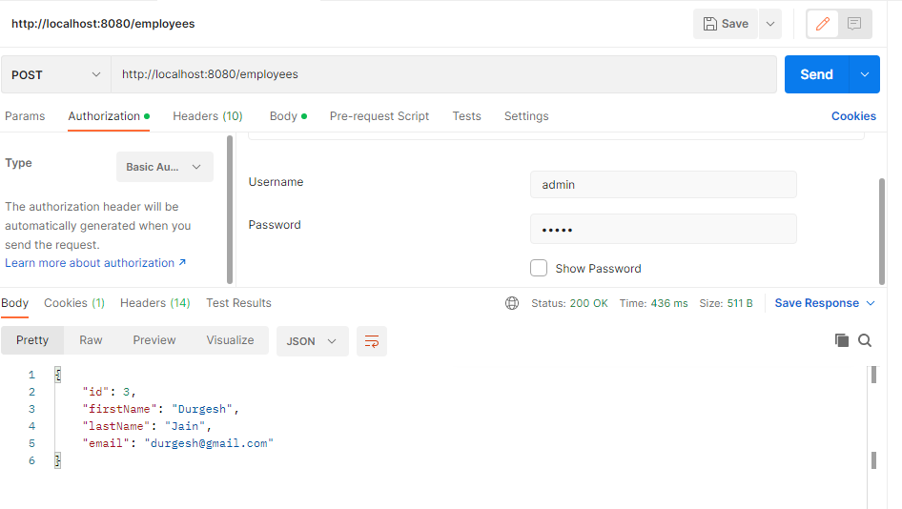

Using normal user authentication-

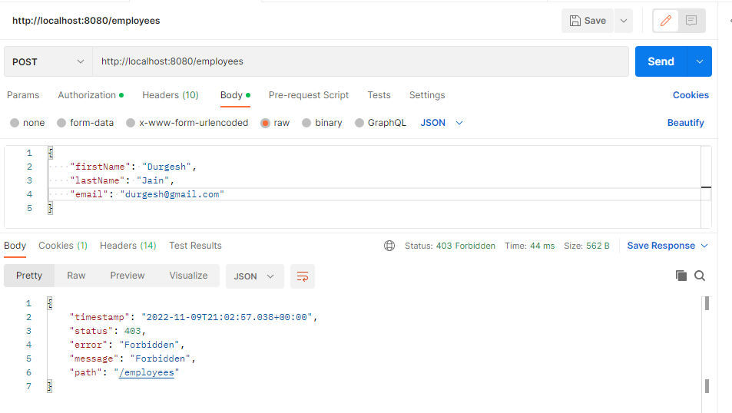

1. **List all the employees stored in the database**

GET – http://localhost:8080/employees

Using admin user authentication-

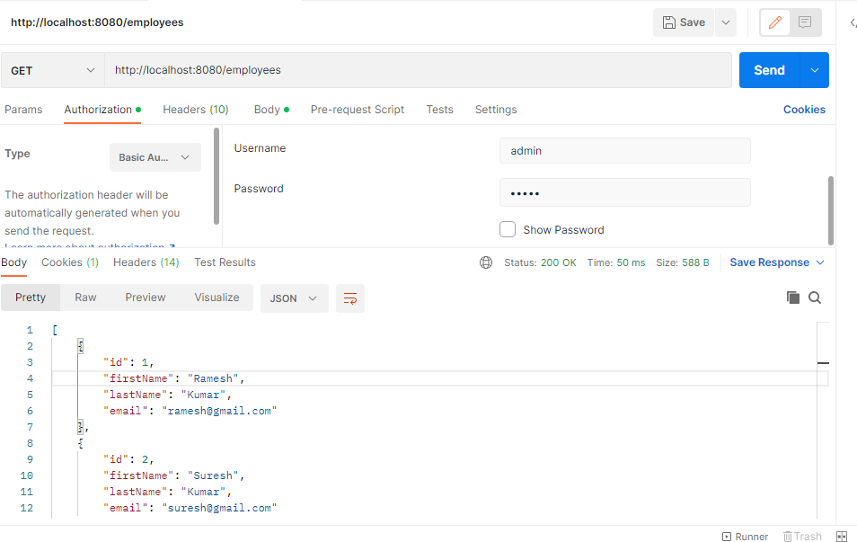

Using temp user authentication –

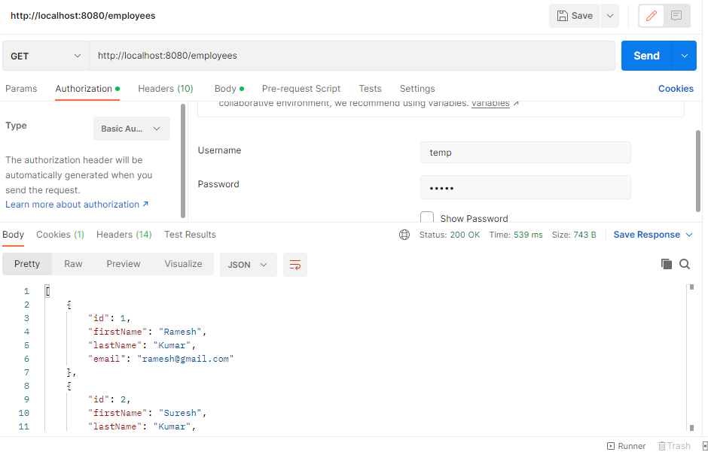

1. **Get an employee record specifically based on the id of that employee**

GET – <http://localhost:8080/employees/1>

Using admin user authentication

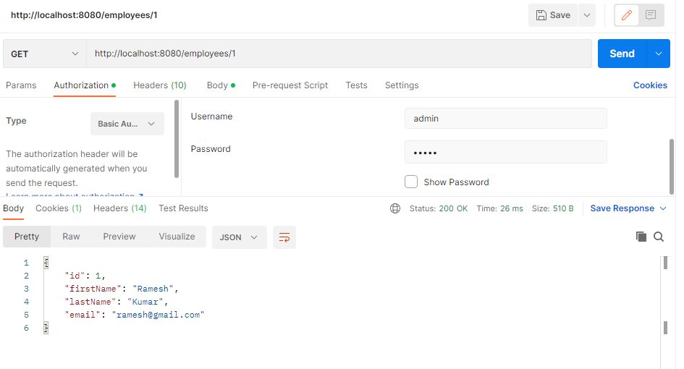

Using normal user authentication –

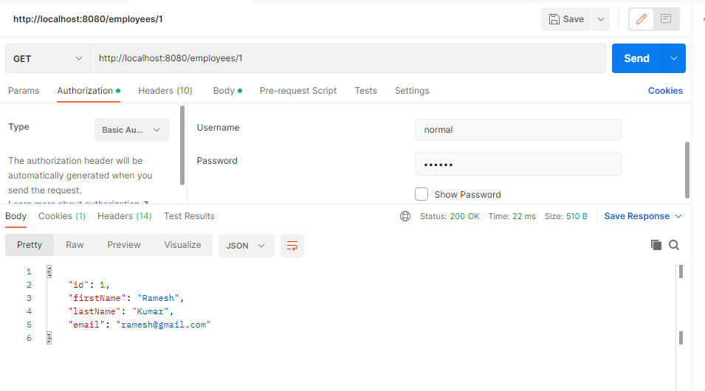

1. **Update an existing employee record with the given updated json object.**

PUT - <http://localhost:8080/employees/3>

Using admin user authentication-

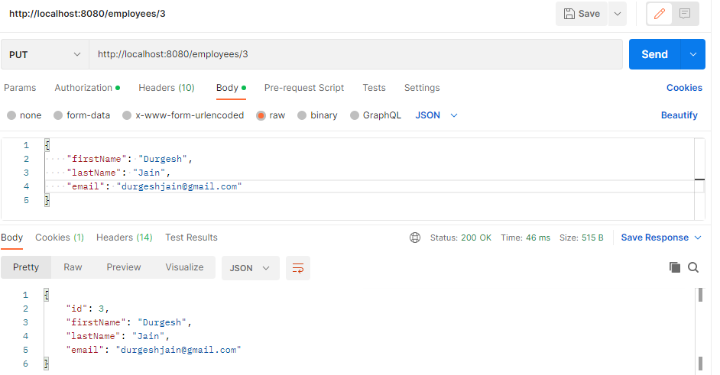

Json object to be updated –

{

    "id": 3,

    "firstName": "Durgesh",

    "lastName": "Jain",

    "email": "durgesh@gmail.com"

}

Response body after updation –

{

    "id": 3,

    "firstName": "Durgesh",

    "lastName": "Jain",

    "email": "durgeshjain@gmail.com"

}

1. **Delete an existing employee record based on the id of the employee**

Delete - <http://localhost:8080/employees/3>

Using admin user authentication –

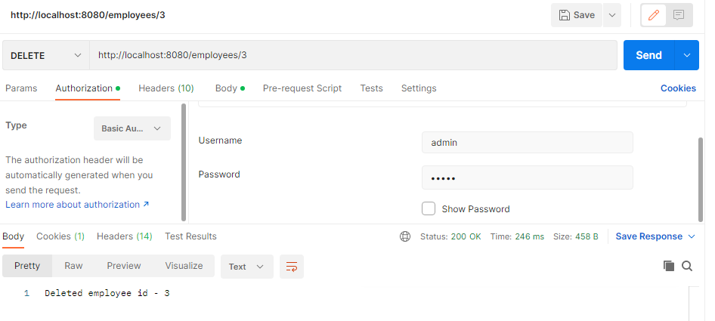

1. **Fetch an employee by his/her first name and if found more than one record then list them all**

GET - http://localhost:8080/employees/search/Suresh

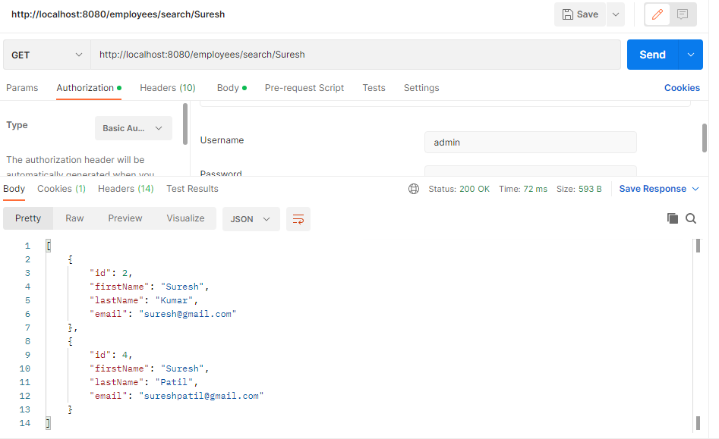

1. **List all employee records sorted on their first name in either ascending order or descending order**

GET - <http://localhost:8080/employees/sortAsc>

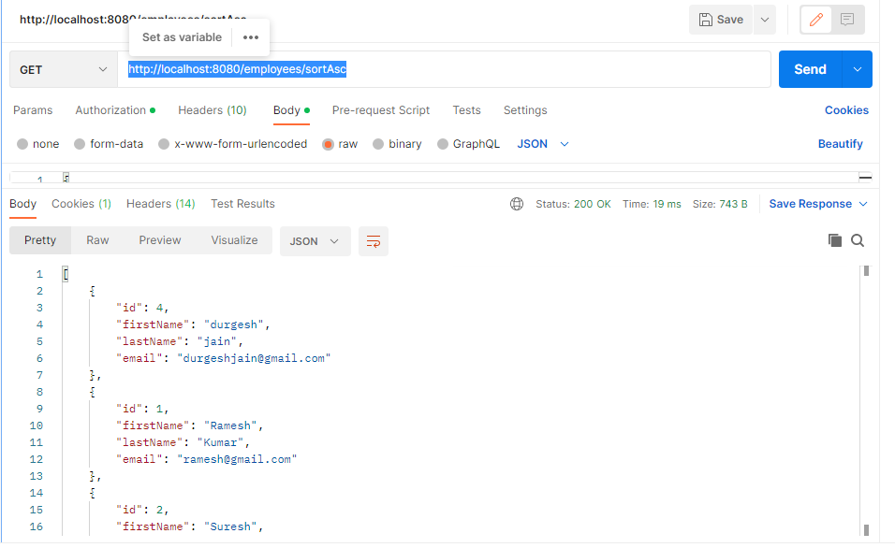

Response Body –

[

{

"id": 4,

"firstName": "durgesh",

"lastName": "jain",

"email": "durgeshjain@gmail.com"

},

{

"id": 1,

"firstName": "Ramesh",

"lastName": "Kumar",

"email": "ramesh@gmail.com"

},

{

"id": 2,

"firstName": "Suresh",

"lastName": "Kumar",

"email": "suresh@gmail.com"

},

{

"id": 3,

"firstName": "vinay",

"lastName": "Patil",

"email": "vinay@gmail.com"

}

]

GET - <http://localhost:8080/employees/sortDesc>

Response Body –

[

{

"id": 3,

"firstName": "vinay",

"lastName": "Patil",

"email": "vinay@gmail.com"

},

{

"id": 2,

"firstName": "Suresh",

"lastName": "Kumar",

"email": "suresh@gmail.com"

},

{

"id": 1,

"firstName": "Ramesh",

"lastName": "Kumar",

"email": "ramesh@gmail.com"

},

{

"id": 4,

"firstName": "durgesh",

"lastName": "jain",

"email": "durgeshjain@gmail.com"

}

]

