Prac 4a

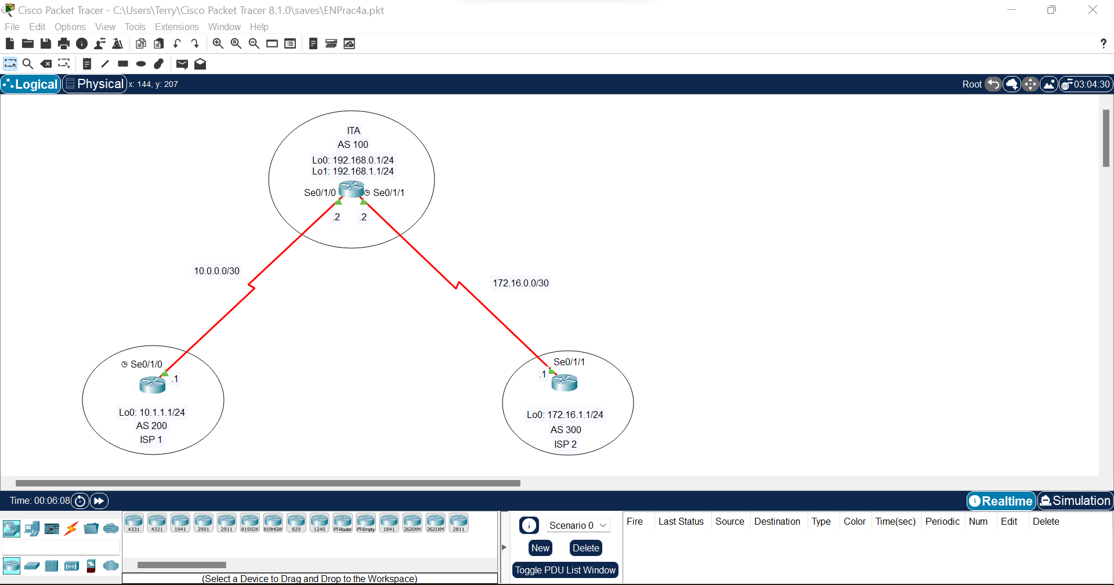

Step 1: Configure Loopback and IP Address

Router>en

Router#conf t

Enter configuration commands, one per line. End with CNTL/Z.

Router(config)#hostname ISP1

ISP1(config)#int lo0

ISP1(config-if)#

%LINK-5-CHANGED: Interface Loopback0, changed state to up

%LINEPROTO-5-UPDOWN: Line protocol on Interface Loopback0, changed state to up

ISP1(config-if)#ip add 10.1.1.1 255.255.255.0

ISP1(config-if)#int se0/1/0

ISP1(config-if)#ip add 10.0.0.1 255.255.255.252

ISP1(config-if)#clock rate 128000

ISP1(config-if)#no shut

xxxxxxxxxxxxxxxxxxxxxxxxxxxxxxxxxxxxxxxx

Router>en

Router#hostname ITA

^

% Invalid input detected at '^' marker.

Router#conf t

Enter configuration commands, one per line. End with CNTL/Z.

Router(config)#hostname ITA

ITA(config)#int lo0

ITA(config-if)#

%LINK-5-CHANGED: Interface Loopback0, changed state to up

%LINEPROTO-5-UPDOWN: Line protocol on Interface Loopback0, changed state to up

ITA(config-if)#ip add 192.168.0.1 255.255.255.0

ITA(config-if)#int lo1

ITA(config-if)#

%LINK-5-CHANGED: Interface Loopback1, changed state to up

%LINEPROTO-5-UPDOWN: Line protocol on Interface Loopback1, changed state to up

ITA(config-if)#ip add 192.168.1.1 255.255.255.0

ITA(config-if)#int se0/1/0

ITA(config-if)#ip add 10.0.0.2 255.255.255.252

ITA(config-if)#no shut

ITA(config-if)#

%LINK-5-CHANGED: Interface Serial0/1/0, changed state to up

ITA(config-if)#int se0/1/1

%LINEPROTO-5-UPDOWN: Line protocol on Interface Serial0/1/0, changed state to up

ITA(config-if)#ip add 172.16.0.2 255.255.255.252

ITA(config-if)#no shut

Xxxxxxxxxxxxxxxxxxxxxxxxxxxxxxxxxxxxxxxxx

Router>en

Router#conf t

Enter configuration commands, one per line. End with CNTL/Z.

Router(config)#hostname ISP2

ISP2(config)#int lo0

ISP2(config-if)#

%LINK-5-CHANGED: Interface Loopback0, changed state to up

%LINEPROTO-5-UPDOWN: Line protocol on Interface Loopback0, changed state to up

ISP2(config-if)#ip add 172.16.1.1 255.255.255.0

ISP2(config-if)#int se0/1/1

ISP2(config-if)#ip add 172.16.0.1 255.255.255.252

ISP2(config-if)#no shut

Step 2: Configure BGP on the routers

ISP1#conf t

Enter configuration commands, one per line. End with CNTL/Z.

ISP1(config)#router bgp 200

ISP1(config-router)#neighbor 10.0.0.2 remote-as 100

ISP1(config-router)#network 10.1.1.0 mask 255.255.255.0

ISP1(config-router)#

Xxxxxxxxxxxxxxxxxxxxxxxxxxxxxxxxxxxx

ISP2#conf t

Enter configuration commands, one per line. End with CNTL/Z.

ISP2(config)#router bgp 300

ISP2(config-router)#neighbor 172.16.0.2 remote-as 100

ISP2(config-router)#network 172.16.1.0 mask 255.255.255.0

ISP2(config-router)#

ITA#conf t

Enter configuration commands, one per line. End with CNTL/Z.

ITA(config)#router bgp 100

ITA(config-router)#neighbor 10.0.0.1 remote-as 200

ITA(config-router)#%BGP-5-ADJCHANGE: neighbor 10.0.0.1 Up

ITA(config-router)#neighbor 172.16.0.1 remote-as 300

ITA(config-router)#%BGP-5-ADJCHANGE: neighbor 172.16.0.1 Up

ITA(config-router)#network 192.168.0.0

ITA(config-router)#network 192.168.1.0

ITA(config-router)#

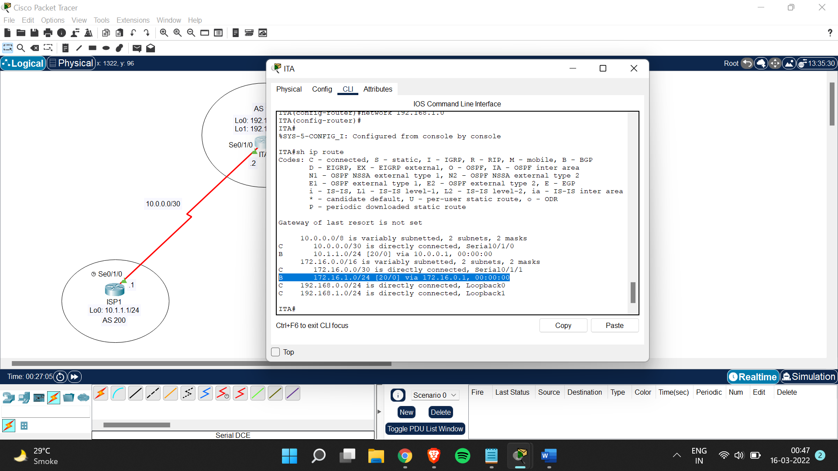

Step 3: Configure root filters

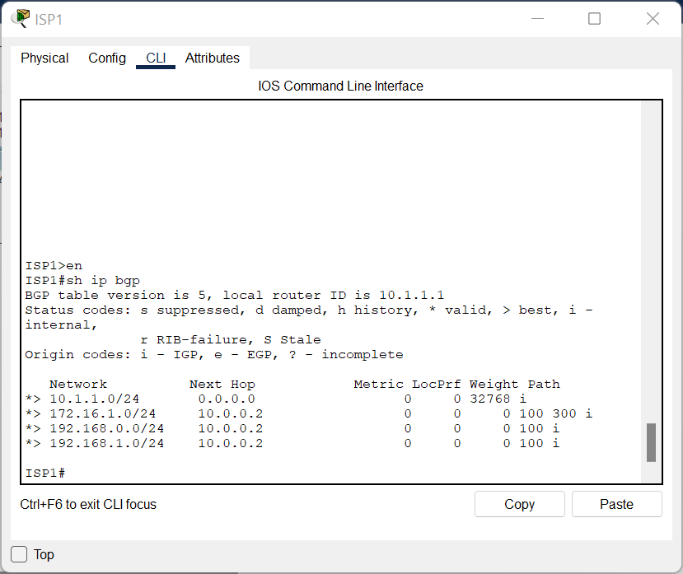

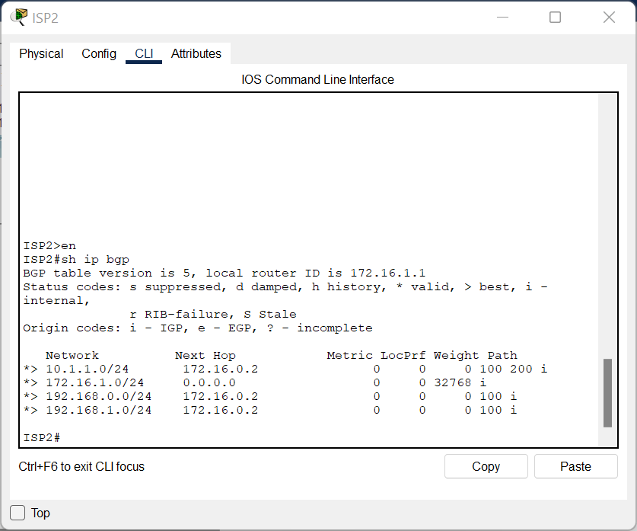

ITA>en

ITA#conf t

Enter configuration commands, one per line. End with CNTL/Z.

ITA(config)#access-list 1 permit 192.168.0.0 0.0.1.255

Step 4: Configuring primary &amp; backup routes using floating static routes

ITA>en

ITA#conf t

Enter configuration commands, one per line. End with CNTL/Z.

ITA(config)#ip route 0.0.0.0 0.0.0.0 10.0.0.1 210

ITA(config)#ip route 0.0.0.0 0.0.0.0 172.16.0.1 210

ITA(config)#exit

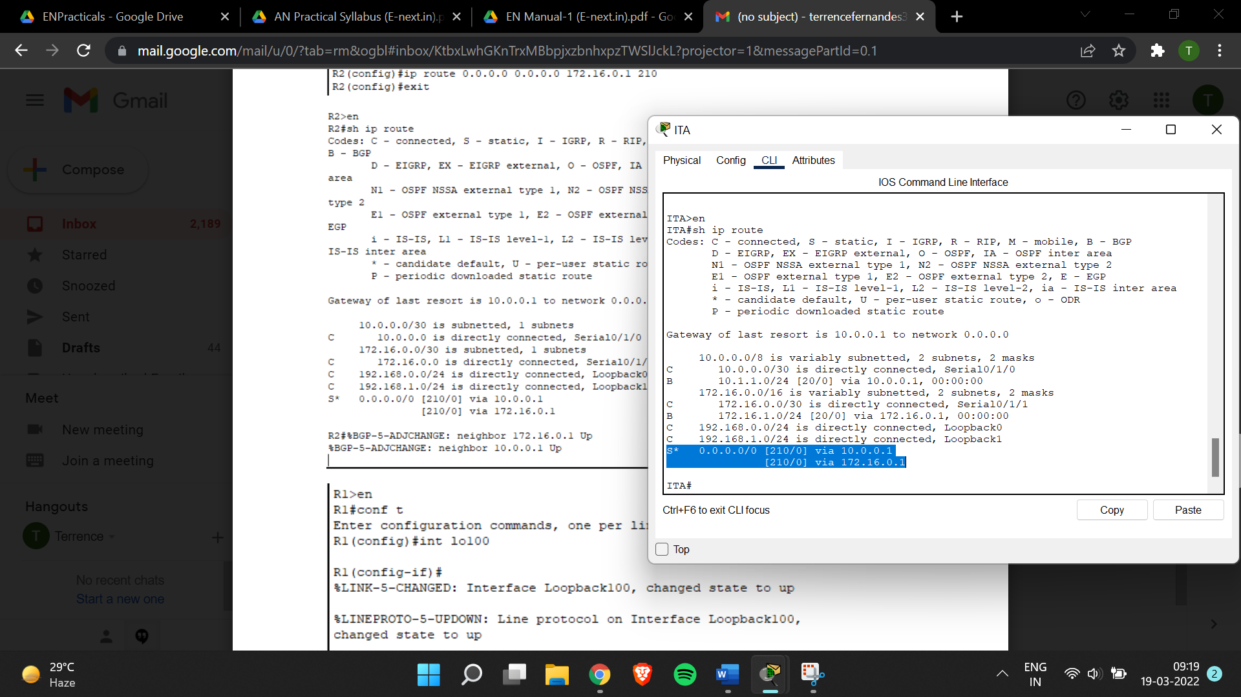

ISP1>en

ISP1#conf t

Enter configuration commands, one per line. End with CNTL/Z.

ISP1(config)#int lo100

ISP1(config-if)#

%LINK-5-CHANGED: Interface Loopback100, changed state to up

%LINEPROTO-5-UPDOWN: Line protocol on Interface Loopback100, changed state to up

ISP1(config-if)#ip add 192.168.100.1 255.255.255.0

