Prac 10:

Topology:

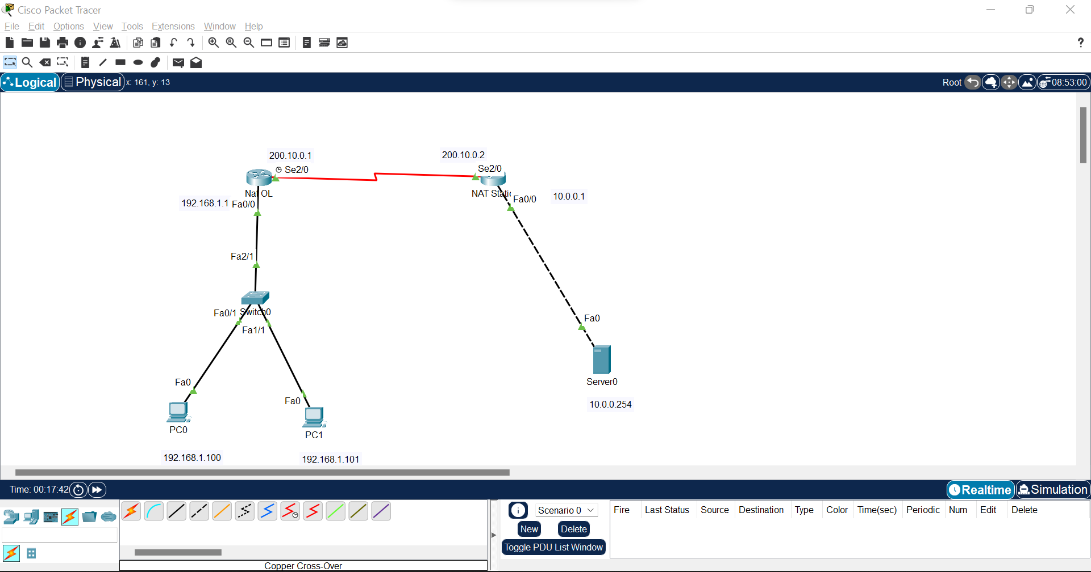

Step 1:

Router>en

Router#conf t

Enter configuration commands, one per line. End with CNTL/Z.

Router(config)#hostname NAT_OL

NAT_OL(config)#int fa0/0

NAT_OL(config-if)#ip add 192.168.1.1 255.255.255.0

NAT_OL(config-if)#no shut

NAT_OL(config-if)#

%LINK-5-CHANGED: Interface FastEthernet0/0, changed state to up

%LINEPROTO-5-UPDOWN: Line protocol on Interface FastEthernet0/0, changed state to up

NAT_OL(config-if)#int se2/0

NAT_OL(config-if)#ip add 200.10.0.1 255.255.255.0

NAT_OL(config-if)#clock rate 64000

NAT_OL(config-if)#bandwidth 64

NAT_OL(config-if)#no shut

Xxxxxxxxxxxxxxxxxxxxxxxxxxxxxxxxxxxxxxxxxxxxxxxx

Router>en

Router#conf t

Enter configuration commands, one per line. End with CNTL/Z.

Router(config)#hostname NAT_Static

NAT_Static(config)#int se2/0

NAT_Static(config-if)#ip add 200.10.0.2 255.255.255.0

NAT_Static(config-if)#no shut

NAT_Static(config-if)#

%LINK-5-CHANGED: Interface Serial2/0, changed state to up

NAT_Static(config-if)#int fa0/0

NAT_Static(config-if)#ip add

%LINEPROTO-5-UPDOWN: Line protocol on Interface Serial2/0, changed state to up

% Incomplete command.

NAT_Static(config-if)#

NAT_Static(config-if)#ip add 10.0.0.1 255.0.0.0

NAT_Static(config-if)#no shut

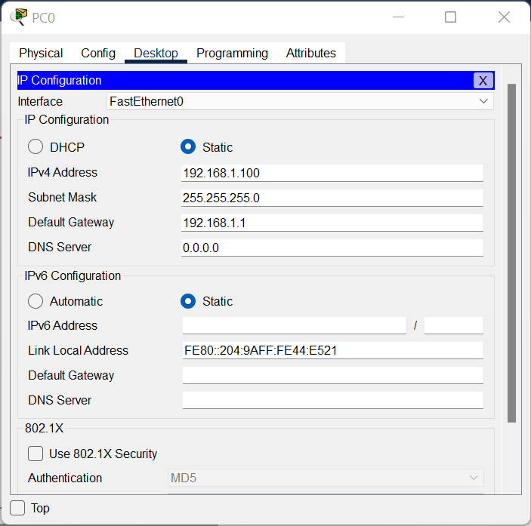 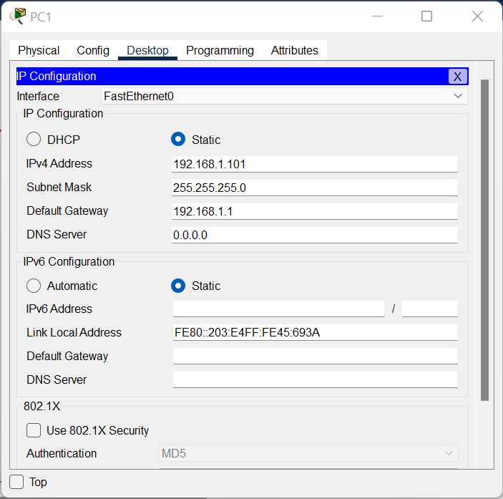

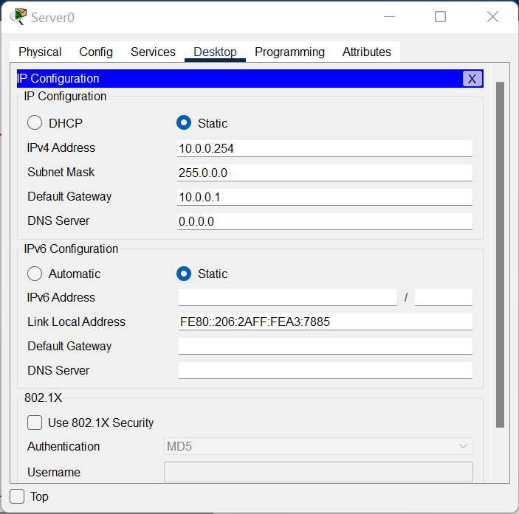

Step 2:  
NAT_OL#conf t

Enter configuration commands, one per line. End with CNTL/Z.

NAT_OL(config)#ip route 0.0.0.0 0.0.0.0 se2/0

Xxxxxxxxxxxxxxxxxxxxxxxxxxxxxxxxxxx

NAT_Static#conf t

Enter configuration commands, one per line. End with CNTL/Z.

NAT_Static(config)#ip route 0.0.0.0 0.0.0.0 se2/0

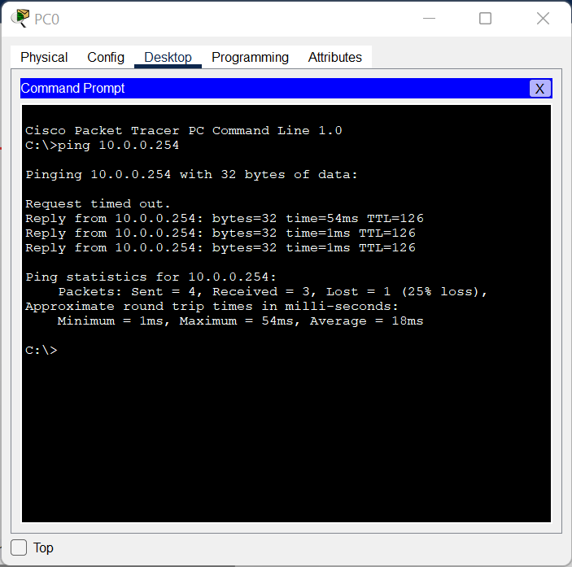 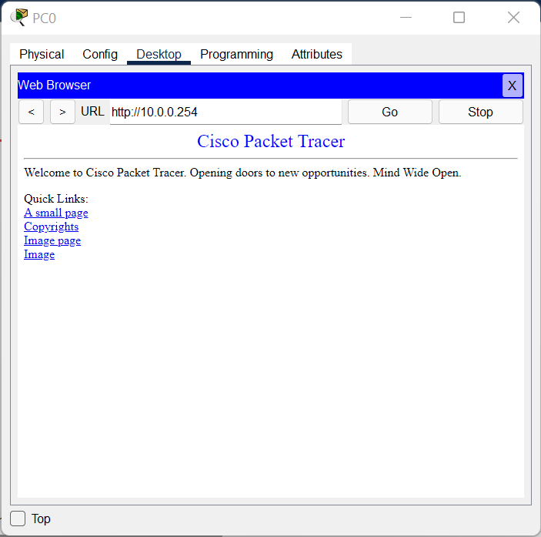

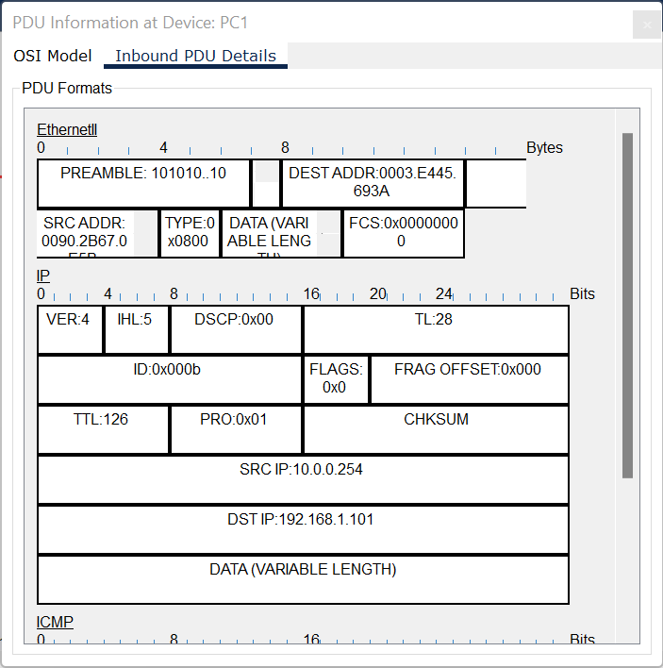

Step 3:  
NAT_Static(config)#ip nat inside source static 10.0.0.254 200.10.0.2

NAT_Static(config)#int se2/0

NAT_Static(config-if)#ip nat outside

NAT_Static(config-if)#int fa0/0

NAT_Static(config-if)#ip nat inside

