Prac 2B

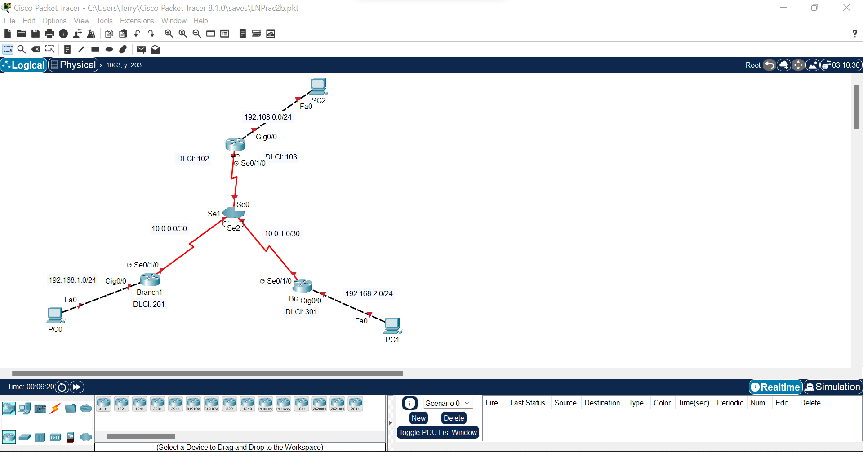

Step 2: Configure routers and physical interfaces with OSPF  
HQ#conf t

Enter configuration commands, one per line. End with CNTL/Z.

HQ(config)#int gig0/0

HQ(config-if)#ip add 192.168.0.1 255.255.255.0

HQ(config-if)#no shut

HQ(config-if)#

%LINK-5-CHANGED: Interface GigabitEthernet0/0, changed state to up

%LINEPROTO-5-UPDOWN: Line protocol on Interface GigabitEthernet0/0, changed state to up

HQ(config-if)#router ospf 1

HQ(config-router)#network 192.168.0.0 0.0.0.255 area 0

HQ(config-router)#network 10.0.0.0 0.0.0.3 area 0

HQ(config-router)#network 10.0.1.0 0.0.0.3 area 0

Xxxxxxxxxxxxxxxxxxxxxxxxxxxxxxxxxxxxxxxxxxxxxxxx

Branch1>en

Branch1#conf t

Enter configuration commands, one per line. End with CNTL/Z.

Branch1(config)#int gig0/0

Branch1(config-if)#ip add 192.168.1.1 255.255.255.0

Branch1(config-if)#no shut

Branch1(config-if)#

%LINK-5-CHANGED: Interface GigabitEthernet0/0, changed state to up

%LINEPROTO-5-UPDOWN: Line protocol on Interface GigabitEthernet0/0, changed state to up

Branch1(config-if)#router ospf 1

Branch1(config-router)#network 192.168.1.0 0.0.0.255 area 0

Branch1(config-router)#network 10.0.0.0 0.0.0.3 area 0

Xxxxxxxxxxxxxxxxxxxxxxxxxxxxxxxxxxxxxxxxxxxxxxxxxx

Branch2>en

Branch2#conf t

Enter configuration commands, one per line. End with CNTL/Z.

Branch2(config)#int gig0/0

Branch2(config-if)#ip add 192.168.2.1 255.255.255.0

Branch2(config-if)#no shut

Branch2(config-if)#

%LINK-5-CHANGED: Interface GigabitEthernet0/0, changed state to up

%LINEPROTO-5-UPDOWN: Line protocol on Interface GigabitEthernet0/0, changed state to up

Branch2(config-if)#router ospf 1

Branch2(config-router)#network 192.168.2.0 0.0.0.255 area 0

Branch2(config-router)#network 10.0.1.0 0.0.0.3 area 0

Step 3: Configure Frame Relay

HQ>en

HQ#conf t

Enter configuration commands, one per line. End with CNTL/Z.

HQ(config)#int se0/1/0

HQ(config-if)#no shut

HQ(config-if)#

%LINK-5-CHANGED: Interface Serial0/1/0, changed state to up

HQ(config-if)#no ip add

HQ(config-if)#clock rate 64000

HQ(config-if)#encapsulation frame-relay

HQ(config-if)#

%LINEPROTO-5-UPDOWN: Line protocol on Interface Serial0/1/0, changed state to up

HQ(config-if)#int se0/1/0.102 point-to-point

HQ(config-subif)#

%LINK-5-CHANGED: Interface Serial0/1/0.102, changed state to up

%LINEPROTO-5-UPDOWN: Line protocol on Interface Serial0/1/0.102, changed state to up

HQ(config-subif)#no shut

HQ(config-subif)#ip add 10.0.0.1 255.255.255.252

HQ(config-subif)#frame-relay interface-dlci 102

HQ#conf t

Enter configuration commands, one per line. End with CNTL/Z.

HQ(config)#int se0/1/0.103 point-to-point

HQ(config-subif)#

%LINK-5-CHANGED: Interface Serial0/1/0.103, changed state to up

%LINEPROTO-5-UPDOWN: Line protocol on Interface Serial0/1/0.103, changed state to up

HQ(config-subif)#frame-relay interface-dlci 103

HQ(config-subif)#ip add 10.0.1.1 255.255.255.252

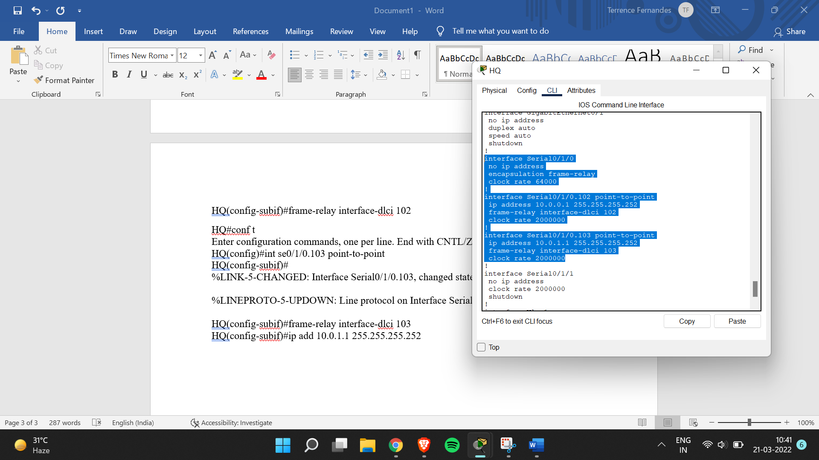

Branch1>en

Branch1#conf t

Enter configuration commands, one per line. End with CNTL/Z.

Branch1(config)#int se0/1/0

Branch1(config-if)#no shut

Branch1(config-if)#

%LINK-5-CHANGED: Interface Serial0/1/0, changed state to up

Branch1(config-if)#encapsulation frame-relay

Branch1(config-if)#

%LINEPROTO-5-UPDOWN: Line protocol on Interface Serial0/1/0, changed state to up

Branch1(config-if)#no ip add

Branch1(config-if)#int se0/1/0.201 point-to-point

Branch1(config-subif)#

%LINK-5-CHANGED: Interface Serial0/1/0.201, changed state to up

%LINEPROTO-5-UPDOWN: Line protocol on Interface Serial0/1/0.201, changed state to up

Branch1(config-subif)#ip add 10.0.0.2 255.255.255.252

Branch1(config-subif)#no shut

Branch1(config-subif)#frame-relay interface-dlci 201

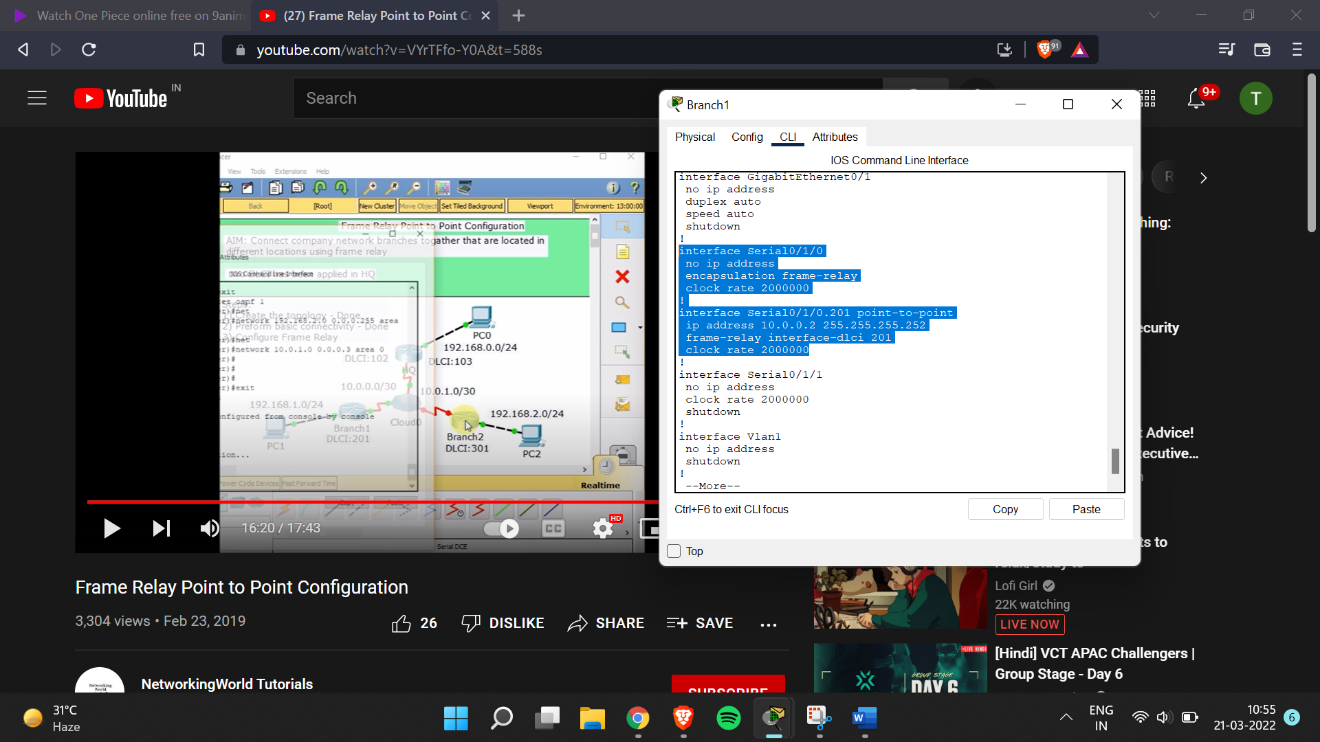

Branch2>en

Branch2#conf t

Enter configuration commands, one per line. End with CNTL/Z.

Branch2(config)#int se0/1/0

Branch2(config-if)#no shut

Branch2(config-if)#

%LINK-5-CHANGED: Interface Serial0/1/0, changed state to up

Branch2(config-if)#encapsulation frame-relay

Branch2(config-if)#

%LINEPROTO-5-UPDOWN: Line protocol on Interface Serial0/1/0, changed state to up

Branch2(config-if)#clock rate 64000

Branch2(config-if)#

%LINEPROTO-5-UPDOWN: Line protocol on Interface Serial0/1/0, changed state to down

%LINEPROTO-5-UPDOWN: Line protocol on Interface Serial0/1/0, changed state to up

Branch2(config-if)#int se0/1/0.301 point-to-point

Branch2(config-subif)#

%LINK-5-CHANGED: Interface Serial0/1/0.301, changed state to up

%LINEPROTO-5-UPDOWN: Line protocol on Interface Serial0/1/0.301, changed state to up

Branch2(config-subif)#no shut

Branch2(config-subif)#ip add 10.0.1.2 255.255.255.252

Branch2(config-subif)#no shut

Branch2(config-subif)#frame-relay interface-dlci 301

