Prac 3 A

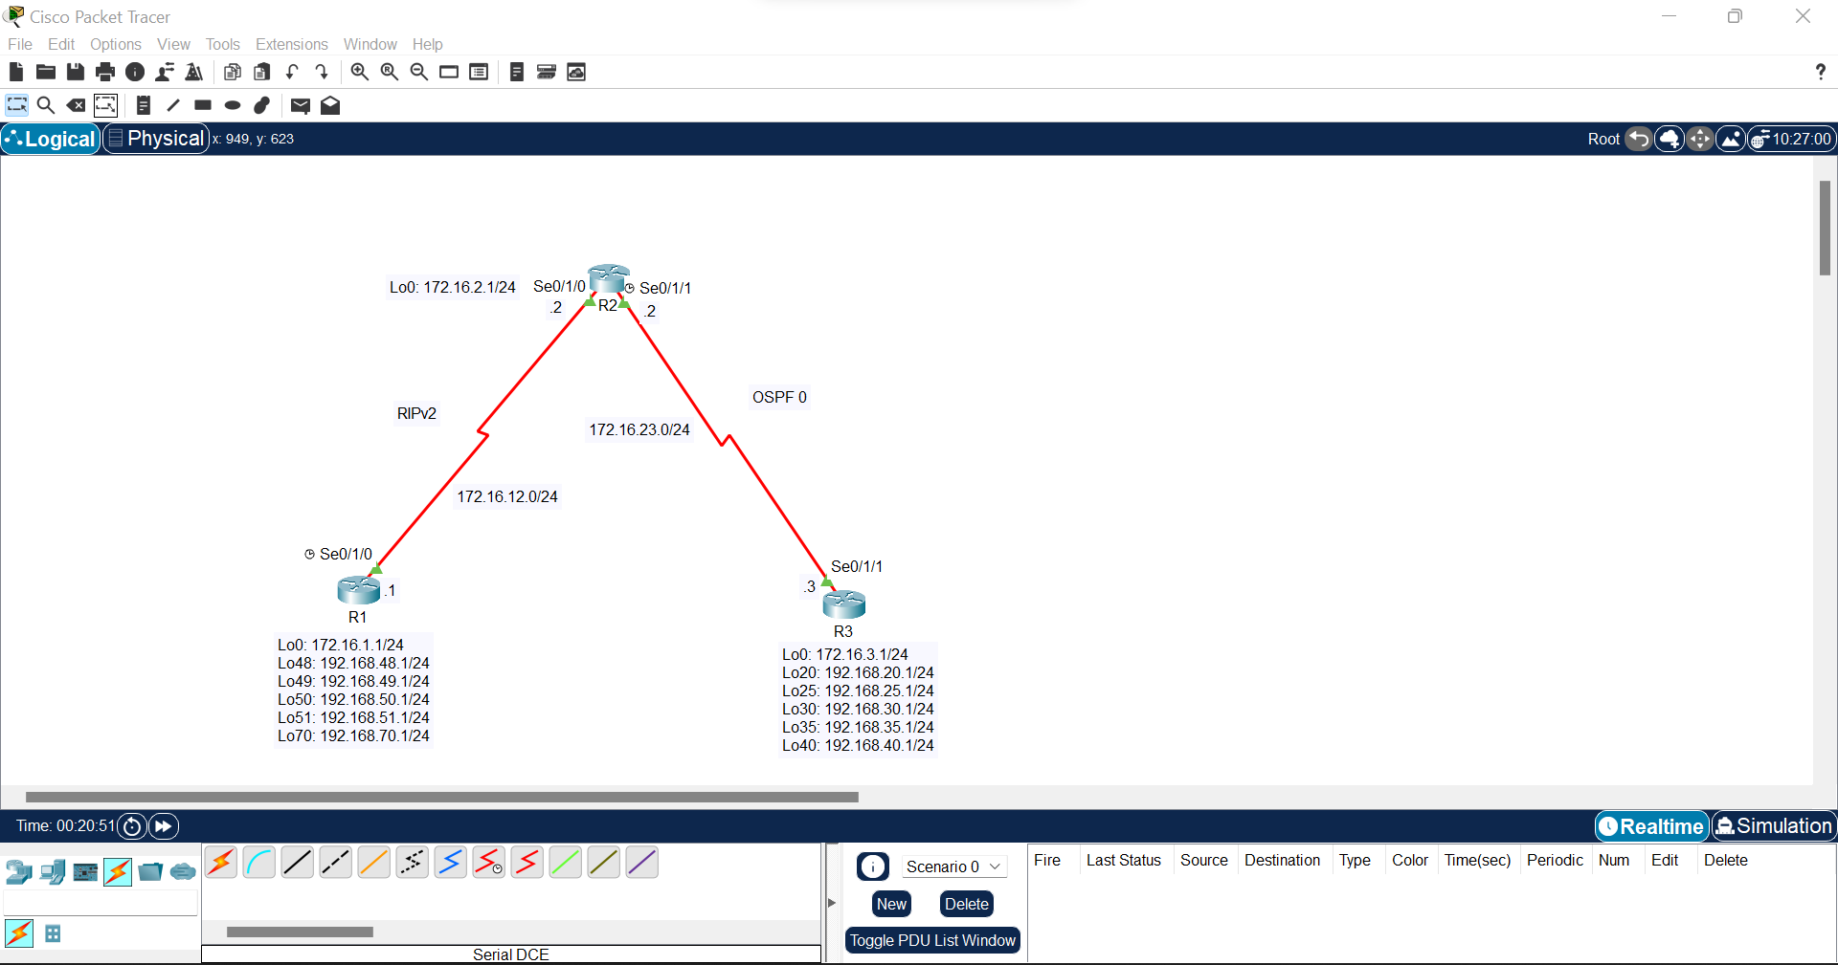

Step 1:

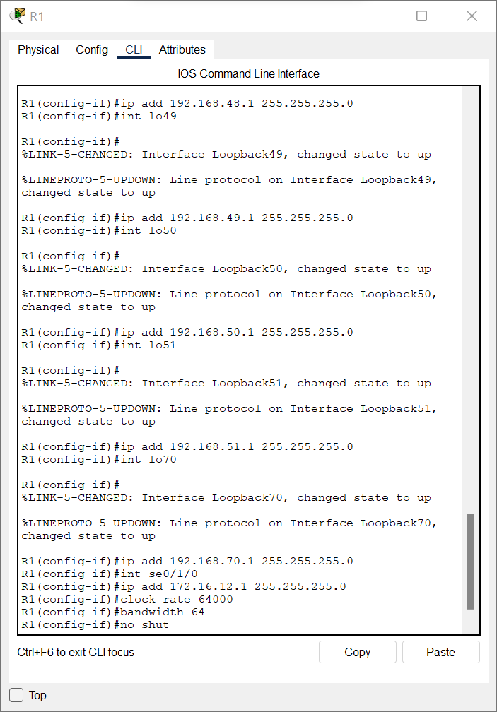

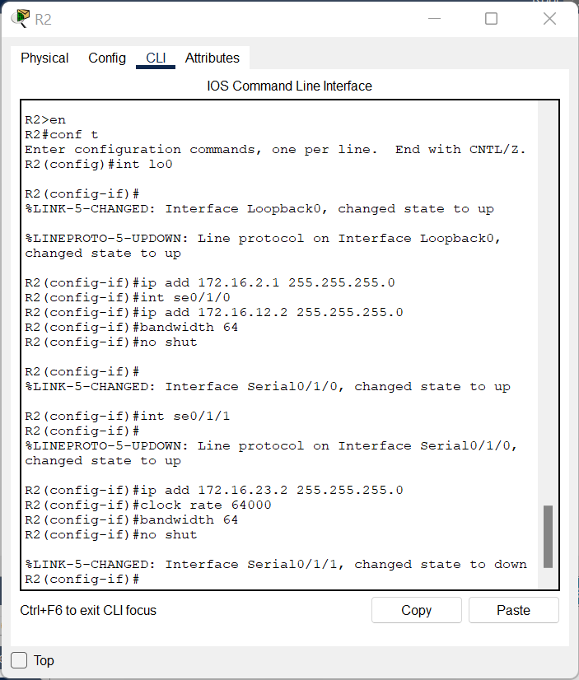

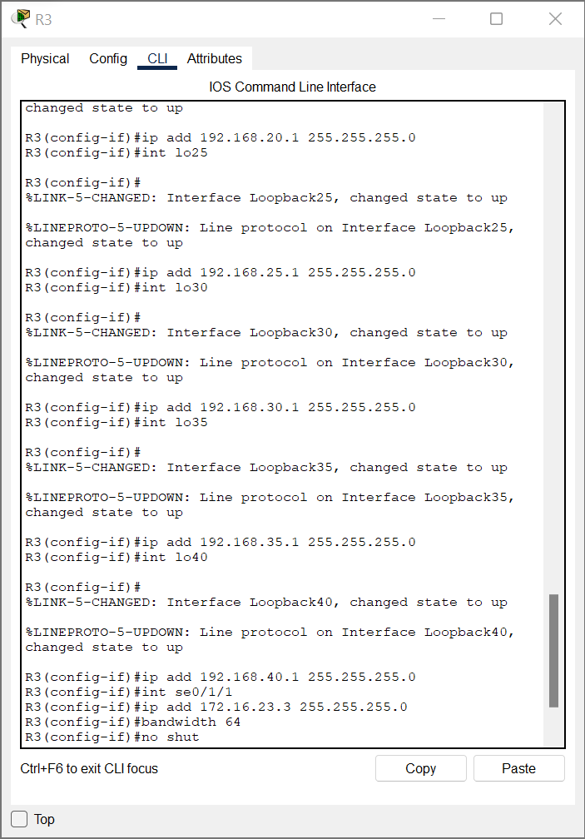

Step 2:

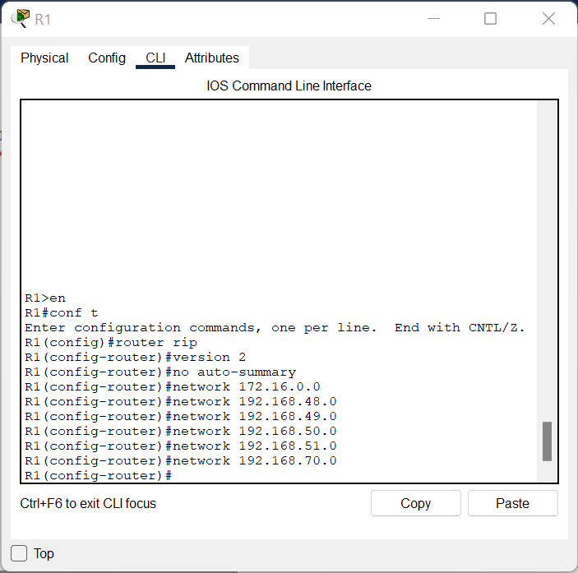

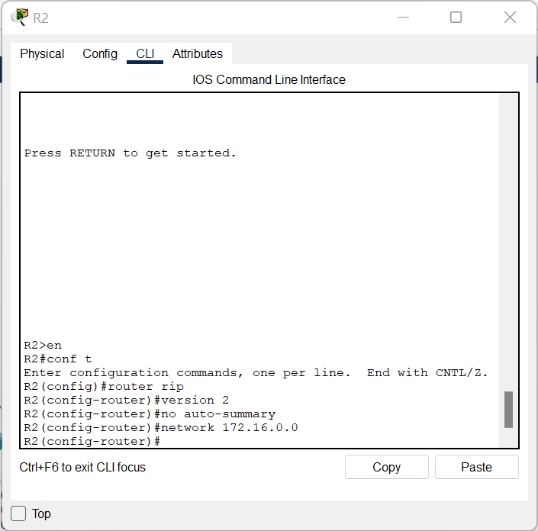

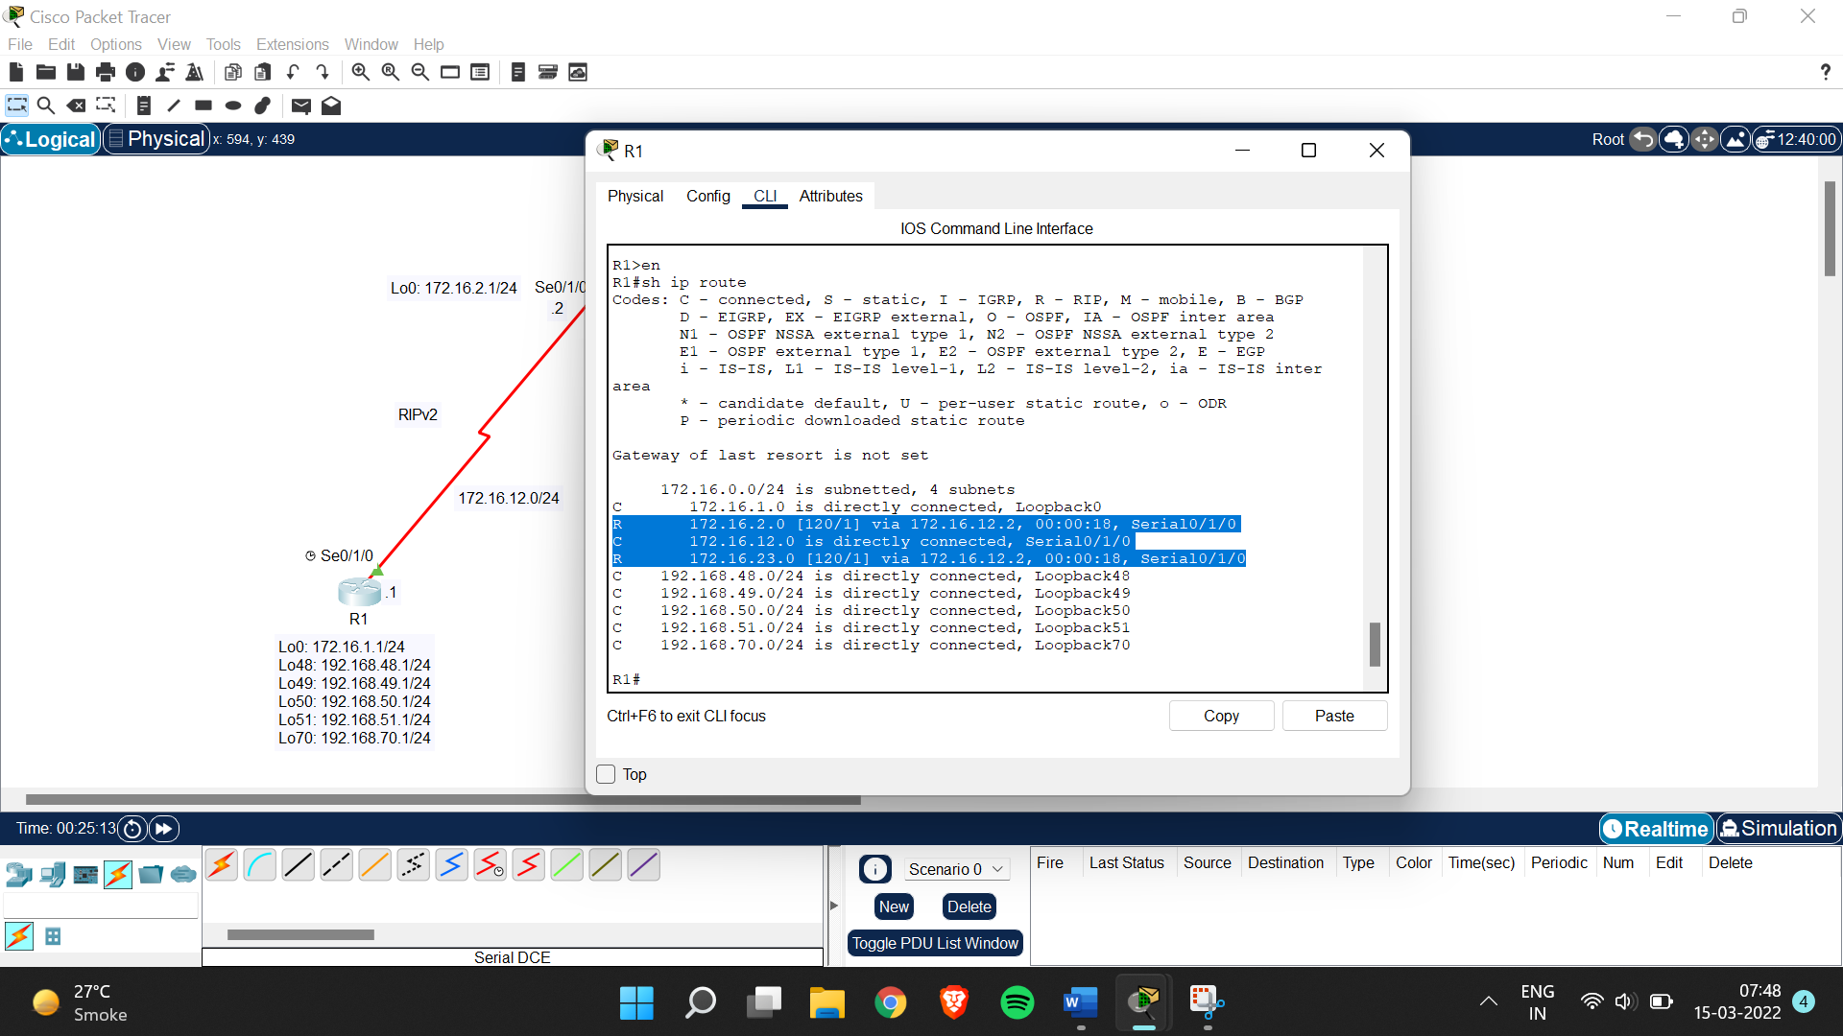

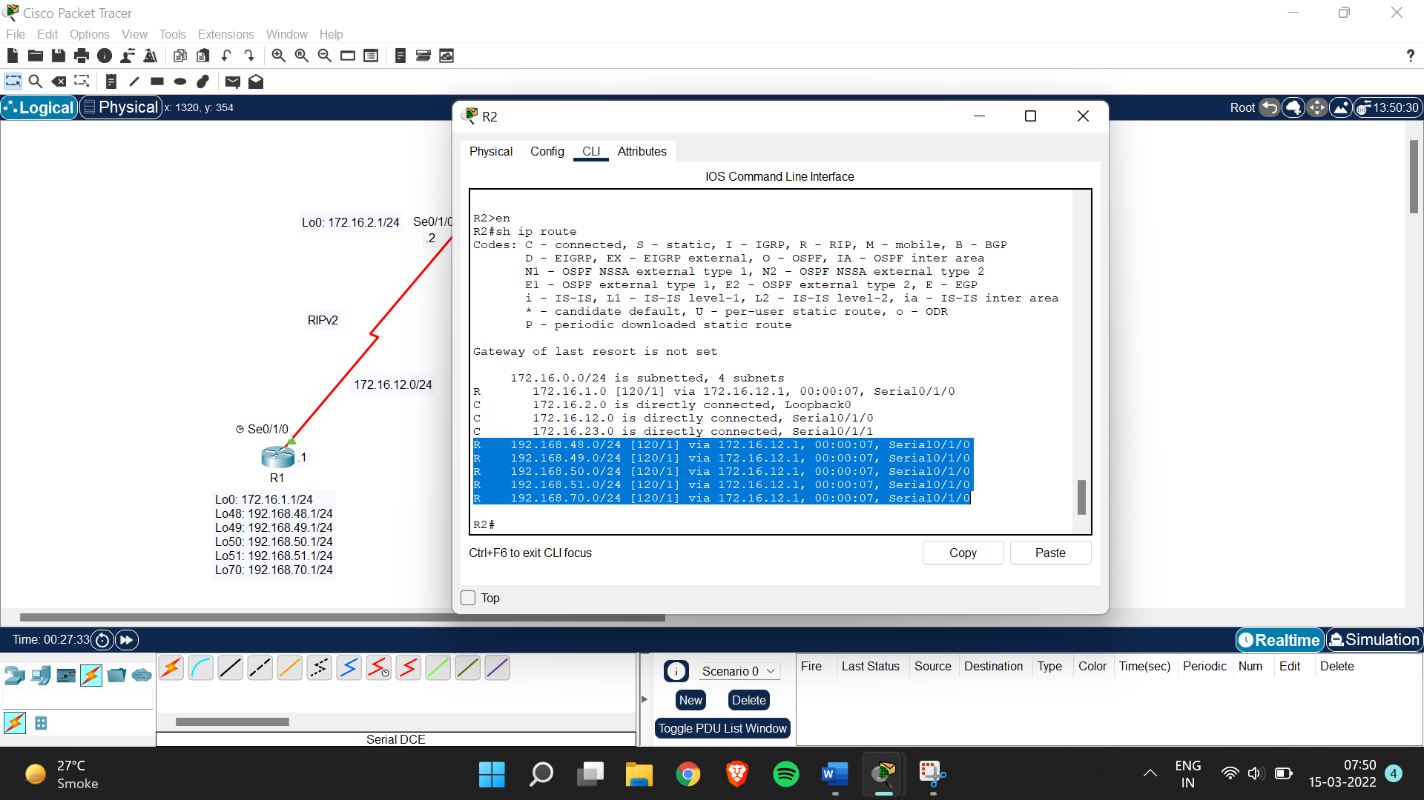

Step 3:

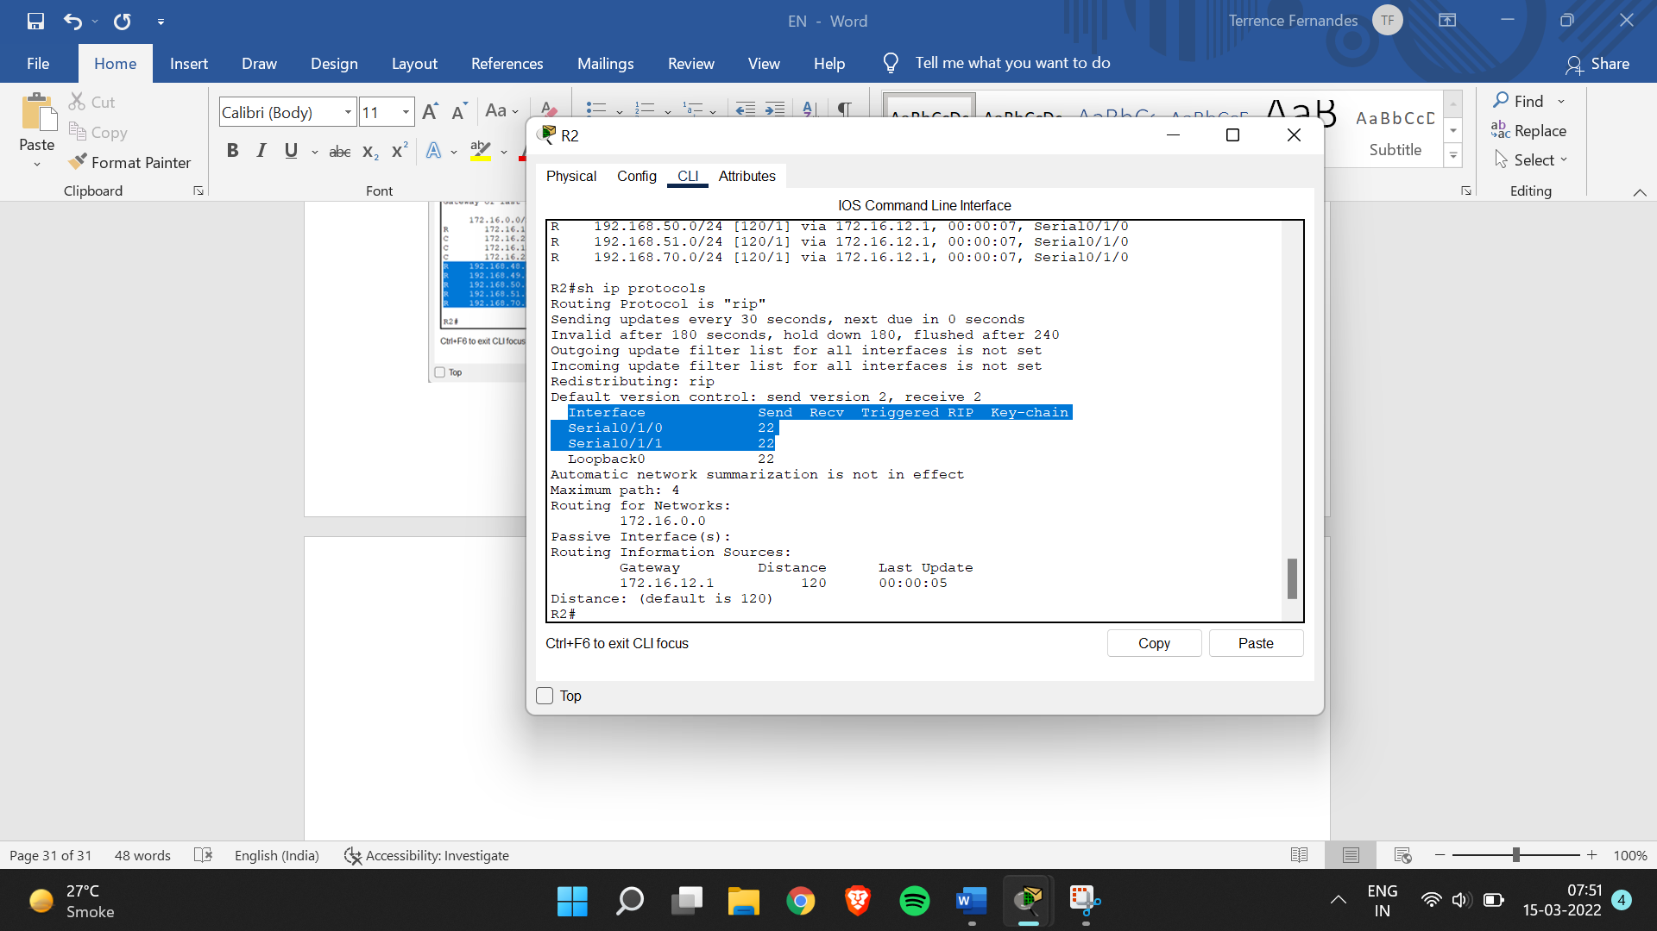

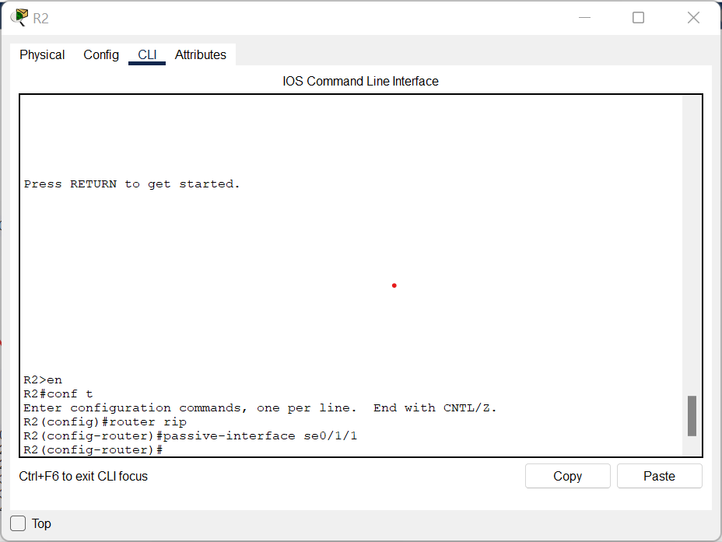

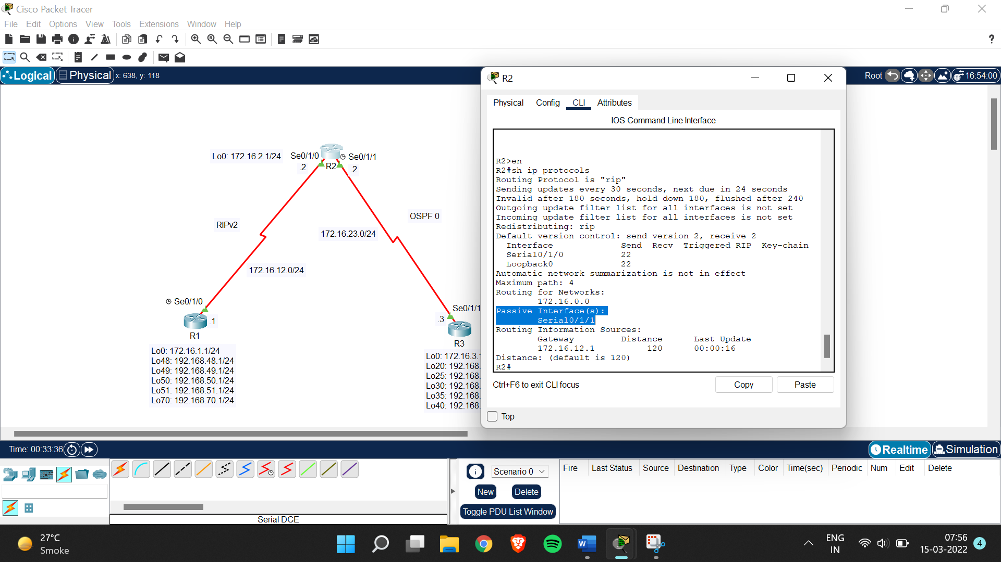

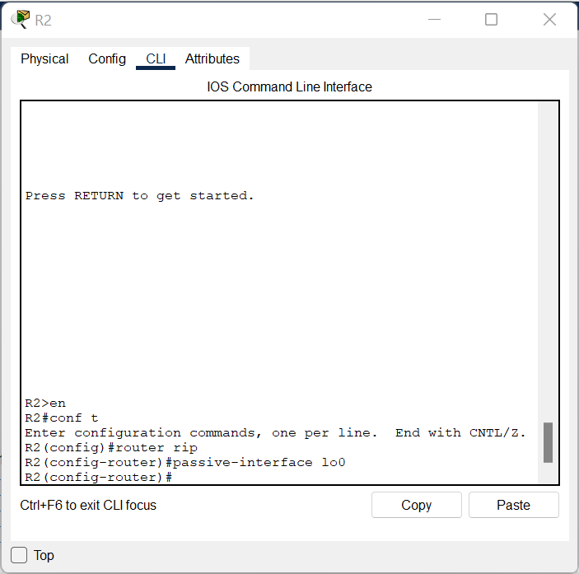

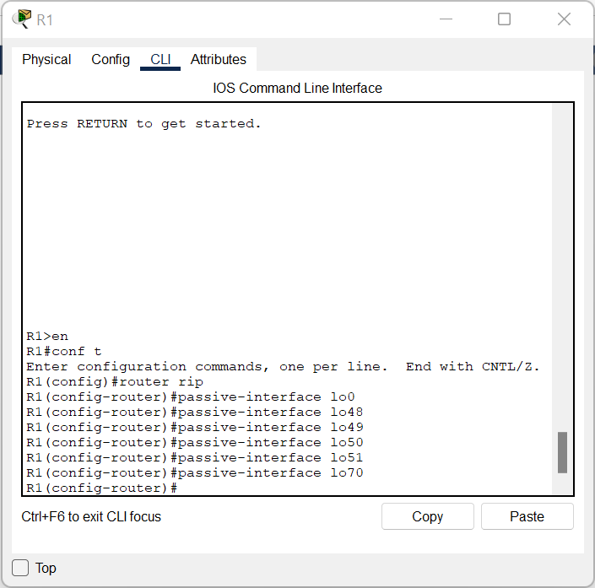

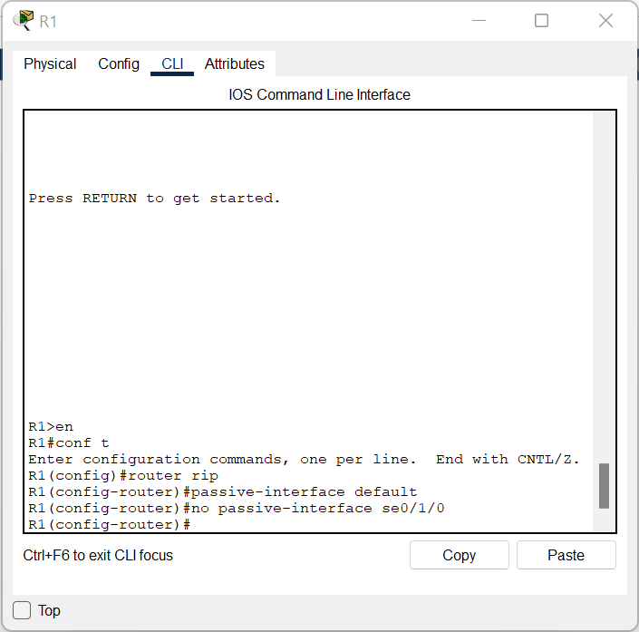

Step 4:

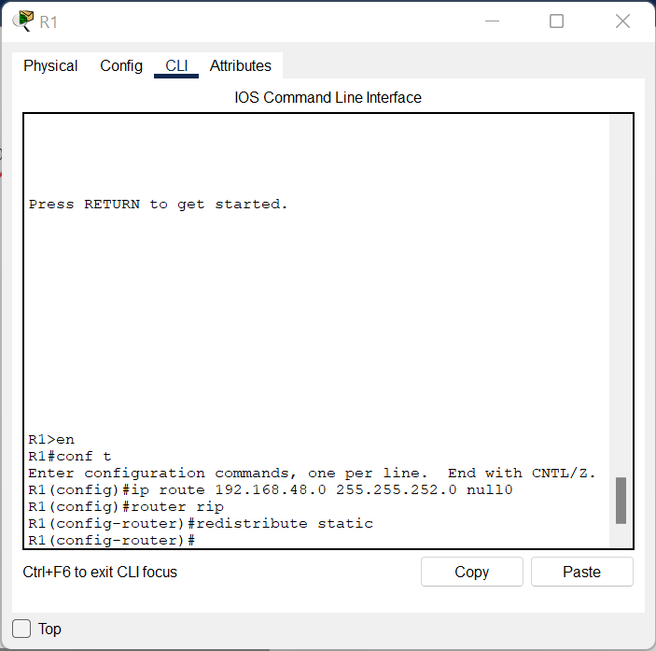

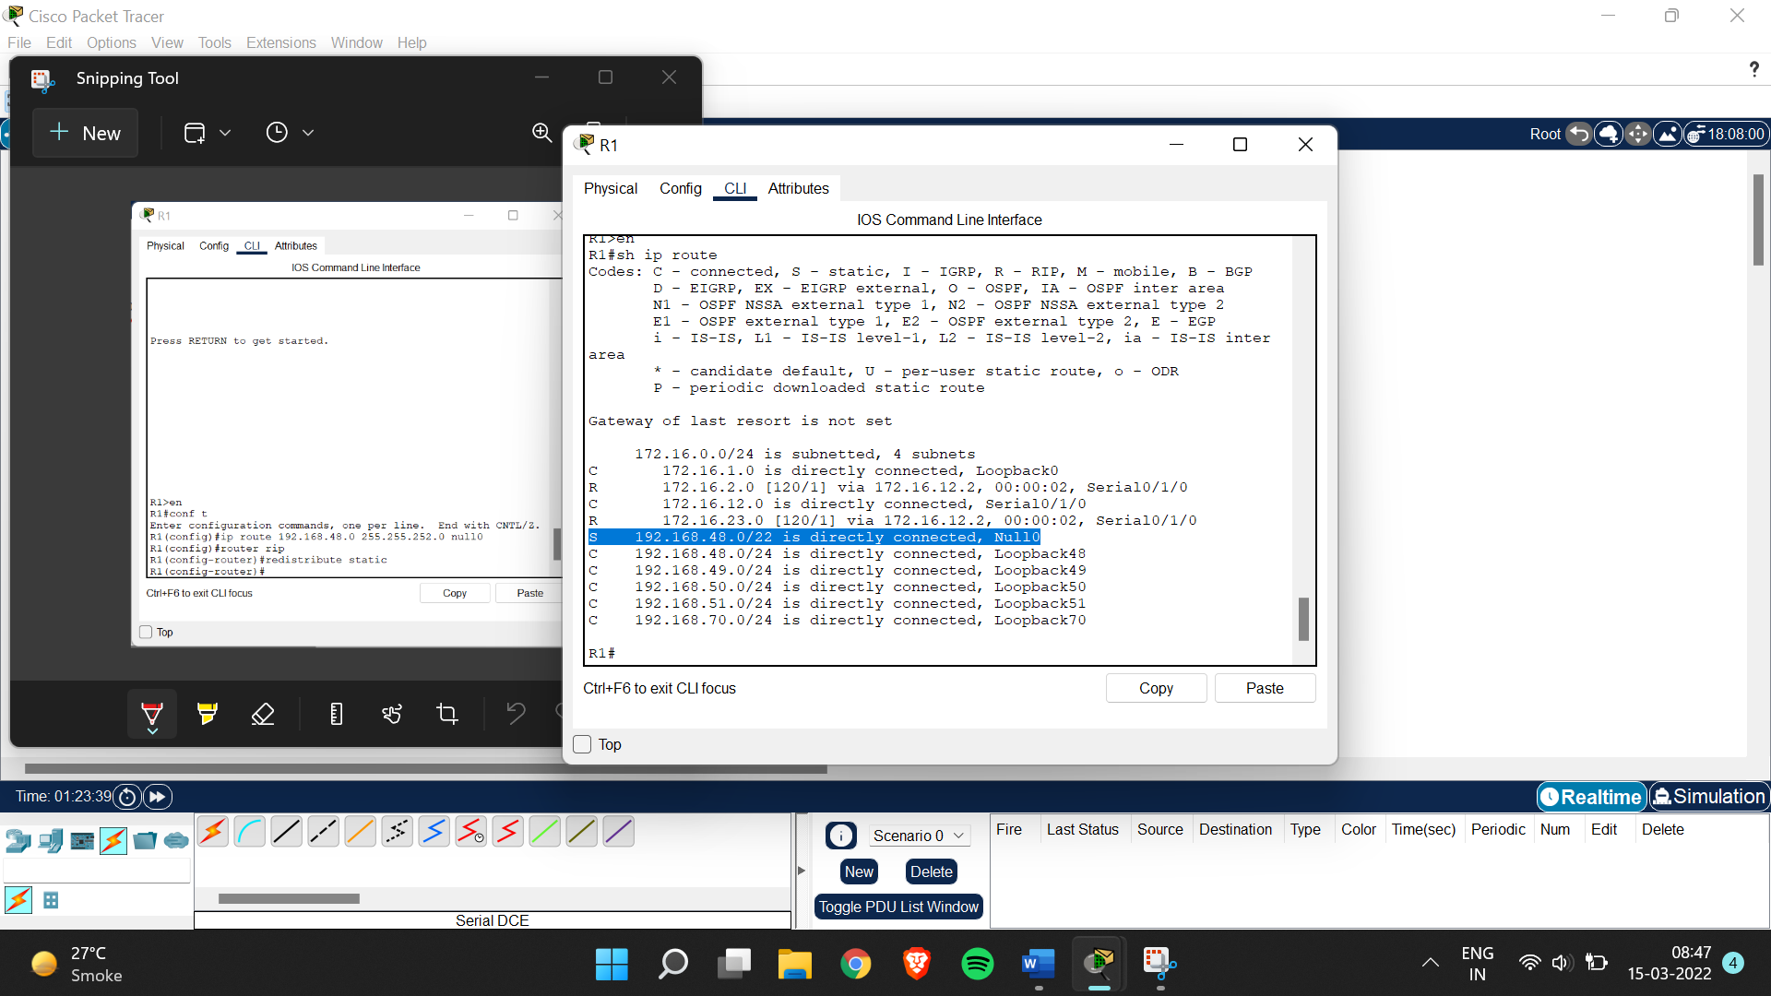

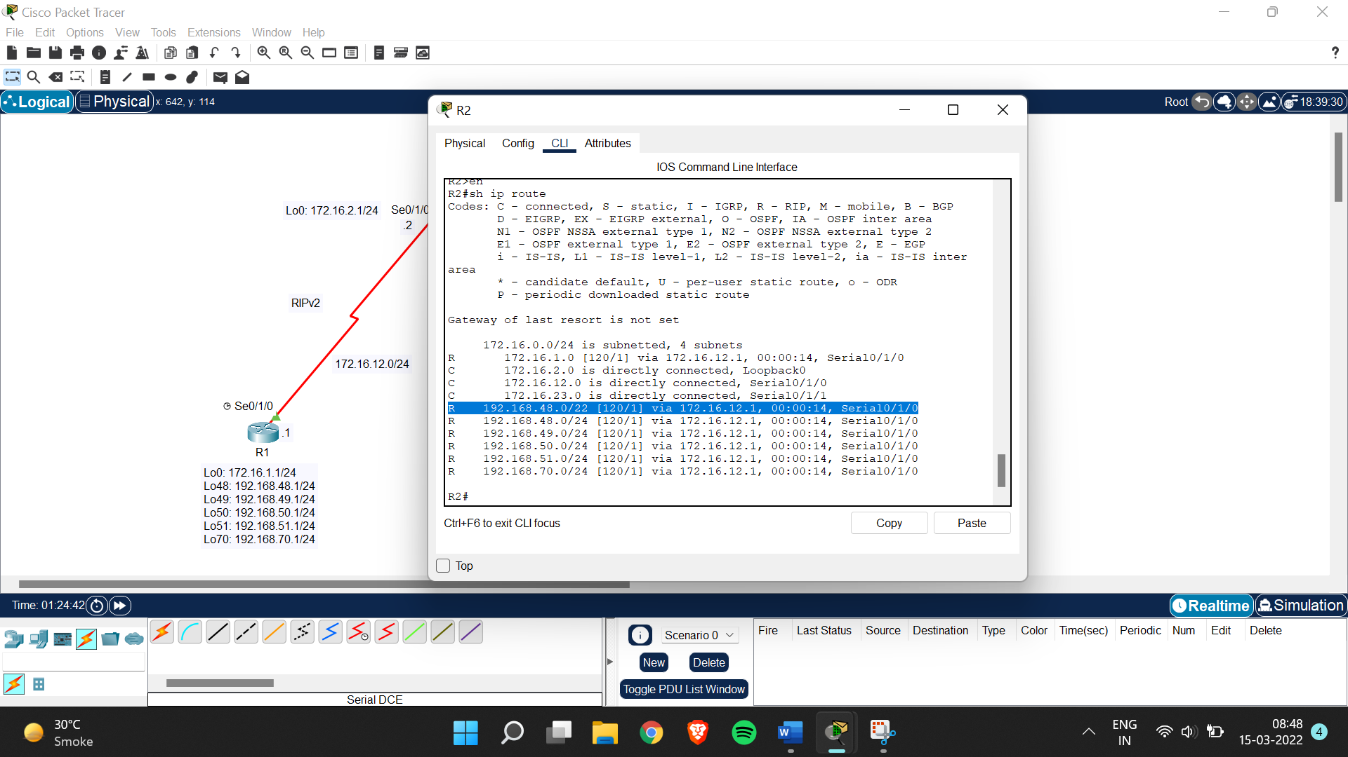

Step 5: Configure OSPF

R2>en

R2#conf t

Enter configuration commands, one per line. End with CNTL/Z.

R2(config)#router ospf 1

R2(config-router)#network 172.16.23.0 0.0.0.255 area 0

Xxxxxxxxxxxxxxxxxxxxxxxxxxxxxxxxxxxxxxxxxxxxxxxxxxxxx

R3>en

R3#conf t

Enter configuration commands, one per line. End with CNTL/Z.

R3(config)#router ospf 1

R3(config-router)#network 172.16.0.0 0.0.255.255 area 0

R3(config-router)#networ

00:02:15: %OSPF-5-ADJCHG: Process 1, Nbr 172.16.2.1 on Serial0/1/1 from LOADING to FULL, Loading Done

k

% Incomplete command.

R3(config-router)#network 192.168.0.0 0.0.255.255 area 0

R3(config-router)#int lo0

R3(config-if)#ip ospf network point-to-point

R3(config-if)#int lo20

R3(config-if)#ip ospf network point-to-point

R3(config-if)#int lo25

R3(config-if)#ip ospf network point-to-point

R3(config-if)#int lo30

R3(config-if)#ip ospf network point-to-point

R3(config-if)#int lo35

R3(config-if)#ip ospf network point-to-point

R3(config-if)#int lo40

R3(config-if)#ip ospf network point-to-point

Step 6: Allow one way redistribution

R2>en

R2#conf t

Enter configuration commands, one per line. End with CNTL/Z.

R2(config)#router rip

R2(config-router)#redistribute ospf 1 metric 4

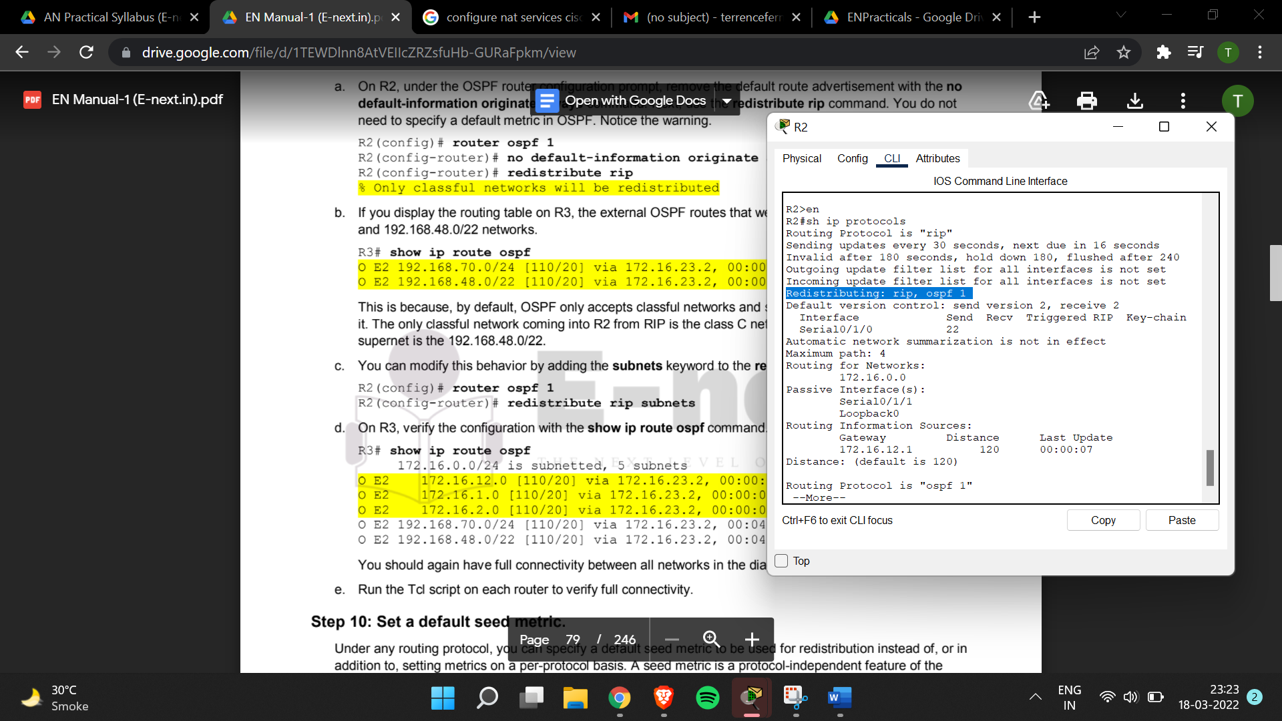

Step 7: Redistribute between two routing protocols.

R2>en

R2#conf t

Enter configuration commands, one per line. End with CNTL/Z.

R2(config)#router ospf 1

R2(config-router)#no default-information originate always

R2(config-router)#redistribute rip

% Only classful networks will be redistributed

R2(config-router)#router ospf 1

R2(config-router)#redistribute rip subnets

