Prac 3b:

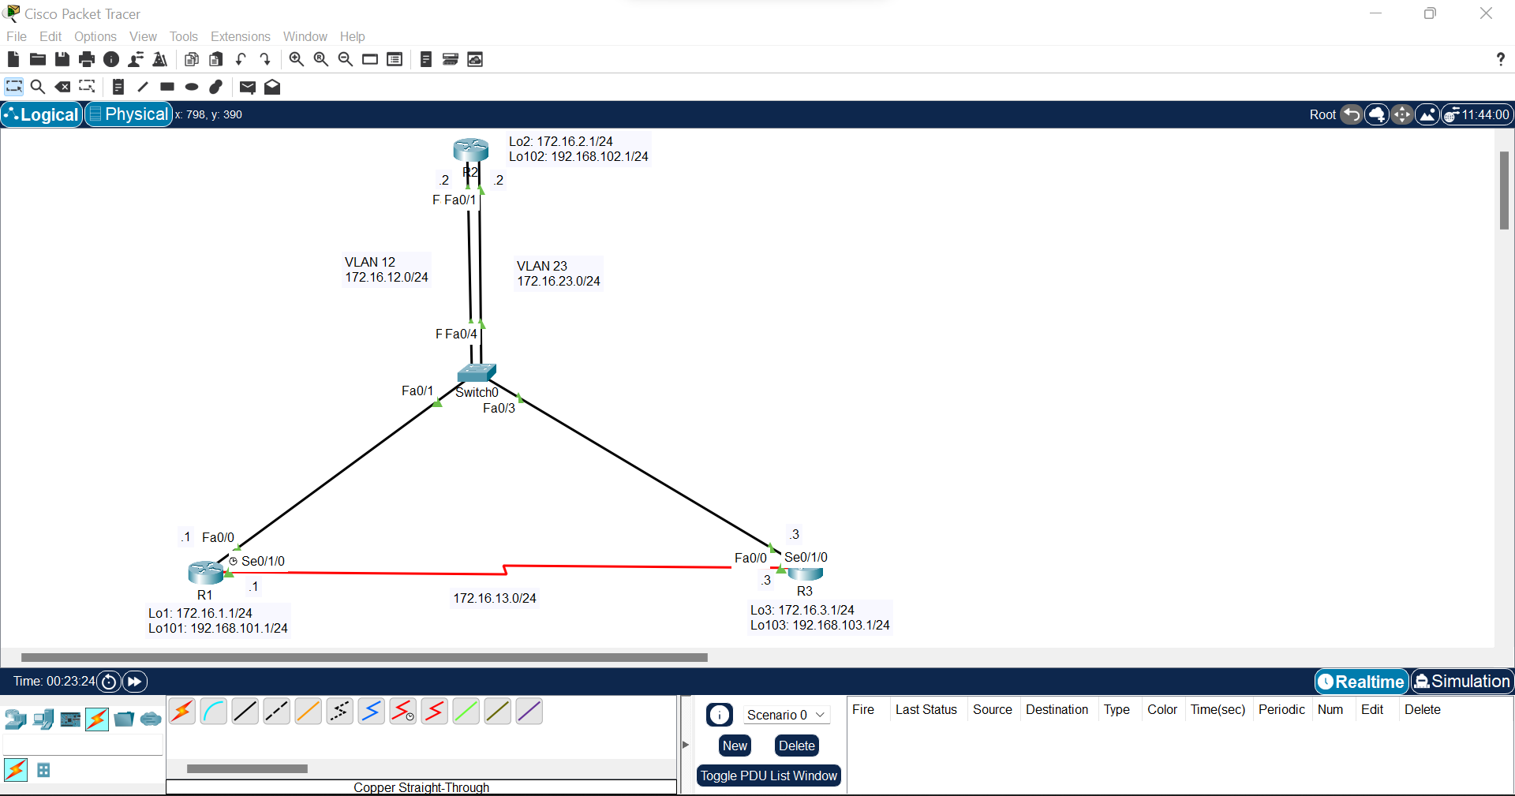

Step 1:

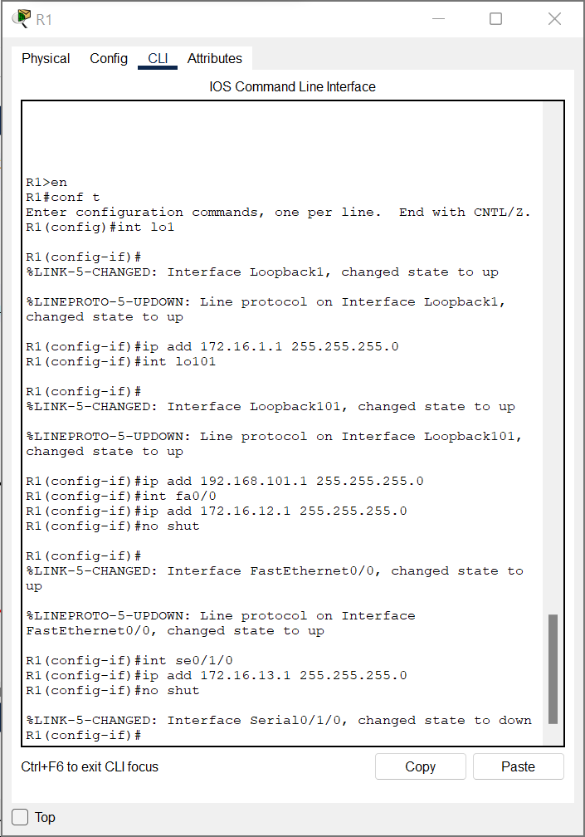

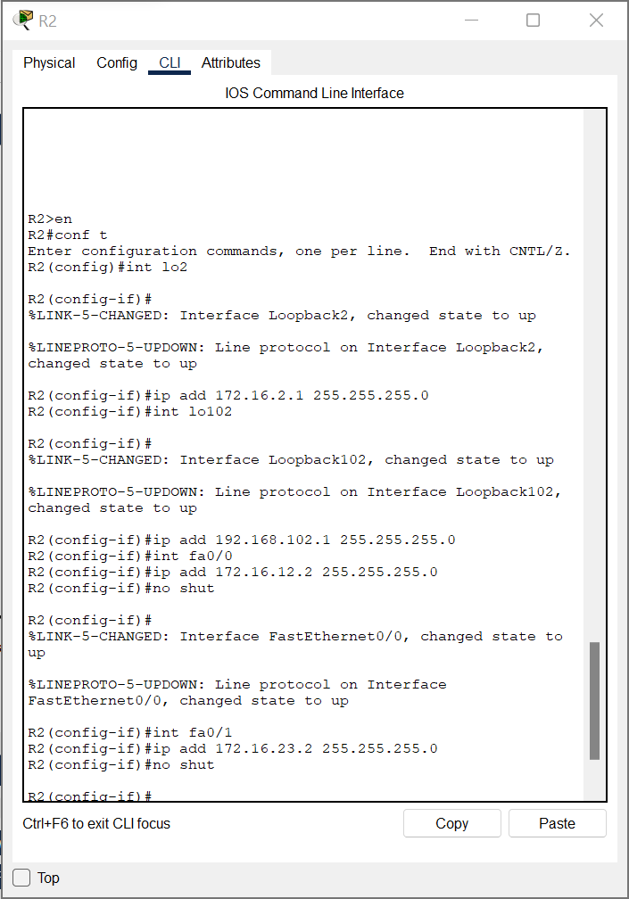

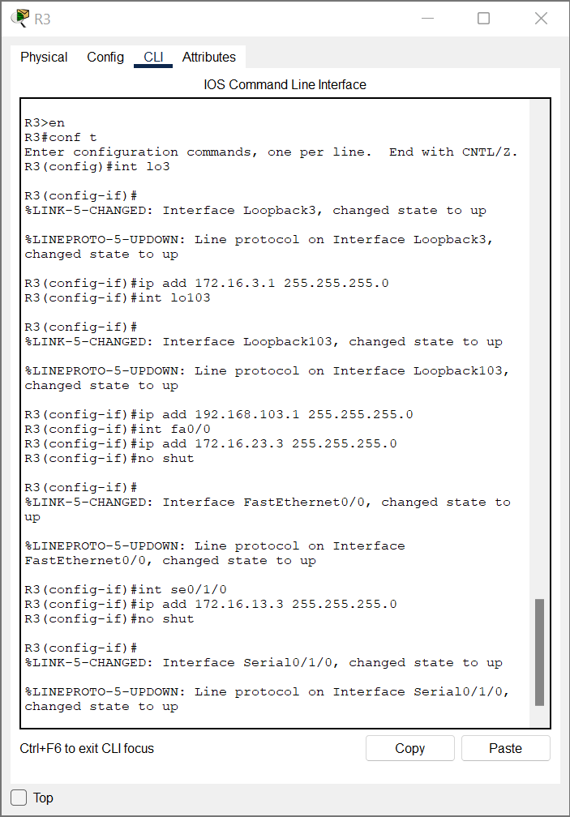

Step 2:

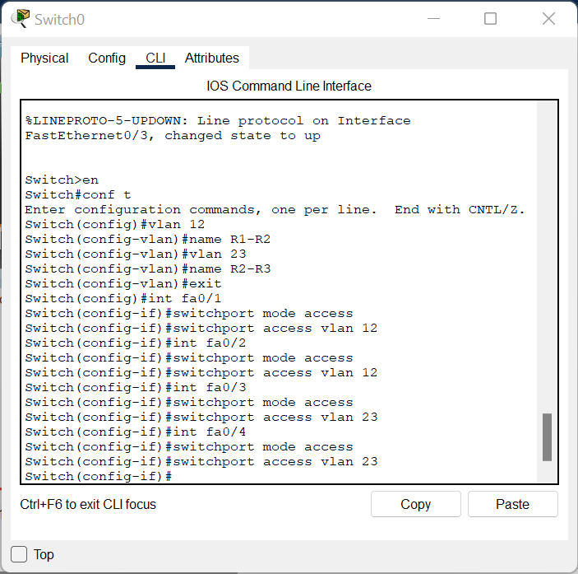

Step 3:

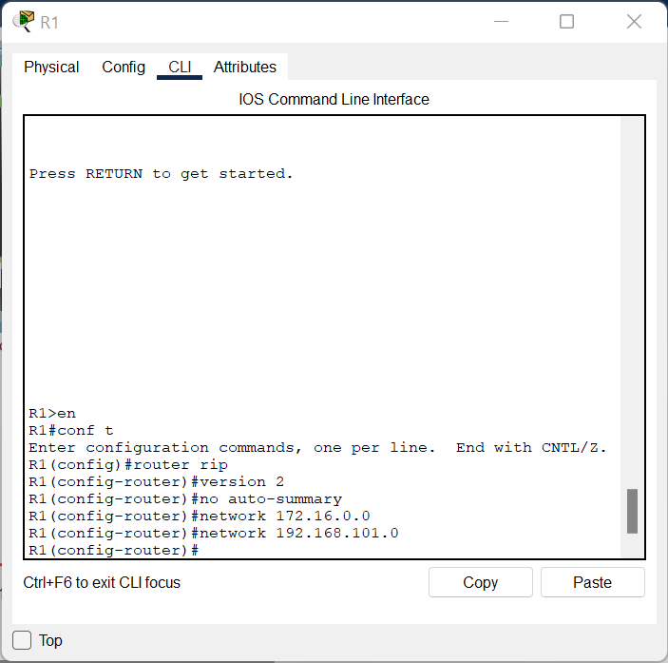

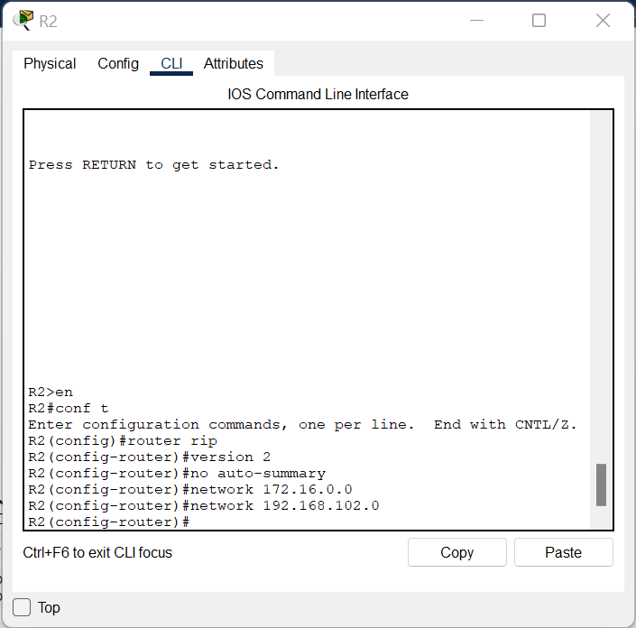

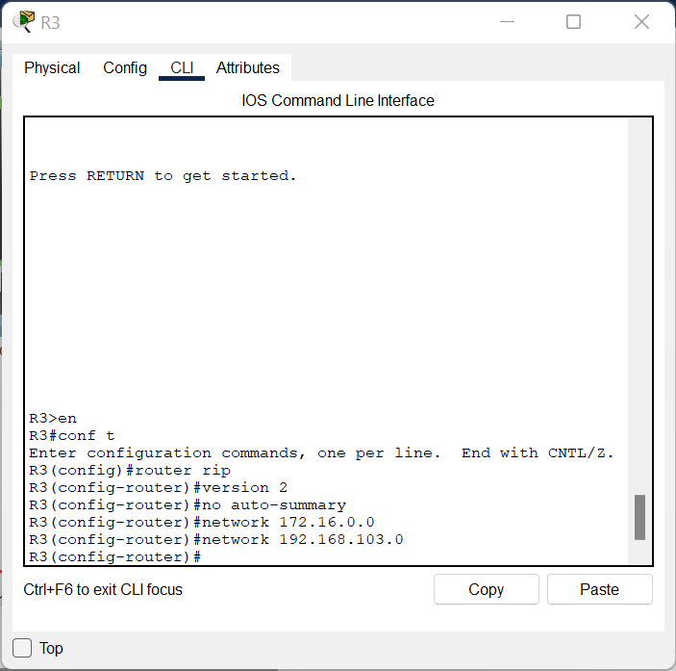

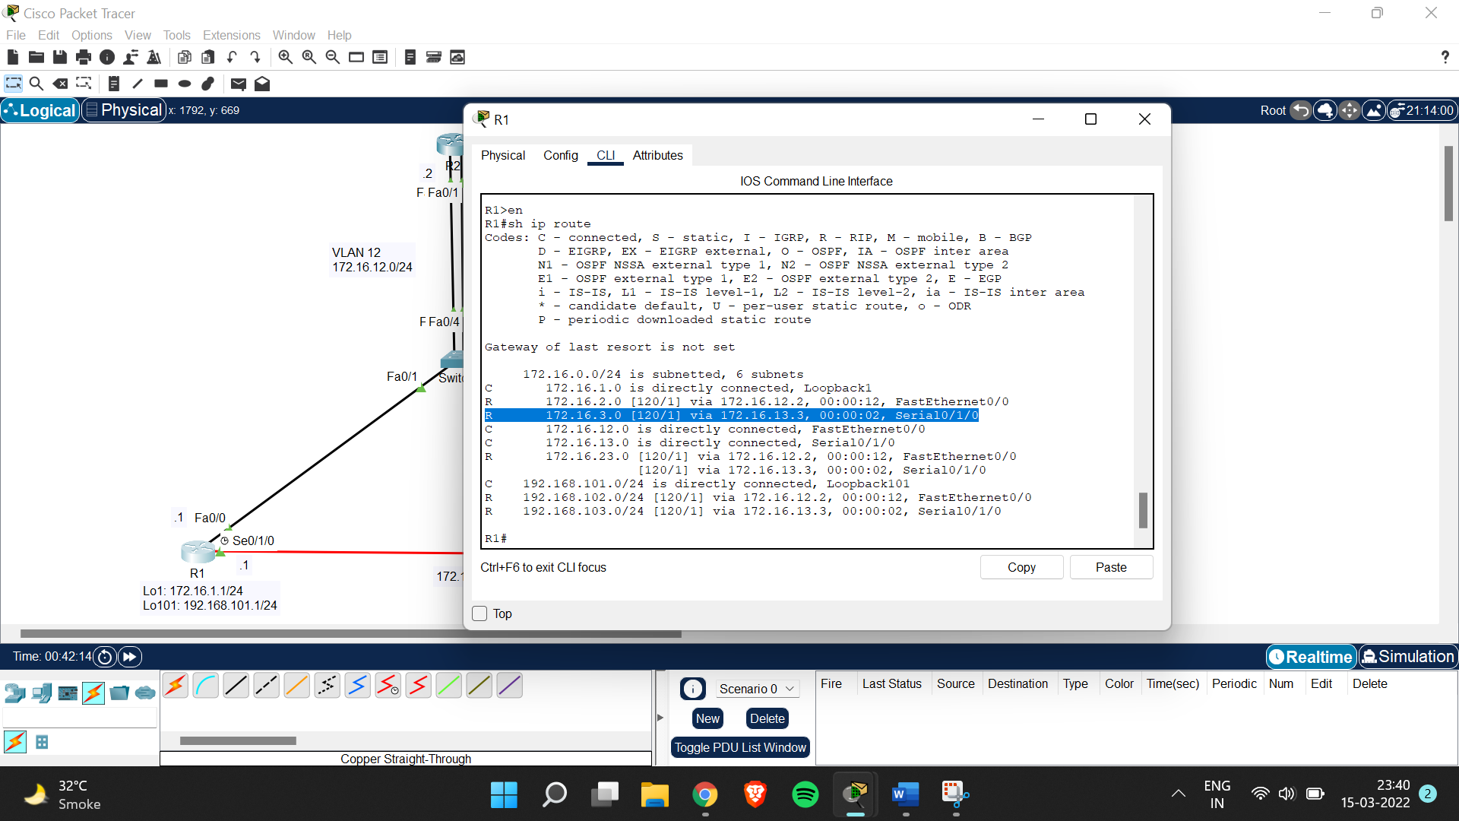

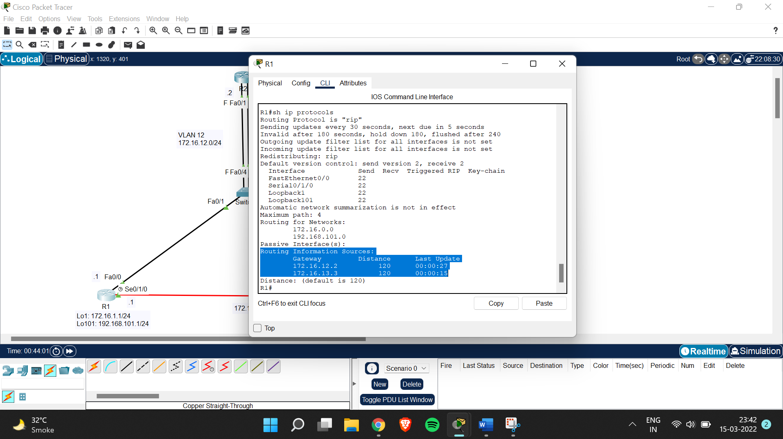

Step 4:

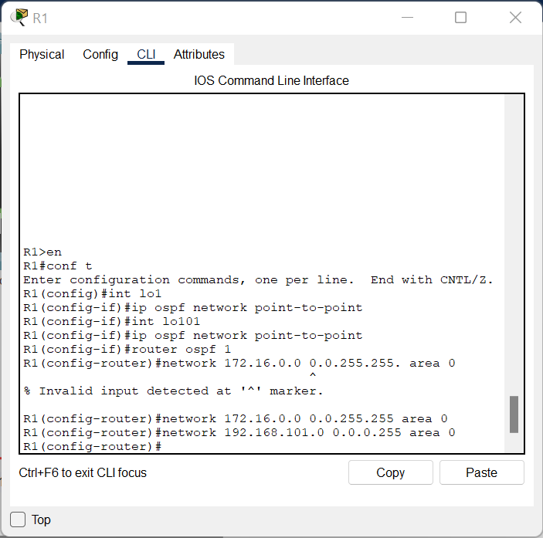

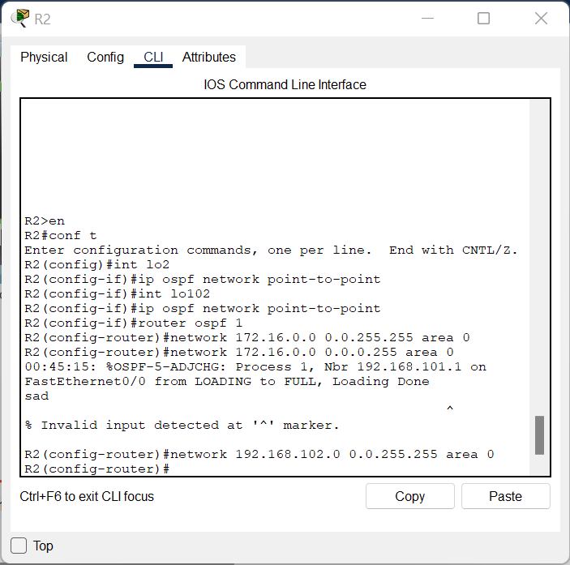

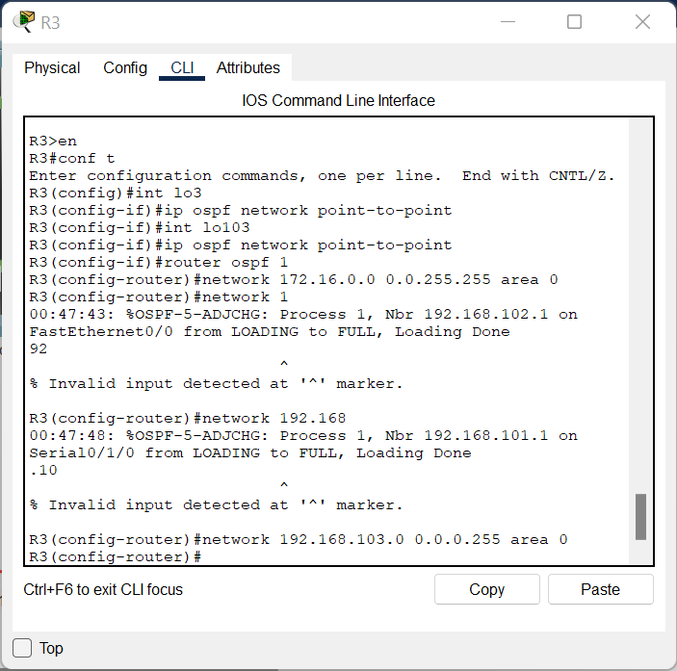

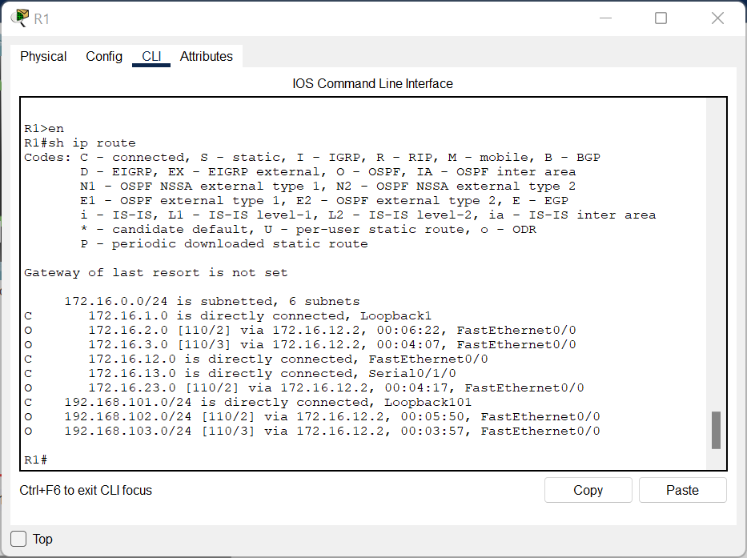

Step 5:

R1#conf t

Enter configuration commands, one per line. End with CNTL/Z.

R1(config)#router rip

R1(config-router)#distance 100

R1(config-router)#

R2>en

R2#conf t

Enter configuration commands, one per line. End with CNTL/Z.

R2(config)#router rip

R2(config-router)#distance 100

R2(config-router)#

R3>en

R3#conf t

Enter configuration commands, one per line. End with CNTL/Z.

R3(config)#router rip

R3(config-router)#distance 100

R3(config-router)#

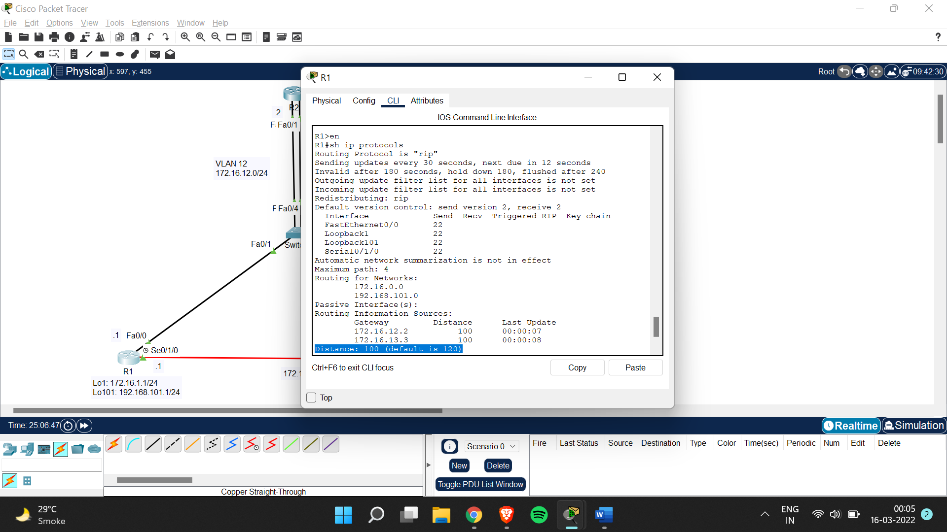

Step 6:

R1#conf t

Enter configuration commands, one per line. End with CNTL/Z.

R1(config)#router ospf 1

R1(config-router)#distance 85 192.168.100.0 0.0.3.255

R2#conf t

Enter configuration commands, one per line. End with CNTL/Z.

R2(config)#router ospf 1

R2(config-router)#distance 85 192.168.100.0 0.0.3.255

R2(config-router)#

R3#conf t

Enter configuration commands, one per line. End with CNTL/Z.

R3(config)#router ospf 1

R3(config-router)#distance 85 192.168.100.0 0.0.3.255

R3(config-router)#