Prac 5a

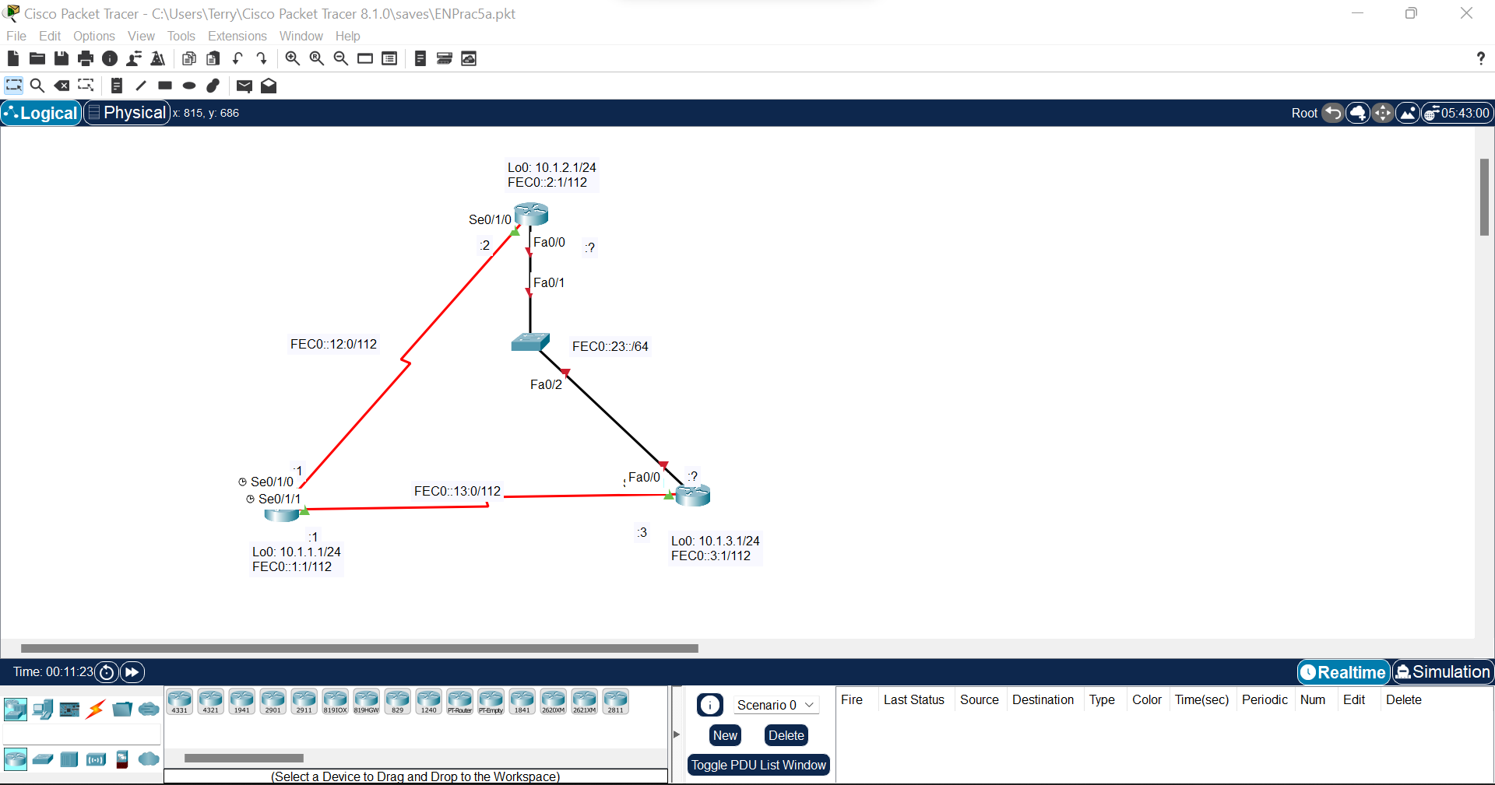

Step 1: Configuring hostname &amp; loopback addresses.

Router>en

Router#conf t

Enter configuration commands, one per line. End with CNTL/Z.

Router(config)#hostname R1

R1(config)#int lo0

R1(config-if)#

%LINK-5-CHANGED: Interface Loopback0, changed state to up

%LINEPROTO-5-UPDOWN: Line protocol on Interface Loopback0, changed state to up

R1(config-if)#ip add 10.1.1.1 255.255.255.0

R1(config-if)#ipv6 add FEC0::1:1/112

Xxxxxxxxxxxxxxxxxxxxxxxxxxxxxxxxxxxxxxxxxxxxxxxxxxx

Router>en

Router#conf t

Enter configuration commands, one per line. End with CNTL/Z.

Router(config)#hostname R2

R2(config)#int lo0

R2(config-if)#

%LINK-5-CHANGED: Interface Loopback0, changed state to up

%LINEPROTO-5-UPDOWN: Line protocol on Interface Loopback0, changed state to up

R2(config-if)#ip add 10.1.2.1 255.255.255.0

R2(config-if)#ipv6 add FEC0::2:1/112

Xxxxxxxxxxxxxxxxxxxxxxxxxxxxxxxxxxxxxxxxxxxxxxxxxxxxxxxx

Router>en

Router#conf t

Enter configuration commands, one per line. End with CNTL/Z.

Router(config)#hostname R3

R3(config)#int lo0

R3(config-if)#

%LINK-5-CHANGED: Interface Loopback0, changed state to up

%LINEPROTO-5-UPDOWN: Line protocol on Interface Loopback0, changed state to up

R3(config-if)#ip add 10.1.3.1 255.255.255.0

R3(config-if)#ipv6 add FEC0::3:1/112

R1#conf t

Enter configuration commands, one per line. End with CNTL/Z.

R1(config)#int se0/1/0

R1(config-if)#ipv6 add FEC0::12:1/112

R1(config-if)#clock rate 64000

R1(config-if)#bandwidth 64

R1(config-if)#no shut

%LINK-5-CHANGED: Interface Serial0/1/0, changed state to down

R1(config-if)#

R1(config-if)#exit

R1(config)#int se0/1/1

R1(config-if)#ipv6 add FEC0::13:1/112

R1(config-if)#bandwidth 64

R1(config-if)#no shut

Xxxxxxxxxxxxxxxxxxxxxxxxxxxxxxxxxxxxxxxxxxxxxxx

R2#conf t

Enter configuration commands, one per line. End with CNTL/Z.

R2(config)#int se0/1/0

R2(config-if)#ipv6 add FEC0::12:2/112

R2(config-if)#bandwidth 64

R2(config-if)#no shut

Xxxxxxxxxxxxxxxxxxxxxxxxxxxxxxxxxxxxxxxxxxxxxxxx

R3#conf t

Enter configuration commands, one per line. End with CNTL/Z.

R3(config)#int se0/1/1

R3(config-if)#ipv6 add FEC0::13:3/112

R3(config-if)#clock rate 64000

This command applies only to DCE interfaces

R3(config-if)#bandwidth 64

R3(config-if)#no shut

Step 2: Pinging router R1 with R2 and R1 with R3

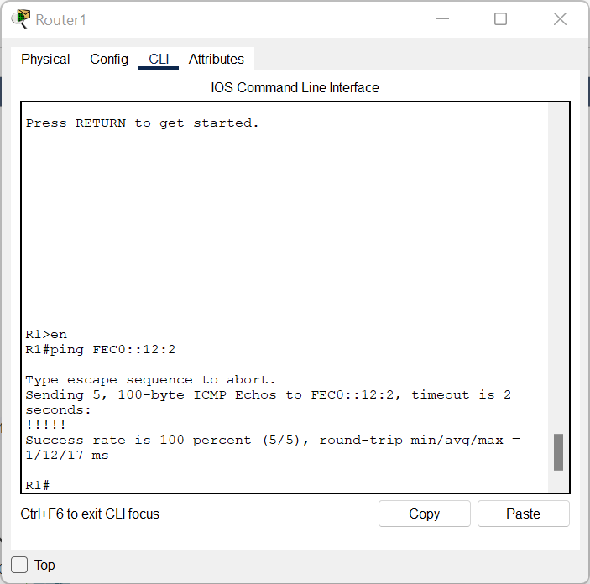

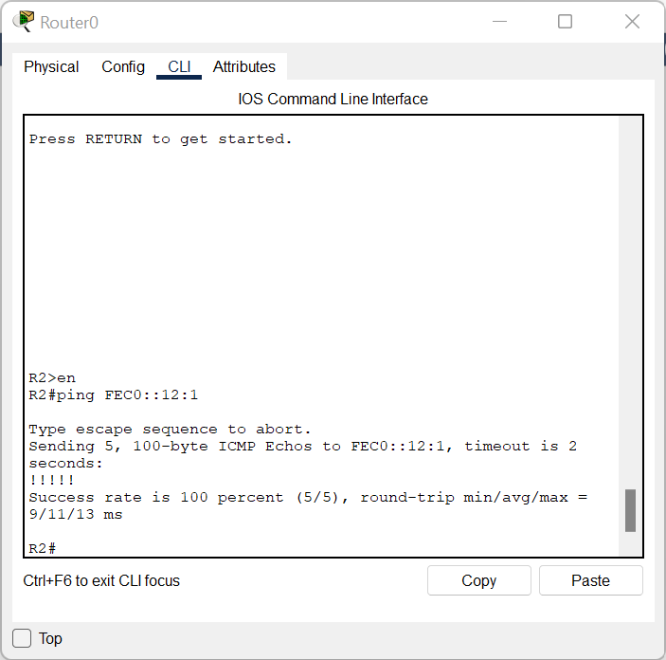

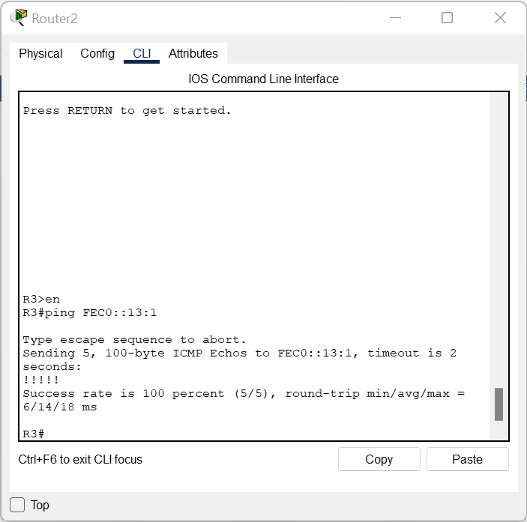

Step 3: Change the link local address on an interface.

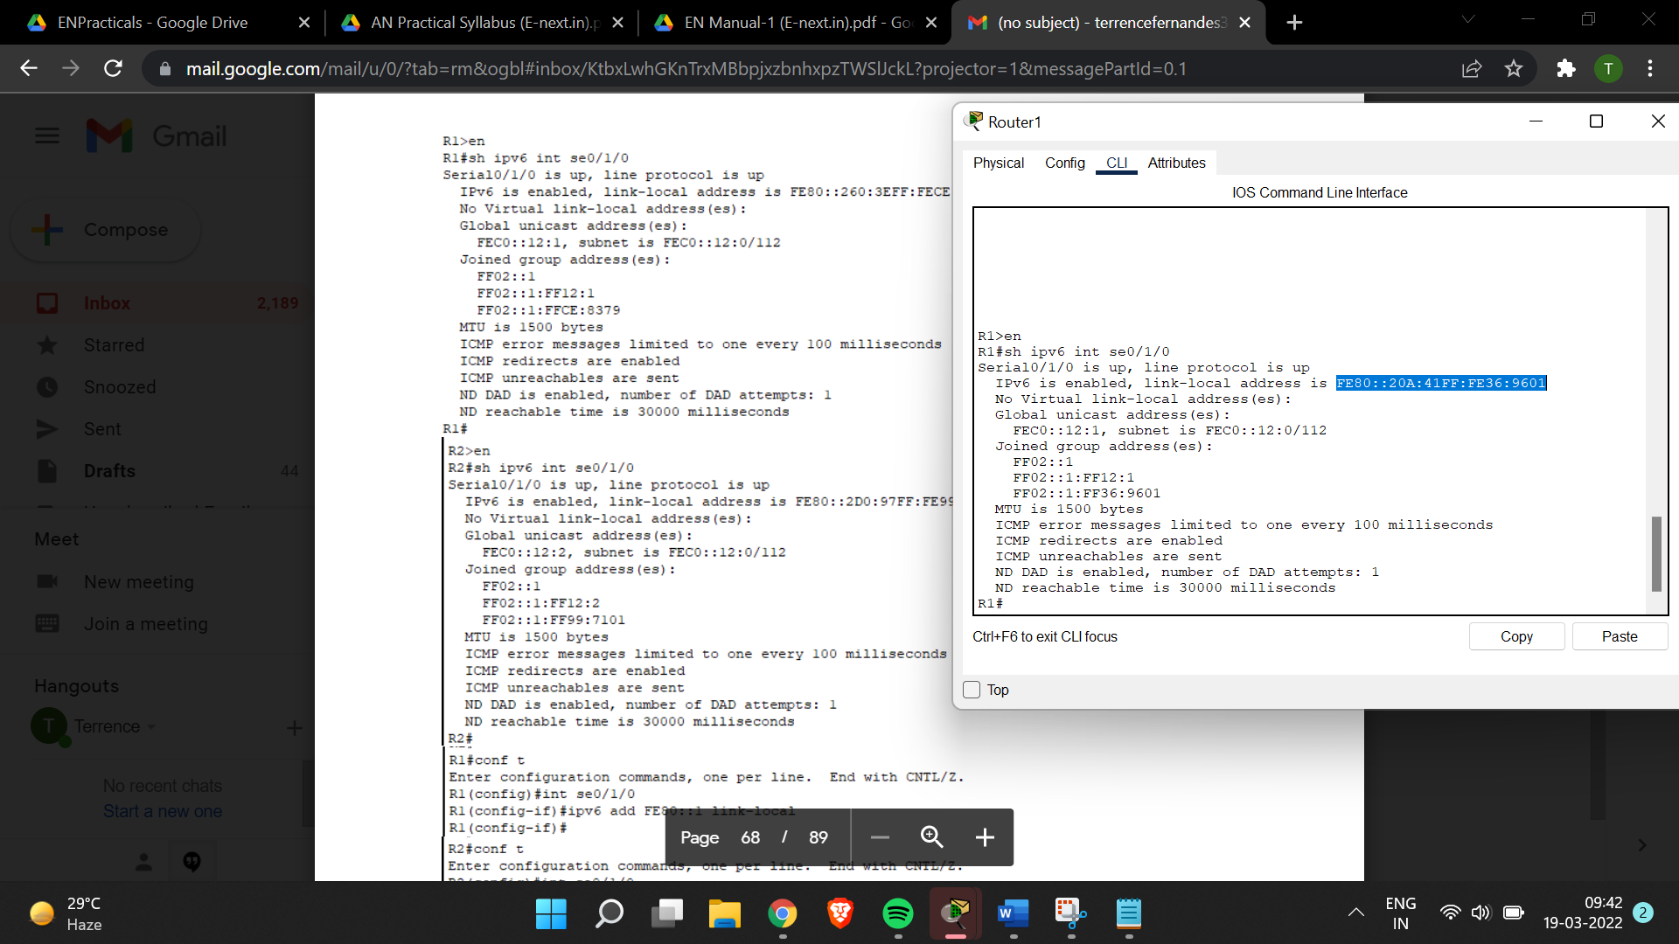

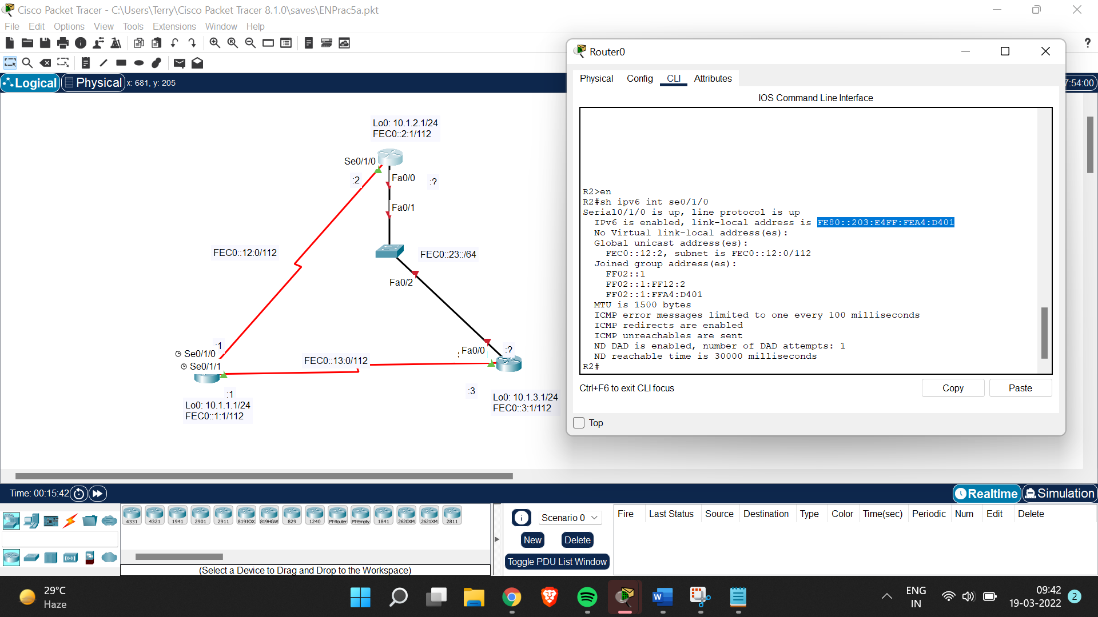

R1>en

R1#conf t

Enter configuration commands, one per line. End with CNTL/Z.

R1(config)#int se0/1/0

R1(config-if)#ipv6 add FE80::11 link:local

^

% Invalid input detected at '^' marker.

R1(config-if)#ipv6 add FE80::11 link-local

R2#conf t

Enter configuration commands, one per line. End with CNTL/Z.

R2(config)#int se0/1/0

R2(config-if)#ipv6 add FE80::2 link-local

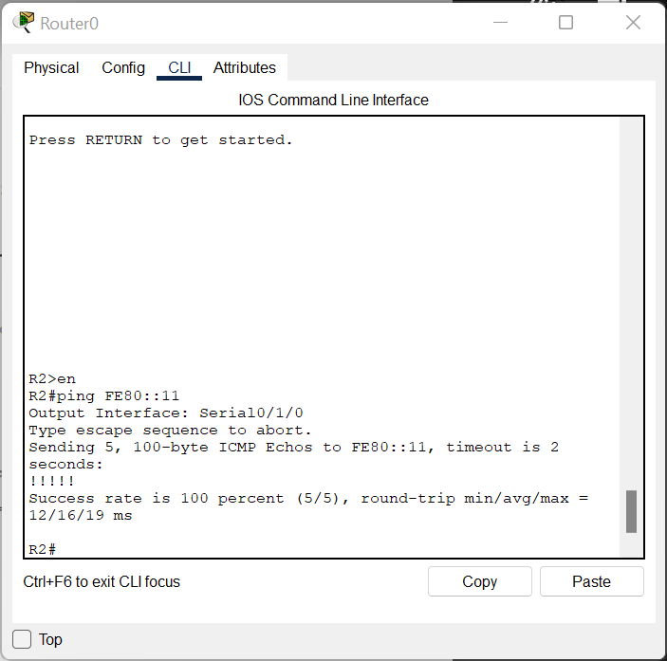

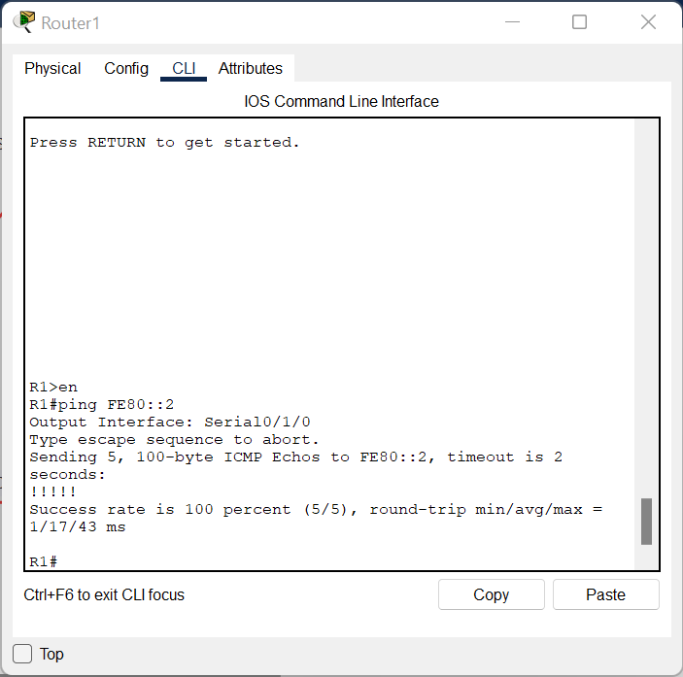

Step 4: Configure EUI-64 addresses.

R2#conf t

Enter configuration commands, one per line. End with CNTL/Z.

R2(config)#int fa0/0

R2(config-if)#ipv6 add FEC0:23::/64 eui-64

R2(config-if)#no shut

R3>en

R3#conf t

Enter configuration commands, one per line. End with CNTL/Z.

R3(config)#int fa0/0

R3(config-if)#ipv6 add FEC0:23::/64 eui-64

R3(config-if)#no shut

