Prac 5B

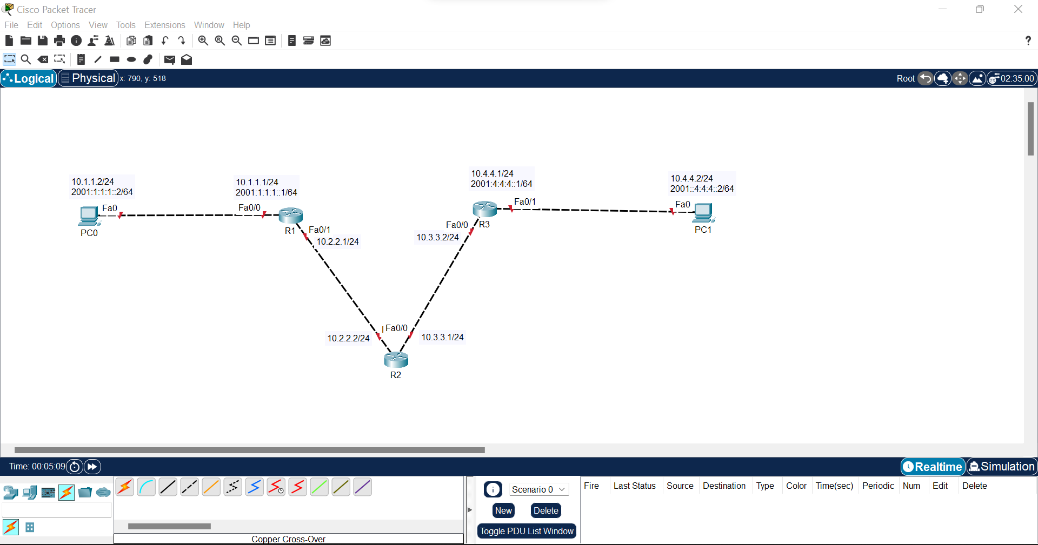

Step 1: Configure loopbacks and addressing

Router>en

Router#conf t

Enter configuration commands, one per line. End with CNTL/Z.

Router(config)#hostname R1

R1(config)#int fa0/0

R1(config-if)#ip add 10.1.1.1 255.255.255.0

R1(config-if)#ipv6 add 2001:1:1:1::1/64

R1(config-if)#no shut

R1(config-if)#

%LINK-5-CHANGED: Interface FastEthernet0/0, changed state to up

%LINEPROTO-5-UPDOWN: Line protocol on Interface FastEthernet0/0, changed state to up

R1(config-if)#int fa0/1

R1(config-if)#ip add 10.2.2.1 255.255.255.0

R1(config-if)#no shut

Xxxxxxxxxxxxxxxxxxxxxxxxxxxxxxxxxxxxxxxxxxxxxxxxxxxxxxxxxx

Router>en

Router#conf t

Enter configuration commands, one per line. End with CNTL/Z.

Router(config)#hostname R2

R2(config)#int fa0/1

R2(config-if)#ip add 10.2.2.2 255.255.255.0

R2(config-if)#no shut

R2(config-if)#

%LINK-5-CHANGED: Interface FastEthernet0/1, changed state to up

%LINEPROTO-5-UPDOWN: Line protocol on Interface FastEthernet0/1, changed state to up

R2(config-if)#int fa0/0

R2(config-if)#ip add 10.3.3.1 255.255.255.0

R2(config-if)#no shut

Xxxxxxxxxxxxxxxxxxxxxxxxxxxxxxxxxxxxxxxxxxxxxxxxxxx

Router>en

Router#conf t

Enter configuration commands, one per line. End with CNTL/Z.

Router(config)#hostname R3

R3(config)#int fa0/0

R3(config-if)#ip add 10.3.3.2 255.255.255.0

R3(config-if)#no shut

R3(config-if)#

%LINK-5-CHANGED: Interface FastEthernet0/0, changed state to up

%LINEPROTO-5-UPDOWN: Line protocol on Interface FastEthernet0/0, changed state to up

R3(config-if)#int fa0/1

R3(config-if)#ip add 10.4.4.1 255.255.255.0

R3(config-if)#ipv6 add 2001:4:4:4::1/64

R3(config-if)#no shut

Step 2: Assigning default route

R1#conf t

Enter configuration commands, one per line. End with CNTL/Z.

R1(config)#ip route 0.0.0.0 0.0.0.0 10.2.2.2

Xxxxxxxxxxxxxxxxxxxxxxxxxxxxxxxxxx

R2#conf t

Enter configuration commands, one per line. End with CNTL/Z.

R2(config)#ip route 10.1.1.0 255.255.255.0 10.2.2.1

R2(config)#ip route 10.4.4.0 255.255.255.0 10.3.3.2

Xxxxxxxxxxxxxxxxxxxxxxxxxxxxxxxxxxxx

R3#conf t

Enter configuration commands, one per line. End with CNTL/Z.

R3(config)#ip route 0.0.0.0 0.0.0.0 10.3.3.1

Step 3: Testing the connectivity

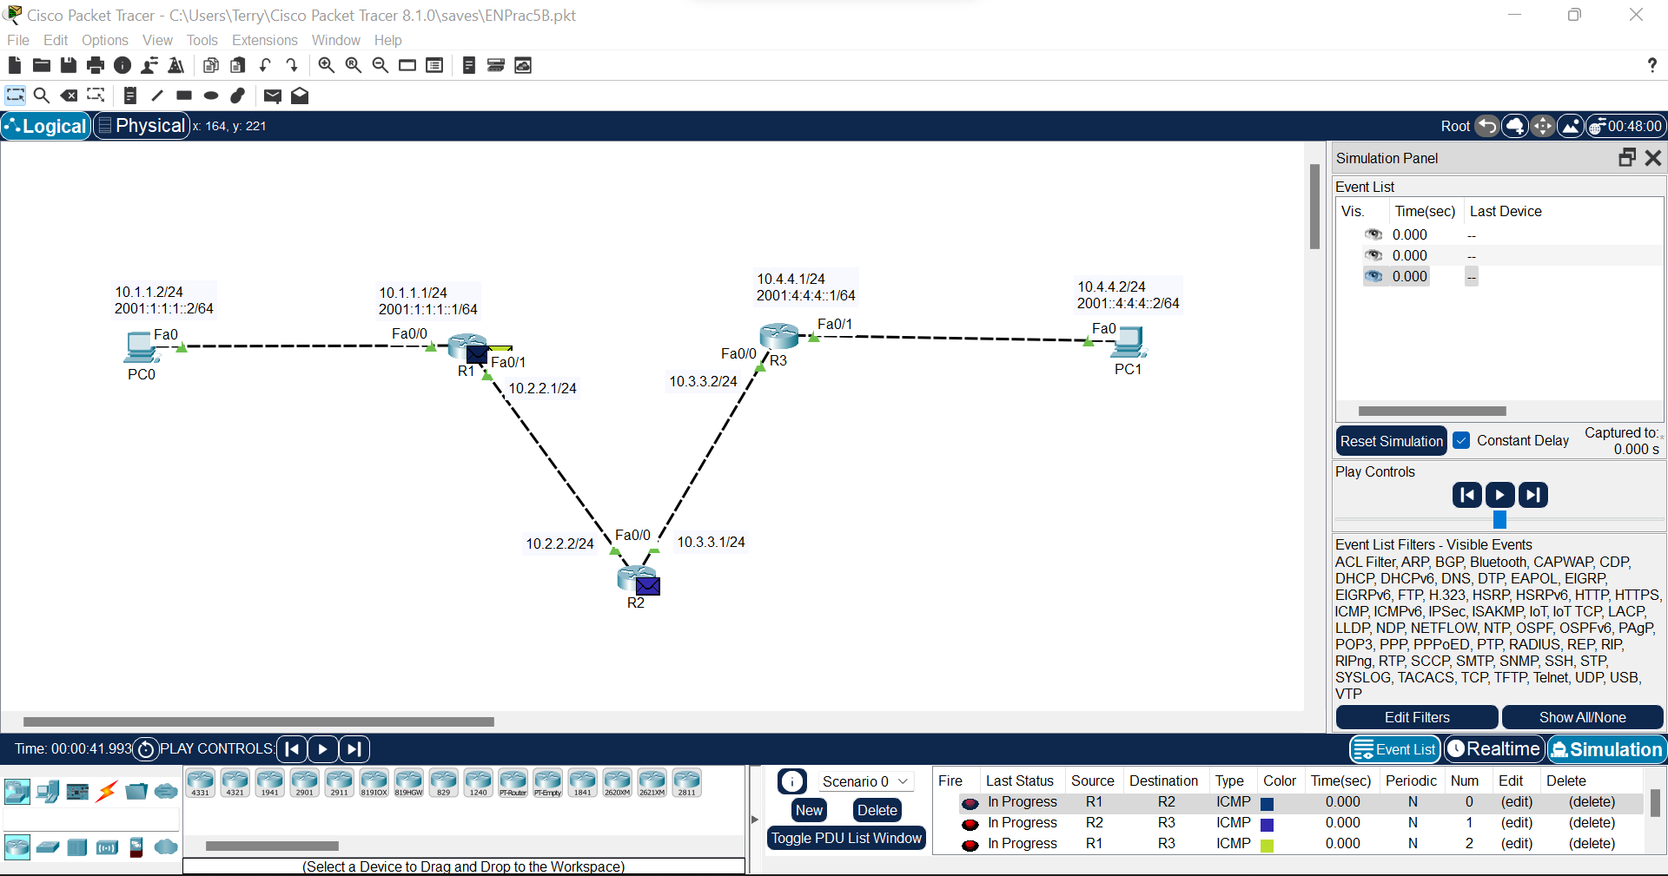

Step 4: Enable IPv6 unicast routing.

R1>en

R1#conf t

Enter configuration commands, one per line. End with CNTL/Z.

R1(config)#ipv6 unicast-routing

R1(config)#int tunnel 0

R1(config-if)#

%LINK-5-CHANGED: Interface Tunnel0, changed state to up

R1(config-if)#tunnel mode ipv6ip

R1(config-if)#ipv6 add 2001:2:2:2::1/64

R1(config-if)#tunnel source fa0/1

R1(config-if)#

%LINEPROTO-5-UPDOWN: Line protocol on Interface Tunnel0, changed state to up

R1(config-if)#tunnel destination 10.3.3.2

Xxxxxxxxxxxxxxxxxxxxxxxxxxxxxxxxxxxxx

R3>en

R3#conf t

Enter configuration commands, one per line. End with CNTL/Z.

R3(config)#ipv6 unicast-routing

R3(config)#int tunnel 0

R3(config-if)#

%LINK-5-CHANGED: Interface Tunnel0, changed state to up

R3(config-if)#ipv6 add 2001:2:2:2::2/64

R3(config-if)#tunnel source fa0/0

R3(config-if)#tunnel destination 10.2.2.1