Prac 6A:  
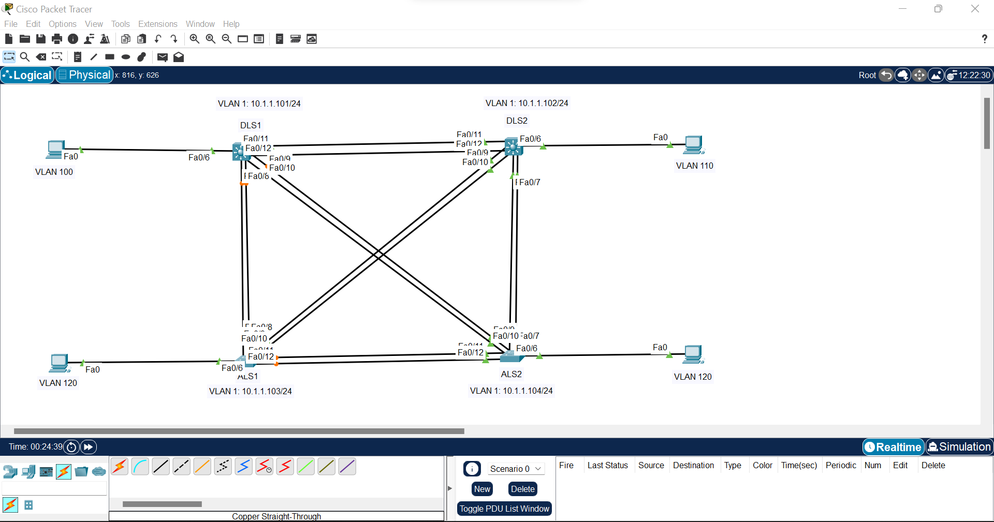

Step 1:  
Switch>en

Switch#conf t

Enter configuration commands, one per line. End with CNTL/Z.

Switch(config)#hostname DLS1

DLS1(config)#int vlan 1

DLS1(config-if)#ip add 10.1.1.101 255.255.255.0

DLS1(config-if)#no shut

Xxxxxxxxxxxxxxxxxxxxxxxxxxxxxxxxxxxxxxxxxxxxxxxxx

Switch>en

Switch#conf t

Enter configuration commands, one per line. End with CNTL/Z.

Switch(config)#hostname DLS2

DLS2(config)#int vlan 1

DLS2(config-if)#ip add 10.1.1.102 255.255.255.0

DLS2(config-if)#no shut

Xxxxxxxxxxxxxxxxxxxxxxxxxxxxxxxxxxxxxxxxxxxxxxxxx

Switch>en

Switch#conf t

Enter configuration commands, one per line. End with CNTL/Z.

Switch(config)#hostname ALS1

ALS1(config)#int vlan 1

ALS1(config-if)#ip add 10.1.1.103 255.255.255.0

ALS1(config-if)#no shut

Xxxxxxxxxxxxxxxxxxxxxxxxxxxxxxxxxxxxxxxxxxxxxxxxx

Switch>en

Switch#conf t

Enter configuration commands, one per line. End with CNTL/Z.

Switch(config)#hostname ALS2

ALS2(config)#int vlan 1

ALS2(config-if)#ip add 10.1.1.104 255.255.255.0

ALS2(config-if)# no shut

Step 2:  
  
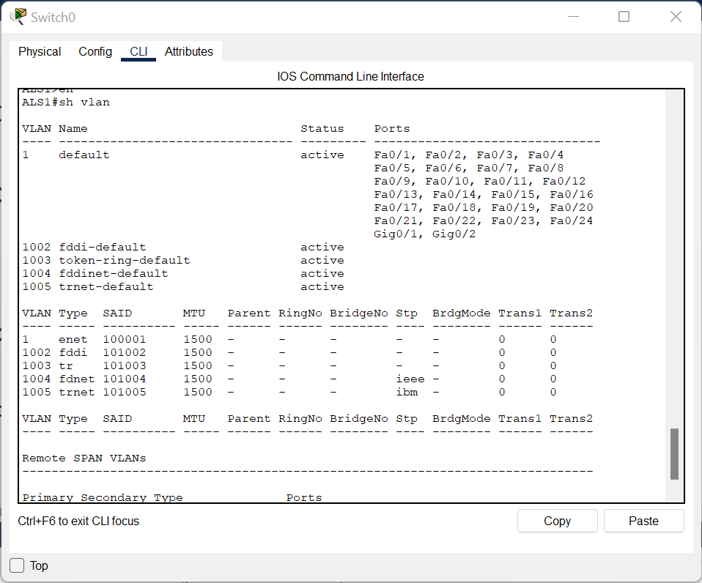

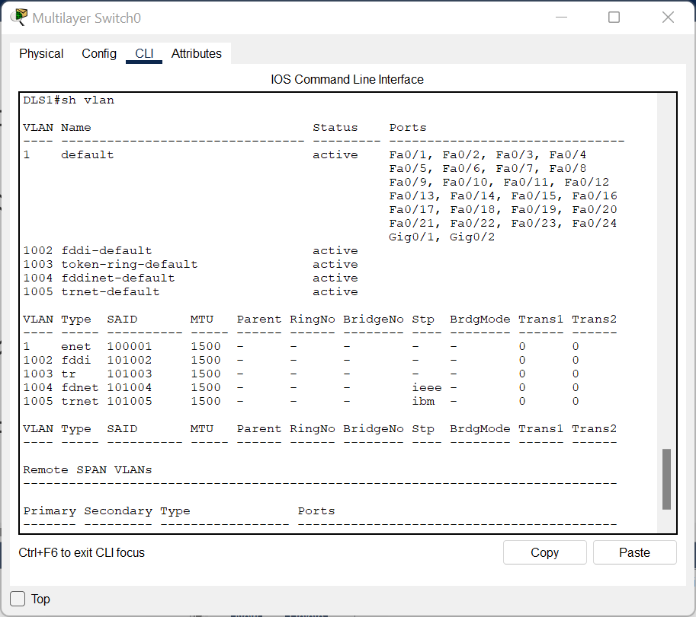

Step 3:  
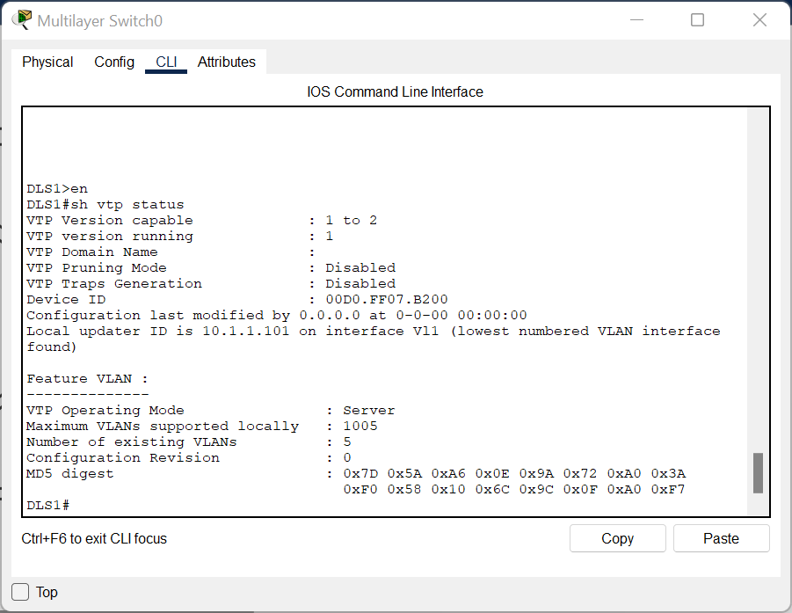

Step 4:

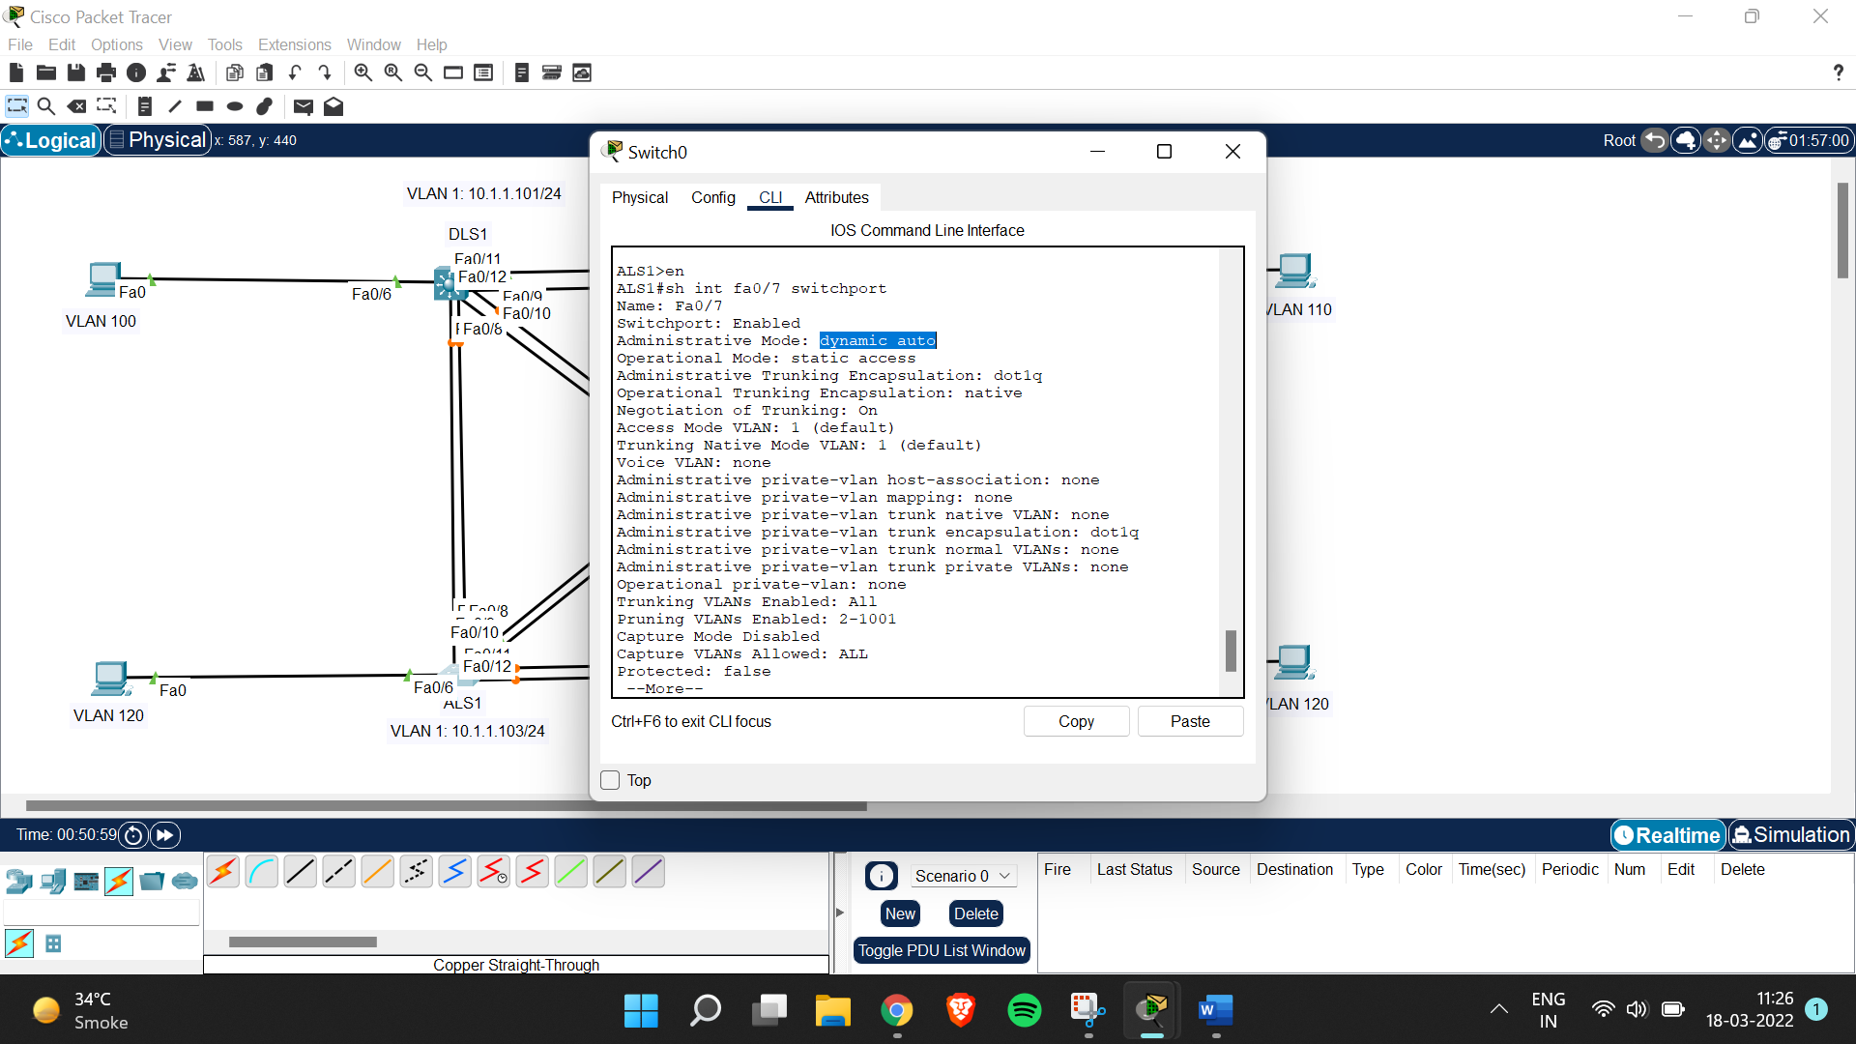

DLS1#conf t

Enter configuration commands, one per line. End with CNTL/Z.

DLS1(config)#int fa0/7-10

^

% Invalid input detected at '^' marker.

DLS1(config)#int range fa0/7-10

DLS1(config-if-range)#switchport trunk encapsulation dot1q

DLS1(config-if-range)#switchport mode trunk

DLS1(config-if-range)#exit

DLS1(config)#int range fa0/11-12

DLS1(config-if-range)#switchport trunk encapsulation dot1q

DLS1(config-if-range)#switchport mode trunk

Xxxxxxxxxxxxxxxxxxxxxxxxxxxxxxxxxxxxxxxxxxxxxxxxxxxxxxxxxxxxxx

ALS1#conf t

Enter configuration commands, one per line. End with CNTL/Z.

ALS1(config)#int range fa0/7-12

ALS1(config-if-range)#switchport mode trunk

Xxxxxxxxxxxxxxxxxxxxxxxxxxxxxxxxxxxxxxxxxxxxxxxxxxxxxxxxxxxxxxxxxxxxxxxxxxx

DLS2>en

DLS2#conf t

Enter configuration commands, one per line. End with CNTL/Z.

DLS2(config)#int range fa0/7-12

DLS2(config-if-range)#switchport trunk encapsulation dot1q

DLS2(config-if-range)#switchport mode trunk

Xxxxxxxxxxxxxxxxxxxxxxxxxxxxxxxxxxxxxxxxxxxxxxxxxxxxxxxxxxxxxxxxxxxxxxxxxx

ALS2>en

ALS2#conf t

Enter configuration commands, one per line. End with CNTL/Z.

ALS2(config)#int range fa0/7-12

ALS2(config-if-range)#switchport mode trunk

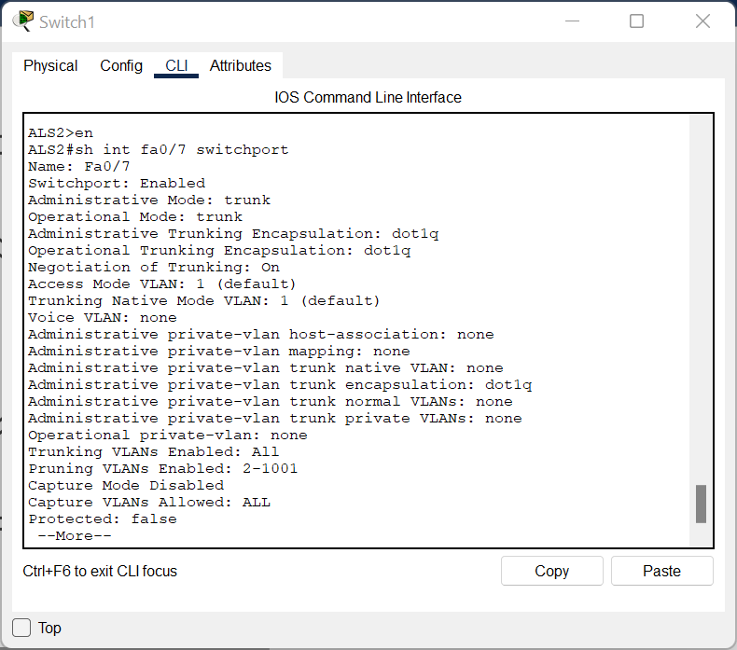

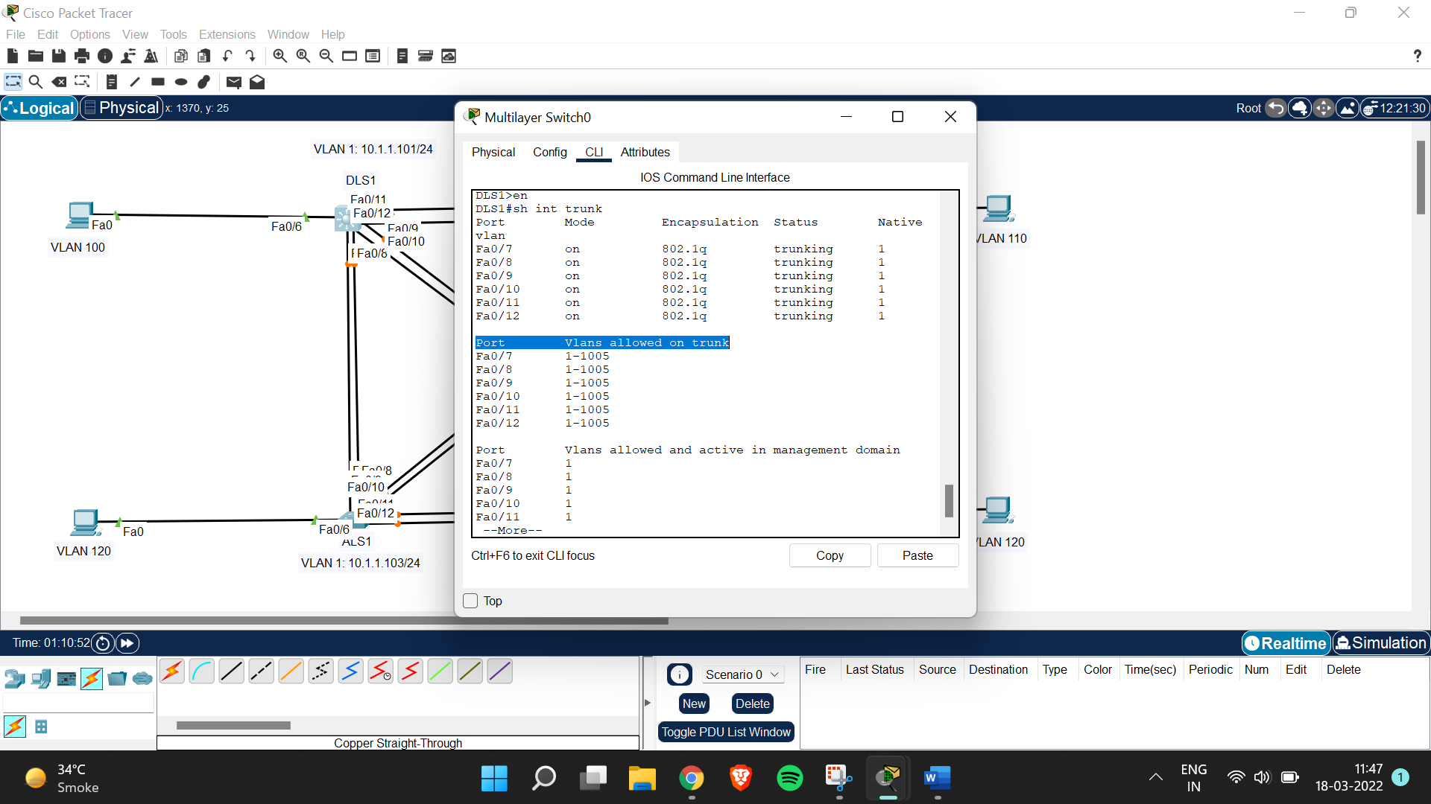

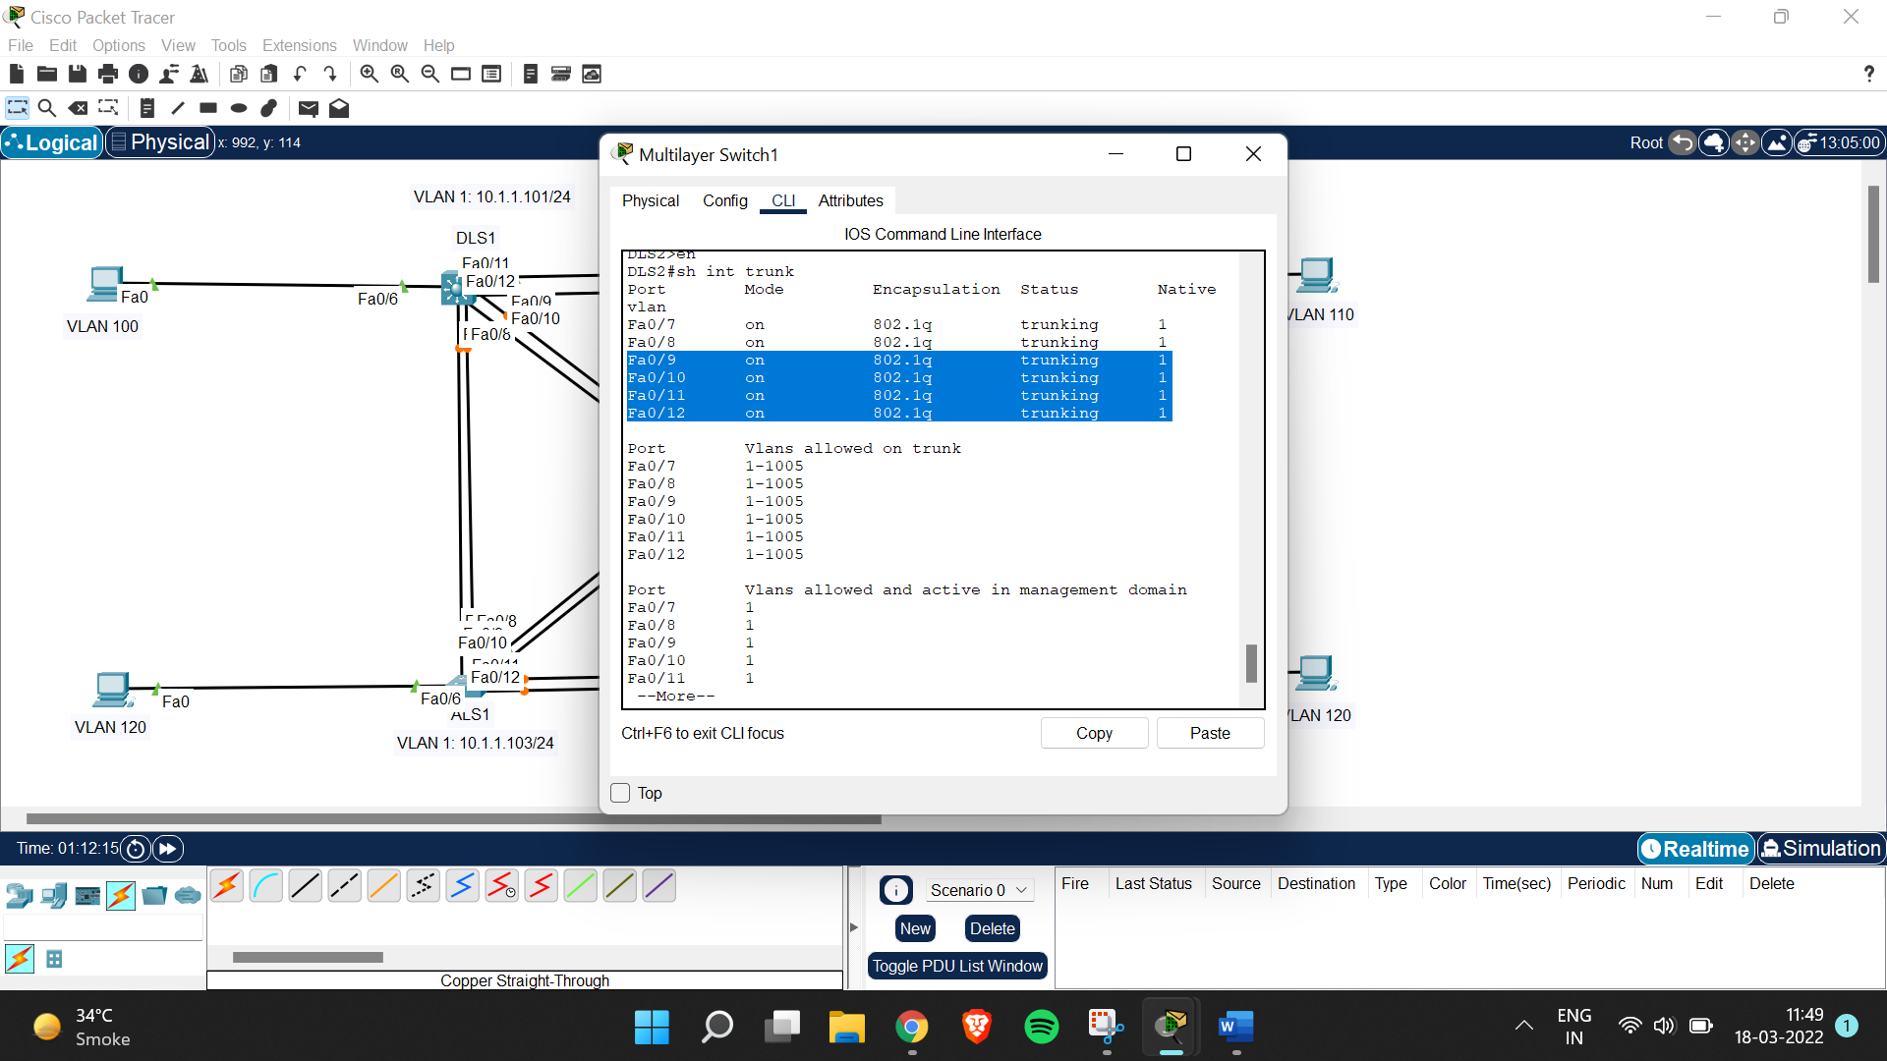

Step 5:

DLS1>en

DLS1#conf t

Enter configuration commands, one per line. End with CNTL/Z.

DLS1(config)#int fa0/6

DLS1(config-if)#switchport mode access

Xxxxxxxxxxxxxxxxxxxxxxxxxxx

ALS1>en

ALS1#conf t

Enter configuration commands, one per line. End with CNTL/Z.

ALS1(config)#int fa0/6

ALS1(config-if)#switchport mode access

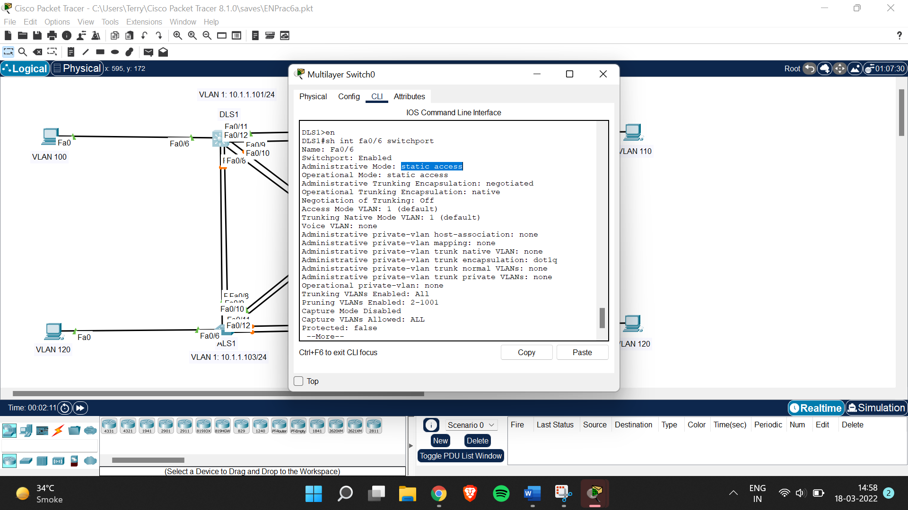

Step 6:  
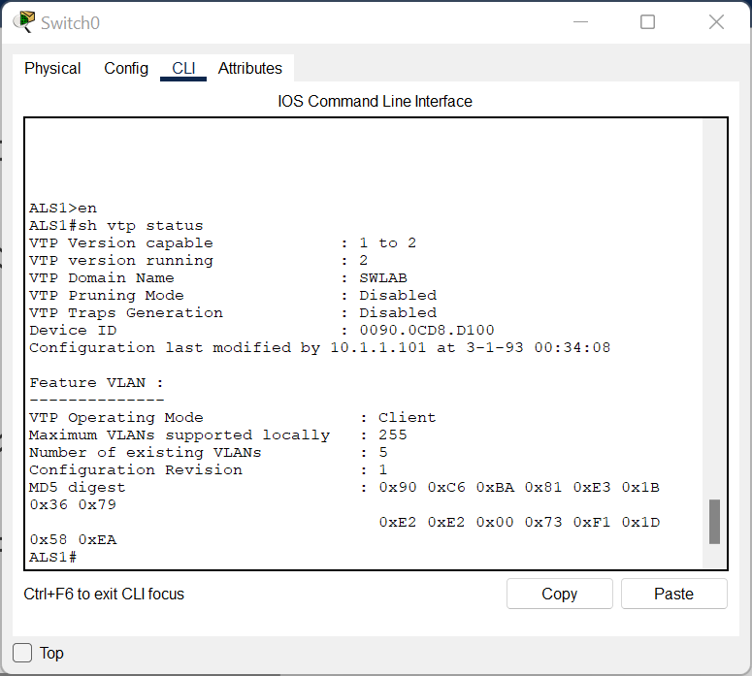

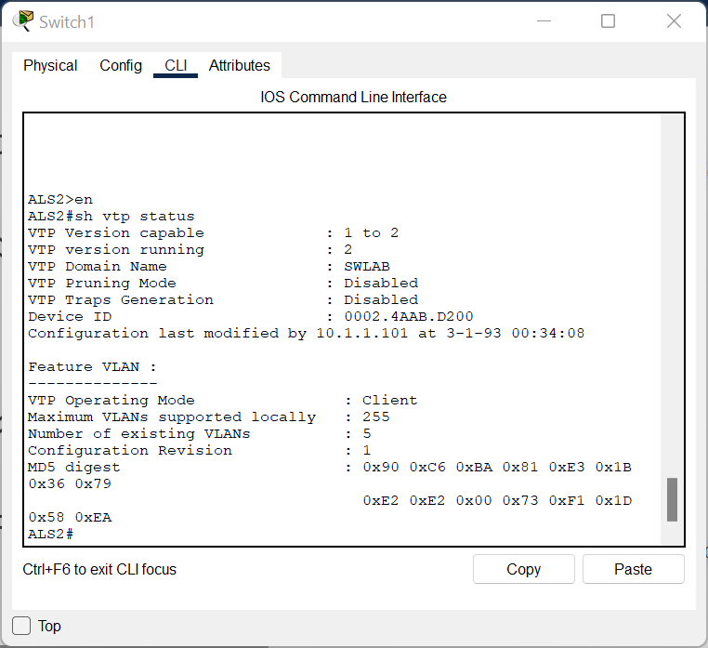

Step 7:  
DLS1>en

DLS1#conf t

Enter configuration commands, one per line. End with CNTL/Z.

DLS1(config)#int fa0/6

DLS1(config-if)#switchport access vlan 100

Xxxxxxxxxxxxxxxxxxxxxxxxxxxxxxxxxxxxxxxxxxxxxxxxxxxxxxxxx

DLS2>en

DLS2#conf t

Enter configuration commands, one per line. End with CNTL/Z.

DLS2(config)#int fa0/6

DLS2(config-if)#switchport access vlan 110

Xxxxxxxxxxxxxxxxxxxxxxxxxxxxxxxxxxxxxxxxxxxxxxxxxxxxxxxxxxxxxx

ALS1#conf t

Enter configuration commands, one per line. End with CNTL/Z.

ALS1(config)#int fa0/6

ALS1(config-if)#switchport access vlann 120

^

% Invalid input detected at '^' marker.

ALS1(config-if)#switchport access vlan 120

Xxxxxxxxxxxxxxxxxxxxxxxxxxxxxxxxxxxxxxxxxxxxxxxxxxxxxxxxxxxxxx

ALS2#conf t

Enter configuration commands, one per line. End with CNTL/Z.

ALS2(config)#int fa0/6

ALS2(config-if)#switchport access vlan 120

Step 8:

ALS1#conf t

Enter configuration commands, one per line. End with CNTL/Z.

ALS1(config)#vlan 120

VTP VLAN configuration not allowed when device is in CLIENT mode.

ALS1(config)#state suspend

^

% Invalid input detected at '^' marker.

ALS1(config)#state active

^

% Invalid input detected at '^' marker.

ALS1(config)#state shutdown