Prac 6B:  
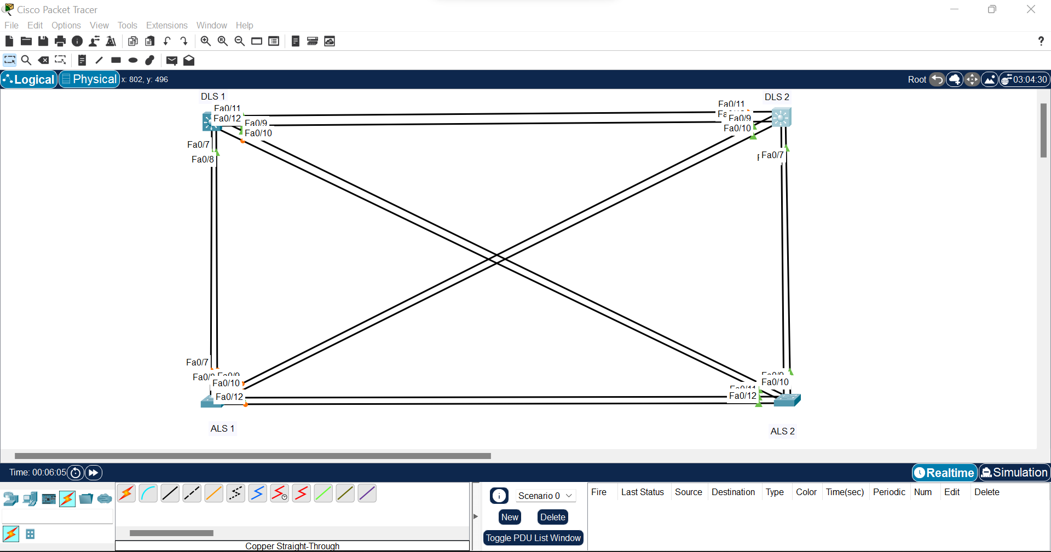

Step 1:

Switch>en

Switch#hostname DLS1

^

% Invalid input detected at '^' marker.

Switch#conf t

Enter configuration commands, one per line. End with CNTL/Z.

Switch(config)#hostname DLS1

DLS1(config)#int range fa0/7-12

DLS1(config-if-range)#switchport mode trunk encapsulation dot1q

^

% Invalid input detected at '^' marker.

DLS1(config-if-range)#switchport trunk encapsulation dot1q

DLS1(config-if-range)#switchport mode trunk

Xxxxxxxxxxxxxxxxxxxxxxxxxxxxxxxxxxxxxxxx

Switch>en

Switch#conf t

Enter configuration commands, one per line. End with CNTL/Z.

Switch(config)#hostname DLS 2

^

% Invalid input detected at '^' marker.

Switch(config)#hostname DLS2

DLS2(config)#int range fa0/7-12

DLS2(config-if-range)#switchport trunk encapsulation dot1q

DLS2(config-if-range)#switchport mode trunk

Xxxxxxxxxxxxxxxxxxxxxxxxxxxxxxxxxxxxxxxxxx

Switch>en

Switch#

%LINEPROTO-5-UPDOWN: Line protocol on Interface FastEthernet0/9, changed state to down

%LINEPROTO-5-UPDOWN: Line protocol on Interface FastEthernet0/9, changed state to up

%LINEPROTO-5-UPDOWN: Line protocol on Interface FastEthernet0/10, changed state to down

%LINEPROTO-5-UPDOWN: Line protocol on Interface FastEthernet0/10, changed state to up

conf t

Enter configuration commands, one per line. End with CNTL/Z.

Switch(config)#hostname ALS1

ALS1(config)#int range fa0/7-12

ALS1(config-if-range)#switchport mode trunk

Xxxxxxxxxxxxxxxxxxxxxxxxxxxxxxxxxxxxxxxxxxxxx

Switch>en

Switch#conf t

Enter configuration commands, one per line. End with CNTL/Z.

Switch(config)#hostname ALS2

ALS2(config)#int range fa0/7-12

ALS2(config-if-range)#switchport mode trunk

Step 2:

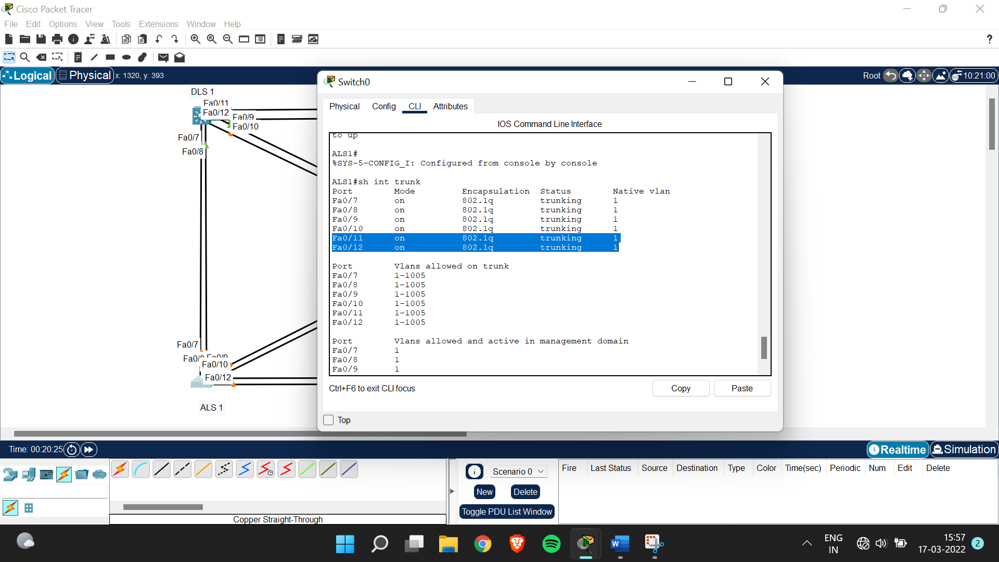

ALS1#conf t

Enter configuration commands, one per line. End with CNTL/Z.

ALS1(config)#int range fa0/11-12

ALS1(config-if-range)#channel-group 1 mode desirable

ALS1(config-if-range)#

Creating a port-channel interface Port-channel 1

%LINEPROTO-5-UPDOWN: Line protocol on Interface FastEthernet0/11, changed state to down

%LINEPROTO-5-UPDOWN: Line protocol on Interface FastEthernet0/11, changed state to up

%LINEPROTO-5-UPDOWN: Line protocol on Interface FastEthernet0/12, changed state to down

%LINEPROTO-5-UPDOWN: Line protocol on Interface FastEthernet0/12, changed state to up

ALS1(config-if-range)#exit

ALS1(config)#int port-channel 1

ALS1(config-if)#switchport mode trunk

Xxxxxxxxxxxxxxxxxxxxxxxxxxxxxxxxxxxxxxxxxxxxxxx

ALS2#conf t

Enter configuration commands, one per line. End with CNTL/Z.

ALS2(config)#int range fa0/11-12

ALS2(config-if-range)#channel-group 1 mode desirable

ALS2(config-if-range)#

Creating a port-channel interface Port-channel 1

%LINEPROTO-5-UPDOWN: Line protocol on Interface FastEthernet0/11, changed state to down

%LINEPROTO-5-UPDOWN: Line protocol on Interface FastEthernet0/11, changed state to up

%LINEPROTO-5-UPDOWN: Line protocol on Interface FastEthernet0/12, changed state to down

%LINEPROTO-5-UPDOWN: Line protocol on Interface FastEthernet0/12, changed state to up

%LINK-5-CHANGED: Interface Port-channel1, changed state to up

%LINEPROTO-5-UPDOWN: Line protocol on Interface Port-channel1, changed state to up

ALS2(config-if-range)#exit

ALS2(config)#int port-channel 1

ALS2(config-if)#switchport mode trunk

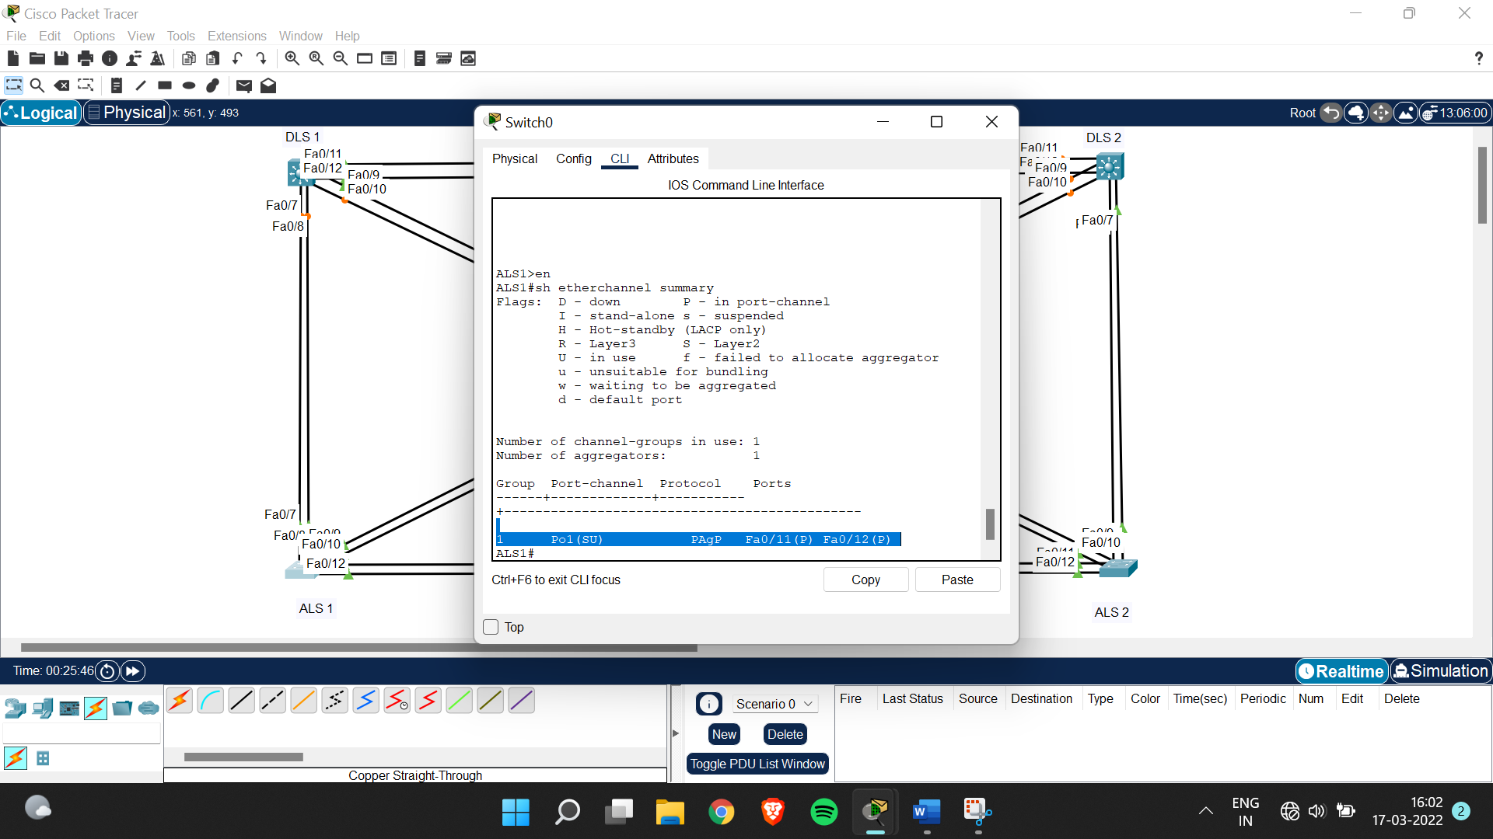

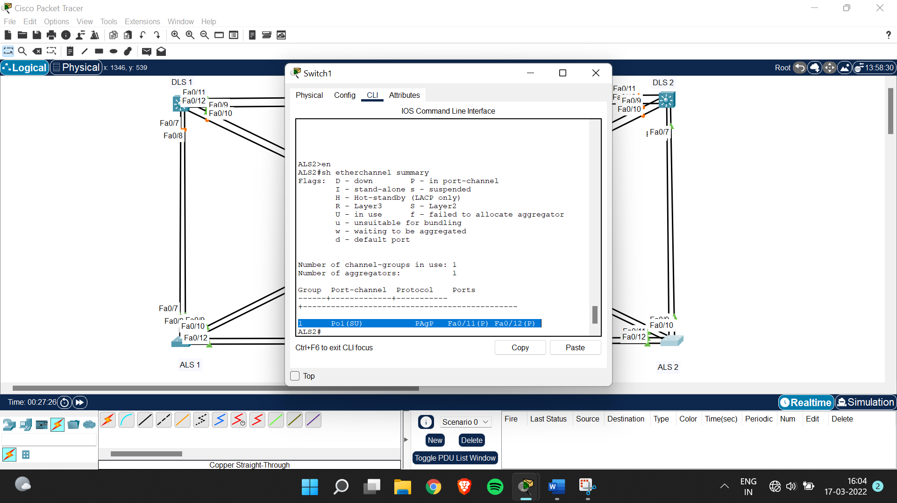

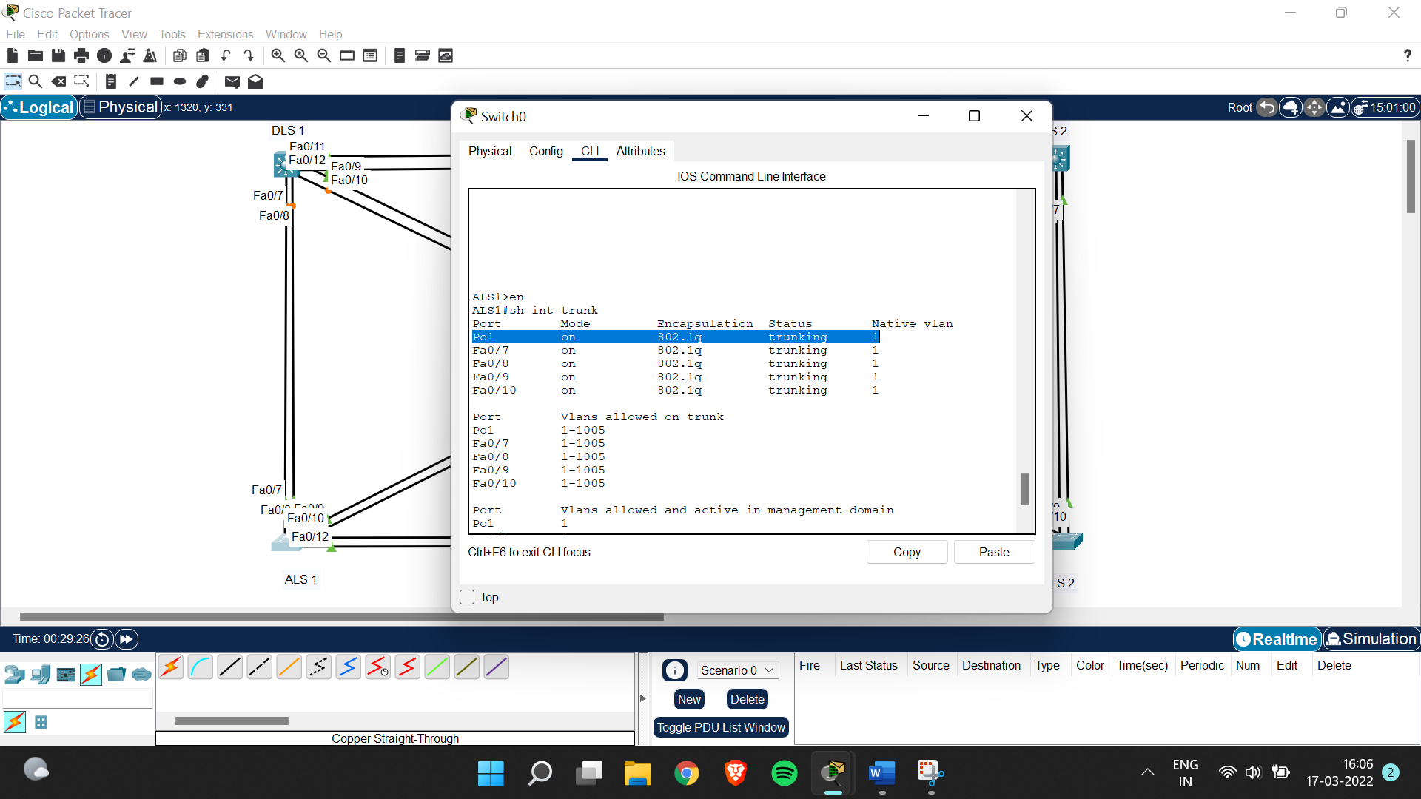

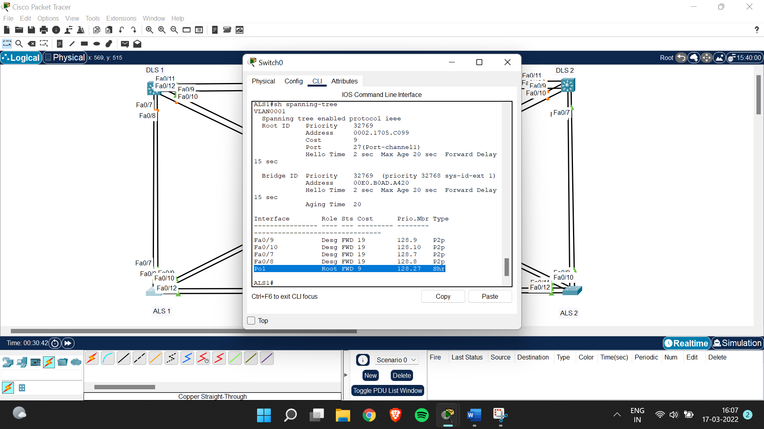

Step 3:

ALS1#conf t

Enter configuration commands, one per line. End with CNTL/Z.

ALS1(config)#int range fa0/7-8

ALS1(config-if-range)#channel-group 2 mode active

ALS1(config-if-range)#

Creating a port-channel interface Port-channel 2

%LINEPROTO-5-UPDOWN: Line protocol on Interface FastEthernet0/7, changed state to down

%LINEPROTO-5-UPDOWN: Line protocol on Interface FastEthernet0/7, changed state to up

%LINEPROTO-5-UPDOWN: Line protocol on Interface FastEthernet0/8, changed state to down

%LINEPROTO-5-UPDOWN: Line protocol on Interface FastEthernet0/8, changed state to up

ALS1(config-if-range)#exit

ALS1(config)#int port-channel 2

ALS1(config-if)#switchport mode trunk

Xxxxxxxxxxxxxxxxxxxxxxxxxxxxxxxxxxxxxxxxxxxxx

DLS1>en

DLS1#conf t

Enter configuration commands, one per line. End with CNTL/Z.

DLS1(config)#int range fa0/7-8

DLS1(config-if-range)#channel-group 2 mode active

DLS1(config-if-range)#

Creating a port-channel interface Port-channel 2

%LINEPROTO-5-UPDOWN: Line protocol on Interface FastEthernet0/7, changed state to down

%LINEPROTO-5-UPDOWN: Line protocol on Interface FastEthernet0/7, changed state to up

%LINEPROTO-5-UPDOWN: Line protocol on Interface FastEthernet0/8, changed state to down

%LINEPROTO-5-UPDOWN: Line protocol on Interface FastEthernet0/8, changed state to up

%LINK-5-CHANGED: Interface Port-channel2, changed state to up

%LINEPROTO-5-UPDOWN: Line protocol on Interface Port-channel2, changed state to up

exit

DLS1(config)#int port-channel 2

DLS1(config-if)#switchport mode trunk

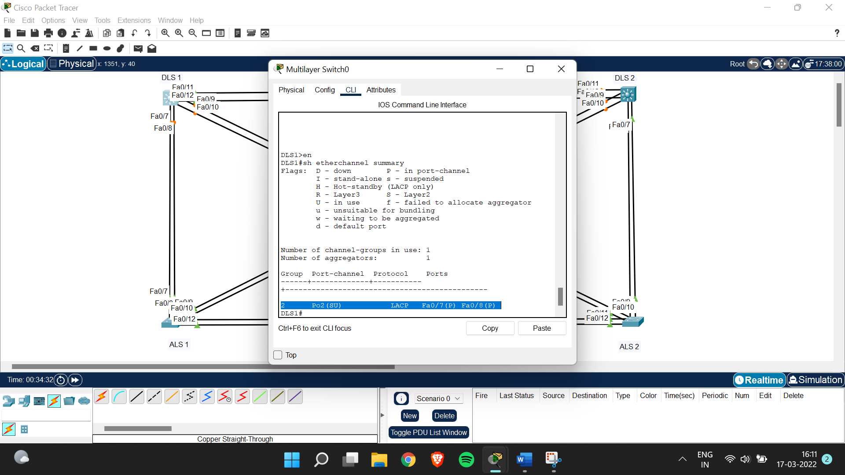

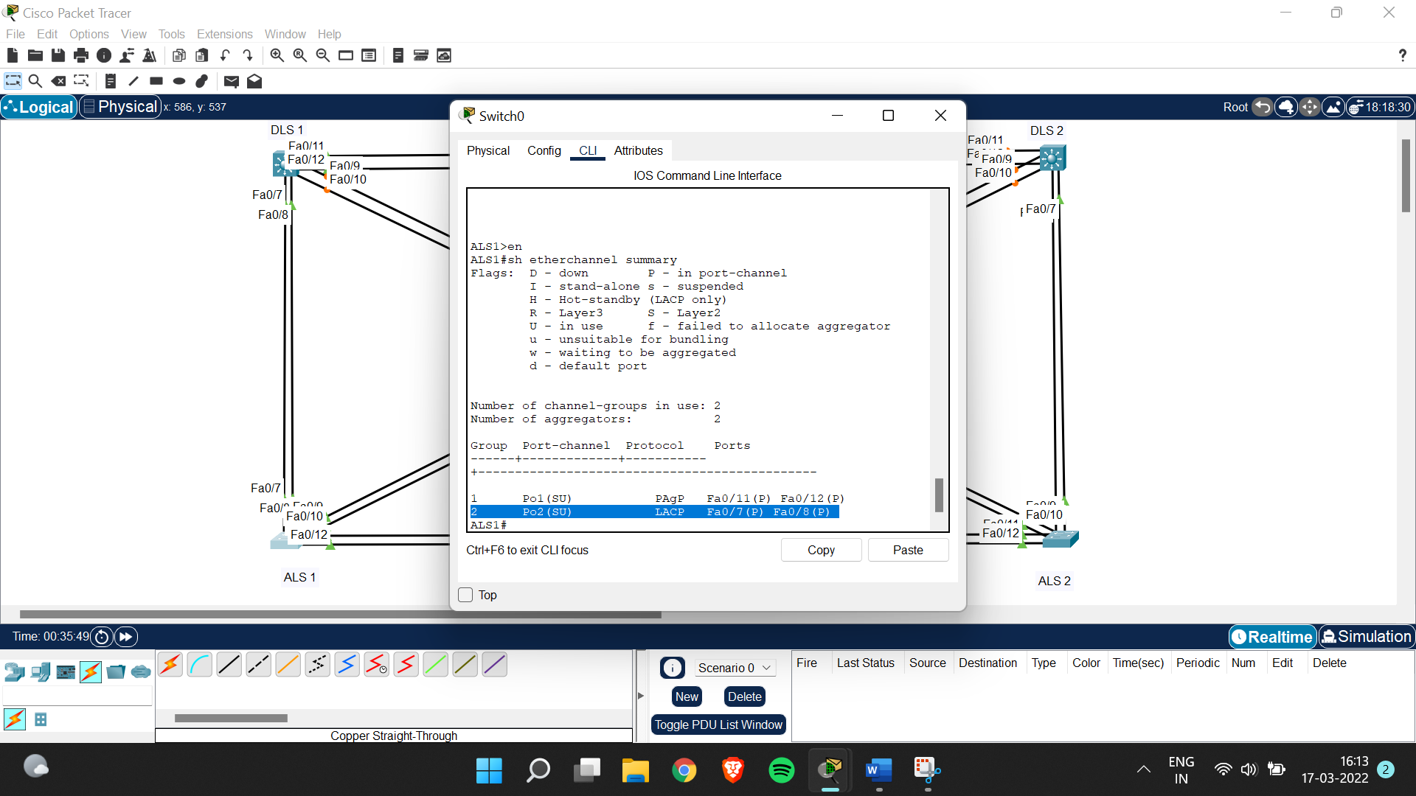

Step 4:

DLS1>en

DLS1#conf t

Enter configuration commands, one per line. End with CNTL/Z.

DLS1(config)#int range fa0/11-12

DLS1(config-if-range)#no switchport

DLS1(config-if-range)#channel-group 3 mode desirable

DLS1(config-if-range)#int port-channel 3

DLS1(config-if)#no switchport

DLS1(config-if)#ip address 10.0.0.1 255.255.255.0

Xxxxxxxxxxxxxxxxxxxxxxxxxxxxxxxxxxxxxxxxxxxxxxxxxxxxxxxx

DLS2>en

DLS2#conf t

Enter configuration commands, one per line. End with CNTL/Z.

DLS2(config)#int range fa0/11-12

DLS2(config-if-range)#no switchport

DLS2(config-if-range)#channel-group 3 mode desirable

DLS2(config-if-range)#int port-channel 3

DLS2(config-if)#no switchport

DLS2(config-if)#ip address 10.0.0.2 255.255.255.0

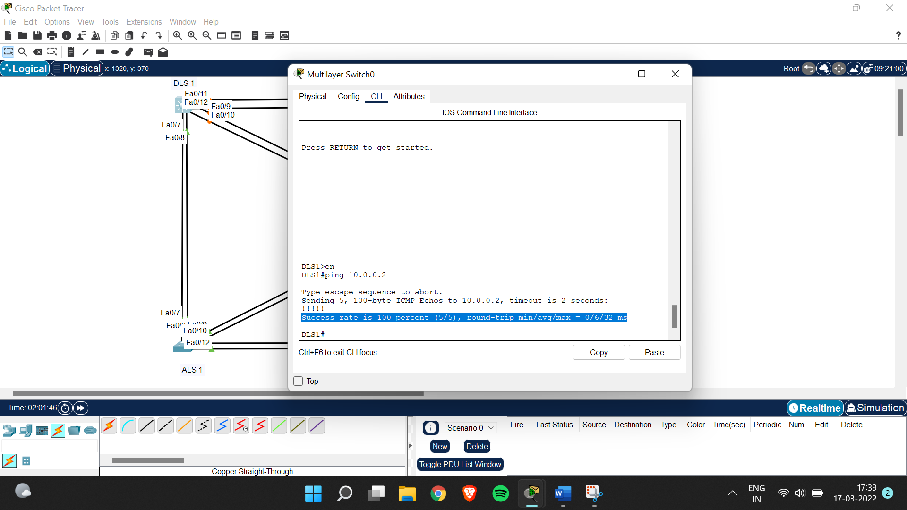

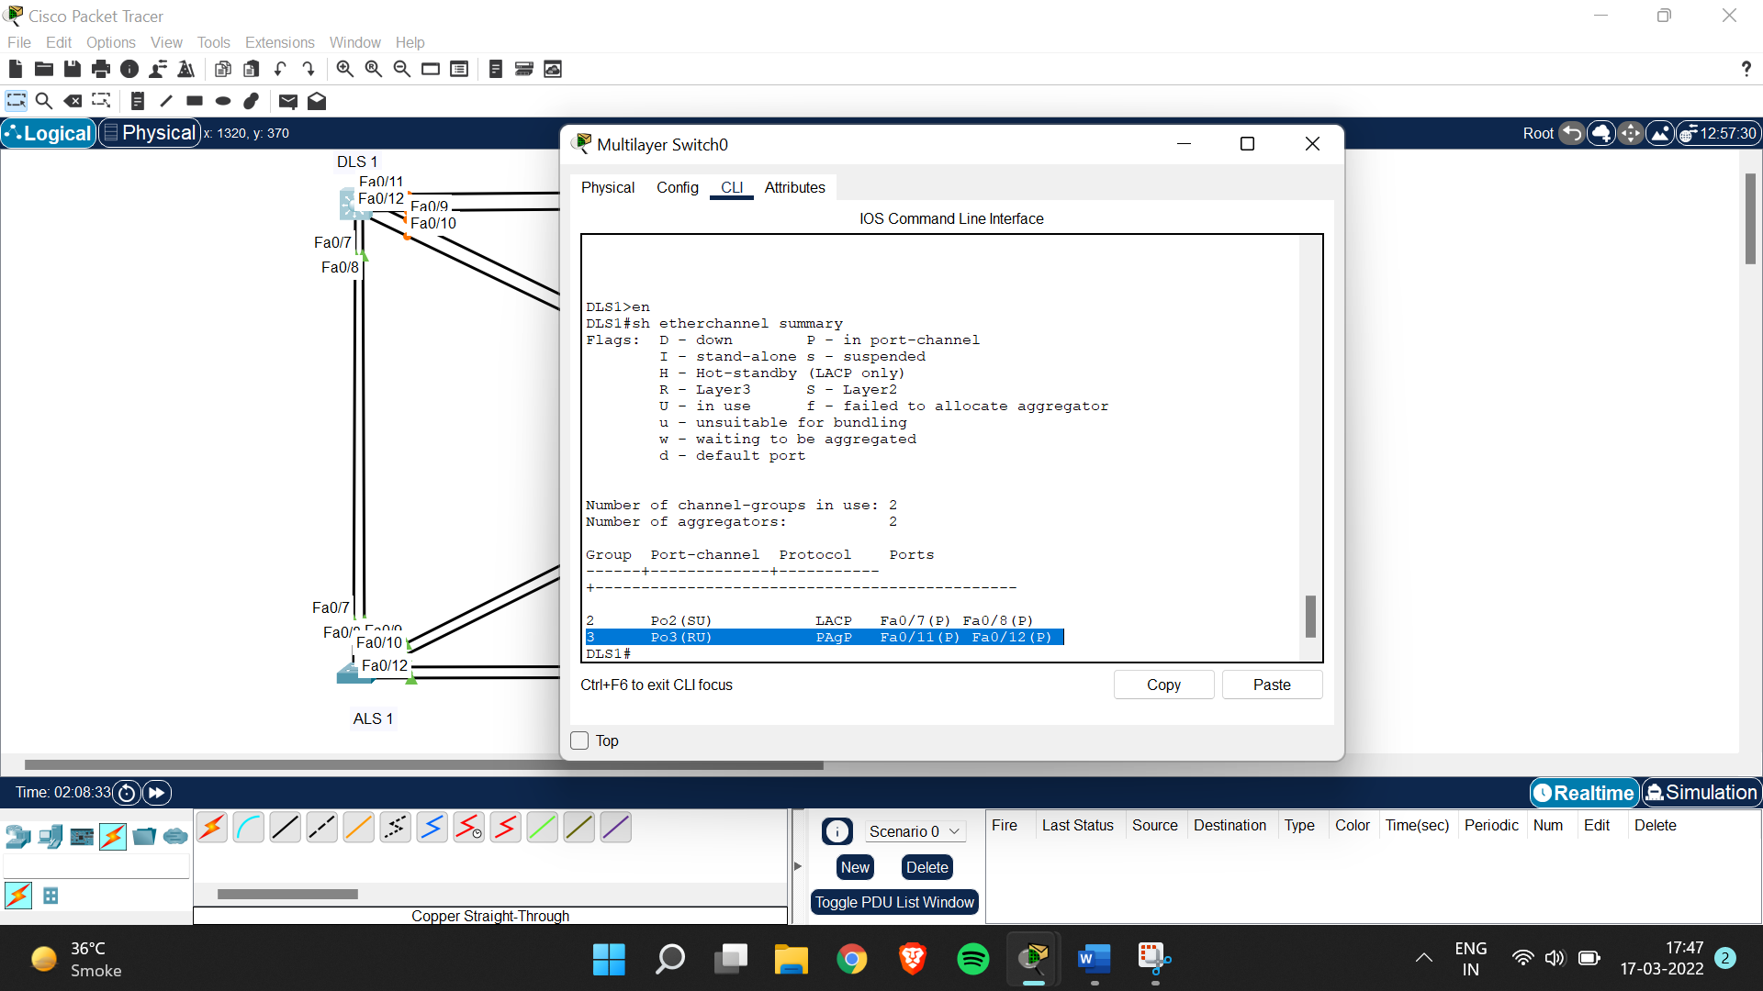

Step 5:

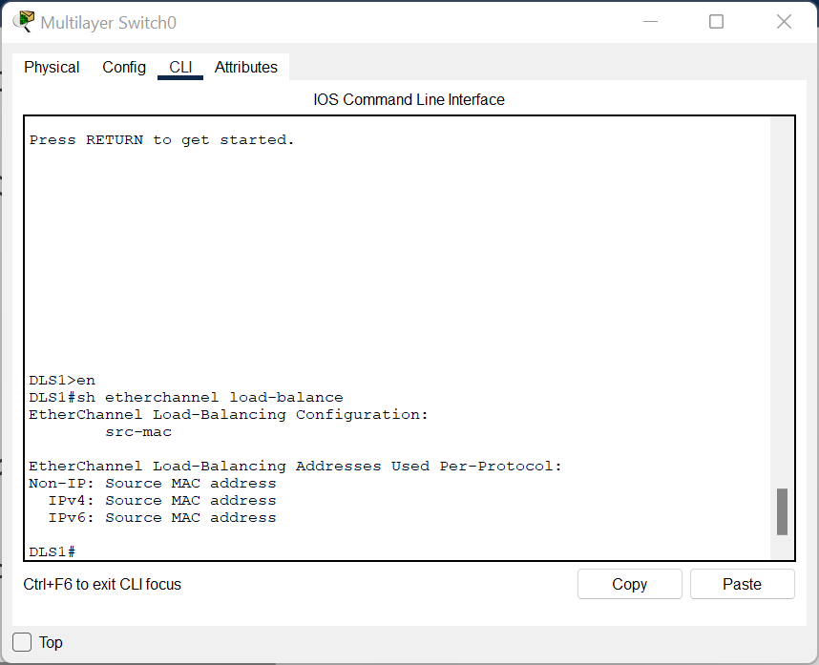

ALS1(config)#port-channel load-balance src-dst-mac

