Prac 7a

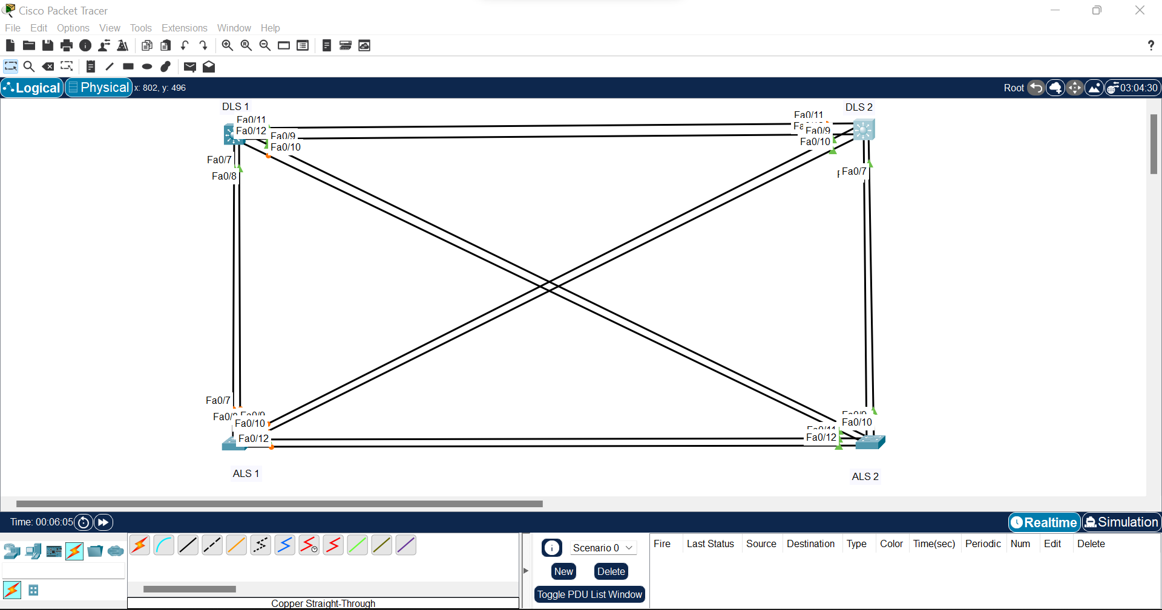

Step 1:  
Switch>en

Switch#conf t

Enter configuration commands, one per line. End with CNTL/Z.

Switch(config)#hostname ALS 1

^

% Invalid input detected at '^' marker.

Switch(config)#hostname ALS1

Xxxxxxxxxxxxxxxxxxxxxxxxxxxxxxxxxxxxxxxxxx

Switch>en

Switch#conf t

Enter configuration commands, one per line. End with CNTL/Z.

Switch(config)#hostname ALS2

Xxxxxxxxxxxxxxxxxxxxxxxxxxxxxxxxxxxxxxxxxxxxxx

Switch>en

Switch#conf t

Enter configuration commands, one per line. End with CNTL/Z.

Switch(config)#hostname DLS1

Xxxxxxxxxxxxxxxxxxxxxxxxxxxxxxxxxxxxxxxxxxxxxxxxxx

Switch>en

Switch#conf t

Enter configuration commands, one per line. End with CNTL/Z.

Switch(config)#hostname DLS2

Step 2:  
