Prac 7B:

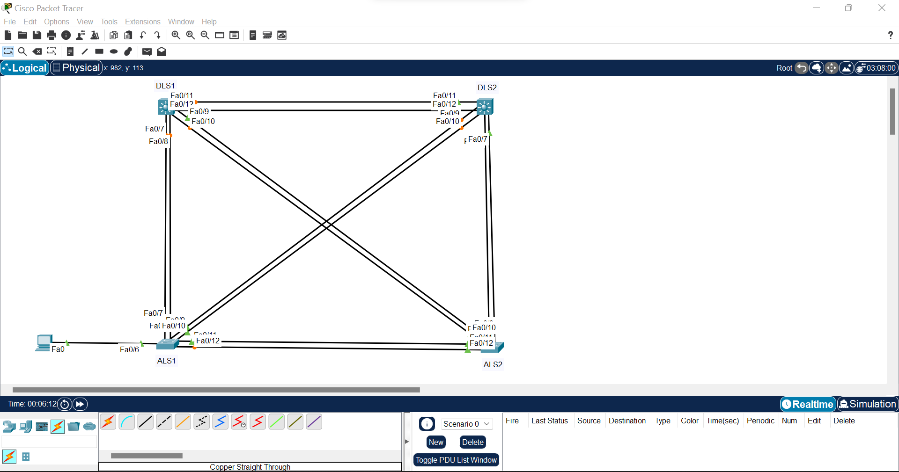

Step 1:  
Switch>en

Switch#conf t

Enter configuration commands, one per line. End with CNTL/Z.

Switch(config)#hostname ALS1

ALS1(config)#int range fa0/7-12

ALS1(config-if-range)#switchport mode trunk

Xxxxxxxxxxxxxxxxxxxxxxxxxxxxxxxxxxxxxxxxxxxxxxx

Switch>en

Switch#conf t

Enter configuration commands, one per line. End with CNTL/Z.

Switch(config)#hostname ALS2

ALS2(config)#int range fa0/7-12

ALS2(config-if-range)#switchport mode trunk

Xxxxxxxxxxxxxxxxxxxxxxxxxxxxxxxxxxxxxxxxxxxxxxxxxxx

Switch(config)#hostname DLS1

DLS1(config)#int range fa0/7-12

DLS1(config-if-range)#switchport trunk encapsulation dot1q

DLS1(config-if-range)#switchport mode trunk

Xxxxxxxxxxxxxxxxxxxxxxxxxxxxxxxxxxxxxxxxxxxxxxxxxxxxxxx

Switch(config)#hostname DLS2

DLS2(config)#int range fa0/7-12

DLS2(config-if-range)#switchport trunk encapsulation dot1q

DLS2(config-if-range)#switchport mode trunk

Step 2:

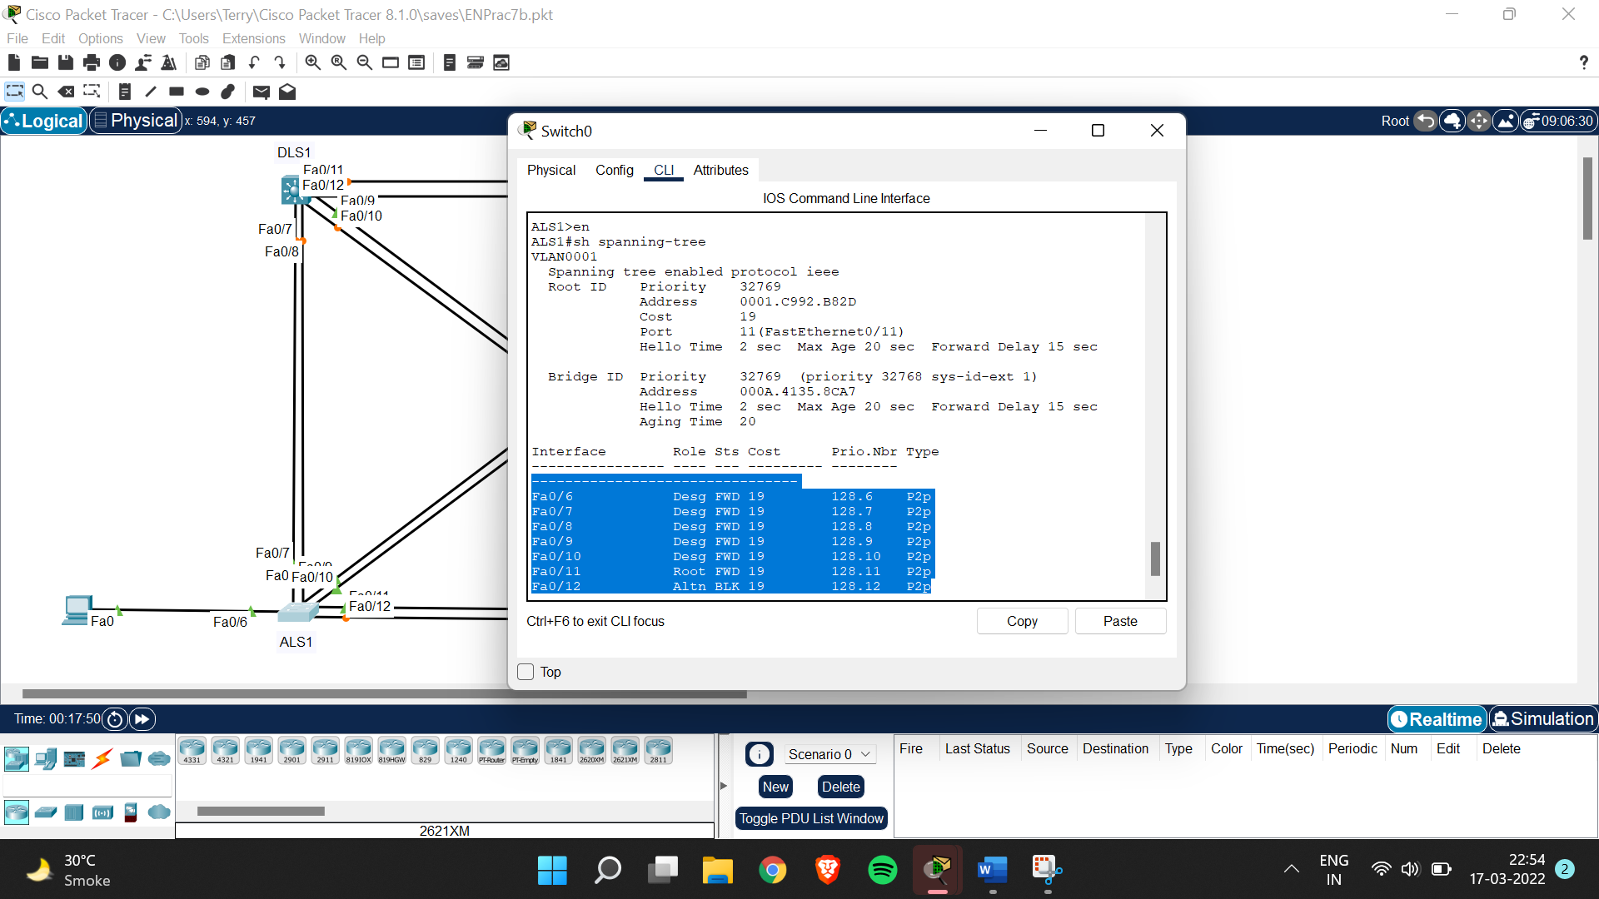

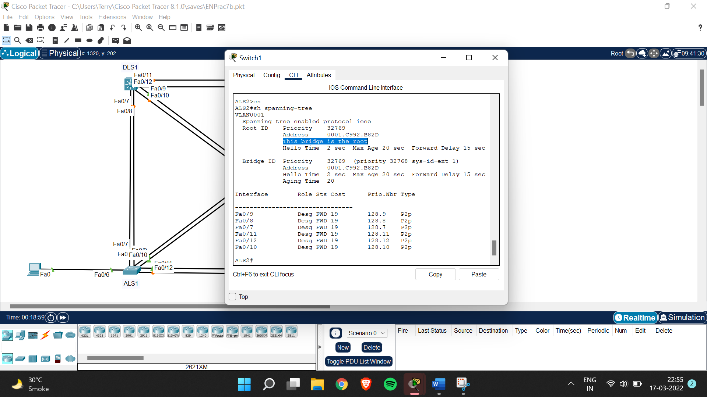

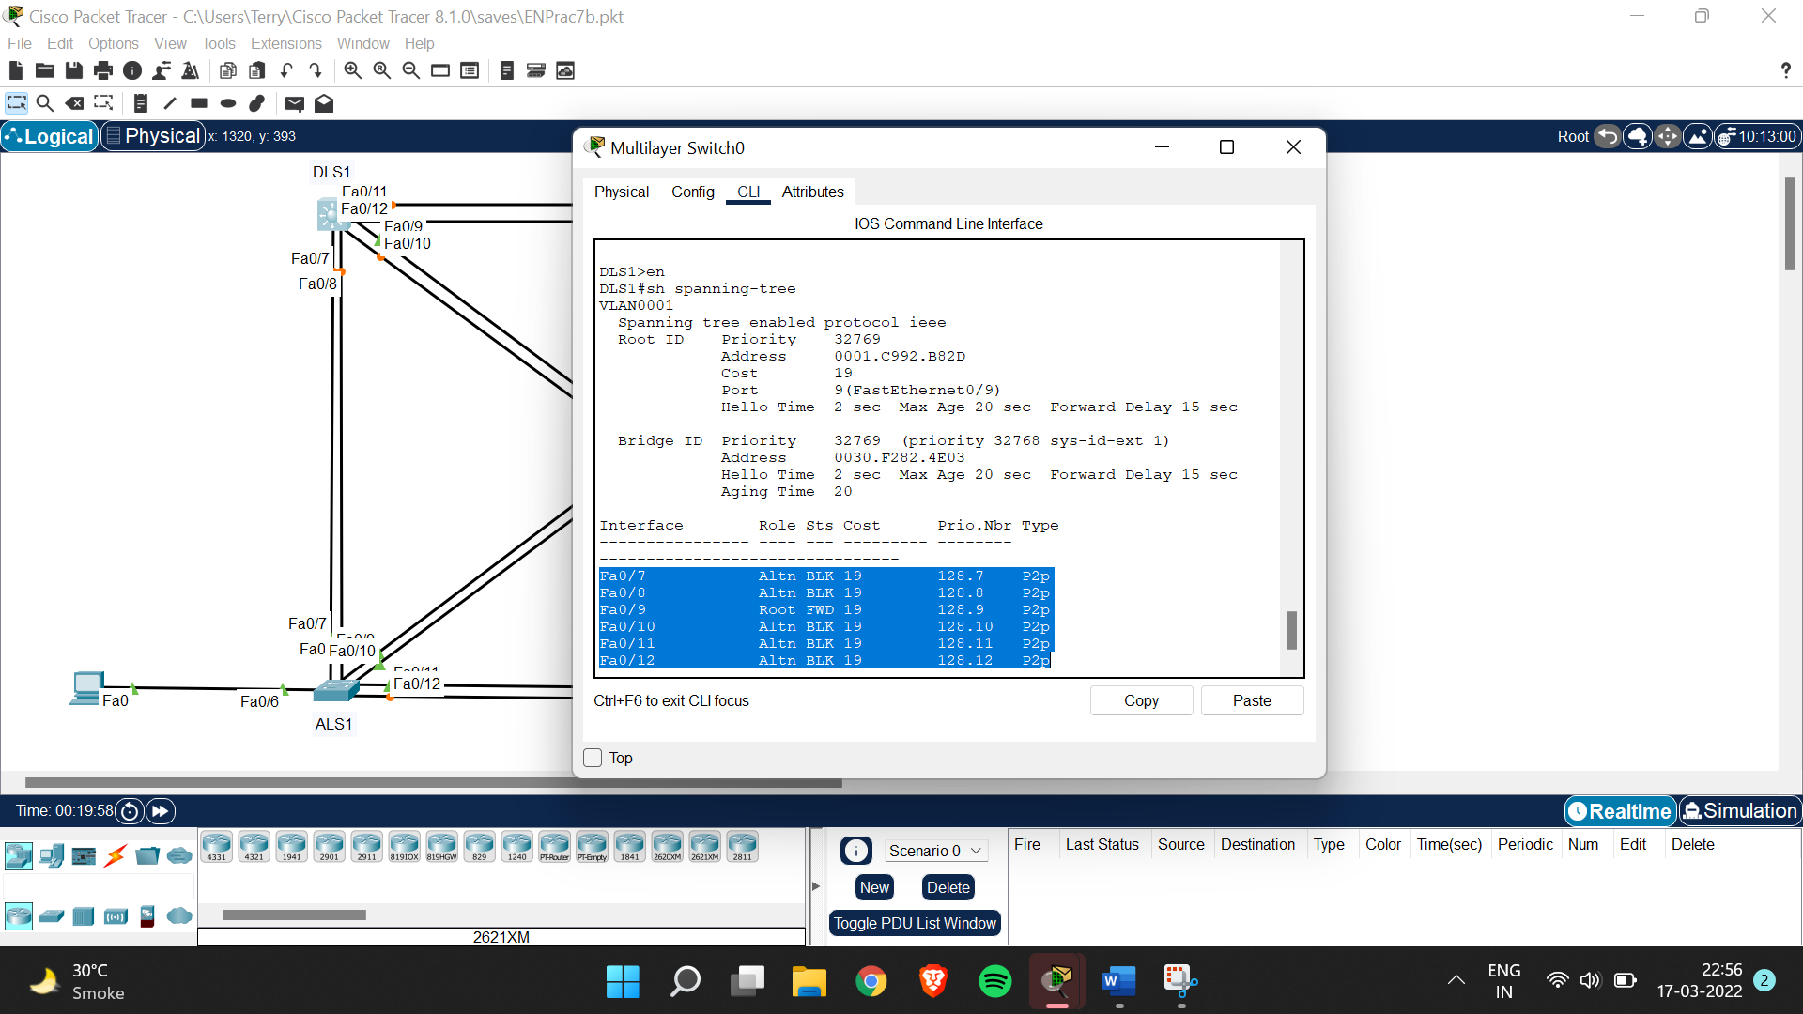

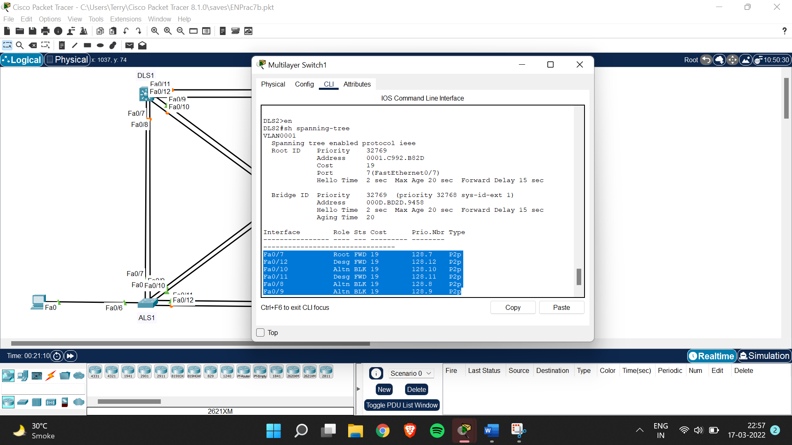

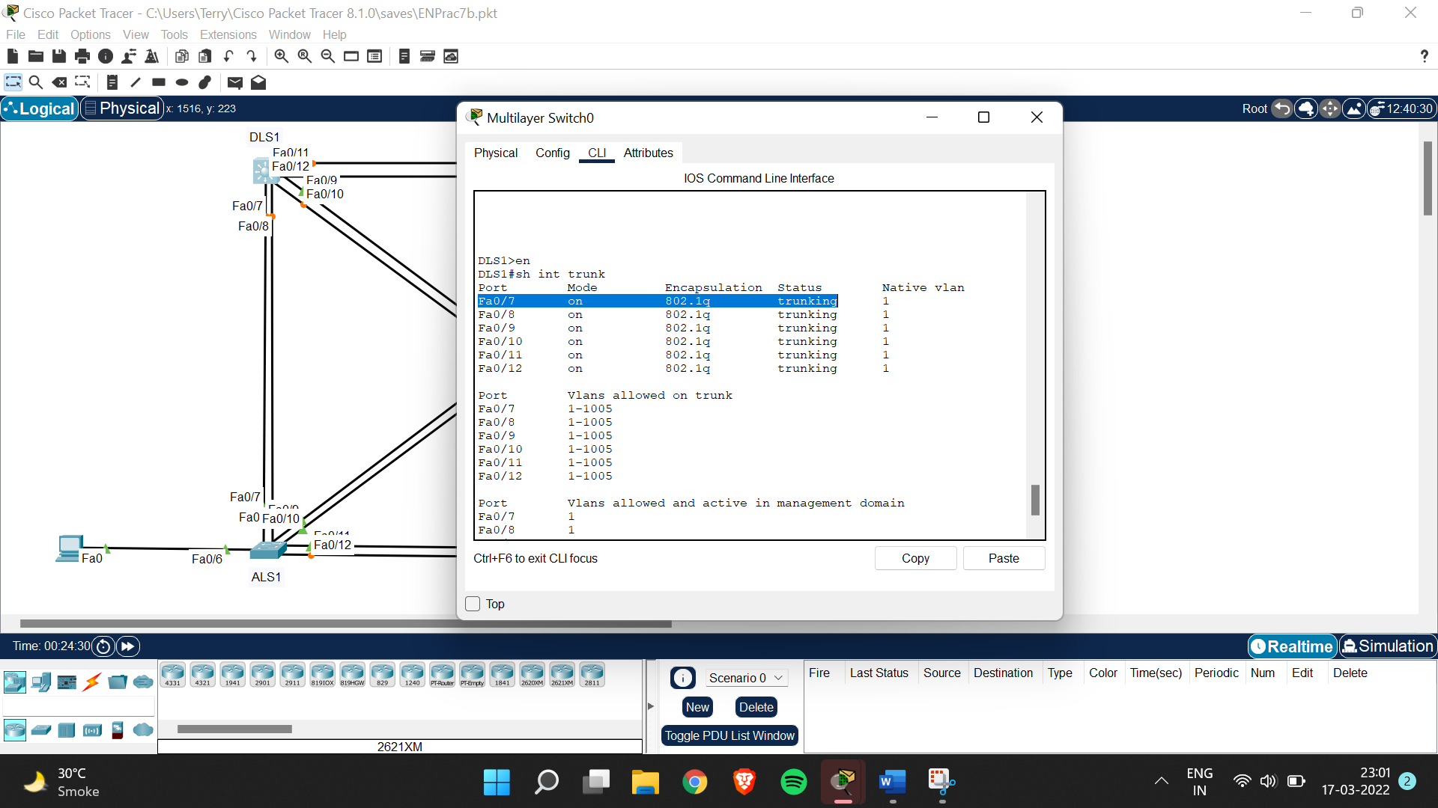

Step 3:

DLS1(config)#spanning-tree vlan 1 root primary

ALS1(config)#spanning-tree vlan 1 root secondary

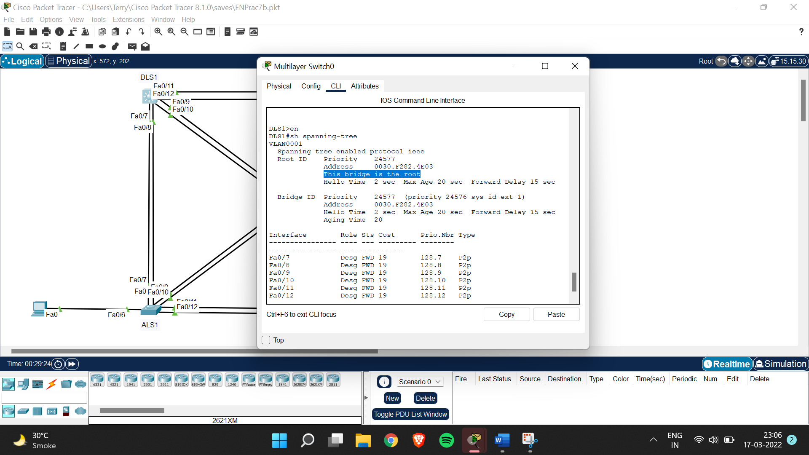

Step 4:

DLS1>en

DLS1#conf t

Enter configuration commands, one per line. End with CNTL/Z.

DLS1(config)#int fa0/12

DLS1(config-if)#spanning-tree port-priority 112

Step 5:

ALS1>en

ALS1#int fa0/6

^

% Invalid input detected at '^' marker.

ALS1#conf t

Enter configuration commands, one per line. End with CNTL/Z.

ALS1(config)#int fa0/6

ALS1(config-if)#shutdown

ALS1(config-if)#

%LINK-5-CHANGED: Interface FastEthernet0/6, changed state to administratively down

%LINEPROTO-5-UPDOWN: Line protocol on Interface FastEthernet0/6, changed state to down

ALS1(config-if)#conf t

^

% Invalid input detected at '^' marker.

ALS1(config-if)#exit

ALS1(config)#int fa0/6

ALS1(config-if)#switchport mode access

ALS1(config-if)#no shut

ALS1(config-if)#

%LINK-5-CHANGED: Interface FastEthernet0/6, changed state to up

%LINEPROTO-5-UPDOWN: Line protocol on Interface FastEthernet0/6, changed state to up

ALS1(config-if)#end

ALS1#

%SYS-5-CONFIG_I: Configured from console by console

ALS1#conf t

Enter configuration commands, one per line. End with CNTL/Z.

ALS1(config)#int fa0/6

ALS1(config-if)#spanning-tree portfast

Step 6:

ALS2#conf t

Enter configuration commands, one per line. End with CNTL/Z.

ALS2(config)#int fa0/10

ALS2(config-if)#spanning-tree cost 10