Prac 9A

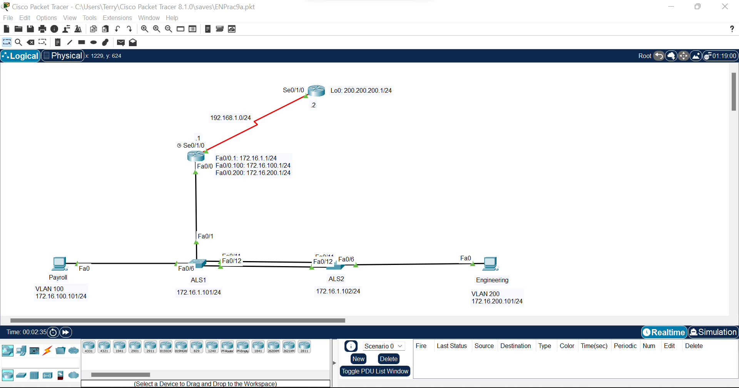

Step 1:

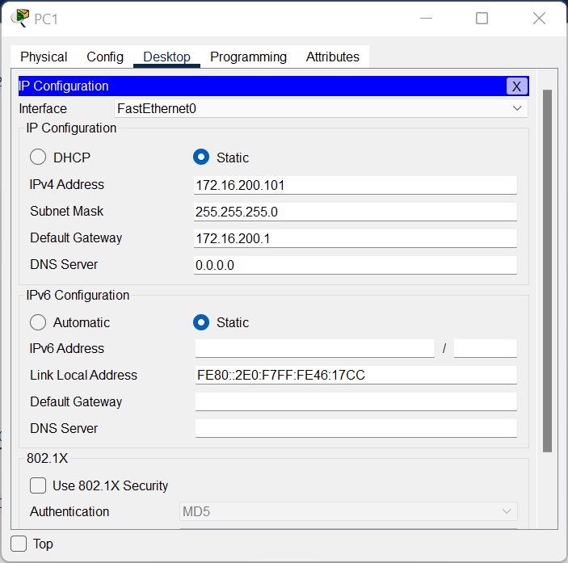

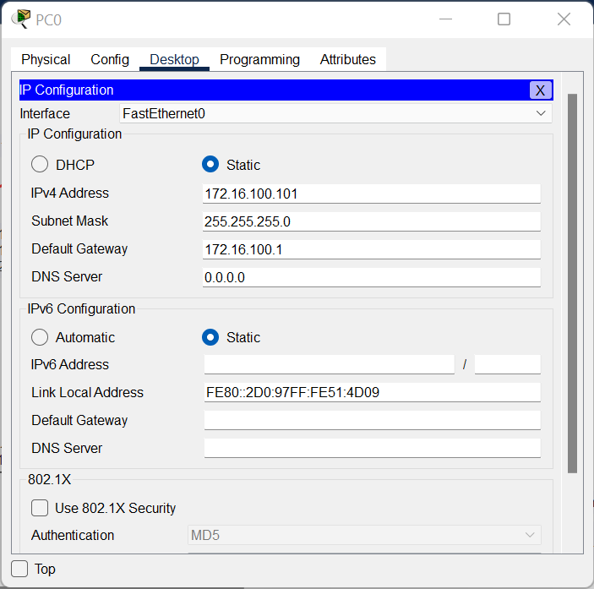

Step 2:

Router>en

Router#conf t

Enter configuration commands, one per line. End with CNTL/Z.

Router(config)#hostname ISP

ISP(config)#int lo0

ISP(config-if)#

%LINK-5-CHANGED: Interface Loopback0, changed state to up

%LINEPROTO-5-UPDOWN: Line protocol on Interface Loopback0, changed state to up

ISP(config-if)#ip add 200.200.200.1 255.255.255.0

ISP(config-if)#int se0/1/0

ISP(config-if)#ip add 192.168.1.2 255.255.255.0

ISP(config-if)#no shut

%LINK-5-CHANGED: Interface Serial0/1/0, changed state to down

ISP(config-if)#exit

ISP(config)#ip route 172.16.0.0 255.255.0.0 192.168.1.1

Xxxxxxxxxxxxxxxxxxxxxxxxxxxxxxxxxxxxxxxxxxxxxxxxxxxxxxxxxxxx

Router>en

Router#conf t

Enter configuration commands, one per line. End with CNTL/Z.

Router(config)#hostname Gateway

Gateway(config)#int se0/1/0

Gateway(config-if)#ip add 192.168.1.1 255.255.255.0

Gateway(config-if)#clock rate 64000

Gateway(config-if)#no shut

Gateway(config-if)#

%LINK-5-CHANGED: Interface Serial0/1/0, changed state to up

Gateway(config-if)#exit

Gateway(config)#ip route

%LINEPROTO-5-UPDOWN: Line protocol on Interface Serial0/1/0, changed state to up

% Incomplete command.

Gateway(config)#ip route 0.0.0.0 0.0.0.0 192.168.1.2

Step 3:  
Switch>en

Switch#conf t

Enter configuration commands, one per line. End with CNTL/Z.

Switch(config)#hostname ALS1

ALS1(config)#int vlan 1

ALS1(config-if)#ip add 172.16.1.101 255.255.255.0

ALS1(config-if)#no shut

ALS1(config-if)#

%LINK-5-CHANGED: Interface Vlan1, changed state to up

%LINEPROTO-5-UPDOWN: Line protocol on Interface Vlan1, changed state to up

ALS1(config-if)#exit

ALS1(config)#default-gateway 172.16.1.1

^

% Invalid input detected at '^' marker.

ALS1(config)#ip default-gateway 172.16.1.1

Xxxxxxxxxxxxxxxxxxxxxxxxxxxxxxxxxxxxxxxxxxxxxxxxxxxxxxxx

Switch>en

Switch#conf t

Enter configuration commands, one per line. End with CNTL/Z.

Switch(config)#hostname ALS2

ALS2(config)#int vlan 1

ALS2(config-if)#ip add 182.16.1.102 255.255.255.0

ALS2(config-if)#no shut

ALS2(config-if)#

%LINK-5-CHANGED: Interface Vlan1, changed state to up

%LINEPROTO-5-UPDOWN: Line protocol on Interface Vlan1, changed state to up

ALS2(config-if)#exit

ALS2(config)#ip default-gateway 172.16.1.1

Step 4:

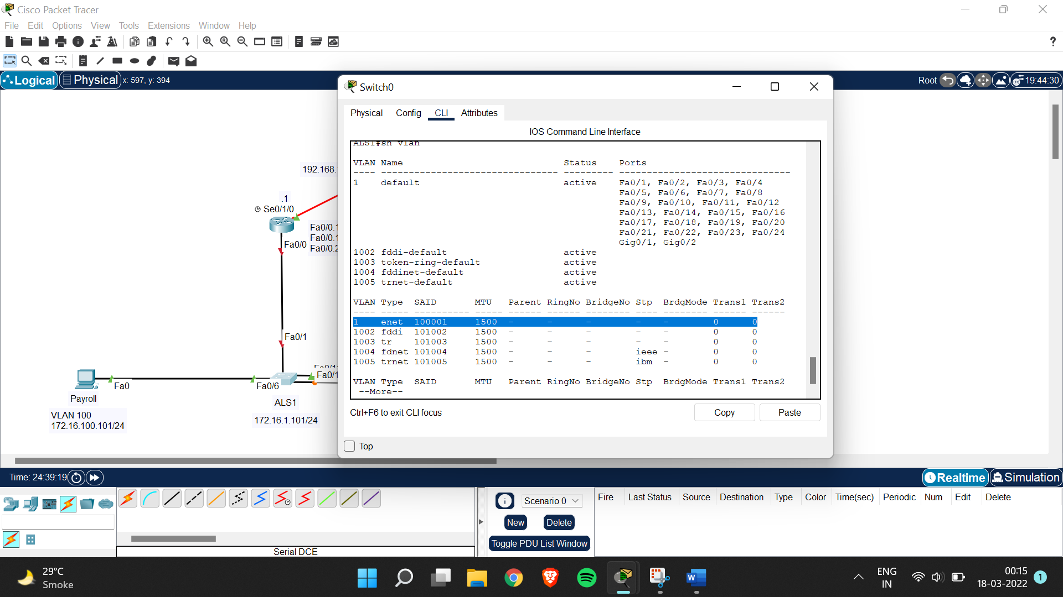

Step 5:  
ALS1>en

ALS1#conf t

Enter configuration commands, one per line. End with CNTL/Z.

ALS1(config)#int range fa0/11-12

ALS1(config-if-range)#swtichport mode trunk

^

% Invalid input detected at '^' marker.

ALS1(config-if-range)#switchport mode trunk

ALS1(config-if-range)#channel-group 1 mode desirable

Xxxxxxxxxxxxxxxxxxxxxxxxxxxxxxxxxxxxxxxxxxxxxxxxxxxxxxxxxxxxxxxxxxxxxxx

ALS2>en

ALS2#conf t

Enter configuration commands, one per line. End with CNTL/Z.

ALS2(config)#int range fa0/11-12

ALS2(config-if-range)#switchport mode trunk

ALS2(config-if-range)#channel-group 1 mode desirable

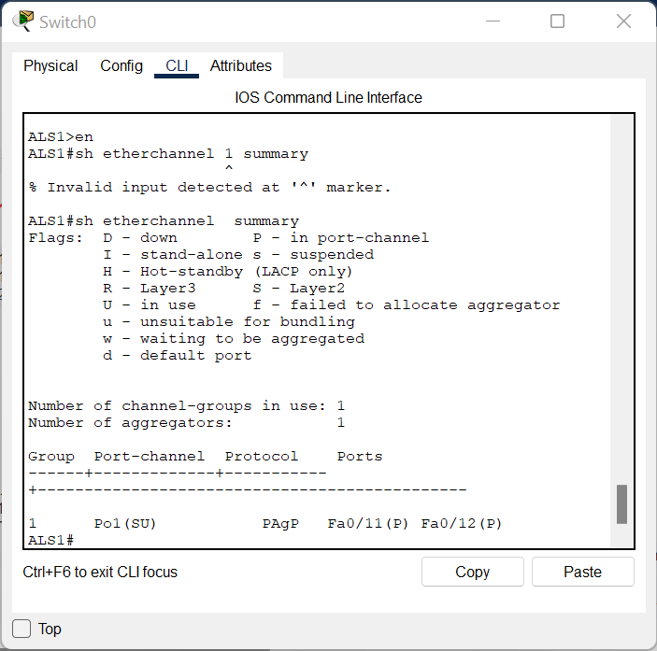

Step 6:  
ALS2#conf t

Enter configuration commands, one per line. End with CNTL/Z.

ALS2(config)#vtp mode client

Xxxxxxxxxxxxxxxxxxxxxxxxxxxxxxxxxxxxxxxxxxxxxxxxxxxxxxx

ALS1#conf t

Enter configuration commands, one per line. End with CNTL/Z.

ALS1(config)#vtp domain SWLAB

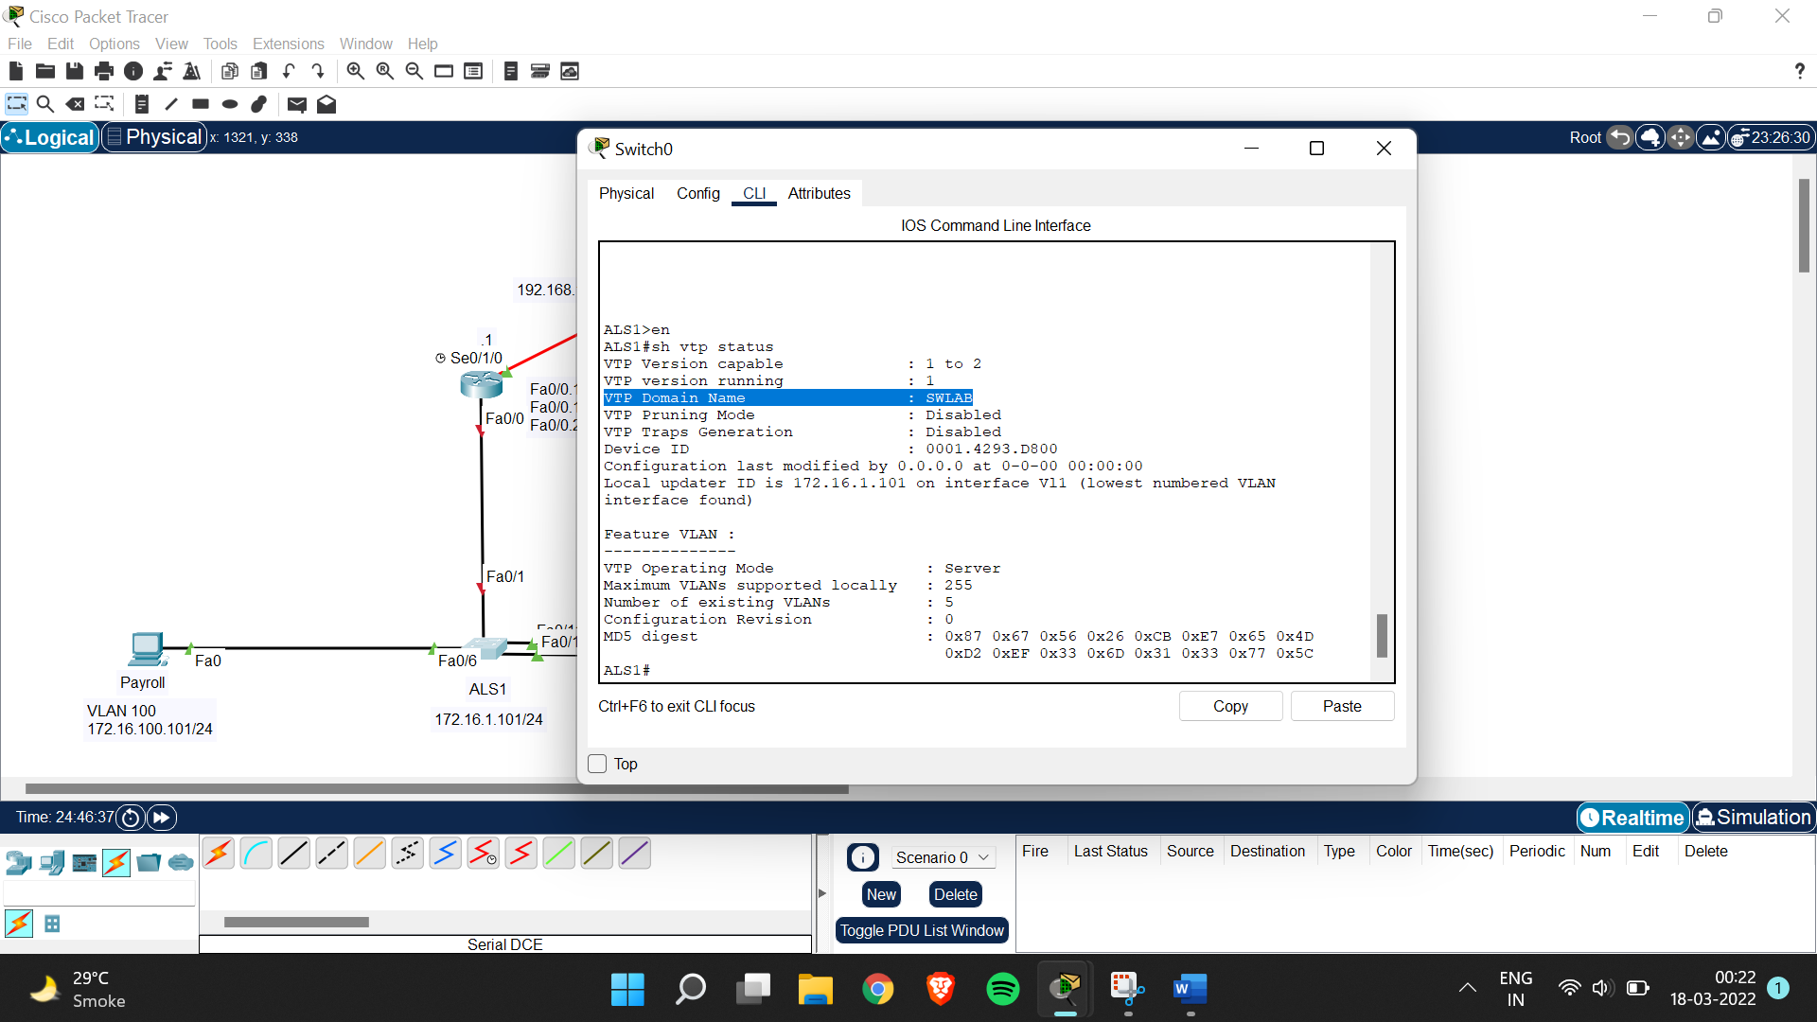

Step 7:

ALS1#conf t

Enter configuration commands, one per line. End with CNTL/Z.

ALS1(config)#vlan 100

ALS1(config-vlan)#name Payroll

ALS1(config-vlan)#vlan 200

ALS1(config-vlan)#name Engineering

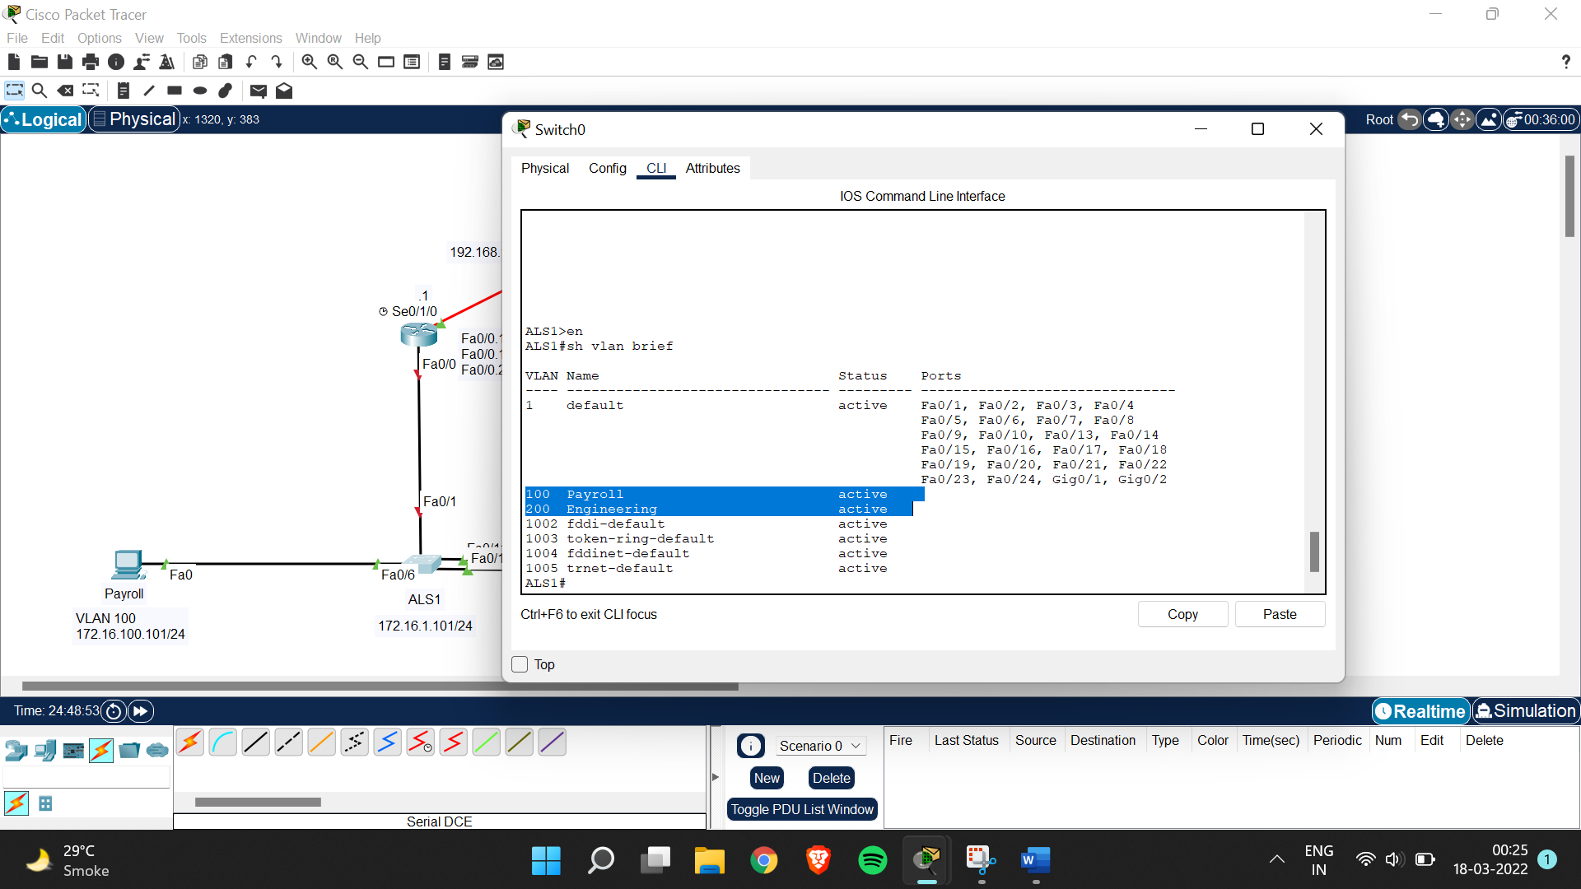

ALS1#conf t

Enter configuration commands, one per line. End with CNTL/Z.

ALS1(config)#int fa0/6

ALS1(config-if)#switchport mode access

ALS1(config-if)#switchport access vlan 100

ALS1(config-if)#spanning-tree portfast

Xxxxxxxxxxxxxxxxxxxxxxxxxxxxxxxxxxxxxxxxxxxxxxxxxxxxxxxxxx

ALS2>en

ALS2#conf t

Enter configuration commands, one per line. End with CNTL/Z.

ALS2(config)#int fa0/6

ALS2(config-if)#switchport mode access

ALS2(config-if)#switchport access vlan 200

ALS2(config-if)#spanning-tree portfast

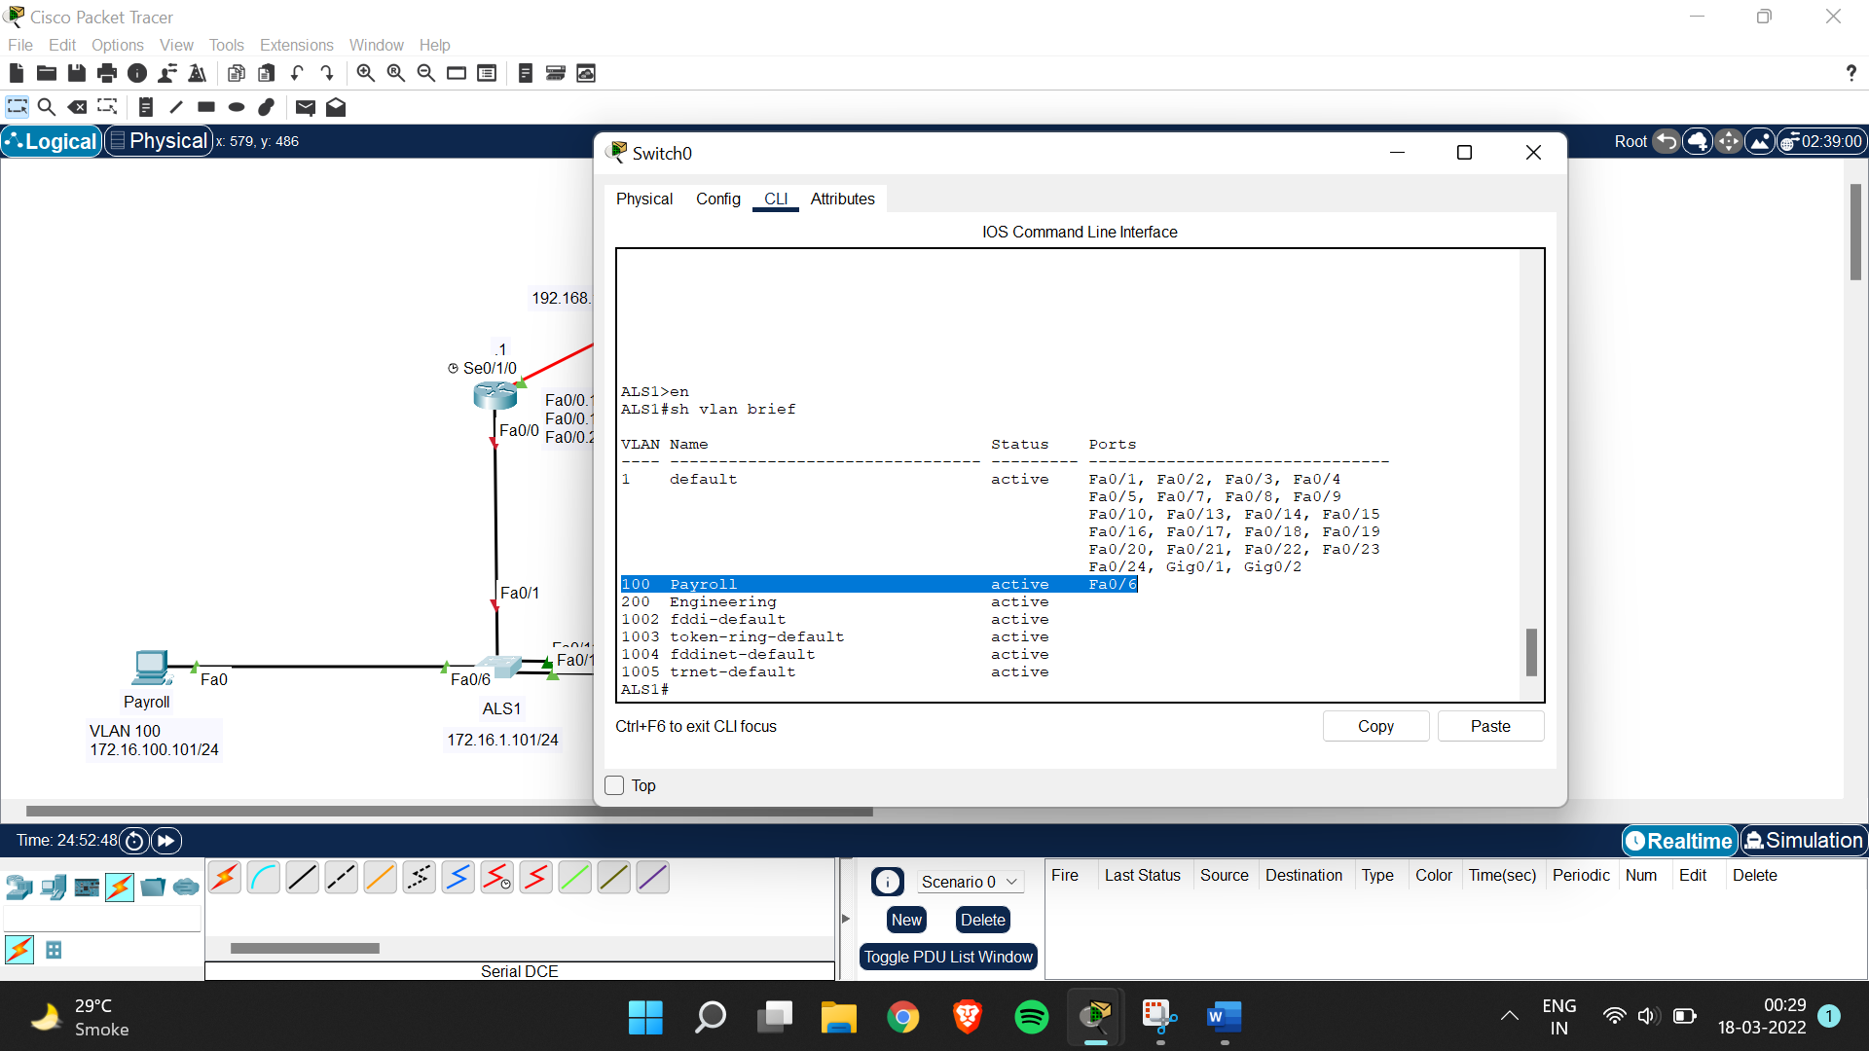

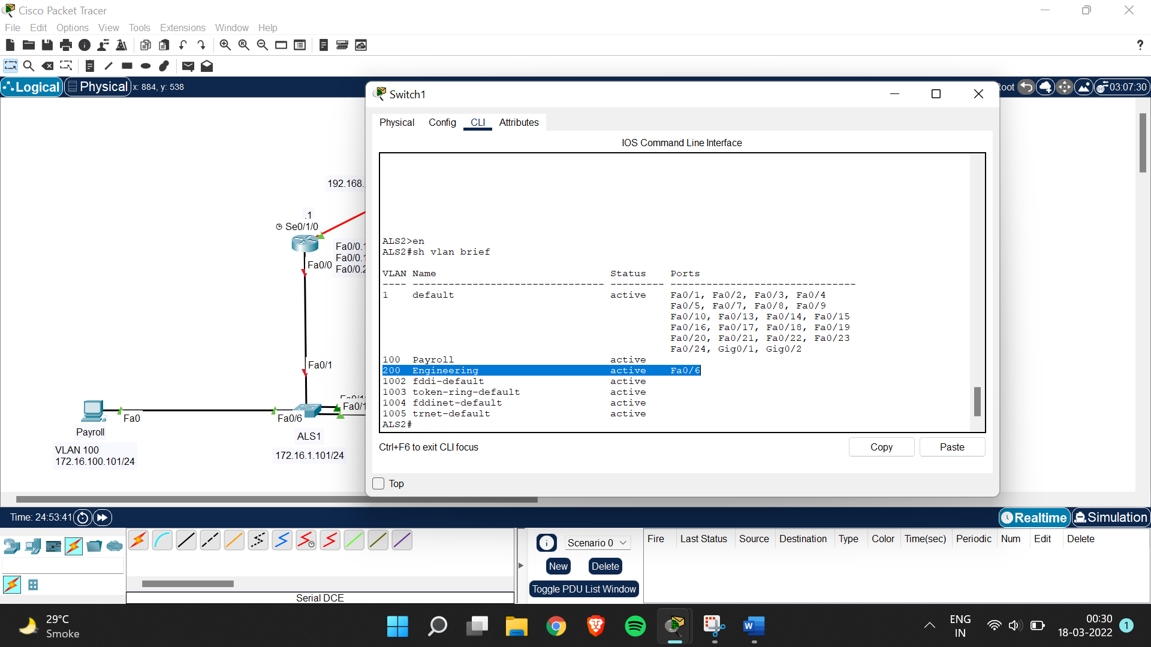

Step 8:

ALS1#conf t

Enter configuration commands, one per line. End with CNTL/Z.

ALS1(config)#int fa0/1

ALS1(config-if)#switchport mode trunk

Step 9:

Gateway>en

Gateway#conf t

Enter configuration commands, one per line. End with CNTL/Z.

Gateway(config)#int fa0/0.1

Gateway(config-subif)#encapsulation dot1q 1 native

Gateway(config-subif)#ip add 172.16.1.1 255.255.255.0

Gateway(config-subif)#int fa0/0.100

Gateway(config-subif)#encapsulation dot1q 100

Gateway(config-subif)#ip add 172.16.100.1 255.255.255.0

Gateway(config-subif)#int fa0/0.200

Gateway(config-subif)#encapsulation dot1q 200

Gateway(config-subif)#ip add 172.16.200.1 255.255.255.0

