Prac 9B

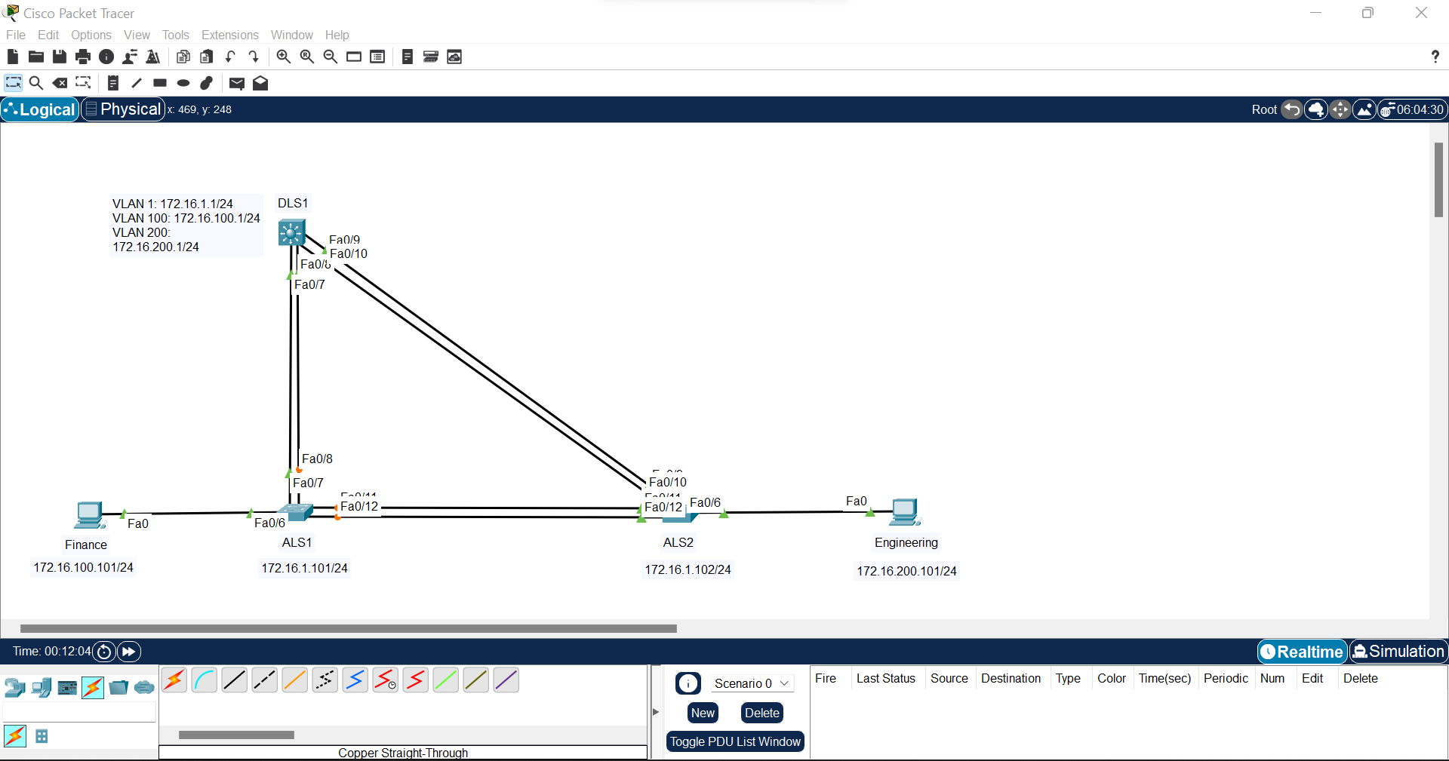

Step 1:  
Switch>en

Switch#conf t

Enter configuration commands, one per line. End with CNTL/Z.

Switch(config)#hostname ALS1

ALS1(config)#int vlan 1

ALS1(config-if)#ip add 172.16.1.101 255.255.255.0

ALS1(config-if)#no shut

ALS1(config-if)#

%LINK-5-CHANGED: Interface Vlan1, changed state to up

%LINEPROTO-5-UPDOWN: Line protocol on Interface Vlan1, changed state to up

ALS1(config-if)#exit

ALS1(config)#ip default-gateway 172.16.1.1

Xxxxxxxxxxxxxxxxxxxxxxxxxxxxxxxxxxxxxxxxxxxxxxxxxx

Switch>en

Switch#conf t

Enter configuration commands, one per line. End with CNTL/Z.

Switch(config)#hostname ALS2

ALS2(config)#int vlan 1

ALS2(config-if)#ip add 172.16.1.102 255.255.255.0

ALS2(config-if)#no shut

ALS2(config-if)#

%LINK-5-CHANGED: Interface Vlan1, changed state to up

%LINEPROTO-5-UPDOWN: Line protocol on Interface Vlan1, changed state to up

ALS2(config-if)#exit

ALS2(config)#ip default-gateway 172.16.1.1

Xxxxxxxxxxxxxxxxxxxxxxxxxxxxxxxxxxxxxxxxxxxxxxxxxxxxxx

Switch>en

Switch#conf t

Enter configuration commands, one per line. End with CNTL/Z.

Switch(config)#hostname DLS1

DLS1(config)#int vlan 1

DLS1(config-if)#ip add 172.16.1.1 255.255.255.0

DLS1(config-if)#no shut

Step 2:  
DLS1#conf t

Enter configuration commands, one per line. End with CNTL/Z.

DLS1(config)#int range fa0/7-8

DLS1(config-if-range)#switchport trunk encapsulation dot1q

DLS1(config-if-range)#switchport mode trunk

DLS1(config-if-range)#channel-group 1 mode desirable

Xxxxxxxxxxxxxxxxxxxxxxxxxxxxxxxxxxxxxxxxxxxxxxxxxxxxxxxxxxxxxxxxxxxxx

DLS1#conf t

Enter configuration commands, one per line. End with CNTL/Z.

DLS1(config)#int range fa0/9-10

DLS1(config-if-range)#switchport trunk encapsulation dot1q

DLS1(config-if-range)#switchport mode trunk

DLS1(config-if-range)#channel-group 2 mode desirable

Xxxxxxxxxxxxxxxxxxxxxxxxxxxxxxxxxxxxxxxxxxxxxxxxxxxxxxxxxxxxxxxxxx

ALS1>en

ALS1#conf t

Enter configuration commands, one per line. End with CNTL/Z.

ALS1(config)#int range fa0/11-12

ALS1(config-if-range)#switchport mode trunk

ALS1(config-if-range)#channel-group 1 mode desirable

Xxxxxxxxxxxxxxxxxxxxxxxxxxxxxxxxxxxxxxxxxxxxxxxxxxxxxxxxxxxxxxxxxxx

ALS1#conf t

Enter configuration commands, one per line. End with CNTL/Z.

ALS1(config)#int range fa0/7-8

ALS1(config-if-range)#switchport mode trunk

ALS1(config-if-range)#channel-group 2 mode desirable

Xxxxxxxxxxxxxxxxxxxxxxxxxxxxxxxxxxxxxxxxxxxxxxxxxxxxxxxxxx

ALS2>en

ALS2#conf t

Enter configuration commands, one per line. End with CNTL/Z.

ALS2(config)#int range fa0/9-10

ALS2(config-if-range)#switchport mode trunk

ALS2(config-if-range)#channel-group 2 mode desirable

Xxxxxxxxxxxxxxxxxxxxxxxxxxxxxxxxxxxxxxxxxxxxxxxxxxxxxxxxxxxxxxxx

ALS2#conf t

Enter configuration commands, one per line. End with CNTL/Z.

ALS2(config)#int range fa0/11-12

ALS2(config-if-range)#switchport mode trunk

ALS2(config-if-range)#channel-group 1 mode desirable

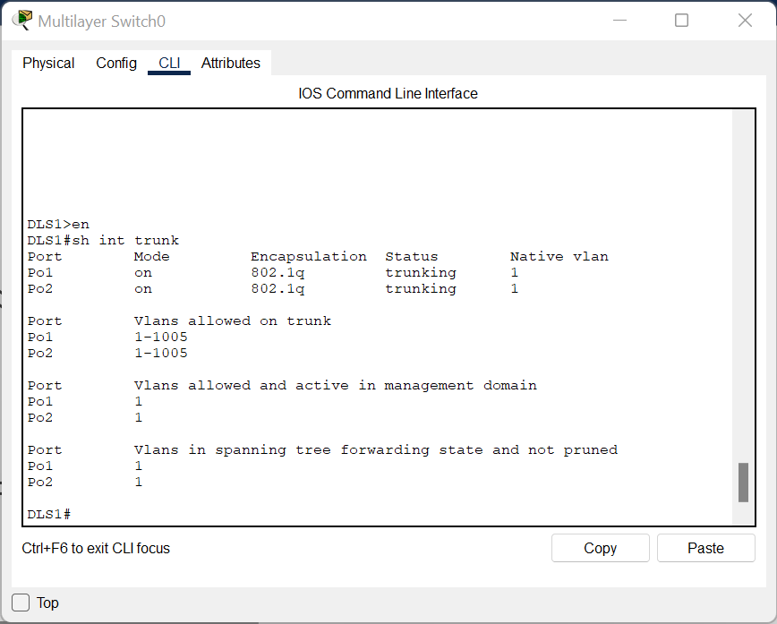

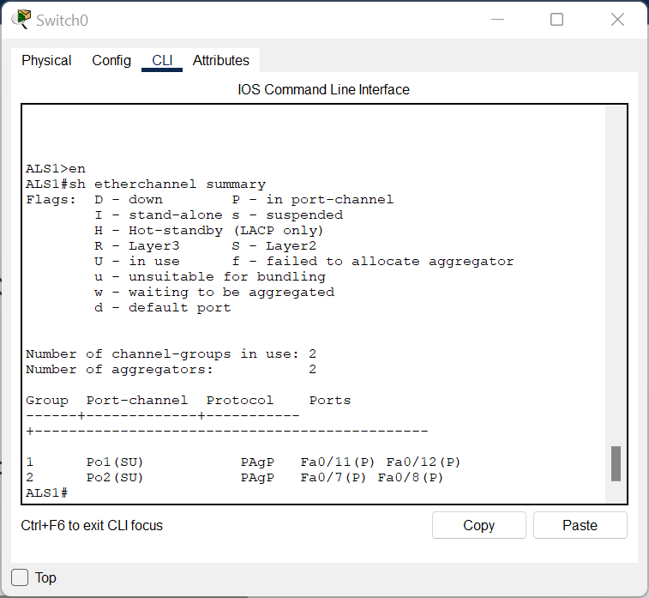

Step 3:

ALS1(config)#vtp mode client

Xxxxxxxxxxxxxxxxxxxxxxxxxxxxxx

ALS2(config)#vtp mode client

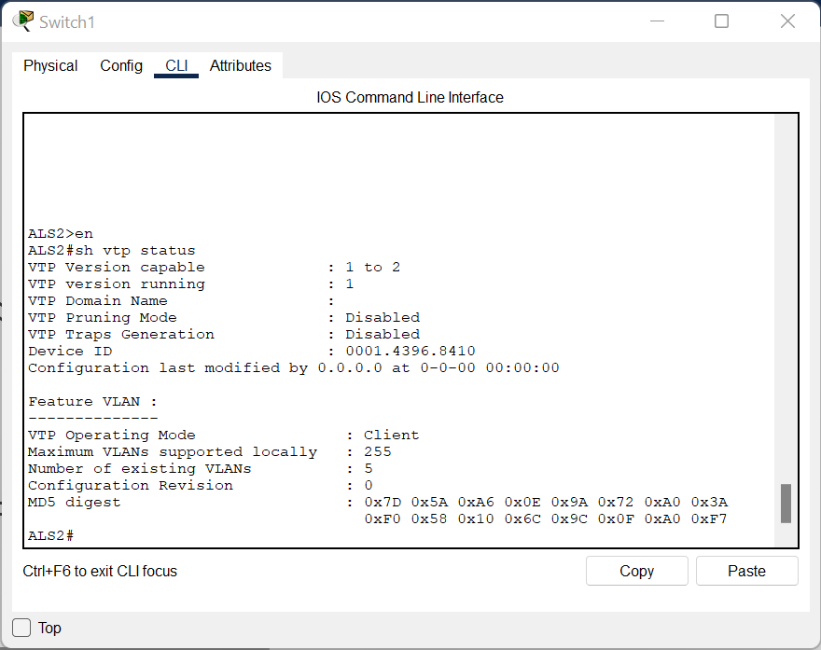

Step 4:  
DLS1>en

DLS1#conf t

Enter configuration commands, one per line. End with CNTL/Z.

DLS1(config)#vtp domain SWLAB

Changing VTP domain name from NULL to SWLAB

DLS1(config)#vtp version 2

DLS1(config)#vlan 100

DLS1(config-vlan)#name Finance

DLS1(config-vlan)#vlan 200

DLS1(config-vlan)#name Engineering

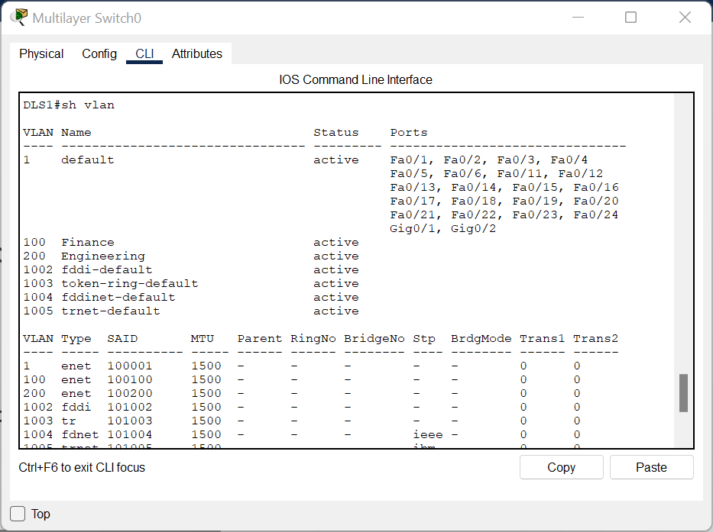

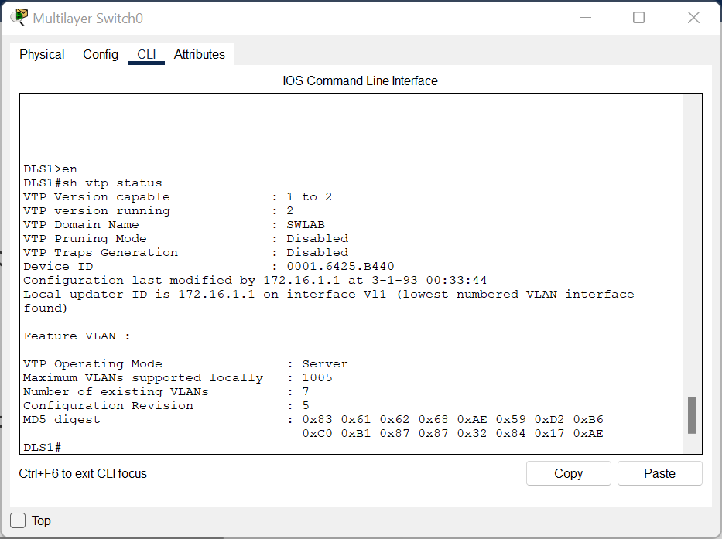

Step 5:  
ALS1>en

ALS1#conf t

Enter configuration commands, one per line. End with CNTL/Z.

ALS1(config)#int fa0/6

ALS1(config-if)#switchport mode access

ALS1(config-if)#switchport access vlan 100

Xxxxxxxxxxxxxxxxxxxxxxxxxxxxxxxxxxxxxxxxxxxxxxxxx

ALS2>en

ALS2#conf t

Enter configuration commands, one per line. End with CNTL/Z.

ALS2(config)#int fa0/6

ALS2(config-if)#switchport mode access

ALS2(config-if)#switchport access vlan 200

Step 6:  
DLS1#conf t

Enter configuration commands, one per line. End with CNTL/Z.

DLS1(config)#int vlan 100

DLS1(config-if)#

%LINK-5-CHANGED: Interface Vlan100, changed state to up

%LINEPROTO-5-UPDOWN: Line protocol on Interface Vlan100, changed state to up

DLS1(config-if)#ip add 172.16.100.1 255.255.255.0

DLS1(config-if)#no shut

DLS1(config-if)#int vlan 200

DLS1(config-if)#

%LINK-5-CHANGED: Interface Vlan200, changed state to up

%LINEPROTO-5-UPDOWN: Line protocol on Interface Vlan200, changed state to up

DLS1(config-if)#ip add 172.16.200.1 255.255.255.0

DLS1(config-if)#no shut

DLS1(config-if)#exit

DLS1(config)#ip routing

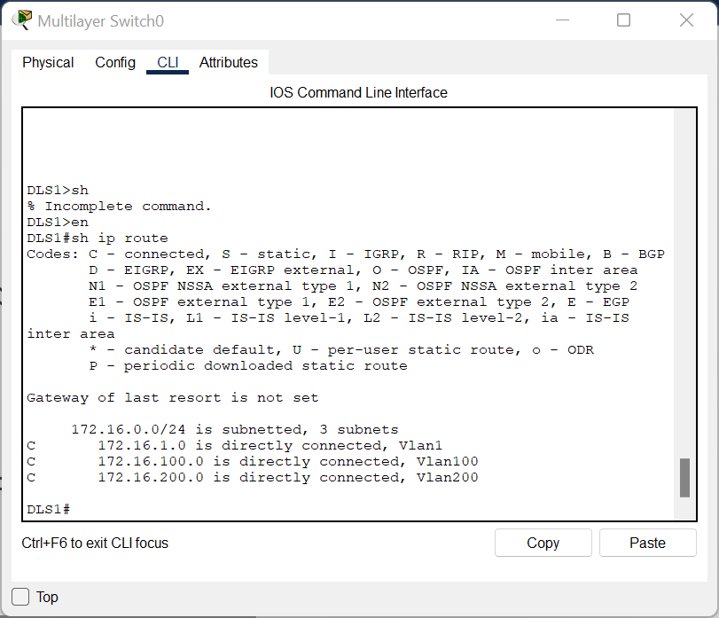

Step 7:

