Cyclistic Bike-Share Analysis

Oleksandr Synichenko

18 May, 2026

1. Introduction

Project Title: How Does Bike Rental Drive Rapid Success?
Company: Cyclistic Bike
Goal: To analyze how regular cyclists and annual members use Cyclistic bikes differently and provide insights into converting regular cyclists into annual members.
Business Objective: Cyclistic’s marketing team is looking to increase annual memberships. Understanding the differences in usage patterns between regular cyclists and annual members will help develop a targeted marketing strategy.

2. Scenario
Cyclistic operates a fleet of over 5,800 bikes, accessible from over 600 docks across the city. Bikes can be borrowed from one dock, ridden, and then returned to any dock. Over the years, marketing campaigns have been broad and targeted to a wide range of potential users. Data analysis has shown that bicyclists with annual memberships are more profitable than regular bicyclists. Lili Moreno, the company’s marketing director, wants to implement a new marketing strategy to convert regular bicyclists into annual members. She believes that with the right campaign, there is a very high probability of such conversions across user types. There are also convenient bike options, such as electric bikes, classic bikes, and docked bikes. This makes Cyclistic’s services more inclusive for people. Lily has the marketing analytics team analyze user data from the past year to identify trends and habits among Cyclistic users that will help create this marketing campaign. The marketing analytics team would like to know:

• What is the difference between annual members and regular cyclists
• Why do regular cyclists buy memberships
• How can Cyclistic use digital media to influence regular cyclists to become members?

Here I have to analyze historical cycling data to identify trends in bicycle usage by both regular cyclists and subscribers.

3. Phase 1: Ask
3.0.1 Business Objective
The business objective of this case study is to identify opportunities for targeted marketing campaigns to convert casual cyclists into regular members. This will be done by analyzing cycling trip data and understanding user behavior and preferences. The ultimate goal is to increase profitability and drive future growth for the company.

3.0.2 Business Objective
As an analyst, I see the following:
• Analyze historical data on Cyclistic’s cycling trips
• Identify trends and patterns in cycling usage by casual cyclists and participating cyclists
• Understand the behavior and preferences of these two user groups
• Identify opportunities for targeted marketing campaigns to convert casual cyclists into regular members
• Use the analytics to develop a new marketing strategy for the company
• Set a goal to increase profitability and drive future growth.

3.0.3 Stakeholders
The stakeholders in this case study include:
• Lily Moreno: Marketing Director at Cyclistic, responsible for implementing marketing campaigns at Cyclistic.
• Cyclistic’s marketing team: They will be responsible for conducting the analysis and developing a marketing strategy based on the data obtained.
• Cyclistic’s investors and shareholders: They have a financial interest in the company’s success and may be interested in the results of the analysis and any changes to the marketing strategy.

4. Phase 2: Preparation
4.0.1 Where is your data?
The data for this analysis can be obtained from the link provided. It includes 12 months of historical trip data from Cyclistic, a fictional bike rental company based in Chicago. It should be noted that this data is public and can be used to study how different types of customers use Cyclistic bikes.

4.0.2 How is the data organized?
The data used for this project consists of monthly CSV files for the last 12 months (January 2025 - December 2025). All files contain 13 columns of information related to trip details, such as trip ID, passenger type, trip time, start and end location, geographic coordinates, etc. The data is organized in a way that allows for analysis of trends and patterns in the use of Cyclistic bike rental services.

4.0.3 Data Integrity
Motivate, Inc. collected the data for this analysis directly from the City of Chicago’s Cyclistic Bike Share program. The data is comprehensive and consistent because it includes information about all trips made by users and is not simply a sample. It is also timely because it is published monthly by the City of Chicago.

4.0.4 Licensing, Privacy, Security, and Accessibility.
The data used for this analysis has been stripped of all personally identifiable information to protect user privacy. This data restriction limits the scope of analysis possible because it is not possible to determine whether occasional riders are regular users or residents of the Chicago area. The data is released under a specific license and is provided for use in this analysis.

4.0.5 Ability of the data to answer business questions.
The available data set is sufficient to answer the business question regarding the differences in usage patterns between annual members and occasional passengers. Through detailed observation of the variables in the data, it was determined that occasional passengers typically pay for individual or daily trips, while participating passengers tend to purchase annual subscriptions. This information is important for understanding the behavioral differences between the two groups and can be used to shape targeted marketing campaigns. Additional analysis of other variables in the data, such as trip duration and location, can provide additional insight into the usage patterns of annual members and occasional passengers.

4.0.6 Data Issues.
Problems I encountered during data analysis:
• Data preparation revealed several problems, including duplicate records, missing fields, etc., which were resolved by data cleaning
• The large data volume of 1,115,087,310 bytes (1.12 GB on disk) for 12 items caused a load on the computer's processor and memory.
• Data cleaning, removing unnecessary variables, and saving to a CSV file on the hard drive allowed for efficient processing and analysis of the data
• Specialized tools or methods were required to work with large amounts of data. Tools such as Excel could not cope with such a volume of data, so R was used for both calculations and visualization.
5. Phase 3: Data Processing.
5.0.1 What tools do you choose and why?
To effectively prepare, process, clean, analyze, and visualize the data for this project, I chose RStudio Desktop for Mac as my primary tool. The large size of the dataset made it impossible to use tools like Microsoft Excel or Google Sheets, and RStudio Cloud could not handle the volume of data. RStudio Desktop for Mac provided the necessary capabilities to work with the data efficiently and draw meaningful conclusions.

5.0.2 Data Review.
In order to understand the data and its potential for analysis, a review was conducted to assess the content of the variables, data format, and data integrity. This initial review provided a general overview of the data and helped identify any potential issues or difficulties that would need to be addressed during the preparation and analysis process.

The data review included the following:
• Reviewing column names in all 12 original files.
• Check for missing values.
• Check for gaps.
• Check for duplicate records.
• Other data anomalies.

The results of the check revealed the following:
• Duplicate ID records.
• Records with missing start or end station names.
• Records with very short or very long trip durations.
• Trip records starting or ending at an administrative station (repair or test station).

All 12 files were merged into a single dataset after the initial review was completed. The final dataset consisted of 5,552.994 rows with 13 columns of character and numeric data. This matched the number of records in all 12 monthly data files.

5.0.3 Environment settings

#Load packages
library (tidyverse)
library (lubridate)
library (dplyr)
library (janitor)
library (tidyr)
library (data.table)
library (readr)
library (psych)
library (hrbrthemes)
library (ggplot2)
library (lifecycle)
library (rlang)
library (vctrs)
library (languageserver)

5.0.4 Data Validation
To enable more efficient and comprehensive analysis, it was necessary to load the individual data files into new vectors and merge them into one large dataset. This process involved merging the library of data frames into a single entity, which allowed for more efficient analysis and interpretation of the data.
#Setting Up Working Directory
setwd("/Documents/Cyclistic_Bike_Analysis")

#Import Data
Jan_2025 <- read.csv("202501-divvy-tripdata.csv")
Feb_2025 <- read.csv("202502-divvy-tripdata.csv")
Mar_2025 <- read.csv("202503-divvy-tripdata.csv")
Apr_2025 <- read.csv("202504-divvy-tripdata.csv")
May_2025 <- read.csv("202505-divvy-tripdata.csv")
Jun_2025 <- read.csv("202506-divvy-tripdata.csv")
Jul_2025 <- read.csv("202507-divvy-tripdata.csv")
Aug_2025 <- read.csv("202508-divvy-tripdata.csv")
Sep_2025 <- read.csv("202509-divvy-tripdata.csv")
Oct_2025 <- read.csv("202510-divvy-tripdata.csv")
Nov_2025 <- read.csv("202511-divvy-tripdata.csv")
Dec_2025 <- read.csv("202512-divvy-tripdata.csv")

To ensure the accuracy and integrity of the merged data set, it was necessary to check the compatibility of column names in the individual data files to be merged. This involved comparing the names and ensuring that they matched perfectly, regardless of their order. This step was crucial in order to be able to use the command to merge the data into a single file.
#Data Validation
colnames(Jan_2025)
colnames(Feb_2025)
colnames(Mar_2025)
colnames(Apr_2025)
colnames(May_2025)
colnames(Jun_2025)
colnames(Jul_2025)
colnames(Aug_2025)
colnames(Sep_2025)
colnames(Oct_2025)
colnames(Nov_2025)
colnames(Dec_2025)

Colnames result:
.
.
.

Note that the column names in all the individual data files for the merge are the same.
The total number of records in all 12 monthly data files is estimated to be 5,552,994 rows and 13 columns. This information is about the size and scope of the data, which can be useful for planning and executing the analysis process.
#Total number of rows
sum(nrow(Jan_2025) + nrow(Feb_2025) + nrow(Mar_2025) + nrow(Apr_2025) + nrow(May_2025) + nrow(Jun_2025) + nrow(Jul_2025) + nrow(Aug_2025) + nrow(Sep_2025) + nrow(Oct_2025)+ nrow(Nov_2025) + nrow(Dec_2025))
#Result of sum
[1] 5552994

In the previous step, we found that all the input data frames have the same number of columns and that the column names match. In addition, all the columns are in the same order and have compatible data types. Therefore, we can use the rbind() function to join the frames. The monthly data frames were aggregated into a single data frame (df). This involved combining the data from each monthly file into a single whole, which allowed for more efficient and comprehensive data analysis. Aggregating the data in this way also made it easier to identify trends and patterns across the entire data set, rather than having to analyze each month’s data separately.
#Combine Data of 12 month into one
tour_combined <- rbind(Jan_2025, Feb_2025, Mar_2025, Apr_2025, May_2025, Jun_2025, Jul_2025, Aug_2025, Sep_2025, Oct_2025, Nov_2025, Dec_2025)

After combining the monthly data frames into a single data frame, the resulting combined tour_combined dataset was written to a new file tour_combined_raw_data.csv and saved to the hard drive. This provides easier access to the data for further analysis and visualization, and also ensures that it is available for future use. Saving the data to a file on the hard drive also ensures that it is backed up and protected from accidental loss or corruption. Розмір файлу склав - 1,115,087,310 bytes

# Save the combined files
write.csv(tour_combined,file = "tour_combined_raw_data.csv",row.names = FALSE)
Once saved to the hard drive, the data was again reviewed to ensure accuracy, completeness, and consistency. This process included checking the data for errors or inconsistencies, checking for missing or incomplete records, and verifying that the data met the requirements and expectations of the analysis.
#Final data validation
colnames(tour_combined)
str(tour_combined)
View(head(tour_combined))
View(tail(tour_combined))
dim(tour_combined)
summary(tour_combined)

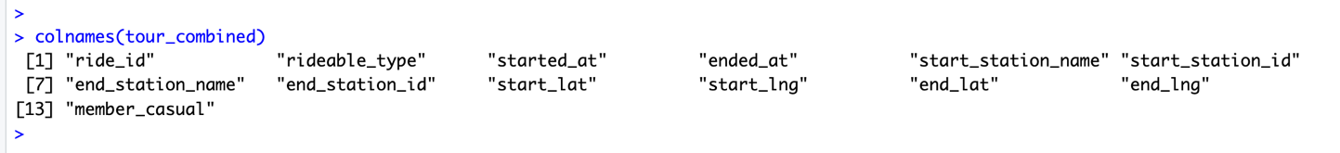

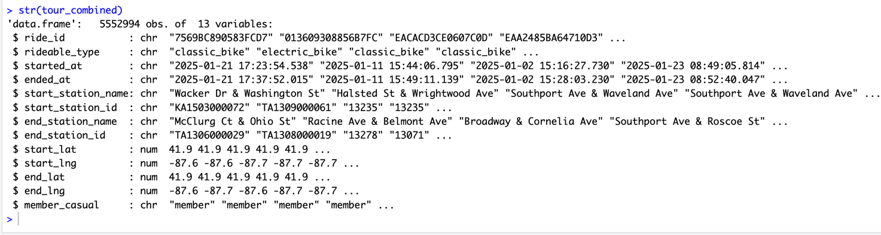

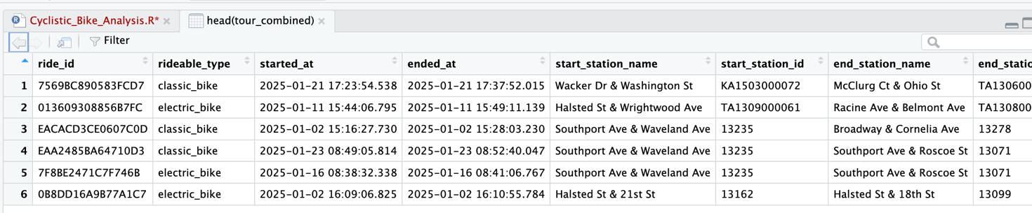

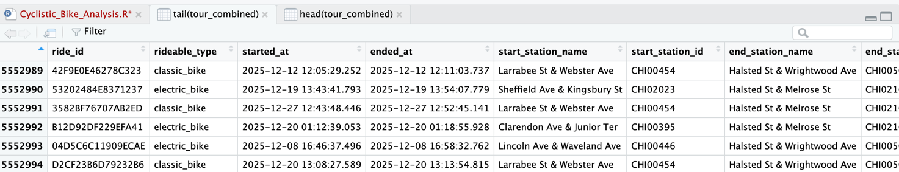

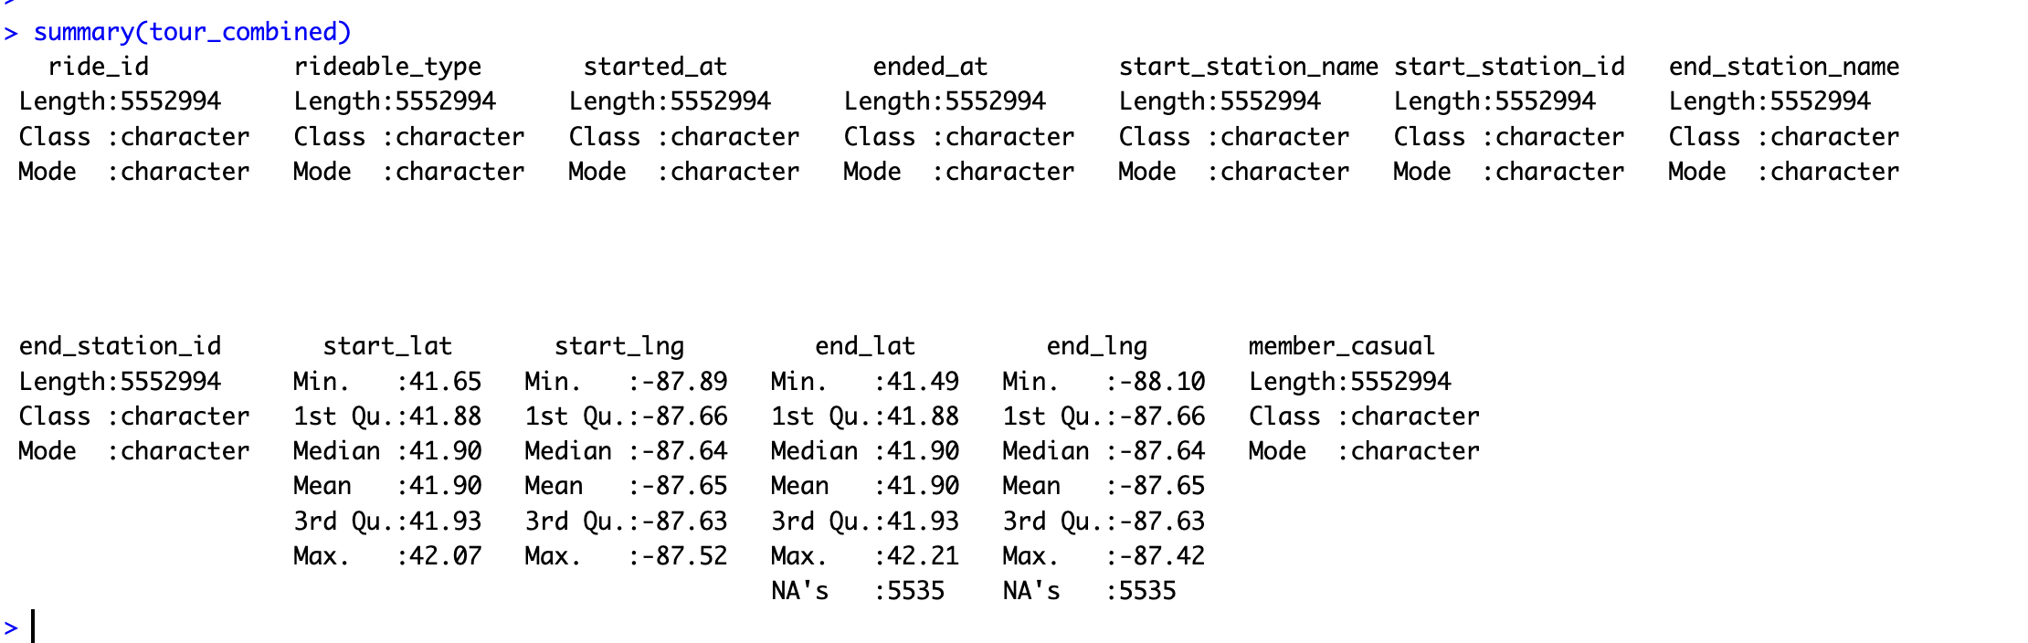

6. Phase 4: Data Cleansing
At this stage, I performed data cleaning to identify and correct or remove errors or inconsistencies from the data. This would include a variety of techniques such as correcting data entry errors, removing duplicate or incorrect records, and standardizing data formats to ensure compatibility with analysis tools. Data cleaning is an important step in the data analysis process because it helps ensure the accuracy and reliability of the data, as well as the meaningfulness and usefulness of the analysis results.
Let's check for records from last year that might have been accidentally saved in the files. Let's look at the minimum and maximum dates specified in our data file.
#The minimum and maximum date
min(tour_combined$started_at)
[1] "2024-12-31 18:54:41.803"

max(tour_combined$started_at)
[1] "2025-12-31 23:53:24.274

Let's count the number of rows for December 2024 and remove them from our dataframe and re-check.
#Сount how many lines for December 2024
sum(as.Date(tour_combined$started_at) < as.Date("2025-01-01"))
[1] 53

tour_combined <- tour_combined %>% filter(as.Date(started_at) >= as.Date("2025-01-01"))
sum(as.Date(tour_combined$started_at) < as.Date("2025-01-01"))
[1] 0
The check shows that 53 rows were deleted.


Next, you need to check the total number of rows with missing or incomplete “NA” values. Understanding the extent of missing or incomplete data helps you make informed decisions about how to handle these values, such as whether to remove them from the dataset or replace them with estimates or placeholders.
#Count rows with "NA" values
colSums(is.na(tour_combined))
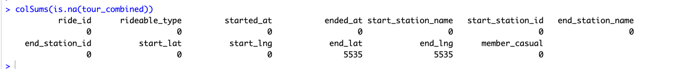

To further refine and clean the data, it is necessary to remove duplicates, empty “NA” values, and missing values. Removing duplicates helps to ensure the most complete and accurate information possible, and also avoids the undue influence of duplicates or erroneous data on the analysis results. In this case, the missing values will be removed, and the unique values will be preserved in the new data frame.
#Remove duplicates
clean_tour <- distinct(tour_combined)

After executing the distinct command, let's check what we got.
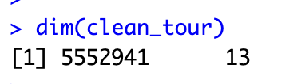

We can see that the number of rows has not changed - 5552941, which tells us that there are no duplicates in our dataframe.

Next, delete rows with missing or incomplete “NA” values

#Remove NA
clean_tour <- drop_na(clean_tour)
dim(clean_tour)
[ 1 ] 5547406 13
Let's count the number of rows that were deleted as a result of the above command:
5552941-5547406 = 5535
Now you need to filter out records where the value of the variable "started_at" is greater than the value of the variable "ended_at". This can help ensure the accuracy and meaningfulness of the data
#Remove data with greater start_at than end_at
clean_tour<- clean_tour %>% filter(started_at < ended_at)
#Check
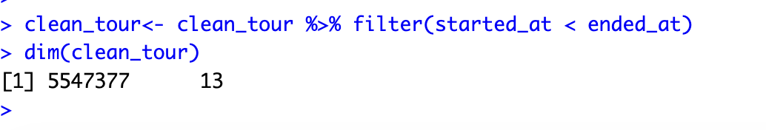
5547406 – 5547377 = 29 rows were removed where the value of the variable "started_at" is greater than the value of the variable "ended_at".
To improve clarity and understanding of the data, you may want to change the names of several columns to more accurately reflect their contents. Column names should be intuitive.

Was member_casual, now customer_type
Was rideable_type, now bike_type

#Renaming column for better context
clean_tour <- rename(clean_tour, customer_type = member_casual, bike_type = rideable_type)

To facilitate more detailed analysis of the data, 4 additional columns were created for date, month, day of the week, and year based on the “started_at” column. This allowed for more detailed analysis of the data by specific dates, days, or months, and also helped identify trends and patterns that might not have been apparent when analyzing the data at a more general level.
#Separate date in date, day, month, year for better analysis
clean_tour$date <- as.Date(clean_tour$started_at)
clean_tour$month <- format(as.Date(clean_tour$date), "%b_%y")
clean_tour$week_day <- format(as.Date(clean_tour$date), "%A")
clean_tour$year <- format(clean_tour$date, "%Y")
Similarly, a new column was created just to display the time the bike was picked up and we create it in the format «%H:%M».
#Separate column for time
clean_tour$time <- as.POSIXct(clean_tour$started_at, format = "%Y-%m-%d %H:%M:%S")
clean_tour$time <- format(clean_tour$time, format = "%H:%M")
Щоб краще зрозуміти тривалість поїздок, було створено стовпець для розрахунку тривалості поїздок на основі часу початку та закінчення кожної поїздки. Це дозволяє проводити детальніший аналіз тривалості поїздок і може допомогти виявити тенденції та закономірності в даних.
To better understand tour duration, a column was created to calculate trip duration based on the start and end times of each tour. This allows for more detailed analysis of trip duration and can help identify trends and patterns in the data.
#Add tour length column
clean_tour$tour_length <- difftime(clean_tour$ended_at, clean_tour$started_at, units = "mins")
Optionally, two more columns were created for possible future calculations and analysis.
#Additionally columns creation
clean_tour <- rename(clean_tour, pickup_time = time)
clean_tour <- clean_tour %>% mutate(hour = as.integer(format(as.POSIXct(pickup_time, format = "%H:%M"), "%H")))
clean_tour <- clean_tour %>% mutate(pickup_hour = as.integer(format(as.POSIXct(pickup_time, format = "%H:%M"), "%H")))

To focus the analysis on the variables of interest, data that would not be used for this analysis was filtered out. This was done using the “select()” function to select only the relevant variables.
#Select the data we are going to use
clean_tour <- clean_tour %>% select(bike_type, started_at, ended_at, start_station_name, end_station_name, customer_type, date, month, week_day, year, pickup_time, tour_length, pickup_hour)

To ensure data accuracy and reliability, excessively long tours need to be removed, as Cyclist may consider them stolen. Tours are typically limited to one day or 1440 minutes or 24 hours, and data less than 1 minute was removed as it was too small to impact this analysis. A 3–4 minute trip is quite realistic (2-block office). The industry standard is to remove trips < 1 minute (these are truly technical anomalies)
#Remove stolen bikes and test drive !!!
clean_tour <- clean_tour[!clean_tour$tour_length>1440,]
clean_tour <- clean_tour[!clean_tour$tour_length<1,]
> dim(clean_tour)
[1] 5547168 13
5547377 – 5547168 = 209- tours longer than 1440 minutes

> dim(clean_tour)
[1] 5399796 13
5547168 – 5399796 = 147372 - tours less than 1 minute

Before moving on to the next stage of the data analysis process, it is important to perform one final check to ensure that all necessary data cleaning and preparation steps have been completed.
#Check Cleaned data
colSums(is.na(clean_tour))
View(filter(clean_tour, clean_tour$tour_length > 1440 | clean_tour$tour_length < 1))
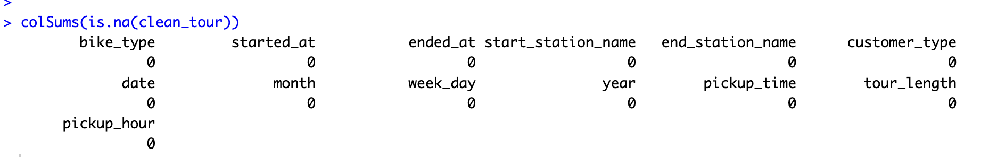
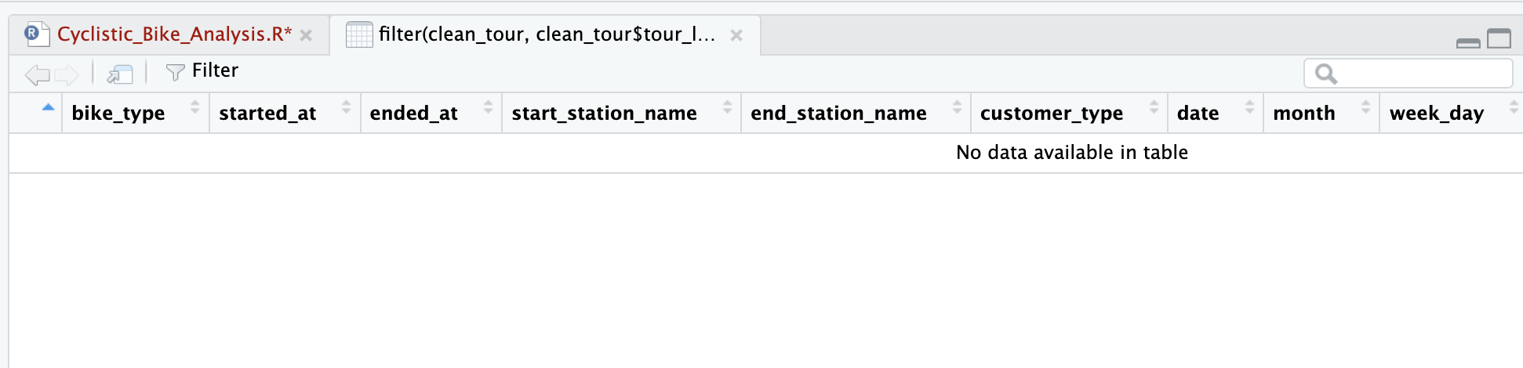
Everything done correctly, there is no extra data for more than a day and less than 1 minute.
After completing all the necessary steps of cleaning and preparing the data, the data can be saved to your hard drive as a csv file.
#Save the cleaned data
write.csv(clean_tour,file = "tour_combined_cleaned.csv",row.names = FALSE)

7. Phase 5: Data Analysis
During the data analysis phase, I explored the data to better understand its characteristics and patterns. I created charts and graphs to help visualize the data and identify trends. By analyzing the data in this way, I was able to derive conclusions and insights that could help inform business decisions and support the decision-making process.
For further analysis, I imported the cleaned tour data into a new dataframe. I again thoroughly checked the data to ensure its accuracy and absence of errors.
#Import the cleaned data
tour_combined_cleaned <- read_csv("tour_combined_cleaned.csv")
str(tour_combined_cleaned)
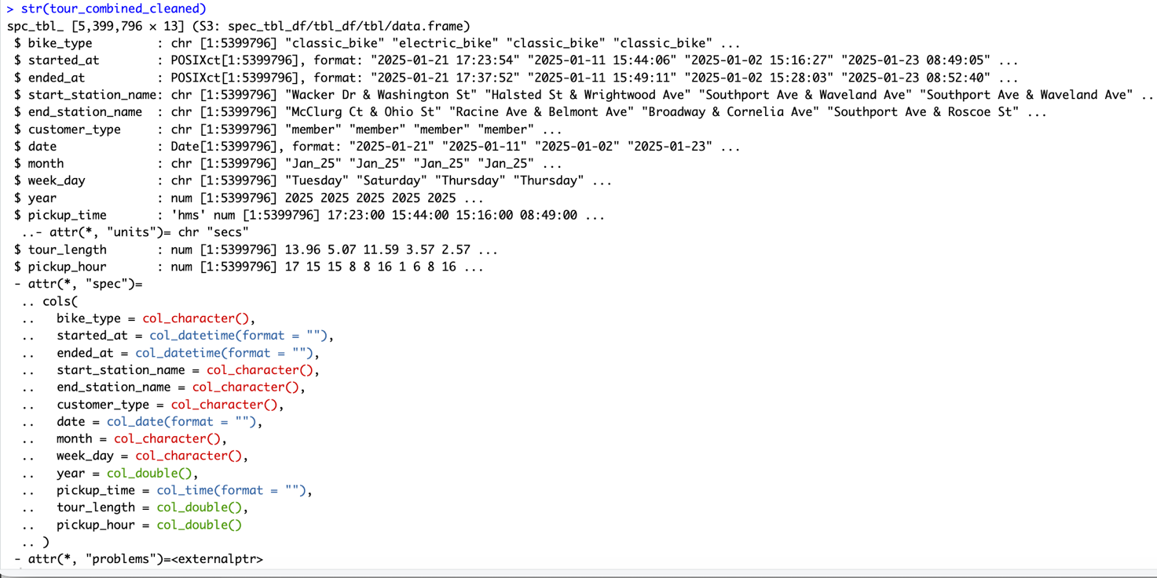

To better facilitate analysis, I sorted the month and day of the week variables in the trip data in ascending order. This allowed me to easily compare and analyze trends across time periods and days of the week.
#Order the data
tour_combined_cleaned$month <- ordered(tour_combined_cleaned$month,levels=c("Jan_25","Feb_25","Mar_25","Apr_25",
"May_25","Jun_25","Jul_25","Aug_25","Sep_25","Oct_25","Nov_25","Dec_25"))
tour_combined_cleaned$week_day <- ordered(tour_combined_cleaned$week_day, levels=c("Sunday", "Monday", "Tuesday","Wednesday", "Thursday","Friday", "Saturday"))

As a first step in my analysis, I calculated key summary statistics for trip duration, including minimum, maximum, median, and mean. These values gave me a general idea of the distribution of trip durations across Cyclistic’s customers and allowed me to identify any outliers or unusual patterns in the data.
#Analysis:- min, max, median, average
View(describe(tour_combined_cleaned$tour_length, fast=TRUE))

 | vars | n | mean | sd | median | min | max | range | skew | kurtosis | se
X1 | 1 | 5399796 | 14.90388 | 28.6632 | 9.67635 | 1 | 1439.976 | 1438.976 | 24.19501 | 882.8766 | 0.01233491
Second step - Analysis by bike type (bike_type)
#Analysis:- bike_type
tour_combined_cleaned %>% group_by(customer_type, bike_type) %>% summarise(count = n(), avg_duration = mean(tour_length)) %>% mutate(pct = count / sum(count) * 100)
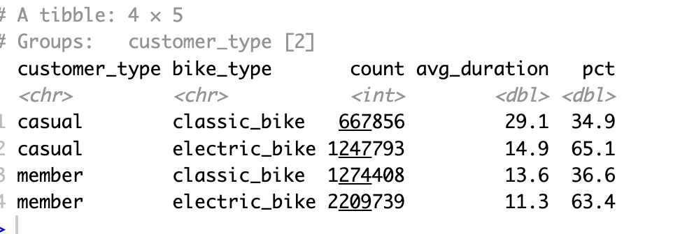
As we can see from these four lines, Casual riders are almost 2 times more likely (1.868 times) to take electric bikes than classic bikes. Probably for longer rides - this is a specific insight for the campaign. A similar situation is emerging for program subscribers - they also prefer electric bikes - 1.734 times
For greater clarity, let's plot this on a graph using the ggplot function
Chart 1 — Number of trips by bicycle type.
tour_combined_cleaned %>% group_by(customer_type, bike_type) %>% summarise(count = n(), .groups = "drop") %>% ggplot(aes(x = bike_type, y = count, fill = customer_type)) + geom_col(position = "dodge") + scale_fill_manual(values = c("casual" = "#E8593C", "member" = "#1D9E75")) + scale_y_continuous(labels = scales::comma) + labs(title = "Tours count by bike type", x = "Bike type", y = "Tours count", fill = "Customer type") + theme_minimal()

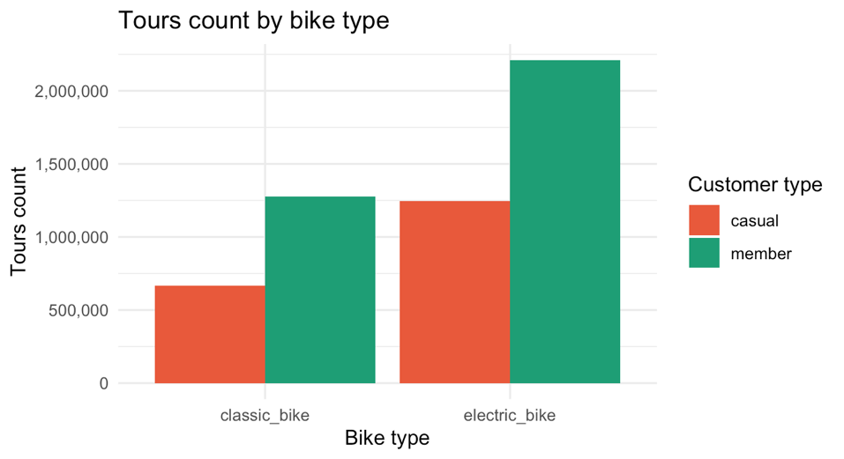
Chart 2 — Usage percentage
tour_combined_cleaned %>% group_by(customer_type, bike_type) %>% summarise(count = n(), .groups = "drop") %>% group_by(customer_type) %>% mutate(pct = count / sum(count) * 100) %>% ggplot(aes(x = customer_type, y = pct, fill = bike_type)) + geom_col(position = "dodge") + scale_fill_manual(values = c("classic_bike" = "#3B8BD4", "electric_bike" = "#EF9F27")) + scale_y_continuous(labels = function(x) paste0(round(x), "%")) + labs(title = "Distribution of bicycle types by customer type", x = "Customer type", y = "Percentage of trips", fill = "Bike type") + theme_minimal()
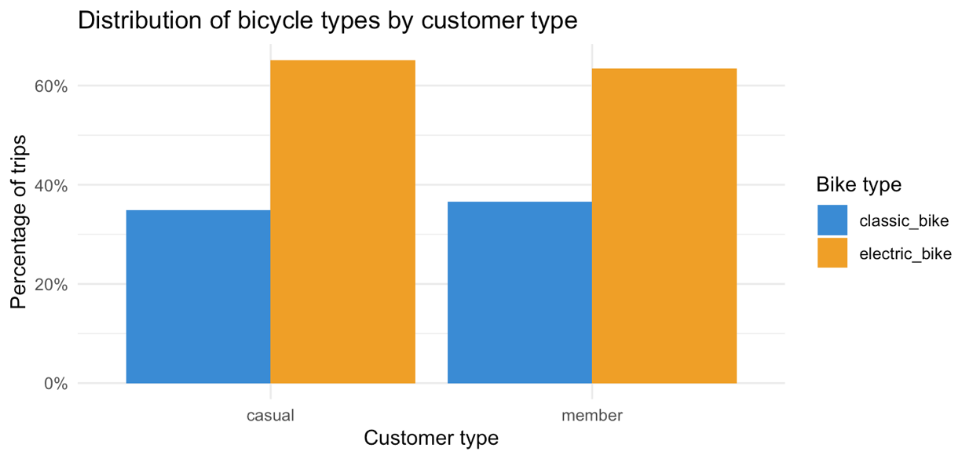

Top stations — where casual vs member tours begin and end.
#Top stations
tour_combined_cleaned %>% filter(customer_type == "casual") %>% count(start_station_name, sort = TRUE) %>% head(10)
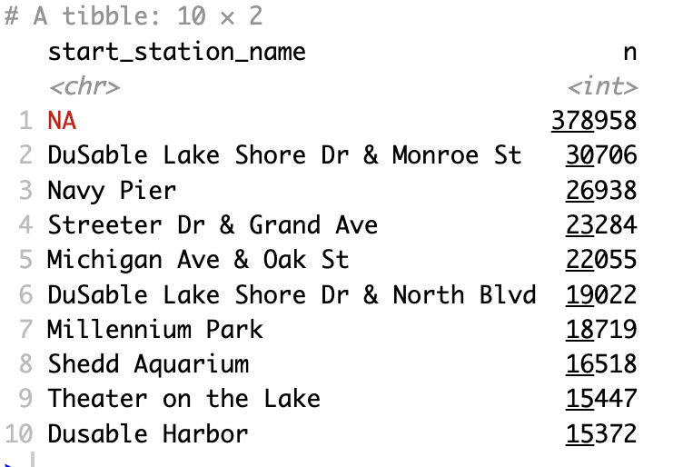
If the top stations for casual riders are near tourist spots (Navy Pier, Millennium Park), it confirms that they are tourists or casual riders, not members. A completely different marketing strategy.

Let's look at the graphs that display “Number of trips by day of the week”, “Average trip duration by month” and “Trip by hour of the day”
# 1. Number of tours by day of the week
ggplot(tour_combined_cleaned, aes(x = week_day, fill = customer_type)) + geom_bar(position = "dodge") + scale_fill_manual(values = c("casual" = "#E8593C", "member" = "#1D9E75")) + scale_y_continuous(labels = scales::comma) + labs(title = "Number of tours by day of the week", x = "Day of the week", y = "Number of tours", fill = "Client type") + theme_minimal()
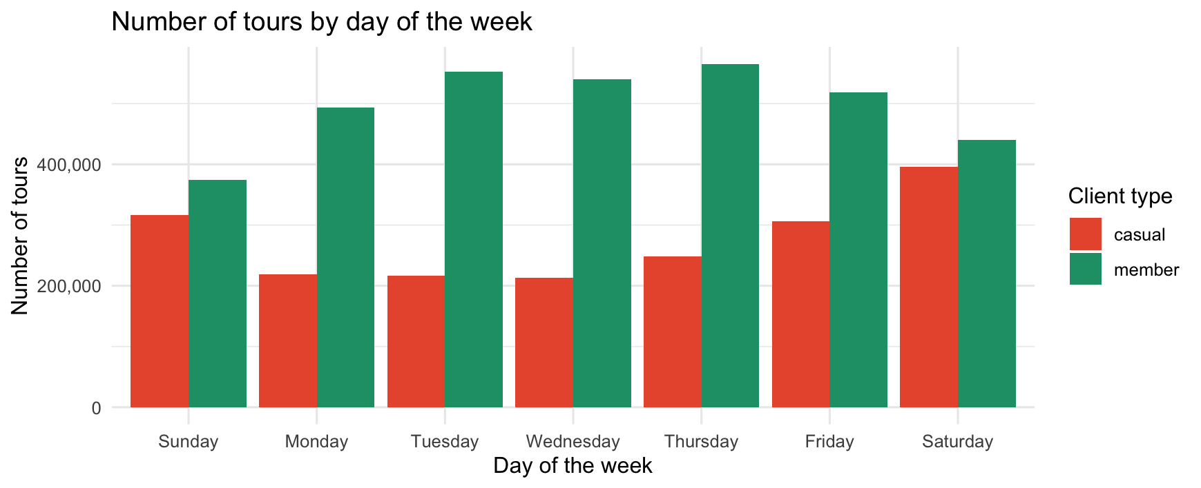

# 2. Average tour duration by month
tour_combined_cleaned %>% group_by(month, customer_type) %>% summarise(avg_duration = mean(as.numeric(tour_length)), .groups = "drop") %>% ggplot(aes(x = month, y = avg_duration, fill = customer_type)) + geom_col(position = "dodge") + scale_fill_manual(values = c("casual" = "#E8593C", "member" = "#1D9E75")) + labs(title = "Average tour duration by month", x = "Month", y = "Average duration (min)", fill = "Client type") + theme_minimal() + theme(axis.text.x = element_text(angle = 45, hjust = 1))
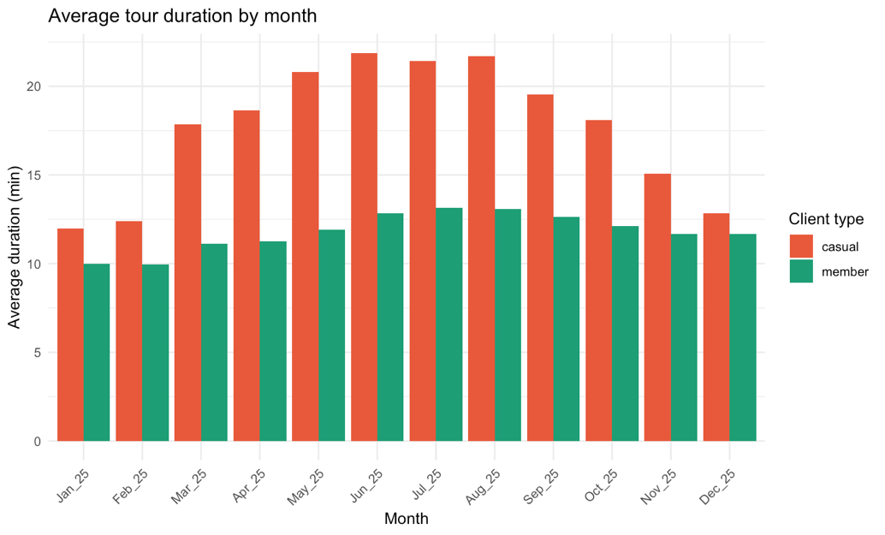

# 3. Tours by hour of the day
tour_combined_cleaned %>% mutate(hour = as.integer(substr(pickup_time, 1, 2))) %>% group_by(customer_type, hour) %>% summarise(count = n(), .groups = "drop") %>% ggplot(aes(x = hour, y = count, color = customer_type)) + geom_line(linewidth = 1.2) + scale_color_manual(values = c("casual" = "#E8593C", "member" = "#1D9E75")) + scale_x_continuous(breaks = 0:23) + scale_y_continuous(labels = scales::comma) + labs(title = "Tours by hour of the day", x = "Hour", y = "Number of tours", color = "Client type") + theme_minimal()
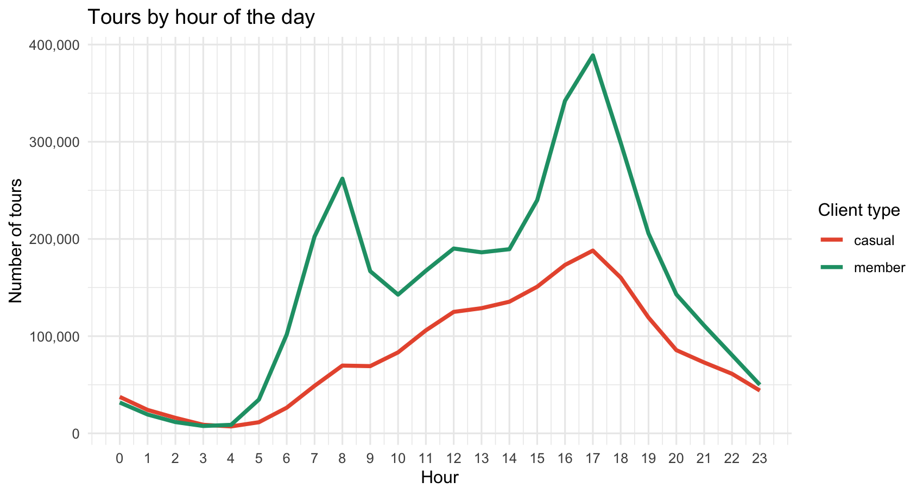
As a next step in my analysis, I examined the distribution of Cyclistic customers by membership type. This included breaking down the data into members who use the service annually and those who use it occasionally.
#Distribution of customers by membership
View(table(tour_combined_cleaned$customer_type))
 | Var1 | Freq
1 | casual | 1915649
2 | member | 3484147

Continuing my analysis, I calculated the total number of trips made by each type of customer, as well as the total duration of those trips in minutes. This analysis allowed me to understand the general usage patterns of Cyclistic’s bike rental service among different types of customers.
#Total rides for each customer type in minutes
View(setNames(aggregate(tour_length ~ customer_type, tour_combined_cleaned, sum), c("customer_type", "total_tour_len(mins)")))
 | Customer type | Total tour length (mins)
1 | casual | 38056549
2 | member | 42421355

In my next analysis, I focused specifically on comparing tour duration patterns for program members who use services annually and those who use services on an occasional basis. To do this, I calculated key summary statistics, including the mean, median, maximum, and minimum, for tour durations among these two types of customers.
#Differences between members and casual riders in terms of length of ride
View(tour_combined_cleaned %>% group_by(customer_type) %>% summarise(min_length_mins = min(tour_length), max_length_mins = max(tour_length), median_length_mins = median(tour_length), mean_length_mins = mean(tour_length)))
 | Costumer type | Min length (min) | Max length (min) | Median length (min) | Mean length (min)
1 | casual | 1.000017 | 1439.976 | 11.892300 | 19.86614
2 | member | 1.000000 | 1439.827 | 8.737867 | 12.17554
У наступному кроці я перейшов до аналізу середньої тривалості поїздки користувачів Cyclistic за днями тижня, а також аналізував загальну кількість поїздок, здійснених у кожен день тижня.
#Average tour length for users by day of week and number of total rides by day of week
View(tour_combined_cleaned %>% group_by(week_day) %>% summarise(Avg_length = mean(tour_length), number_of_ride = n()))
 | Week day | Avgerage length | Number of ride
1 | Sunday | 17.85183 | 691461
2 | Monday | 14.19365 | 712541
3 | Tuesday | 13.46279 | 769396
4 | Wednesday | 12.95130 | 752938
5 | Thursday | 13.46122 | 813047
6 | Friday | 14.90524 | 824994
7 | Saturday | 17.55936 | 835419

I then analyzed the average number of tours made by Cyclistic users by month. This analysis allowed me to understand seasonal fluctuations in usage of the bike rental service and identify any trends or patterns in usage levels throughout the year.
#Average ride_length by month
View(tour_combined_cleaned %>% group_by(month) %>% summarise(Avg_length = mean(tour_length), number_of_ride = n()))
 | Month | Average length | Number of ride
1 | Jan_25 | 10.32330 | 135736
2 | Feb_25 | 10.39674 | 149100
3 | Mar_25 | 13.03937 | 291317
4 | Apr_25 | 13.40201 | 363175
5 | May_25 | 15.09050 | 489642
6 | Jun_25 | 16.65871 | 658192
7 | Jul_25 | 16.60774 | 738821
8 | Aug_25 | 16.71333 | 766648
9 | Sep_25 | 15.15284 | 695665
10 | Oct_25 | 14.15284 | 628461
11 | Nov_25 | 12.59059 | 346601
12 | Dec_25 | 11.90258 | 136438

And now I compared the average tour duration of Cyclistic users by day of the week according to customer type. This analysis allowed me to understand how the behavior and usage patterns of annual members and regular cyclists differed on different days of the week.
#Average tour length comparison by each week day according to each customer type
View(aggregate(tour_combined_cleaned$tour_length ~ tour_combined_cleaned$customer_type + tour_combined_cleaned$week_day, FUN = mean))
 | Customer type | Week day | Tour length
1 | casual | Sunday | 23.06324
2 | member | Sunday | 13.44194
3 | casual | Monday | 19.68036
4 | member | Monday | 11.75543
5 | casual | Tuesday | 17.58817
6 | member | Tuesday | 11.84339
7 | casual | Wednesday | 16.32819
8 | member | Wednesday | 11.62149
9 | casual | Thursday | 17.42103
10 | member | Thursday | 11.72451
11 | casual | Friday | 19.58989
12 | member | Friday | 12.13666
13 | casual | Saturday | 22.30553
14 | member | Saturday | 13.29137

In the following analysis, I compared the average tour duration of Cyclistic users by month, depending on the type of customer.
#Average tour length comparison by each month according to each customer type
View(aggregate(tour_combined_cleaned$tour_length ~ tour_combined_cleaned$customer_type + tour_combined_cleaned$month, FUN = mean))

№ | Customer type | Month | Tour length
1 | casual | Jan_25 | 11.973313
2 | member | Jan_25 | 9.979503
3 | casual | Feb_25 | 12.381231
4 | member | Feb_25 | 9.957846
5 | casual | Mar_25 | 17.848788
6 | member | Mar_25 | 11.127660
7 | casual | Apr_25 | 18.630088
8 | member | Apr_25 | 11.268450
9 | casual | May_25 | 20.799818
10 | member | May_25 | 11.896704
11 | casual | Jun_25 | 21.860043
12 | member | Jun_25 | 12.839433
13 | casual | Jul_25 | 21.426095
14 | member | Jul_25 | 13.154796
15 | casual | Aug_25 | 21.695495
16 | member | Aug_25 | 13.075886
17 | casual | Sep_25 | 19.544962
18 | member | Sep_25 | 12.615738
19 | casual | Oct_25 | 18.080617
20 | member | Oct_25 | 12.119433
21 | casual | Nov_25 | 15.079331
22 | member | Nov_25 | 11.655116
23 | casual | Dec_25 | 12.823042
24 | member | Dec_25 | 11.674715
We can see that the average trip duration of casual users is longer than the average tour duration of subscription users - program participants!

Next, I analyzed Cyclistic user trip duration data by customer type and day of the week. This allowed me to understand the behavior and usage patterns of annual members and regular cyclists on different days of the week. Given that we have already set a minimum value of 1 minute here and there, we will also not calculate the minimum trip duration, which we know to be one minute for both types of users.
#Analyze tour length data by customer type and weekday
View(tour_combined_cleaned %>% group_by(customer_type, week_day) %>% summarise(number_of_ride = n(), avgerage_duration = mean(tour_length), median_duration = median(tour_length), max_duration = max(tour_length)))

 | Customer type | Week day | Number of tours | Avgerage duration | Median duration | Maximum duration
1 | casual | Sunday | 316929 | 23.06324 | 13.857917 | 1439.976
2 | casual | Monday | 219224 | 19.68036 | 11.422533 | 1435.846
3 | casual | Tuesday | 216885 | 17.58817 | 10.517100 | 1436.845
4 | casual | Wednesday | 212732 | 16.32819 | 10.182375 | 1433.299
5 | casual | Thursday | 247875 | 17.42103 | 10.584650 | 1439.275
6 | casual | Friday | 306453 | 19.58989 | 11.815833 | 1439.764
7 | casual | Saturday | 395551 | 22.30553 | 13.768217 | 1434.943
8 | member | Sunday | 374532 | 13.44194 | 9.252067 | 1419.620
9 | member | Monday | 493317 | 11.75543 | 8.395933 | 1427.127
10 | member | Tuesday | 552511 | 11.84339 | 8.628750 | 1418.238
11 | member | Wednesday | 540206 | 11.62149 | 8.555350 | 1438.657
12 | member | Thursday | 565172 | 11.72451 | 8.615917 | 1428.912
13 | member | Friday | 518541 | 12.13666 | 8.645617 | 1439.827
14 | member | Saturday | 439868 | 13.29137 | 9.425458 | 1429.197

Тут я проаналізував дані про тривалість поїздок користувачів Cyclistic за типом клієнта та місяцем. Враховуючи те що ми вже з вами встановили мінімальне значення поїздки 1 хвилина то мінімальну тривалість поїздки ми не будемо підраховувати.
Here I analyzed the data on the duration of tours of Cyclistic users by customer type and month. Considering that we have already set the minimum trip value of 1 minute, we will not calculate the minimum trip duration.
#Analyze tours length data by customer type and month
View(tour_combined_cleaned %>% group_by(customer_type, month) %>% summarise(number_of_tours = n(), average_duration = mean(tour_length), median_duration = median(tour_length), max_duration = max(tour_length)))

 | Customer type | Month | Number of tours | Average duration | Median duration | Maximum duration
1 | casual | Jan_25 | 23405 | 11.973313 | 7.137617 | 1409.990
2 | casual | Feb_25 | 27003 | 12.381231 | 7.382300 | 1433.738
3 | casual | Mar_25 | 82860 | 17.848788 | 10.568642 | 1435.210
4 | casual | Apr_25 | 105256 | 18.630088 | 10.707042 | 1434.943
5 | casual | May_25 | 175648 | 20.799818 | 12.264333 | 1421.168
6 | casual | Jun_25 | 278675 | 21.860043 | 13.378400 | 1428.438
7 | casual | Jul_25 | 308429 | 21.426095 | 12.983367 | 1439.764
8 | casual | Aug_25 | 323523 | 21.695495 | 13.446700 | 1435.846
9 | casual | Sep_25 | 254714 | 19.544962 | 11.957717 | 1433.299
10 | casual | Oct_25 | 214373 | 18.080617 | 10.713317 | 1439.976
11 | casual | Nov_25 | 94689 | 15.079331 | 8.950717 | 1439.275
12 | casual | Dec_25 | 27074 | 12.823042 | 7.668250 | 1431.304
13 | member | Jan_25 | 112331 | 9.979503 | 6.879067 | 1394.468
14 | member | Feb_25 | 122097 | 9.957846 | 7.004050 | 1277.122
15 | member | Mar_25 | 208457 | 11.127660 | 7.887283 | 1414.130
16 | member | Apr_25 | 257919 | 11.268450 | 8.083383 | 1324.190
17 | member | May_25 | 313994 | 11.896704 | 8.716975 | 1399.497
18 | member | Jun_25 | 379517 | 12.839433 | 9.582917 | 1383.424
19 | member | Jul_25 | 430392 | 13.154796 | 9.560233 | 1429.197
20 | member | Aug_25 | 443125 | 13.075886 | 9.656800 | 1384.973
21 | member | Sep_25 | 440951 | 12.615738 | 9.287967 | 1438.657
22 | member | Oct_25 | 414088 | 12.119433 | 8.566442 | 1439.827
23 | member | Nov_25 | 251912 | 11.655116 | 7.914775 | 1434.759
24 | member | Dec_25 | 109364 | 11.674715 | 7.486975 | 1418.238

Conclusions
Who are casual riders? Analyzing the data, we can answer – these are tourists and leisure people, not program subscribers. Three pieces of evidence at once: peak on weekends (Saturday 395K, Sunday 317K), top stations – Navy Pier and Millennium Park, and the average trip duration is almost twice as long (19.9 min vs. 12.2 for members). People don’t commute 20 minutes by bike to work – they walk.
Who are members? Peaks on Tuesday-Thursday (552K–565K trips), short stable duration (~12 min) all year round, even distribution on weekdays – this tells us that these are people of habit – they know the route and ride fast.
Seasonality: July-August is the absolute peak for both, but for casual it is critical: August 323K trips vs. January 23K – a difference of 14 times. For members the difference is more modest: August 443K vs. January 112K — only 4 times. This means that casual riders appear and disappear with the tourist season.
Electric bikes: Both groups choose electric, but casuals even more often (1.87x vs. 1.73x for members). For longer rides, electric is the obvious choice.

Recommendations for Lily Moreno
Recommendation 1 — Seasonal campaign "Summer subscription" (May-June)
You need to launch advertising in May, when casual riders are just starting to appear (175K trips), and not in the summer when they are already there. Message: "You already ride - save with an annual membership." Target: Streeter Dr, DuSable Lake Shore Dr, Millennium Park stations. Discount for the first month of membership as a conversion tool.
Recommendation 2 — Electric bike as an anchor of the offer
Casual riders take electric bikes almost twice as often as classics. But electric rides are more expensive for one-time users. Campaign: "Unlimited electric bike rides for the price of a membership." This is a direct financial argument for a person who already chooses electric.
Recommendation 3 — Weekend membership tier
Data shows that a significant part of casual riders ride exclusively on weekends. A full-price annual membership doesn't make sense to them—they won't be commuting to work on Tuesdays. Solution: A separate, lower-priced "Weekend Pass" product as a stepping stone to full membership. This lowers the barrier to entry and builds a habit.

