**Junior Frontend Developer:** I started getting interested in frontend when I was taking statistic courses at university. I thought programming is so difficult thing that I might not do it. But after trying it I felt it is really amazing to see the result of hardworking. In the future I will improve my knowledge in my future career

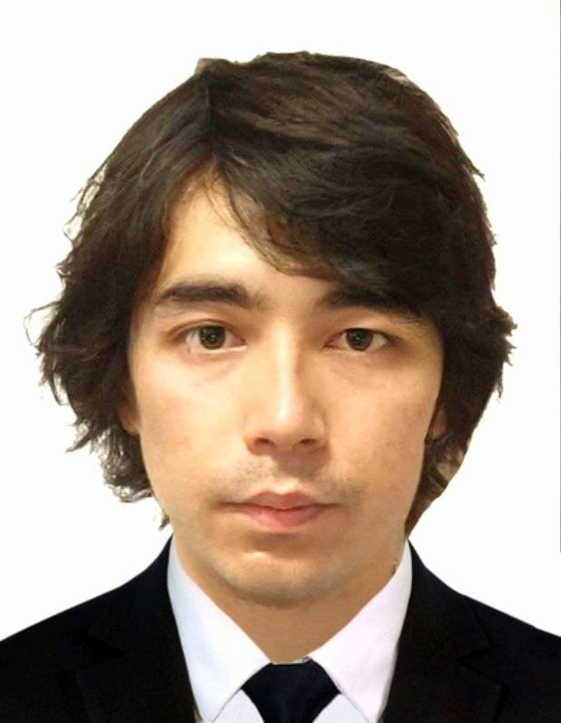

### Highlights

* Results-oriented
* Business development
* Organizational capacity
* Operability and commitment
* Ability to motivate staff and maintain good relations
* Resistance to stress
* Good manners

### Education

Bachelor of Global Management: expected to graduate in Dec,2022

Woosong University, Daejeon, South Korea

### Hobbies

* Playing chess - great way to unwind, destress, and keep the mind sharp.

### Skills

* **HTML**
* **CSS**
* **BOOTSTRAP**
* **SASS**
* **JavaScript**
* **React**

### Language

* **Uzbek: Native**
* **English: IELTS 5.5 (in 2016)**
* **Korean: TOPIK 4 (IN 2022)**

### Frontend

* **Location: ITHouse in Uzbekistan**
* **Date: From last year**
* **Type of course: Online course taught by experienced mentor**

Otabek Toshmukhammedov

+821076295927

[otabektoshmukhammedov@gmail.com](mailto:otabektoshmukhammedov@gmail.com)

Incheon, South Korea