



**SETTING UP A NEW ACCOUNT**

is the new cool git repository website. Creating a account and repository is really easy. The instructions are well laid out.

Step 1

Go to <https://github.com/plans> click on Create a **FREE ACCOUNT**

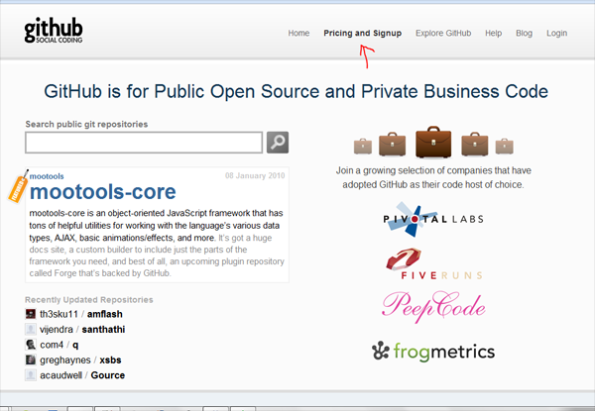

Step 2

SSH PUBLIC KEY

This is an encrypted file stored in your computer and the server. The file you need will be located under “.ssh” folder in your system. It is a hidden directory so you will not be able to see it through the finder/explorer. So open up your terminal (windows git bash program)and type

Windows users need **msysgit** to get these command line features

[**http://code.google.com/p/msysgit/**](http://code.google.com/p/msysgit/)

“cd ~/.ssh”

This will bring you to your hidden directory. If you get “**directory not found**” type

“mkdir .ssh”, then type “ls”

If you have created SSH keys before, this will return results like “id_rsa.pub, id_rsa, know_hosts” if not it should be empty and we need to create your SSH keys.

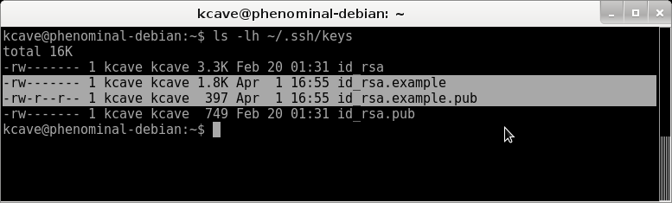

If you need to create keys then type

“ssh-keygen -t rsa -C ‘you@fullsail.com’”

By the way, the **t** option assigns a type, and the **C** option adds a comment. Once you execute the command your screen should look like the image below. Create a copy of the public key on your desktop because we will need it during key setup.

“cp id_rsa.pub ~/Desktop” this will copy your public key to your desktop.

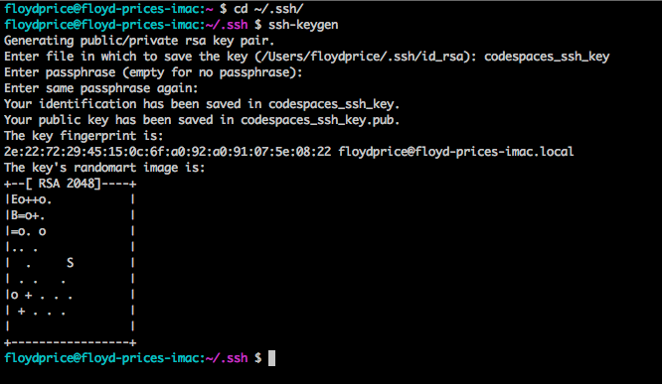

**Step 3**

LOGIN TO ACCOUNT

Let’s create your first repo, remember now you can give your instructor your address so that everyone can see your progress. **https://github.com/youraccountname**

Click on New Repository Button

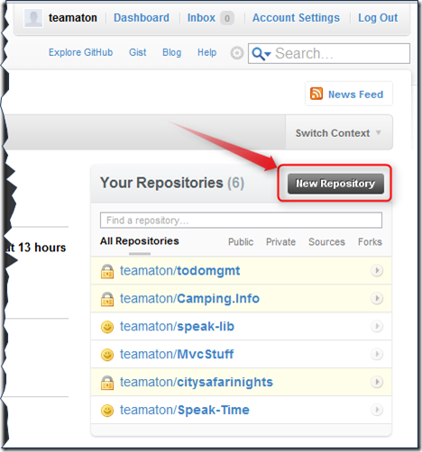

Next setup repository

Fill in “**Repository name**”

Fill in “**Description**” (First & Last Name Class name Repo)

Select “**Public**”

Check “**Initialize this repository with a README**”

Finally click on **Create Repository**

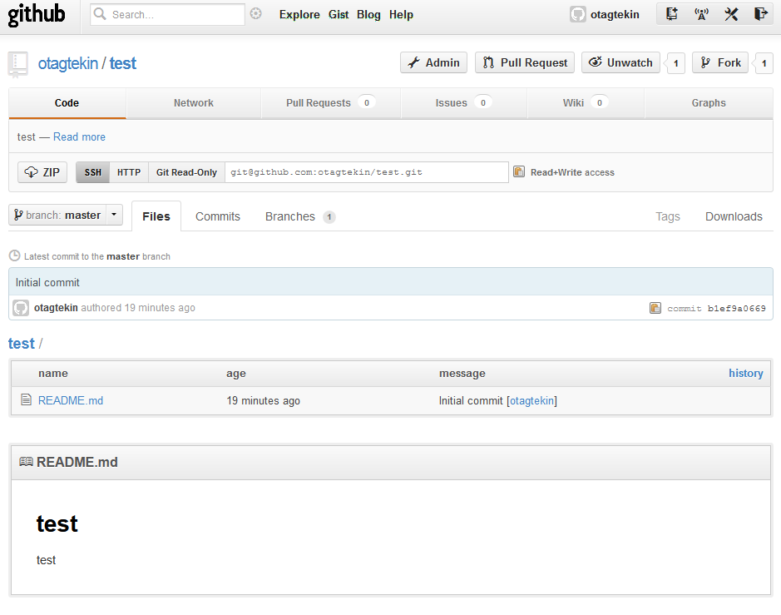

**Step 4**

**Add** your SSH Key

Click on “**Account settings**” button (top right)

Click on “**SSH Keys**” button (On left)

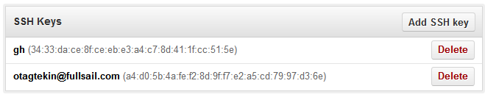

Click on Add SSH Key

Fill in Title “My key”

Fill in Key with your public key content (The file id_rsa.pub copied to desktop on previous step). You need to open up your public key with a text editor copy and paste the contents of it into the “Key” box.

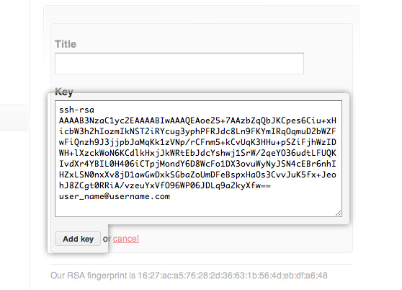

Click “**Add key**”

**Step 5**

Now you are ready to commit files/folders to your repo.

Open up terminal (windows Git Bash) and navigate to the location you would like to create a copy of the repo and its contents.

In my case it is Desktop so “**cd /Desktop**”

Next type the command

“**git clone git@github.com:*username*/yourreponame.git**” now you have copied your repo to your desktop.

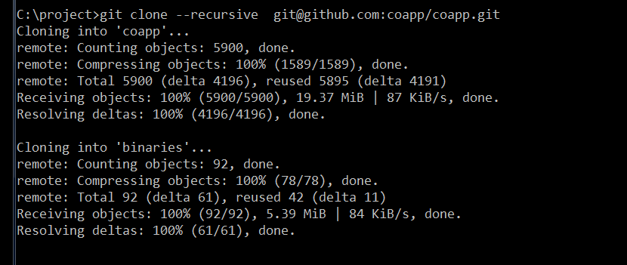

**“cd yourreponame”**

Now you are inside the repo folder on your local machine. This is the place where you will be creating files and folders to be submitted to your instructors and shared with other users online.

**Step 6**

Submit files and push to your repository

Create test file and place it inside your repo folder. “New file.rtf”

Next execute “**ls**” to see the new files in your local directory

Type “**git add new file.rtf**”

Type “**git commit –m ‘committing file”**

Type “**git pull**”

Type “**git push**” and now you have successfully added your files to your public rep on . People now can see your files from your link (**https://github.com/youraccountname)**

