dateOfLastData "yyyy-MM-dd HH:mm:ss or yyyy.MM.dd HH:mm:ss"

Version:6.0，0x60 0x66

- sdk使用说明（operation instructions）：
数据解析流程：Bluetooth 4.0 + byte [] data receiving - > Data Processing - > data return
蓝牙4.0+的 byte[]数据接收->数据处理->数据返回

蓝牙系统onCharacteristicChanged（）方法中接收数据->广播发送数据到BaseActivity->SDK处理数据->dataCallback()返回数据
Receive data in oncharacteristicchanged() method of Bluetooth system - > broadcast and send data to baseactivity - > SDK process data - > datacallback() return data

1：Receive data in oncharacteristicchanged() method of Bluetooth system
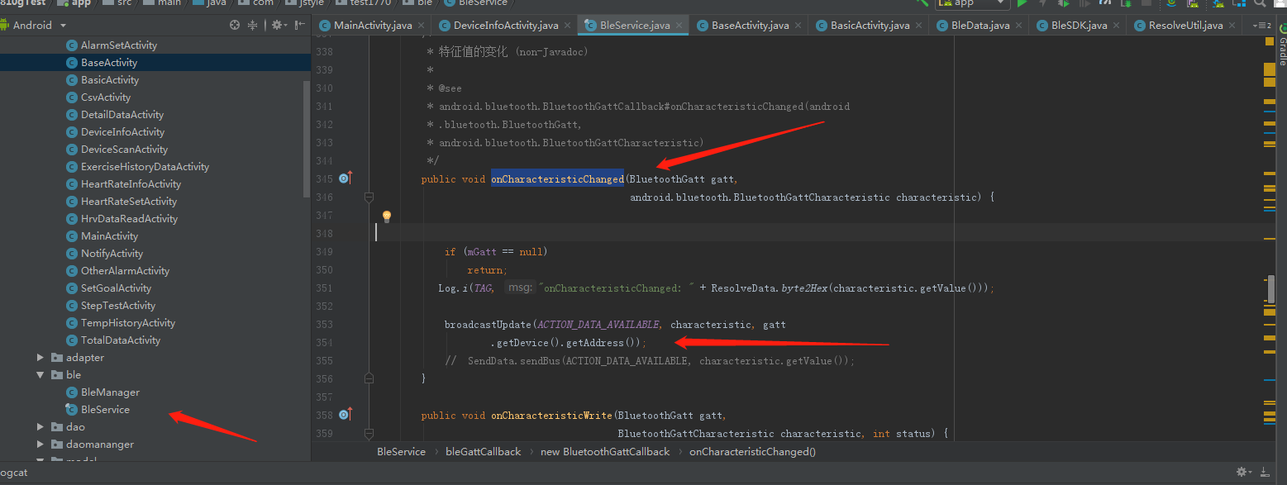
2：broadcast and send data to baseactivity
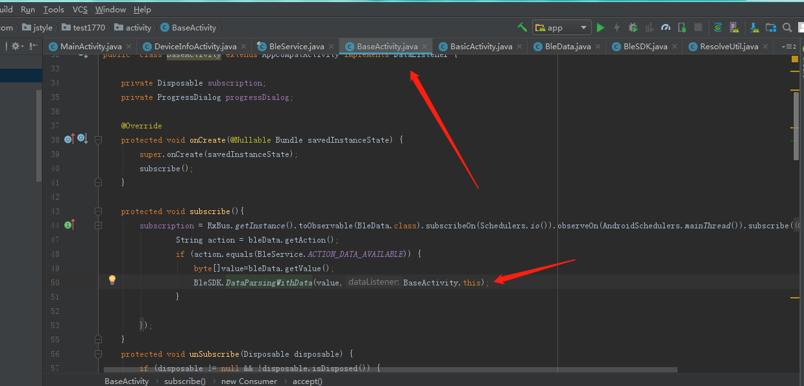

3：SDK process data - > datacallback() return data

Activity implements DataListener{}

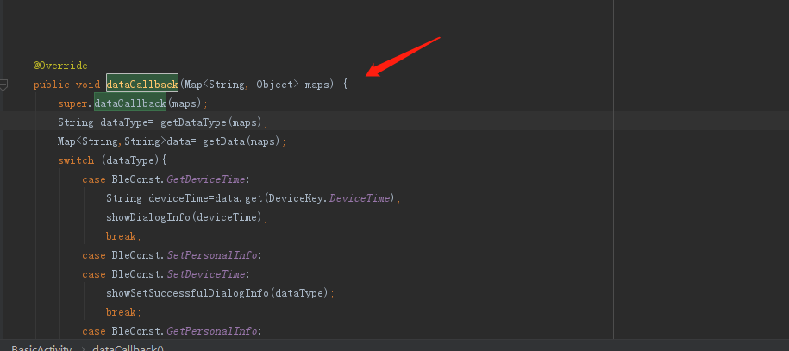

详细接口信息（Detailed interface information）

0： 设置时间（BLE Data Format）
Bluetooth instruction head | 0x01
Usage method | BleSDK.SetDeviceTime(MyDeviceTime )
Parameter | Calendar calendar=Calendar.getInstance();  int year=calendar.get(Calendar.YEAR);  int month=calendar.get(Calendar.MONTH)+1;  int day=calendar.get(Calendar.DAY_OF_MONTH);  int hour=calendar.get(Calendar.HOUR_OF_DAY);  int min=calendar.get(Calendar.MINUTE);  int second=calendar.get(Calendar.SECOND);  MyDeviceTime setTime=new MyDeviceTime();  setTime.setYear(year);  setTime.setMonth(month);  setTime.setDay(day);  setTime.setHour(hour);  setTime.setMinute(min);  setTime.setSecond(second);  sendValue(BleSDK.SetDeviceTime(setTime));
Data returned | {dataType=0, //Current 1th directive  dicData={},  dataEnd=true //End of data ( true or false)  }

1： 获取时间（Get device time）
Bluetooth instruction head | 0x41
Usage method | BleSDK.GetDeviceTime()
Data returned | {dataEnd=true,  dataType=1, dicData={  strDeviceTime=20-04-26 14:41:49,  GPSTime=00.00.00}}

2： 设置用户个人信息（Set user profile）
Bluetooth instruction head | 0x02
Usage method | BleSDK.SetPersonalInfo(MyPersonalInfo)
Parameter | MyPersonalInfo setPersonalInfo=new MyPersonalInfo();  setPersonalInfo.setAge(age);//1-220  setPersonalInfo.setHeight(height);  setPersonalInfo.setWeight(weight);  setPersonalInfo.setStepLength(stepLength);//step length  setPersonalInfo.setSex(gender); //Male 1, female 0  sendValue(BleSDK.SetPersonalInfo(setPersonalInfo));
Data returned | {dataType=2, dicData={}, dataEnd=true}

3： 获取用户个人信息（Get user's personal information）
Bluetooth instruction head | 0x42
Usage method | BleSDK.GetPersonalInfo()
parameter
Data returned | {dataEnd=true, dataType=3, dicData=  {MyStride=13,//step length  MyAge=30,  MyWeight=120,  MyGender=0,  MyHeight=38  }}

4： 读取手环基本参数（Read basic parameters of Bracelet）
Bluetooth instruction head | 0x04
Usage method | BleSDK.GetDeviceInfo()
Parameter
Data returned | {dataEnd=true, dataType=4, dicData={  handleSign=1,//1 for right hand  wristOn=1, //Hand up and screen on  dcreenBrightness=2,//Current brightness  baseHeartRate=80, //Basic heart rate  isHorizontalScreen=0,//Vertical screen  distancUnit=1, //km or kilometre  dialinterface=8, //Dial style 0-8  timeUnit=0//24 hour  }}

5： 设置手环基本参数（Set basic parameters of Bracelet）
Bluetooth instruction head | 0x03
Usage method | BleSDK.SetDeviceInfo(deviceBaseParameter)
parameter
Data returned | {DataType=5, Data={}, DataEnd=true}

6： 设置设备的mac地址（Set the MAC address of the device）
Bluetooth instruction head | 0x05
Usage method | BleSDK.SetDeviceName(name)  name aabbccddffee
Data returned | {DataType=6,  Data=,  dataEnd=true}

7： 读取目标步数（Read target steps）
Bluetooth instruction head | 0x4B
Usage method | BleSDK.GetStepGoal()
Data returned | {dataType=7, dicData={  stepGoal=2000 //Currently set step target  }, dataEnd=true}

8： 设置目标步数（Set target steps）
Bluetooth instruction head | 0x0B
Usage method | BleSDK.SetStepGoal(goal)  goal :int  0 represents the number of steps to close the target
Data returned | {dataType=8, dicData={}, dataEnd=true}

9： 读取设备电量（Read device power）
Bluetooth instruction head | 0x13
Usage method | BleSDK.GetDeviceBatteryLevel()
Data returned | {dataType=9, dicData={batteryLevel=10  }, dataEnd=true}

10： 读取MAC地址（Read MAC address）
Bluetooth instruction head | 0x22
Usage method | BleSDK.GetDeviceMacAddress()
Data returned | {dataEnd=true, dataType=10, dicData={macAddress=FE:53:8C:0D:73:FB}}

11： 读取软件版本号（Read software version number）
Bluetooth instruction head | 0x27
Usage method | BleSDK.GetDeviceVersion()
Data returned | {dataType=11, dicData={deviceVersion=0.3.2.1}, dataEnd=true}

12： 恢复出厂设置（Restore factory settings）
Bluetooth instruction head | 0x12
Usage method | BleSDK.Reset()
Data returned | {dataType=12, dataEnd=true}

13： MCU软复位指令（MCU soft reset command）
Bluetooth instruction head | 0x2E
Usage method | BleSDK.MCUReset()
Data returned | {dataType=13, dataEnd=true}

14： 传送马达振动信号（Transmit motor vibration signal）
Bluetooth instruction head | 0x36
Usage method | BleSDK.MotorVibrationWithTimes(int times)  times :The unit is 0.5s for each vibration and 0.5 for stop. The maximum value range is 5
Data returned | {dataType=14, dicData={}, dataEnd=true}

16： 读取自动检测时段（Read auto detect heart rate period）
Bluetooth instruction head | 0x2B
Usage method | BleSDK.GetAutomatic(AutoMode type)
Data returned | {dataType=17, dicData={  heartStartMinter=00,  workModel=2, //0 ,1, 2 One of the three models  heartEndHour=23,  heartEndMinter=59,  heartStartHour=00,  workTime=5,//Indicates how many minutes to prompt  weekValue=1-1-1-1-1-1-1},  //Bit1 = 0 means Monday is not enabled, Bit1 = 1 means Monday is enabled.  Bit2 = 0 means Tuesday is not enabled, bit2 = 1 means Tuesday is enabled.  Bit3 = 0 means Wednesday is not enabled, bit3 = 1 means Wednesday is enabled.  Bit4 = 0 means Thursday is not enabled, bit4 = 1 means Thursday is enabled.  Bit5 = 0 means Friday is not enabled, bit5 = 1 means Friday is enabled.  Bit6 = 0 means Saturday is not enabled, bit6 = 1 means Saturday is enabled.  Bit7 = 0 means Sunday is not enabled, bit7 = 1 means Sunday is enabled.  dataEnd=true}

17： 设置自动检测时段（Set automatic heart rate detection period）
Bluetooth instruction head | 0x2A
Usage method | SetAutomatic(WorkMode workMode, MyAutomaticHRMonitoring time, AutoMode type  )  Time 多少时间测试一次，单位是分钟。每次测试时间是1分钟。  AutoMode :AutoHeartRate, AutoSpo2,AutoTemp,AutoHrv
Data returned | {dataType=17, dicData={}, dataEnd=true}

18： 读取或删除闹钟（Read or delete alarm clock）
Bluetooth instruction head | 0x57
Usage method | BleSDK.GetAlarmClock(byte mode)  mode  0x99: delete alarm data  0: read alarm data.
Data returned | {dataEnd=false, dataType=16, dicData=[{clockOpenOrClose=1, alarmHour=20, weekValue=1-0-1-1-1-1-1, alarmLength=1, alarmId=0, clockType=1, alarmMinter=00}, {clockOpenOrClose=1, alarmHour=21, weekValue=1-1-1-0-0-0-0, alarmLength=1, alarmId=1, clockType=2, alarmMinter=00}, {clockOpenOrClose=1, alarmHour=22, weekValue=1-1-0-0-0-0-0, alarmLength=1, alarmId=2, clockType=3, alarmMinter=00}]}

19： 设置闹钟（Set alarm）
Bluetooth instruction head | 0x23
Usage method | public static byte[] setClockData(List<Clock> clockList) {  int size = clockList.size();  int length = 39;  byte[] totalValue = new byte[length * size + 2];  for (int i = 0; i < clockList.size(); i++) {  Clock clock = clockList.get(i);  byte[] value = new byte[length];  String content = clock.getContent();  byte[] infoValue = getInfoValue(content, 30);  value[0] = DeviceConst.CMD_Set_Clock;  value[1] = (byte) size;  value[2] = (byte) clock.getNumber();  value[3] = (byte) (clock.isEnable() ? 1 : 0);  value[4] = (byte) clock.getType();  value[5] = ResolveUtil.getTimeValue(clock.getHour());  value[6] = ResolveUtil.getTimeValue(clock.getMinute());  value[7] = (byte) clock.getWeek();  value[8] = (byte) (infoValue.length == 0 ? 1 : infoValue.length);  System.arraycopy(infoValue, 0, value, 9, infoValue.length);  System.arraycopy(value, 0, totalValue, i * length, value.length);  }  Log.i(TAG, "setClockData: " + totalValue.length);  totalValue[totalValue.length - 2] = DeviceConst.CMD_Set_Clock;  totalValue[totalValue.length - 1] = (byte) 0xff;  return totalValue;  }
Data returned | {dataType=18, dicData={KClockLast=3}, dataEnd=true}

20： 第三方提醒命令（Third party reminder order）
Bluetooth instruction head | 0x4D
Usage method | Notifier notifier=new Notifier();  notifier.setInfo(content);//content  notifier.setType(type);/  0:来电  1手机信息，其它APP也是属于信息。  2.微信，3,facebook,4,instagram，5,skype，6,telegram，7,tweetie2，8,vkclient  9.WhatsApp 10.QQ 11.in 0xff停止来电  .  sendValue(BleSDK.setNotifyData(notifier));
Data returned | {dataType=20,dicData={}, dataEnd=true}

21： 读取运动时段(Read sport period）
Bluetooth instruction head | 0x26
Usage method | GetSedentaryReminder()
Data returned | {dataEnd=true, dataType=21, dicData={sportEndHour=12, sportStartMinter=00, weekValue=1-0-0-0-0-0-0, sportEndMinter=00, leastSteps=100, sportStartHour=08, intervalTime=30}}

22： 设置运动时段(Set up exercise periods ）
Bluetooth instruction head | 0x25
Usage method | MySedentaryReminder sportPeriod = new MySedentaryReminder();  sportPeriod.setStartHour(hourStart);  sportPeriod.setStartMinute(minStart);  sportPeriod.setEndHour(hourEnd);  sportPeriod.setEndMinute(minEnd);  sportPeriod.setIntervalTime(minInterval);  sportPeriod.setLeastStep(minStep);  sportPeriod.setWeek(week);  sendValue(BleSDK.SetSedentaryReminder(sportPeriod));
Data returned | {dataType=22, dicData={}, dataEnd=true}

23：开始实时计步（Start real time step ）
Bluetooth instruction head | 0x09
Usage method | BleSDK.RealTimeStep(boolean enable,boolean tempEnable )
Parameter | enable //True turns counting on, false turns counting off  tempEnable //True opening temperature, false closing temperature
Data returned | {dataType=19, dicData={  heartRate=89,//Heart rate  distance=0.12, //distance  step=193, //Step number  ExerciseTime=0,  calories=11.3,  exerciseMinutes=1,  }, dataEnd=true}

24： 获得计步总数据(Get step total data）
Bluetooth instruction head | 0x51
Usage method | GetTotalActivityDataWithMode(Mode,String dateOfLastData  )  Mode 0: table ⽰ is read from the latest location (up to 50 groups of data) 2: table ⽰ then read (when the total data is ⼤ 50) 0x99: table ⽰ delete all the motion data
Data returned | {dataEnd=false, dataType=24, dicData=[{date=20.04.18, goal=0, distance=0.00, step=0, ExerciseTime=0, calories=0.00, exerciseMinutes=0}, {date=20.04.17, goal=26, distance=1.61, step=2647, ExerciseTime=19, calories=79.64, exerciseMinutes=1339}, {date=20.04.16, goal=0, distance=0.00, step=0, ExerciseTime=0, calories=0.00, exerciseMinutes=0}, {date=20.04.15, goal=46, distance=3.70, step=4689, ExerciseTime=23, calories=244.83, exerciseMinutes=1712}]}  {dataEnd=true, dataType=24, dicData=[]}

25： 获得步数详细数据（Get step details）
Bluetooth instruction head | 0x52
Usage method | GetDetailSleepDataWithMode(byte modeString dateOfLastData  )  *0x99: delete step details,  *0: read the latest step details.  *1: read the step details of the specified location.  *2: continue the next segment of data at the last read location
Data returned | {dataEnd=true, dataType=25, dicData=[{date=20.04.15 17:00:53, detailMinterStep=102, distance=0.05, calories=2.77, arraySteps=16 0 18 10 36 0 0 22 0 0}, {date=20.04.15 15:48:24, detailMinterStep=1175, distance=1.08, calories=75.99, arraySteps=196 192 194 193 195 183 22 0 0 0}, {date=20.04.15 15:38:19, detailMinterStep=1931, distance=1.77, calories=124.93, arraySteps=183 196 195 196 192 196 194 194 192 193}]}

26： 获得睡眠详细数据（Get sleep details）
Bluetooth instruction head | 0x53
Usage method | GetDetailSleepDataWithMode(byte modeString dateOfLastData)  *0x99: delete step details,  *0: read the latest step details.  *1: read the step details of the specified location.  *2: continue the next segment of data at the last read location  dateOfLastData: yyyy-MM-dd HH:mm:ss or yyyy.MM.dd HH:mm:ss
Data returned | {dataEnd=false, dataType=26, dicData=[{  date=2021-10-21 14:00:02,  sleepUnitLength=1, //1 for 1 minute sleep, 5 for 5 minutes sleep  arraySleepQuality=39 2 2 2 2 2 2 2 2 2 2 2 3 2 2 2 2 2 2 2 2 2 2 2 2 2 2 2 2 2 1 1 1 1 1 1 1 1 1 2 2 2 2 2 2 2 2 2 2 2 2 }]}  {DataType=26, Data=[], DataEnd=true}  DataEnd=true数据已经同步完成

27： 获得心率数据（Get heart rate data）
Bluetooth instruction head | 0x54
Usage method | GetDynamicHRWithMode(byte Number,String dateOfLastData  )  Number  0x99: delete all heart rate data,  0: read the latest heart rate data.  1: Read the heart rate data at the specified location.  2: Continue the next segment of data at the last read location.
Data returned | {dataEnd=false, dataType=27, dicData=[{date=20.04.15 19:19:59, arrayDynamicHR=84 89 94 86 86 87 89 87 86 87 90 83 81 81 80}, {date=20.04.15 18:27:59, arrayDynamicHR=75 77 0 0 0 0 0 0 0 0 0 0 0 0 0}, {date=20.04.15 17:15:59, arrayDynamicHR=78 75 79 0 0 0 0 0 0 0 0 0 0 0 0}, {date=20.04.15 16:52:59, arrayDynamicHR=79 80 85 85 81 90 83 77 79 80 74 72 75 76 81}, {date=20.04.15 16:09:59, arrayDynamicHR=70 72 0 0 0 0 0 0 0 0 0 0 0 0 0}]}  {dataEnd=true, dataType=27, dicData=[]}

28： 获得单次心率数据（间隔测试心率）（Obtain single heart rate data (interval test heart rate)
Bluetooth instruction head | 0x55
Usage method | GetStaticHRWithMode(byte mode,String dateOfLastData  )  )  mode  0x99: delete all single heart rate data,  0: read the latest single heart rate data.  1: Read the single heart rate data at the specified location.  2: Continue the next segment of data at the last read location
Data returned | {dataEnd=false, dataType=28, dicData=[{date=20.04.15 17:20:30, onceHeartValue=108}, {date=20.04.15 17:00:30, onceHeartValue=78}, {date=20.04.15 16:55:30, onceHeartValue=71}, {date=20.04.15 16:50:30, onceHeartValue=80}, {date=20.04.15 16:45:30, onceHeartValue=77}, {date=20.04.15 16:40:30, onceHeartValue=59}, {date=20.04.15 16:30:30, onceHeartValue=70}, {date=20.04.15 16:25:30, onceHeartValue=70}, {date=20.04.15 16:20:30, onceHeartValue=83}, {date=20.04.15 16:15:30, onceHeartValue=64}, {date=20.04.15 16:10:30, onceHeartValue=92}, {date=20.04.15 16:00:30, onceHeartValue=71}]}  {dataEnd=true, dataType=29, dicData=[]}

29： 获得运动数据（这里指运动模式里的数据，如跑步，自行车。。。）
Get exercise data (this refers to the data in exercise mode, such as running, cycling...)
Bluetooth instruction head | 0x5C
Usage method | GetActivityModeDataWithMode(int mode)  mode  99: delete all motion data,  1: Read the movement data of the specified position.  2: Continue the next segment of data at the last read location.
Data returned | {dataEnd=true, dataType=29, dicData=[{date=20.04.15 19:19:35, heartRate=0, distance=0.08, sportModelSpeed=99'59", ExerciseTime=50492, step=142, calories=4.2, sportModel=0}]}

30： 运动模式控制开关（Sport mode control switch）
Bluetooth instruction head | 0x19
Usage method | EnterActivityMode(int activityMode, int WorkMode)  activityMode: 1 for start, 4 for end  WorkMode: 0：Run，1：Cycling 6.Yoga
Data returned | {dataEnd=true, dataType=30, dicData={heartRate=69, step=0, calories=0.0}}

当通过APP打开手环运动模式后，每秒会发送一个心跳数据包给手环。
命令格式： 0x17 D1 D2 D3 D4 MM SS GG 00 00 00 00 00 00 00 CRC
D1 D2 D3 D4:距离，浮点数。单位是KM。
MM SS：配速度，MM:分钟，SS秒钟。最小配速是255分59秒
When you open the bracelet movement mode through app, a heartbeat packet will be sent to the bracelet every second.
Command format: 0x17 D1 D2 D3 D4 mm SS GG 00 00 00 00 00 CRC
D1 D2 D3 D4: distance, floating point. The unit is km.

Mm SS: speed, mm: minute, SS second. The minimum speed is 255 minutes and 59 seconds

sendHeartPackage(float distance, int space, int rssi)

Distance:km
Space:Space represents the pace in the phone
Rssi:RSSI stands for satellite in mobile phone

37： 获得/删除HRV测试数据（Set/Get HRV test data）
Bluetooth instruction head | 0x56
Usage method | GetHRVDataWithMode(int mode)  0x99: delete all motion data,  1: Read the movement data of the specified position.  2: Continue the next segment of data at the last read location
Data returned | {DataType=37, Data=[{hrvBloodValue=0, historyDate=20.04.10 09:10:30, heartValue=0, HighPressure=0, hrvValue=63, KHrvBreathRate=89, LowPressure=0, KHrvMoodValue=86, hrvTired=53}, {hrvBloodValue=55, historyDate=10.09.05 30:41:00, heartValue=0, HighPressure=86, hrvValue=0, KHrvBreathRate=32, LowPressure=90, KHrvMoodValue=0, hrvTired=0}, {hrvBloodValue=0, historyDate=00.30.6c 00:00:3a, heartValue=86, HighPressure=0, hrvValue=0, KHrvBreathRate=16, LowPressure=32, KHrvMoodValue=4, hrvTired=91}, {hrvBloodValue=92, historyDate=33.00.00 43:00:00, heartValue=0, HighPressure=4, hrvValue=86, KHrvBreathRate=80, LowPressure=16, KHrvMoodValue=8, hrvTired=32}, {hrvBloodValue=32, historyDate=00.3f.00 00:56:5d, heartValue=4, HighPressure=8, hrvValue=0, KHrvBreathRate=138, LowPressure=69, KHrvMoodValue=48, hrvTired=16}, {hrvBloodValue=16, historyDate=00.00.56 5e:00:20, heartValue=8, HighPressure=48, hrvValue=4, KHrvBreathRate=0, LowPressure=65, KHrvMoodValue=0, hrvTired=64}, {hrvBloodValue=9, historyDate=56.5f.00 20:03:28, heartValue=89, HighPressure=0, hrvValue=8, KHrvBreathRate=0, LowPressure=0, KHrvMoodValue=69, hrvTired=66}], DataEnd=false}  {DataType=37, Data=[{hrvBloodValue=0, historyDate=20.03.23 19:49:59, heartValue=0, HighPressure=0, hrvValue=83, KHrvBreathRate=97, LowPressure=0, KHrvMoodValue=86, hrvTired=69}, {hrvBloodValue=69, historyDate=20.14.59 59:53:00, heartValue=0, HighPressure=86, hrvValue=0, KHrvBreathRate=32, LowPressure=98, KHrvMoodValue=0, hrvTired=0}], DataEnd=true}
deletehrv | {dataEnd=true, dataType=72, dicData=[]}

59：自动测试温度数据（Automatic test temperature data）
Bluetooth instruction head | 0x62
Usage method | sendValue(BleSDK.GetTemperature_historyDataWithMode(mode,String dateOfLastData  )  ));  Mode：  0x99: delete all temperature data,  1: Read the temperature data of the specified position.  2: Continue to read the last location of the next piece of data
Data returned

62：手动测试温度数据（Manual test temperature data）
Bluetooth instruction head | 0x65
Usage method | sendValue(BleSDK.GetAxillaryTemperatureDataWithMode(mode,String dateOfLastData  )  ));  Mode：  0x99: delete all temperature data,  1: Read the temperature data of the specified position.  2: Continue to read the last location of the next piece of data
Data returned

68：获得血氧数据（手动）
Bluetooth instruction head | 0x60
Usage method | GetBloodOxygen(byte Number,String dateOfLastData)  Number0x99: delete all single heart rate data,  0: read the latest single heart rate data.  1: Read the single heart rate data at the specified location.  2: Continue the next segment of data at the last read location
Data returned

69：获得血氧数据（自动测试）（Obtaining blood oxygen data (automatic test)）
Bluetooth instruction head | 0x66
Usage method | sendValue(BleSDK.Obtain_The_data_of_manual_blood_oxygen_test(ModeStart,String dateOfLastData  ));  0x99: delete all motion data,  0：  1: Read the movement data of the specified position.  2: Continue the next segment of data at the last read location
Data returned

74： 健康测量控制
Bluetooth instruction head | 0x28
Usage method | sendValue(BleSDK.StartDeviceMeasurementWithType(type,open,measureTime  ));  Type:  1；hrv  2:heart  - Blood oxygen  Open:ture,open false close  measureTime:最小30秒，一般设置120000秒，也就是两分钟  Min 30 seconds, usually set to 120000 seconds, which is two minutes
Data returned | - Hrv  Open:  {dataEnd=true, dataType=74, dicData={stress=0, lowPressure=0, heartRate=82, Blood_oxygen=0, hrv=0, highPressure=0}}  - Heart  {dataEnd=true, dataType=73, dicData={stress=12, lowPressure=75, heartRate=85, Blood_oxygen=0, hrv=64, highPressure=120}}  - blood oxygen  {dataEnd=true, dataType=75, dicData={stress=12, lowPressure=75, heartRate=0, Blood_oxygen=0, hrv=64, highPressure=120}}

75：血糖（blood sugar）
Bluetooth instruction head | 0x78
Usage method | sendValue(BleSDK.ppgWithMode(int ppgMode,int ppgStatus));  /*!  * @method ppgWithMode::  * @param ppgMode 1 表示开启ppg测量 2表示给设备发送测量结果 3表示停止ppg测量 4表示给设备发送ppg测量的进度 5表示退出ppg测量  * @param ppgStatus 当 ppgMode=2或者 ppgMode=4的时候才有效。当ppgMode=2时，0表示测量失败 1 表示测量结果偏低 2表示测量结果正常 3表示测量结果偏高 。 当ppgMode=4时，ppgStatus表示测量的进度值，范围是0-100  * @discussion Turn on ECG measurement 开启ECG测量  *  */  /*!  * @method ppgWithMode::  *@param ppgmode 1 means to start PPG measurement, 2 means to send measurement results to the device, 3 means to stop PPG measurement, 4 means to send the progress of PPG measurement to the device, 5 means to exit PPG measurement  *@param ppgstatus is valid only when ppgmode=2 or ppgmode=4. When ppgmode=2, 0 means the measurement fails, 1 means the measurement result is low, 2 means the measurement result is normal, and 3 means the measurement result is high. When ppgmode=4, ppgstatus represents the measured progress value, and the range is 0-100  *@discussion turn on ECG measurement start ECG measurement  *  */
Usage method | 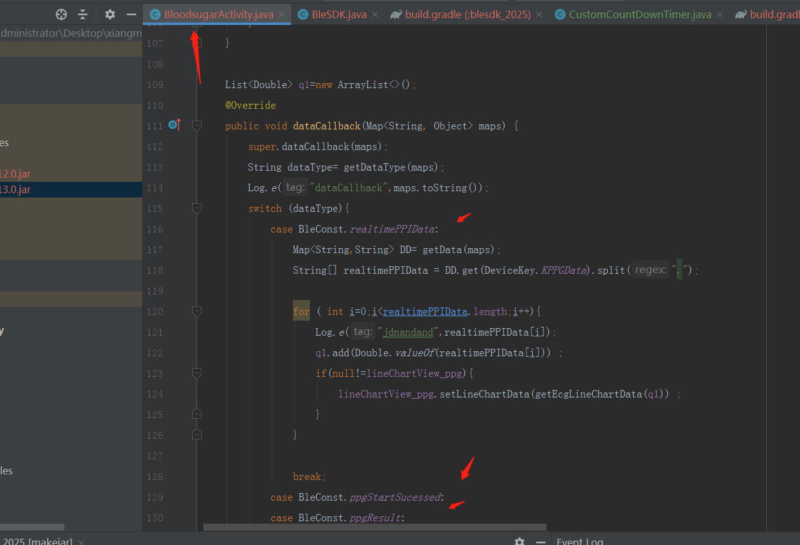

76：设置血压校准（Set Blood pressure calibration）
Bluetooth instruction head | 0x87
Usage method | 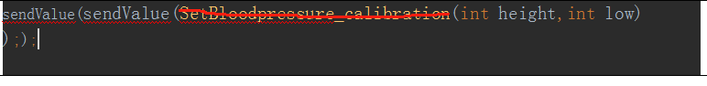  BloodPressureCalibrationWithMinDiastolicBP(int minDiastolicBP,int maxDiastolicBP,int minSystolicBP,int maxSystolicBP)
Usage method | {dataEnd=true, dataType=103, dicData={}}

77：读取血压校准（Get Blood pressure calibration）
Bluetooth instruction head | 0x88
Usage method |   sendValue(BleSDK.GetBloodPressureCalibrationValue());
Usage method | {dataEnd=true, dataType=104, dicData={KHrvBloodHighPressure=90, KHrvBloodLowPressure=61}}

连接设备状态监听 Connected device status monitoring

BleManager.getInstance().connectDevice(address, true, new BleConnectionListener() {
@Override
public void BleStatus(int status, int newState) {//蓝牙4.0连接状态 Bluetooth 4.0 connection status
Log.e(TAG, "BleStatus: "+status+"***"+newState);
}
@Override
public void ConnectionSucceeded() {//连接设备成功 Successfully connected the device
Log.e(TAG, "ConnectionSucceeded");
}
@Override
public void Connecting() {//设备连接中 Device is connected
Log.e(TAG, "Connecting");
}
@Override
public void ConnectionFailed() {//设备连接失败 Device connection failed
Log.e(TAG, "ConnectionFailed");
}
@Override
public void OnReconnect() {//重新连接中 Reconnecting
Log.e(TAG, "OnReconnect");
}

@Override
public void BluetoothSwitchIsTurnedOff() {//蓝牙开关被关闭 Bluetooth switch is turned off
Log.e(TAG, "BluetoothSwitchIsTurnedOff");
}
});

手机蓝牙开关状态获取Mobile Bluetooth switch status acquisition

protected class ListenerReceiver extends BroadcastReceiver {
@Override
public void onReceive(Context context, Intent intent) {
if (Objects.requireNonNull(intent.getAction()).equals(BluetoothAdapter.ACTION_STATE_CHANGED)) {
int state = intent.getIntExtra(BluetoothAdapter.EXTRA_STATE, BluetoothAdapter.ERROR);
switch (state) {
case BluetoothAdapter.STATE_ON://Bluetooth on
if (TextUtils.isEmpty(address)) {
Log.i(TAG, "onCreate: address null ");
return;
}
BleManager.getInstance().connectDevice(address,true,null);
break;
case BluetoothAdapter.STATE_OFF://Bluetooth off
if(null!=mainAdapter){
mainAdapter.setEnable(false);
}
if(null!=btConnect){
btConnect.setEnabled(true);}
BleManager.getInstance().disconnectDevice();
break;

}
}
}
}

