Abdulrhman Al-Otaibi 202321505

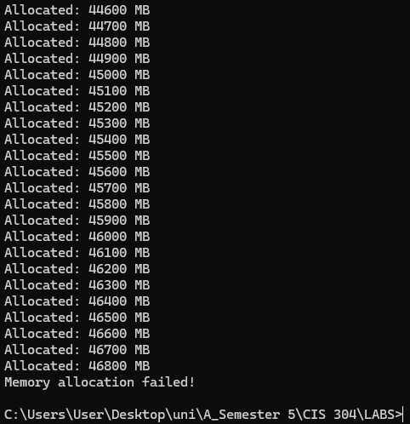
This program maximize the memory of a system:
- Using “C” I createed a program to allocate memory in fixed increments over time <”0.03s”> the program continues allocating memory until the system can no longer provide additional memory, which then will show a message <“Memory allocation failed!”>.
- We are gradually increasing <”100mb”>, and letting the program itself touch the memory using a for loop that will jump exactly a whole step “4096Bytes for each”, so 4096 -> 8192 -> 12,288 -> …etc.

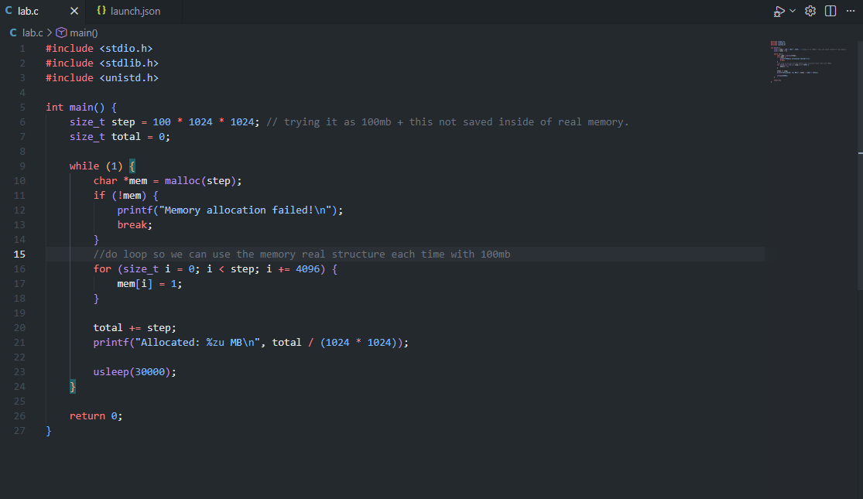

“The code that was used to test the system.”

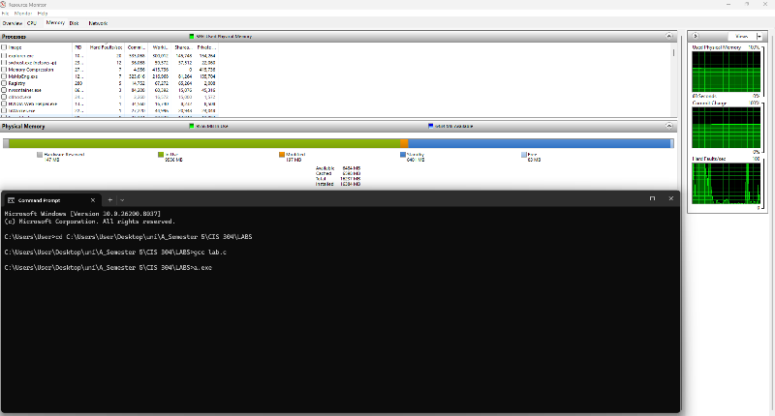
What happened?
Before starting “while compiling the program”
- Analyzing before starting, while running, and after failure we can see in the figure exactly on the right side the measures, also noticing that the Hard Faults are normal and low.

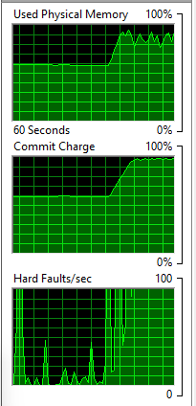
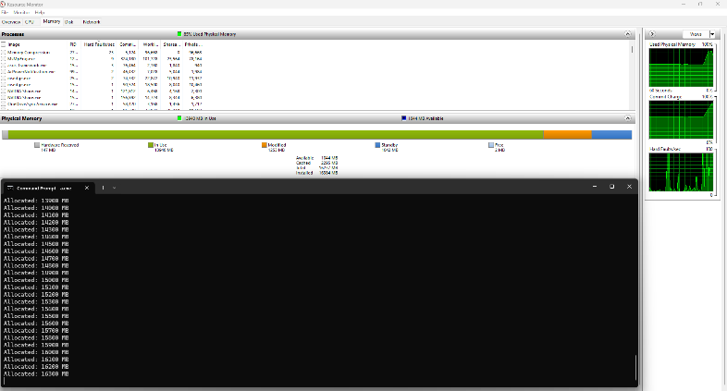
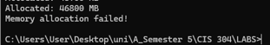
- RAM starts getting full [~90%], Hard faults are high and the green bar representing the usage is spiking; going to its max and then freeing some space, this is called “Swapping behavior”, which occurs when the memory is used at its max power where space is created using swapping technic by the system.
While running, “graphs are zoomed”.
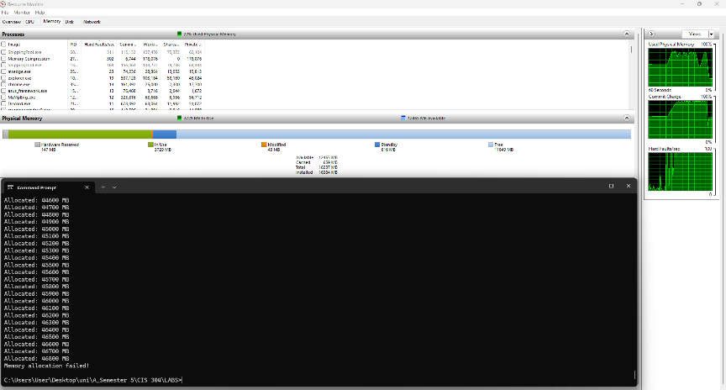
- System hits failure, Eventually, the program reaches a point where the system cannot allocate more memory. Then the green bar “Usage” becomes low.

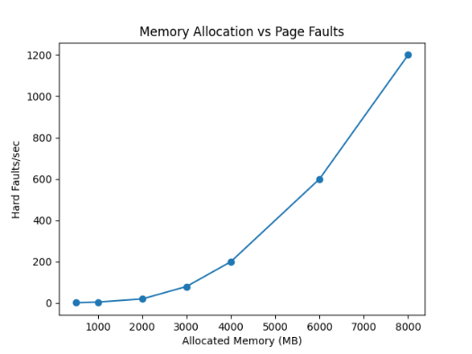
Conclusion:
1) Virtual memory allows programs to run even if RAM is limited
2) Page faults increase as memory usage increases
the system may enter a state called “thrashing”, where it spends most of the time swapping data instead of executing processes. Which obviously will result in making it slower.

