QA(i)

**Oil returns**

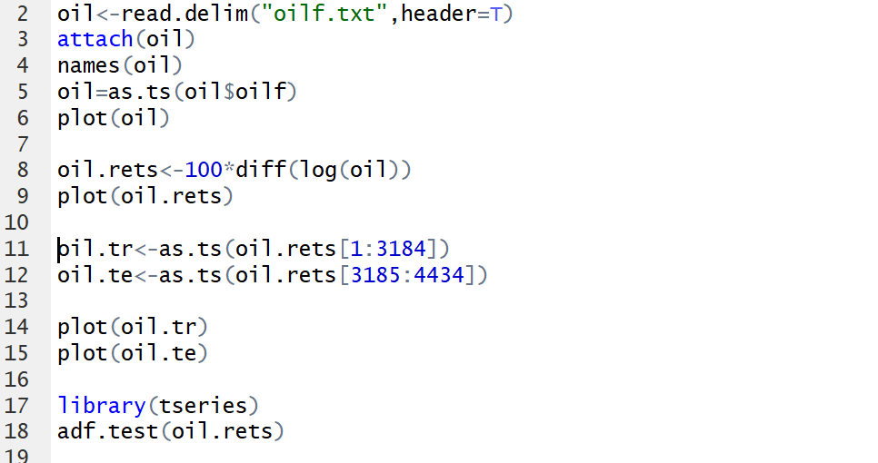

**Basic Stats analysis**

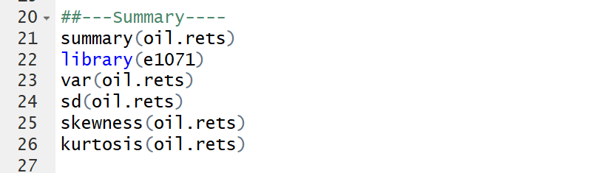  
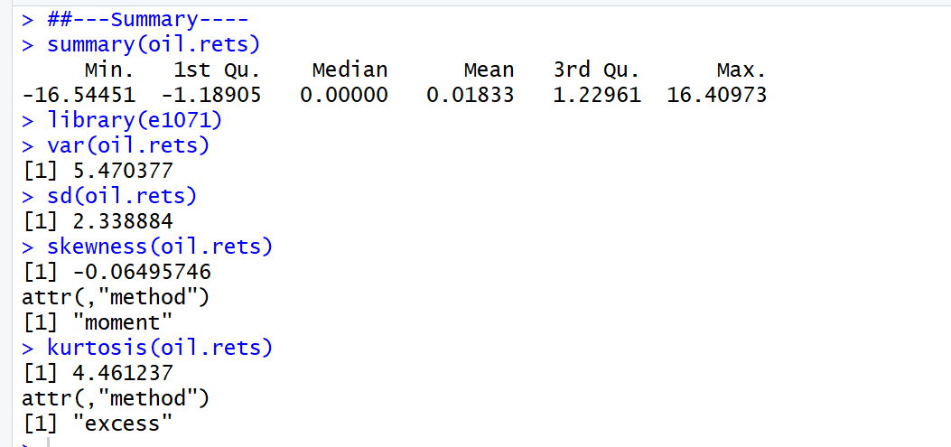

**Mean**

Sample mean of 0.01833 indicates that on average, daily return on oil price increased over the time by 0.01833%.

**Standard Deviation**

The daily return on oil price is deviated from the mean by 2.338884% on average over the time.

**Skewness**

Output gives the value of -0.06495746, which implies that during that time, the occurrence of negative return was greater than that of positive return.

**Excess Kurtosis**

The value of 4.461237 implies that the high possibility of big positive and negative return realizations.

**Minimum**

Minimum rate of return is negative 16.54451%

**Maximum**

Maximum rate of return is 16.40973%

**Normality diagnosis**

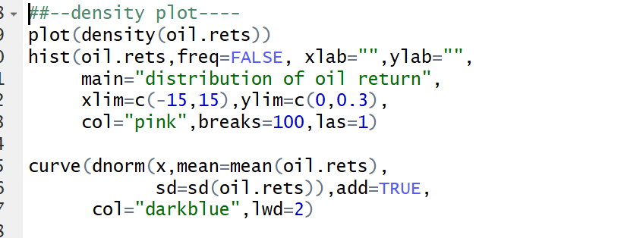

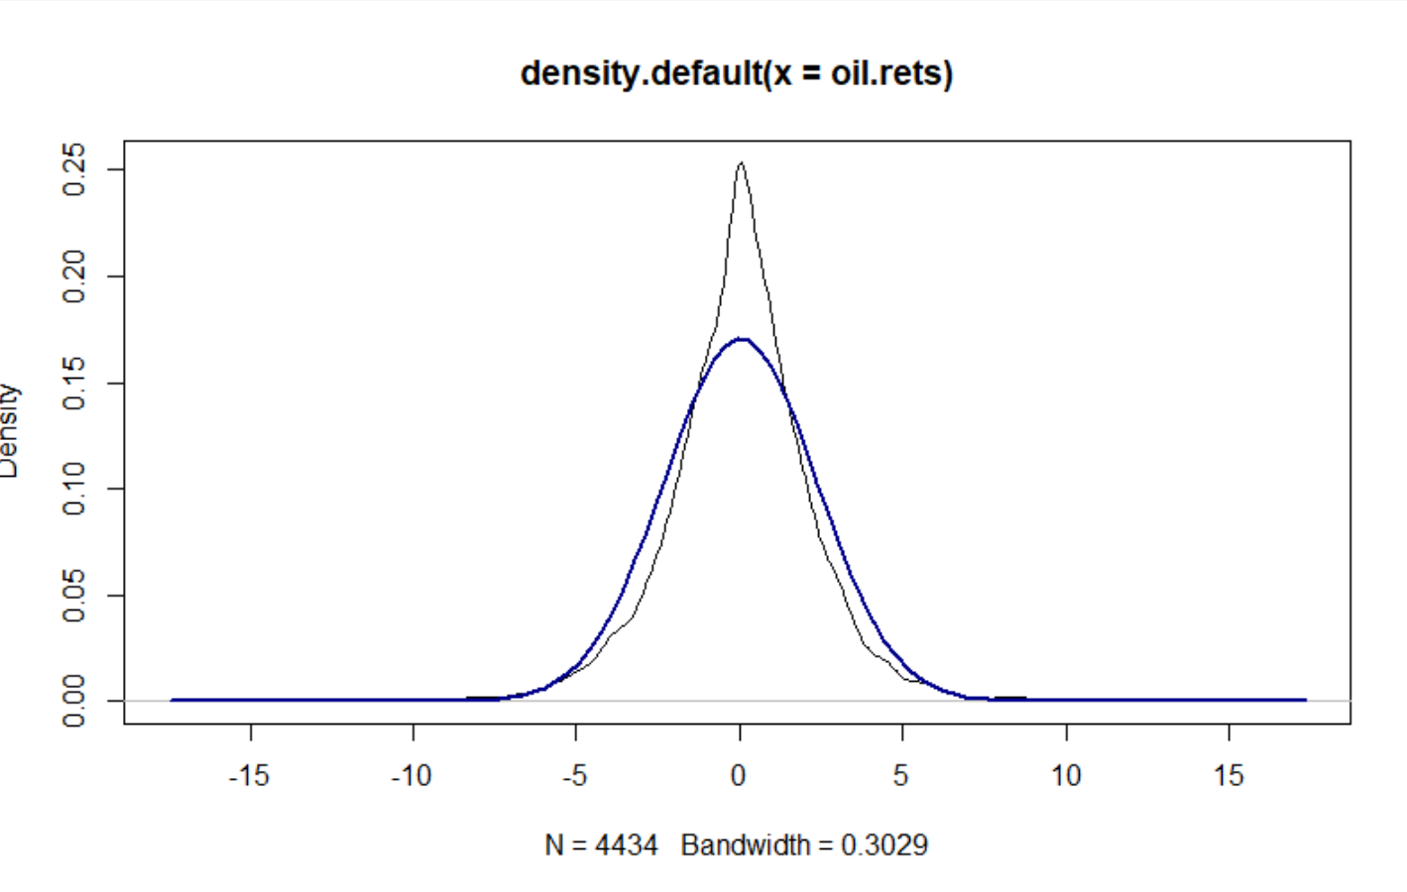

Based on the density plot about oil log return, real data (black line) does not follow the shape of theoretical normal density (Blue curve). Therefore, we might be able to conclude our oil log return data is not normally distributed.

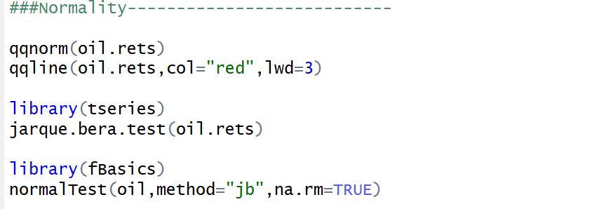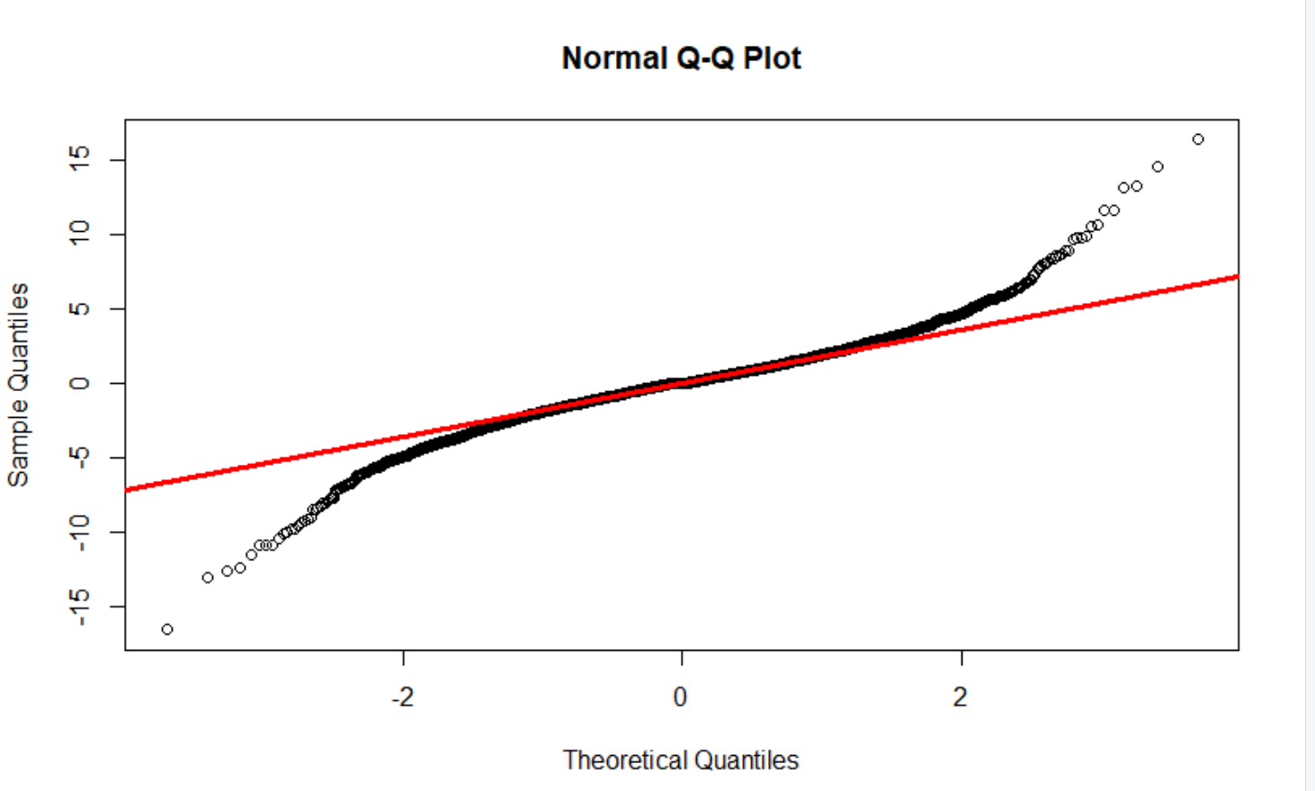

Based on QQ plot, intuitively, data does not seem to follow normally distributed data. Since when we look at the both tail of line, most of data point is far away from redline, which indicates non-normally distributed data.

To be ensure data is behave normally distributed, we could perform “Jarque Bera test”.

Output is given below.

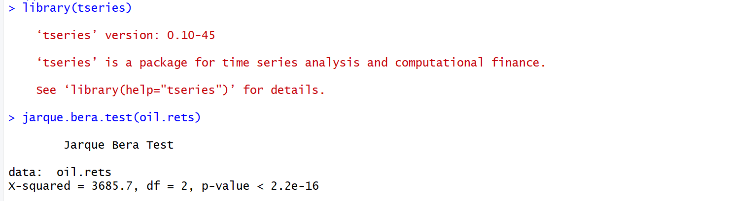

Based on R output, p-value is very small, then we reject the null hypothesis stating a joint hypothesis of the skewness being zero and the excess kurtosis being zero. The indicates that our oil log return data is not normally distributed.