**Revision**

**Returns**

**Example 1**

The following asset price info is given:

|  |  |
| --- | --- |
| 07/08/2018 | 08/08/2018 |
| 52 | 49 |

If the one-day log excess return is 1.5% on 08/08/2018, find the log return of a reference asset.

**Example 2**

If the monthly log return of an asset is 5.23%, find the simple net return.

**Example 3**

Transform the simple net return into log return. The simple return is given to be 2%.

**Example 4**

Show that Cov(X,Y)=E(XY)-E(X)E(Y).

**Writing down the fitted model**

$r_{t}=ϕ_{0}+ϕ_{1}r_{t-1}+u_{t}+θ_{1}u_{t-1}$ (1)

Remark:

A non-seasonal ARIMA model can be written as

$$\left(1-ϕ_{1}B-…-ϕ_{p}B^{p}\right){\left(1-B\right)}^{d}y_{t}=c+\left(1+θ_{1}B+…+θ_{q}B^{q}\right)ε_{t}$$

or equivalently as

$$\left(1-ϕ_{1}B-…-ϕ_{p}B^{p}\right){\left(1-B\right)}^{d}{(y}_{t}-μt^{d}/d!)=\left(1+θ_{1}B+…+θ_{q}B^{q}\right)ε_{t}$$

where $c=μ(1-ϕ_{1}-…-ϕ_{p})$ and $μ$ is the mean of ${\left(1-B\right)}^{d}y_{t}$

Therefore, Eq. 1 can be writtes as

$$\left(1-ϕ_{1}B\right){\left(1-B\right)}^{d}{(r}_{t}-μt^{d}/d!)=\left(1+θ_{1}B\right)u_{t}$$

where $d=0.$

**Forecasting accuracy measures:**

In this unit, we have focused on MSE and MAE loss functions.

**The ARCH model**

The first model that provides a systematic framework for volatility modeling is the ARCH model of Engle (1982). Specifically, an ARCH(m) model assumes that

$u_{t}=σ_{t}ϵ_{t}$, $σ_{t}^{2}=α_{0}+α_{1}u_{t-1}^{2}+…+α_{m}u_{t-m}^{2}$

where {$ϵ_{t}$} is a sequence of independent and identically distributed (iid) random variables with mean zero and variance 1, $α_{0}>0$, and $α_{i}≥0$ for $i>0$. The coefficients $α_{i}$ must satisfy some regularity conditions to ensure that the unconditional variance of $u_{t}$ is finite. In practice, $ϵ_{t}$ is often assumed to follow the standard normal or a standardized Student- $t$ or a generalized error distribution.

**Properties of ARCH Models**

To understand the ARCH models, it pays to carefully study the ARCH(1) model

$u_{t}=σ_{t}ϵ_{t}$, $σ_{t}^{2}=α_{0}+α_{1}u_{t-1}^{2}$

where, $α_{0}>0$ and $α_{1}≥0$. First, the unconditional mean of $u_{t}$ remains zero because

$$E\left(u_{t}\right)=E\left[E\left(u_{t} | Ψ_{t-1}\right)\right]= E\left[E\left(σ_{t}ϵ_{t} | Ψ_{t-1}\right)\right]=E[σ_{t}E(ϵ_{t})]=0$$

Second, the unconditional variance of $u_{t}$ can be obtained as

$$Var\left(u_{t}\right)=E\left(u_{t}^{2}\right)=E\left[E\left(u_{t}^{2} | Ψ_{t-1}\right)\right]=E\left(α_{0}+α_{1}u_{t-1}^{2}\right)=α_{0}+α_{1}E(u_{t-1}^{2})$$

Because $u_{t}$ is a stationary process with $E\left(u_{t}\right)=0$, $Var\left(u_{t}\right)=Var\left(u_{t-1}\right)=E(u_{t-1}^{2})$.

Therefore, we have $Var\left(u_{t}\right)=α_{0}+α_{1}Var\left(u_{t}\right)$ and $Var\left(u_{t}\right)={α_{0}}/{(1-α_{1}})$. Since the variance of $u_{t}$ must be positive, we require $0≤ α_{1}<1$.

**Order determination**

If an ARCH effect is found to be significant, one can use the PACF of $u_{t}^{2}$ to determine the ARCH order. Using PACF of $u_{t}^{2}$ to select the ARCH order can be justified as follows. From the model in Eq. (1), we have

$u_{t}=σ_{t}ϵ_{t}$, $σ_{t}^{2}=α_{0}+α_{1}u_{t-1}^{2}+…+α_{m}u_{t-m}^{2}$

For a given sample, $u_{t}^{2}$ is an unbiased estimate of $σ_{t}^{2}$. Therefore, we expect that $u_{t}^{2}$ is linearly related to $u_{t-1}^{2}, …, u_{t-m}^{2},$ in a manner similar to that of an autoregressive model of order $m$. Note that a single $u_{t}^{2}$ is generally not an efficient estimate of $σ_{t}^{2}$, but it can serve as an approximation that could be informative in specifying the order $m$.

Alternatively, define $η_{t}=u_{t}^{2}-σ_{t}^{2}$. It can be shown that {$η_{t}$} is an uncorrelated series with mean 0. The ARCH model then becomes

$$u_{t}^{2}=α_{0}+α_{1}u_{t-1}^{2}+…+α_{m}u_{t-m}^{2}+η_{t}$$

which is in the form of an AR(*m*) model for $u_{t}^{2}$, except that {$η_{t}$} is not an iid series.

Hence, the PACF of $u_{t}^{2}$ is a useful tool to determine the order *m*.

**Example 5.** We first apply the modeling procedure to build a simple ARCH model for the monthly log returns of Intel stock. The sample ACF and PACF of the squared returns in Figure 1 clearly show the existence of conditional heteroscedasticity. This is confirmed by the ARCH test and we proceed to identify the order of an ARCH model. The sample PACF in Figure 1 indicates that an ARCH(3) model might be appropriate. Consequently, we specify the model

$r_{t}=μ+u_{t}$, $u_{t}=σ_{t}ϵ_{t}$, $σ_{t}^{2}=α_{0}+α_{1}u_{t-1}^{2}+α_{2}u_{t-2}^{2}+α_{3}u_{t-3}^{2}$

for the monthly log returns of Intel stock. Assuming that $ϵ_{t}$ are iid standard normal, we obtain the fitted model

$σ_{t}^{2}=$ 0.0106 $+$ 0.2131 $u_{t-1}^{2}+$ 0.0770 $u_{t-2}^{2}+$ 0.0599 $u_{t-3}^{2}$

While the estimates meet the general requirement of an ARCH(3) model, the estimates of $α_{2}$ and $α_{3}$ appear to be statistically nonsignificant at the 5% level. Therefore, the model can be simplified.

Dropping the two nonsignificant parameters, we obtain the model

$σ_{t}^{2}=$ 0.0111 $+$ 0.3560 $u_{t-1}^{2}$

All the estimates are highly significant.

The Ljung–Box statistics of standardized residuals give Q(10) = 12.64 with a p value of 0.24 and those of squared standardized residuals give Q(10) = 14.75 with a p value of 0.14. Consequently, the ARCH(1) model is adequate for describing the conditional heteroscedasticity of the data at the 5% significance level.

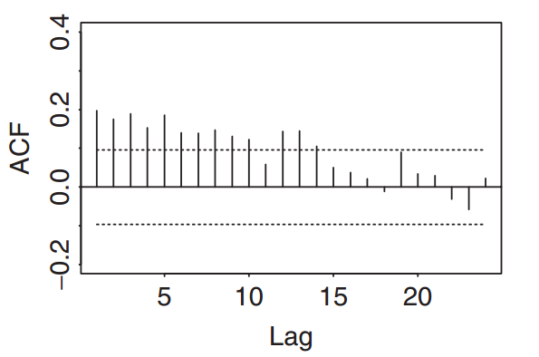

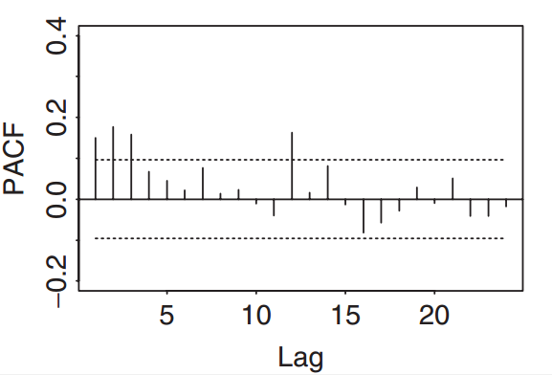

Figure 1: ACF and PACF of the squared log returns.

**Example 6**

Consider the percentage changes of the exchange rate between mark and dollar in 10-minute intervals. As shown in Figure 2, the series has no serial correlations. However, the sample PACF of the squared series $u_{t}^{2}$ shows some big spikes, especially at lags 1 and 3. There are some large PACF at higher lags, but the lower order lags tend to be more important. Following the procedure discussed in the previous section, we specify an ARCH(3) model for the series. Using the conditional Gaussian likelihood function, we obtain the fitted model.

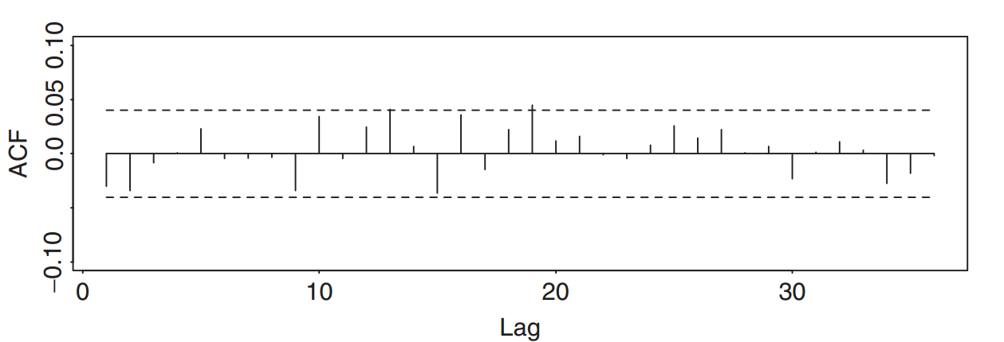

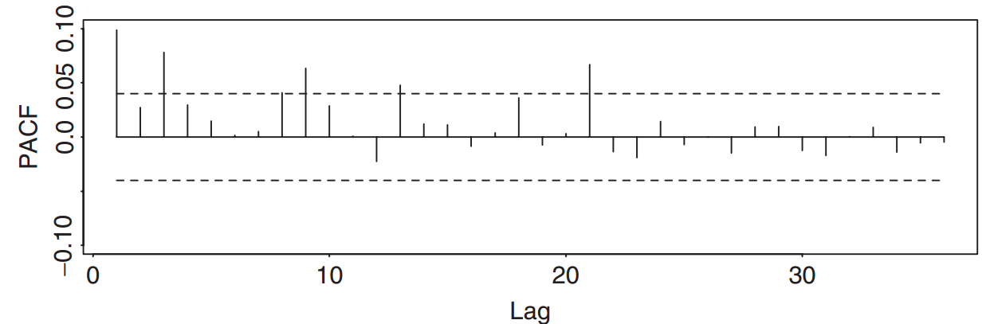

Figure 2: Sample autocorrelation function of return series of mark/dollar exchange rate and sample partial autocorrelation function of squared returns.

**The GARCH Model**

For a log return series $r_{t}$, let $u_{t}=r_{t}-μ_{t}$ be the innovation at time t.

$u_{t}$ follows a GARCH(m, s) model if

$u_{t}=σ_{t}ϵ_{t}$, $σ_{t}^{2}=ω+\sum_{i=1}^{m}{α_{i}u_{t-i}^{2}}+\sum_{j=1}^{s}{β_{j}σ_{t-j}^{2}}$ (2.1)

where again {$ϵ_{t}$} is a sequence of iid random variables with mean 0 and variance 1, $ω>0$, $α_{i}≥0$, $β_{j}≥0$, and $\sum_{i=1}^{max⁡(m,s)}{\left(α_{i}+β_{i}\right)<1}$.

The $α_{i}$ and $β_{i}$ are referred to as ARCH and GARCH parameters, respectively.

To understand properties of GARCH models, it is informative to use the following representation. Let $η_{t}=u_{t}^{2}-σ_{t}^{2}$ so that $σ_{t}^{2}=u_{t}^{2}-η_{t}$. By plugging $σ_{t-i}^{2}=u_{t-i}^{2}-η_{t-i}$ ($i=0,…,s$) into Eq. above and we can rewrite the GARCH model as

$u_{t}^{2}=ω+\sum_{i=1}^{max⁡(m,s)}{(α_{i}+β_{i}{)u}_{t-i}^{2}}+η_{t}-\sum_{j=1}^{s}{β_{j}η_{t-j}}$ (2.2)

$η_{t}$ is the martingale difference series $E\left(η_{t}\right)=0$ and $Cov\left(η_{t}, η_{t-j}\right)=0$ for $j≥1.$ Equation (2.2) is an ARMA form for the squared series $u_{t}^{2}$.

Thus, a GARCH model can be regarded as an application of the ARMA idea to the squared series $u_{t}^{2}$. Using the unconditional mean of an ARMA model, we have

$$E\left(u_{t}^{2}\right)=\frac{ω}{1-\sum_{i=1}^{max⁡(m,s)}{(α_{i}+β_{i})}}$$

provided that the denominator of the prior fraction is positive.

**Example 7**

Figure 3 shows the sample ACF of $r_{t}$ and the sample PACF of $r_{t}^{2}$. The $r_{t}$ series has some serial correlations at lags 1 and 3, but the key feature is that the PACF of $r_{t}^{2}$ shows strong linear dependence.

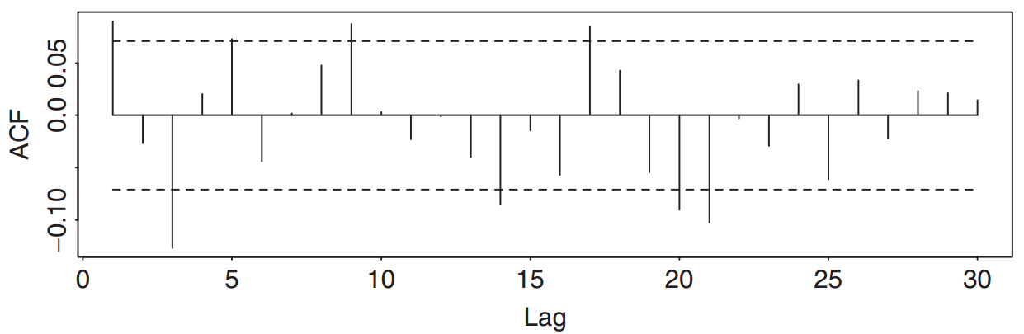

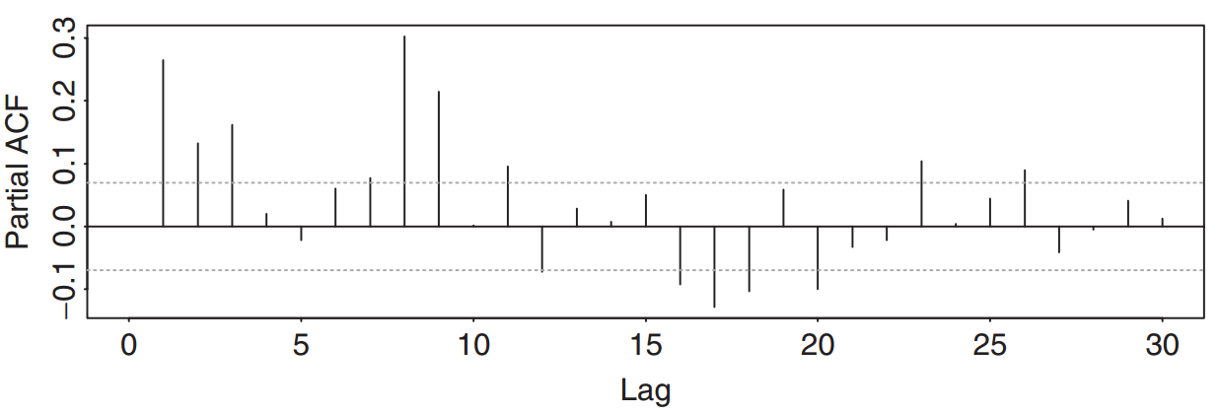

The fitted AR(3) model, under the normality assumption, is

For the GARCH effects, we use the GARCH(1,1) model

$$r_{t}=0.0078+0.032r_{t-1}-0.029r_{t-2}-0.008r_{t-3}+u_{t}$$

$$σ_{t}^{2}=0.000084+0.1213u_{t-1}^{2}+0.8523σ_{t-1}^{2}$$

From the volatility equation, the implied unconditional variance of $u_{t}$ is

$$\frac{0.000084}{1-0.8523-0.1213}=0.00317$$

**The EGARCH model**

To overcome some weaknesses of the GARCH model in handling financial time series, Nelson (1991) proposes the exponential GARCH (EGARCH) model. In particular, to allow for asymmetric effects between positive and negative asset returns, he considered the weighted innovation

$$g\left(ϵ_{t}\right)=θϵ_{t}+γ[\left|ϵ_{t}\right|-E(|ϵ_{t}|)]$$

Where $θ$ and $γ$ are real constants. Both $ϵ_{t}$ and $\left|ϵ_{t}\right|-E(|ϵ_{t}|)$ are zero-mean iid sequences with continuous distributions. Therefore, $E\left(\left|ϵ_{t}\right|\right)=0$. The asymmetry of $g\left(ϵ_{t}\right)$ can easily be seen by rewriting it as

$$g\left(ϵ_{t}\right)=\left\{\begin{matrix} \left(θ+γ\right)ϵ_{t}-γE\left(\left|ϵ_{t}\right|\right), & ϵ_{t}≥0 \\ \left(θ-γ\right)ϵ_{t}-γE\left(\left|ϵ_{t}\right|\right), & ϵ_{t}<0\end{matrix}\right.$$

To better understand the EGARCH model, let us consider the simple model with order (1,1):

$u_{t}=σ_{t}ϵ_{t}$,

Alternative model form

An alternative form for the EGARCH(m, s) model is

$\ln\left(σ_{t}^{2}\right)=α_{0}+\sum_{i=1}^{s}{α_{i}\frac{\left|u_{t-i}\right|+γ_{i}u_{t-i}}{σ_{t-i}}+\sum_{j=1}^{m}{β_{j}ln⁡(σ_{t-j}^{2})}}$

Consider the EGARCH(1, 1) model

$\ln\left(σ_{t}^{2}\right)=α_{0}+α_{1}\frac{\left|u_{t-1}\right|+γ_{1}u_{t-1}}{σ_{t-1}} +β_{1}ln⁡(σ_{t-1}^{2})$

Here a positive $u_{t-1}$ contributes $α_{1}\left(1+γ_{1}\right)|ϵ_{t-1}|$ to the log volatility, whereas negative $u_{t-1}$ gives $α_{1}\left(1-γ_{1}\right)|ϵ_{t-1}|$ where $ϵ_{t-1}={u_{t-1}}/{σ_{t-1}}$. The $γ_{1}$ parameter thus signifies the leverage effect of $u_{t-1}$ and asymmetry.

**The GARCH-M Model**

In finance, the return of a security may depend on its volatility. To model such a phenomenon, one may consider the GARCH-M model, where M stands for GARCH in the mean. A simple GARCH(1,1)-M model can be written as

$r_{t}=μ+cσ_{t}^{2}+u_{t},$ $u_{t}=σ_{t}ϵ_{t}$

$σ_{t}^{2}=ω+α_{1}u_{t-1}^{2}+β_{1}σ_{t-1}^{2}$

where µ and c are constants. The parameter c is called the risk premium parameter. A positive c indicates that the return is positively related to its volatility. Other specifications of risk premium have also been used in the literature, including

$r_{t}=μ+cσ_{t}+u_{t}$ and $r_{t}=μ+c{ln⁡(σ}_{t}^{2})+u_{t}$

R adjustment

ugarchspec(variance.model = list(model = "sGARCH", garchOrder = c(1, 1), submodel = NULL, external.regressors = NULL, variance.targeting = FALSE), mean.model = list(armaOrder = c(1, 1), include.mean = TRUE, **archm = FALSE**, **archpow = 1**, arfima = FALSE, external.regressors = NULL, archex = FALSE), distribution.model = "norm", start.pars = list(), fixed.pars = list(), ...)

**archm** Whether to include ARCH volatility in the mean regression. **archpow** Indicates whether to use st.deviation (1) or variance (2) in the ARCH in mean regression.

**The Threshold GARCH model**

Another volatility model commonly used to handle leverage effects is the threshold GARCH (or TGARCH) model; see Glosten, Jagannathan, and Runkle (1993) and Zakoian (1994). A TGARCH(m, s) model assumes the form

$σ_{t}^{2}=ω+\sum_{i=1}^{s}{\left(α_{i}+γ_{i}I_{t-i}\right)u_{t-i}^{2}}+\sum_{j=1}^{m}{β_{j}σ_{t-j}^{2}}$ (3)

Where $I_{t-i}$ is an indicator for negative $u_{t-i}$, that is,

$I_{t-i}=\left\{\begin{matrix}1 \\ 0\end{matrix}\right.$ $\begin{matrix}if \\ if\end{matrix}$ $\begin{matrix}u_{t-i}<0 , \\ u_{t-i}≥0 ,\end{matrix}$

and $α_{i}$, $γ_{i}$, and $β_{j}$ are nonnegative parameters satisfying conditions similar to those of GARCH models. From the model, it is seen that a positive $u_{t-i}$ contributes $α_{i}u_{t-i}^{2}$ to $σ_{t}^{2}$, whereas a negative $u_{t-i}$ has a larger impact $\left(α_{i}+γ_{i}\right)u_{t-i}^{2}$ with $γ_{i}>0$. The model uses zero as its threshold to separate the impacts of past shocks. Model (3) is also called the GJR model because Glosten et al. (1993) proposed essentially the same model.

For illustration, consider the monthly log returns of IBM stock from 1926 to 2003. The fitted TGARCH(1,1) model with conditional GED innovations is

$r_{t}=0.0121+u_{t}$, $u_{t}=σ_{t}ϵ_{t}$

$σ_{t}^{2}=3.45×{10}^{-4}+\left(0.0658+0.0843I_{t-1}\right)u_{t-1}^{2}+0.8182σ_{t-1}^{2}$

To check the fitted model, we have Q(12) = 18.34(0.106) for the standardized residuals and Q(12) = 5.36 (0.95) for squared standardized residuals. The model is adequate in modeling the first two conditional moments of the log return series. Based on the fitted model, the leverage effect is significant at the 5% level.

Assume that $u_{t-i}=±2σ_{t}$ so that $ϵ_{t}=±2$.

Ignoring the constant term 0.000345, the TGARCH(1,1) model gives

$$\frac{σ_{t}^{2}\left(ϵ_{t}=-2\right)}{σ_{t}^{2}\left(ϵ_{t}=+2\right)}≈\frac{\left[\left(0.0658+0.0843\right)4+0.8182\right]σ_{t-1}^{2}}{\left(0.0658×4+0.8182\right)σ_{t-1}^{2}}=1.312$$

Therefore, the impact of a negative shock of size 2 standard deviations is about 31.2% higher than that of a positive shock of the same size. This example clearly demonstrates the asymmetric feature of TGARCH models. In general, the bigger the shock, the larger the difference in volatility impact.