


Vandelay Health Benefits Application
Requirements Definition
Version Number: 1.2
Version Date: 04/24/2015

Notes to the Author
[This document is a template of a Requirements Definition document for a project. The template includes instructions to the author, boilerplate text, and fields that should be replaced with the values specific to the project.
- Blue italicized text enclosed in square brackets ([text]) provides instructions to the document author, or describes the intent, assumptions and context for content included in this document.
- Blue italicized text enclosed in angle brackets (<text>) indicates a field that should be replaced with information specific to a particular project.
- Text and tables in black are provided as boilerplate examples of wording and formats that may be used or modified as appropriate to a specific project. These are offered only as suggestions to assist in developing project documents; they are not mandatory formats.

When using this template, the following steps are recommended:
- Replace all text enclosed in angle brackets (e.g., <Project Name>) with the correct field document values. These angle brackets appear in both the body of the document and in headers and footers. To customize fields in Microsoft Word (which display a gray background when selected) select File->Properties->Summary and fill in the appropriate fields within the Summary and Custom tabs.
After clicking OK to close the dialog box, update all fields throughout the document selecting Edit>Select All (or Ctrl-A) and pressing F9. Or you can update each field individually by clicking on it and pressing F9.
These actions must be done separately for any fields contained with the document’s Header and Footer.
- Modify boilerplate text as appropriate for the specific project.
- To add any new sections to the document, ensure that the appropriate header and body text styles are maintained. Styles used for the Section Headings are Heading 1, Heading 2 and Heading 3. Style used for boilerplate text is Body Text.
- To update the Table of Contents, right-click on it and select “Update field” and choose the option - “Update entire table”.
- Before submission of the first draft of this document, delete this instruction section “Notes to the Author” and all instructions to the author throughout the entire document.
VERSION HISTORY
[Provide information on how the development and distribution of the Requirements Definition will be controlled and tracked. Use the table below to provide the version number, the author implementing the version, the date of the version, the name of the person approving the version, the date that particular version was approved, and a brief description of the reason for creating the revised version.]
Version  Number | Implemented  By | Revision  Date | Approved  By | Approval  Date | Description of  Change
1.0 | Rickey Otano | 03/12/2015 | self | 03/12/2015 | Project started
1.1 | Rickey Otano | 03/24/2015 | self | 03/24/2015 | ERB & database creation
1.2 | Rickey Otano | 03/30/2015 | self | 03/30/15 | Wire-Frames
1.3 | Rickey Otano | 04/24/2015 | self | 03/24/2015 | CRUD Code

TABLE OF CONTENTS
1 Introduction 3
1.1 Purpose of the Requirements Definition Document 3
2 Business Requirements Overview 3
2.1 Assumptions / Constraints 3
2.2 System Scope 3
3 Functional Requirements 3
3.1 <Functional Requirements Group 1> 3
3.2 <Functional Requirements Group 2> 3
4 Non-Functional Requirements 3
4.1 Design Constraints 3
4.2 Hardware Requirements 3
4.3 Software Requirements 3
4.4 Performance Requirements 3
4.5 Reliability Requirements 3
4.6 Supportability Requirements 3
4.7 User Documentation Requirements 3
4.8 Interface Requirements 3
4.9 Security and Privacy Requirements 3
4.10 Compliance and Standards Requirements 3
5 Business Process Model 3
6 Logical Data Model 3
7 Requirements Traceability Matrix 3
Appendix A: Requirements Definition Approval 3
APPENDIX B: REFERENCES 3
APPENDIX C: Business Process Model 3
APPENDIX D: Logical Data Model 3
APPENDIX E: Requirements Traceability Matrix 3

Introduction

Purpose of the Requirements Definition Document
[Provide the purpose of the Functional Requirements Definition Document. This document should be tailored to fit a particular project’s needs.]
The Requirements Definition defines the functional, non-functional, and technical requirements. The Requirements Definition document is created during the Requirements Analysis Phase of the project. Its intended audience is the project manager, project team, project sponsor, client/user, and any stakeholder whose input/approval into the requirements definitions process is needed.

Business Requirements Overview
[Describe here the business requirements that the project work will fulfill and how and/or where the completed project product will fit into any existing systems. Business requirements can often be described as ‘features.’ Assign a unique ID number to each requirement.]

Assumptions / Constraints
[Describe any overall assumptions / constraints related to project requirements]

System Scope
[Describe the features, users, and interfaced systems. Include a context diagram if appropriate. Assign a unique ID number to each requirement.]

Functional Requirements
[Functional requirements capture and specify intended behavior of the system being developed. They define things such as system calculations, data manipulation and processing, user interface and interaction with the application, and other specific functionality that show how user requirements are satisfied. Assign a unique ID number to each requirement.
The functional requirements are grouped according to the project’s needs, and maybe influenced by the requirements tools and techniques used. ]

<Functional Requirements Group 1>

<Functional Requirements 1>

<Functional Requirements Group 2>

Non-Functional Requirements
[Describe the existing non-functional (also referred to as Quality of Service by the International Institute of Business Analysts, Business Analysis Body of Knowledge), technical environment, systems, functions, and processes. Include an overview of the non-functional requirements necessary to achieve the project’s objectives.]

Design Constraints
[Describe hardware/software requirements that will limit the design or COTS options. These may include laws, regulations, hardware limitations, interfaces, development environment, operational environment, criticality, safety, and/or security. Assign a unique ID number to each requirement.]

Hardware Requirements
[Describe hardware requirements and any related processes. Include a detailed description of specific hardware requirements and associate them to specific project functionality/deliverables. Include information such as type of hardware, brand name, specifications, size, security, etc. Assign a unique ID number to each requirement.]

Software Requirements
[Describe software requirements and any related processes. Include a detailed description of specific software requirements and associate them to specific project functionality/deliverables. Include information such as in-house development or purchasing, security, coding language, version numbering, functionality, data, interface requirements, brand name, specifications, etc. Assign a unique ID number to each requirement.]

Performance Requirements
[Describe performance requirements and any related processes. Include a detailed description of specific performance requirements and associate them to specific project functionality/deliverables. Include information such as system capacity, cycle time, speed per transaction, test requirements, minimum bug counts, speed, reliability, utilization etc. Assign a unique ID number to each requirement.]

Reliability Requirements
[Describe all of the technical requirements that affect availability such as hours of operation, level of availability required, down-time impact, support availability, accuracy, etc. Assign a unique ID number to each requirement.]

Supportability Requirements
[Describe all of the technical requirements that affect supportability and maintainability such as coding standards, naming CONVENTIONS; maintenance access, required utilities, etc. Assign a unique ID number to each requirement.]

User Documentation Requirements
[Describe the requirements, for any special or on-line user documentation or help systems, etc. Assign a unique ID number to each requirement.]

Interface Requirements
[Describe all of the user interface (such as user navigation, presentation of application and associated functionality, screen location of interface elements, data display and manipulation, etc), system interface, and technical (hardware and software) requirements that affect interfaces such as look-and-feel, protocol management, scheduling, directory services, broadcasts, message types, error and buffer management, security, etc. Assign a unique ID number to each requirement.]

Security and Privacy Requirements
[Summarize and make reference to Privacy Impact Assessment produced during Planning phase and its impact on security requirements. Provide justifications for why a specific privacy item is needed. Provide Security Categorization if available.
Describe all of the technical requirements that affect security such as security audits, cryptography, user data, system identification/authentication, resource utilization, facility access times, etc. Assign a unique ID number to each requirement. ]

Compliance and Standards Requirements
[Describe the existing compliance environment as it affects project requirements, and the standards the system development must follow. Include an overview of the compliance or standards requirements necessary to achieve the project’s objectives. List all that are applicable to the project. Assign a unique ID number to each requirement.]

Business Process Model
User Stories:

Id | Request | Requestor | Status | Phase | Priority
1 | I need to be able to add insurance companies, company code, and company description. | HR | In Progress | Code | 1
2 | I need to be able to add dependent code, and description. | HR | In Progress | Code | 2
3 | I need to be able to add departments and department description. | HR | In Progress | Code | 3
4 | I need to be able to add insurance rates, need ability to select dependent code and insurance code. | HR | In Progress | Code | 4
5 | I need to be able to enroll employees in insurance. I need access to employee id, HMO or PPO as health care, dental & vision optional insurance, dependent codes for each, and the insurance effective date. | HR | In Progress | Code | 6
6 | I need to be able to add an employee. I need to be able to assign employee id and add address, city, state, zip, first & last name, and extension number. | HR | In Progress | Code | 5
7 | I need to be able to generate a report for employees by insurance policy. The report needs to be sort-able first by insurance company, and then by employee name. Each report needs to have the employee's id, first and last name, and dependent code. | HR | Ready | Planning | 7
8 | I need to generate a report that shows the number of employees in both ppo and hmo insurance. | HR | Ready | Planning | 8
9 | I need to generate a report that shows a list employees that have insurance on only 2 or more kids, no spouse. | HR | Ready | Planning | 9
10 | I need to generate a report that will show a count of employees by insurance company. The report needs to show the insurance company, the description of the company, and number of employees enrolled. | HR | Ready | Planning | 10

Use Case:
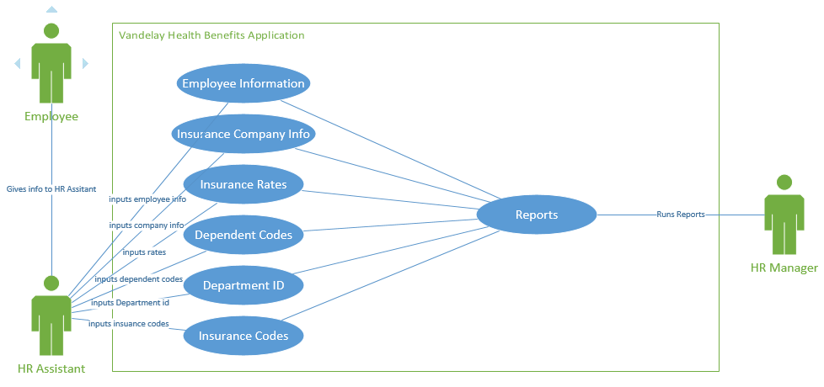
See Appendix D – Vandelay Health Benefits Business Process Model.

Logical Data Model
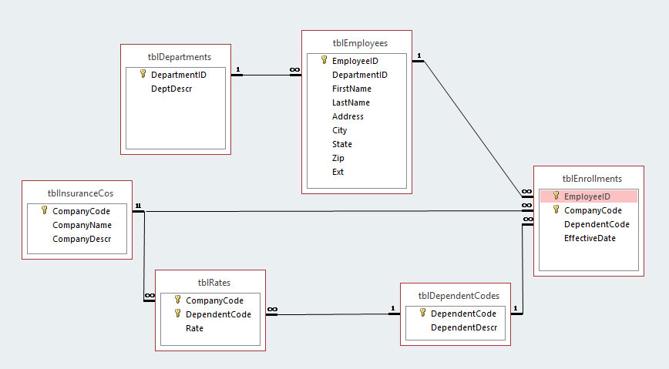

User Interface Data Entry Form Wire-Frames:

Insurance Company Entry Form, User Story #1
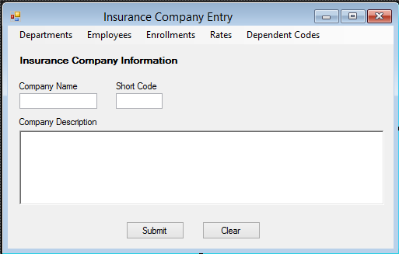

Dependent Code Entry Form, User Story #2
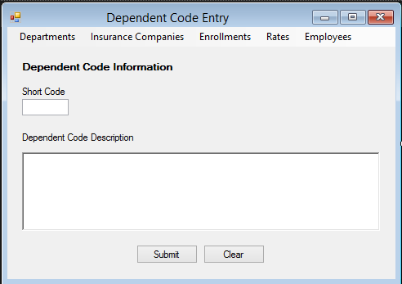

Department Entry Form, User Story #3
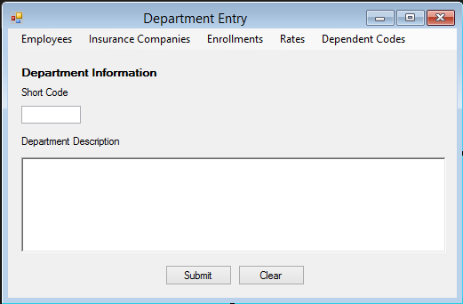

Insurance Rate Entry Form, User Story #4

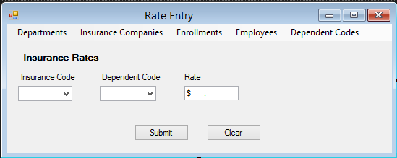

Employee Insurance Enrollment Entry Form, User Story #5

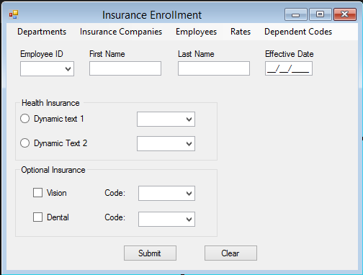

Employee Information Entry Form, User Story #6

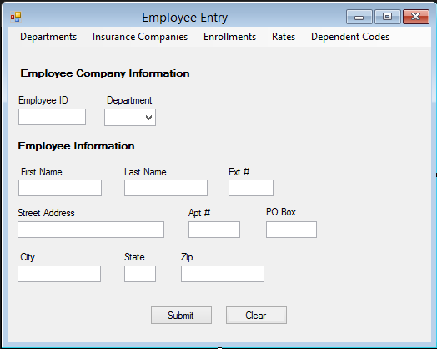
See Appendix E – Vandelay Health Benefits Logical Data Model.

Requirements Traceability Matrix
[Include the Traceability Matrix as an appendix. In the Requirements Analysis phase, the matrix is populated with requirements identified in the Requirements Definition. It is a living document that should be populated with information throughout design, construction, and test phases, etc.]
See Appendix F - <Project Name> Requirements Traceability Matrix.
Appendix A: Requirements Definition Approval
The undersigned acknowledge that they have reviewed the <Project Name> Requirements Definition and agree with the information presented within this document. Changes to this Requirements Definition will be coordinated with, and approved by, the undersigned, or their designated representatives.
[List the individuals whose signatures are desired. Examples of such individuals are Business Owner, Project Manager (if identified), and any appropriate stakeholders. Add additional lines for signature as necessary.]

Signature: |  | Date:
Print Name:
Title:
Role:

Signature: |  | Date:
Print Name:
Title:
Role:

Signature: |  | Date:
Print Name:
Title:
Role:

APPENDIX B: REFERENCES
[Insert the name, version number, description, and physical location of any documents referenced in this document. Add rows to the table as necessary.]
The following table summarizes the documents referenced in this document.
Document Name | Description | Location
<Document Name and Version Number> | <Document description> | <URL or Network path where document is located>

APPENDIX C: Business Process Model
The Business Process Model is attached as a separate document.

APPENDIX D: Logical Data Model
The Logical Data Model is attached as a separate document.

APPENDIX E: Requirements Traceability Matrix
The Requirements Traceability Matrix is attached as a separate document.

