Rickey Otano
week 1 user stories
Business Application Development

User Stories

# | Request | Requester
1 | As a HR Manager I need to be able to generate a report for employees by insurance policy. The report needs to be sort-able first by insurance company, and then by employee name. Each report needs to have the employee's id, first and last name, and dependent code. | HR Manager
2 | As a HR Manager I need to generate a report that shows the number of employees in both ppo and hmo insurance. | HR Manager
3 | As a HR Manager I need to generate a report that shows a list employees that have insurance on only 2 or more kids, no spouse. | HR Manager
4 | As a HR Manager I need to generate a report that will show a count of employees by insurance company. The report needs to show the insurance company, the description of the company, and number of employees enrolled.  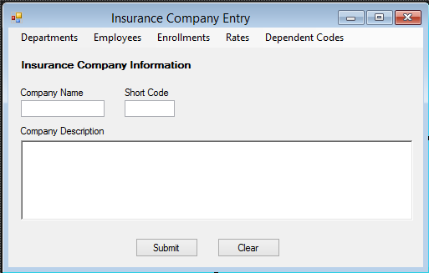 | HR Manager
5 | As a HR Manager I need to be able to track employee information. This includes the employee id, department id, first name, last name, street address, city, state, zip code, and office extension number.  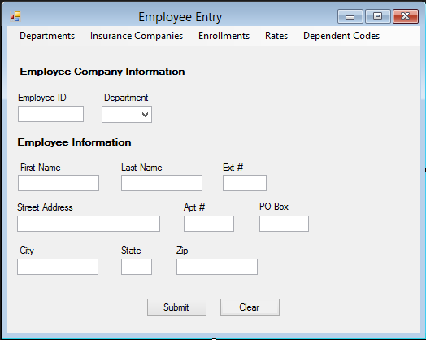 | HR Manager
6 | As an employee I need to be able to change my insurance plan. Change main type, either ppo or hmo. This also includes adding dental and or vision codes(for self, self and spouse, self-spouse and child(ren), self no spouse and child(ren). | Employee
7 | As an employee I need to be able to see my rates after I pick my plan(s). After all codes have been entered rate of plan needs to be shown. | Employee
8 | As a HR Manager I need to be able to modify employee info if not correct. This includes the employee id, department id, first name, last name, street address, city, state, zip code, and office extension number.  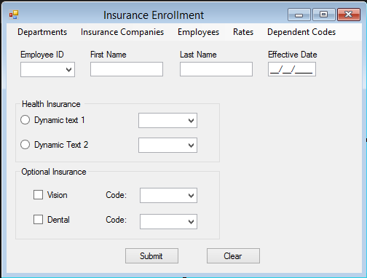 | HR Manager
9 | As a HR Manager I need to be able to track departments. Be able to change or add new departments.  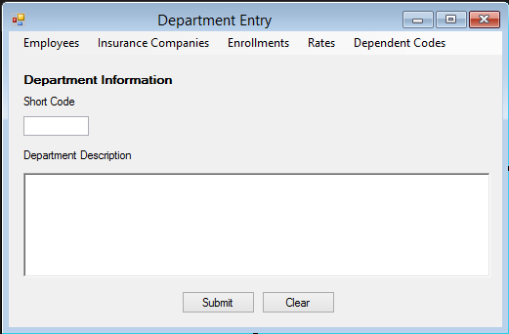 | HR Manager
10 | As HR manager I need to be able to manage dependent codes. Add, change/modify, and remove codes.  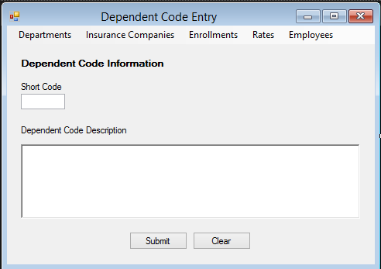 | HR Manager
11 | As a HR Manager I need to be able to track enrollment. | HR Manager

