Simple Marketing Agency Web API

This project provides the skeleton for optimization of Marketing Agency companies. It includes basic CRUD operations and structured database schema with relationships

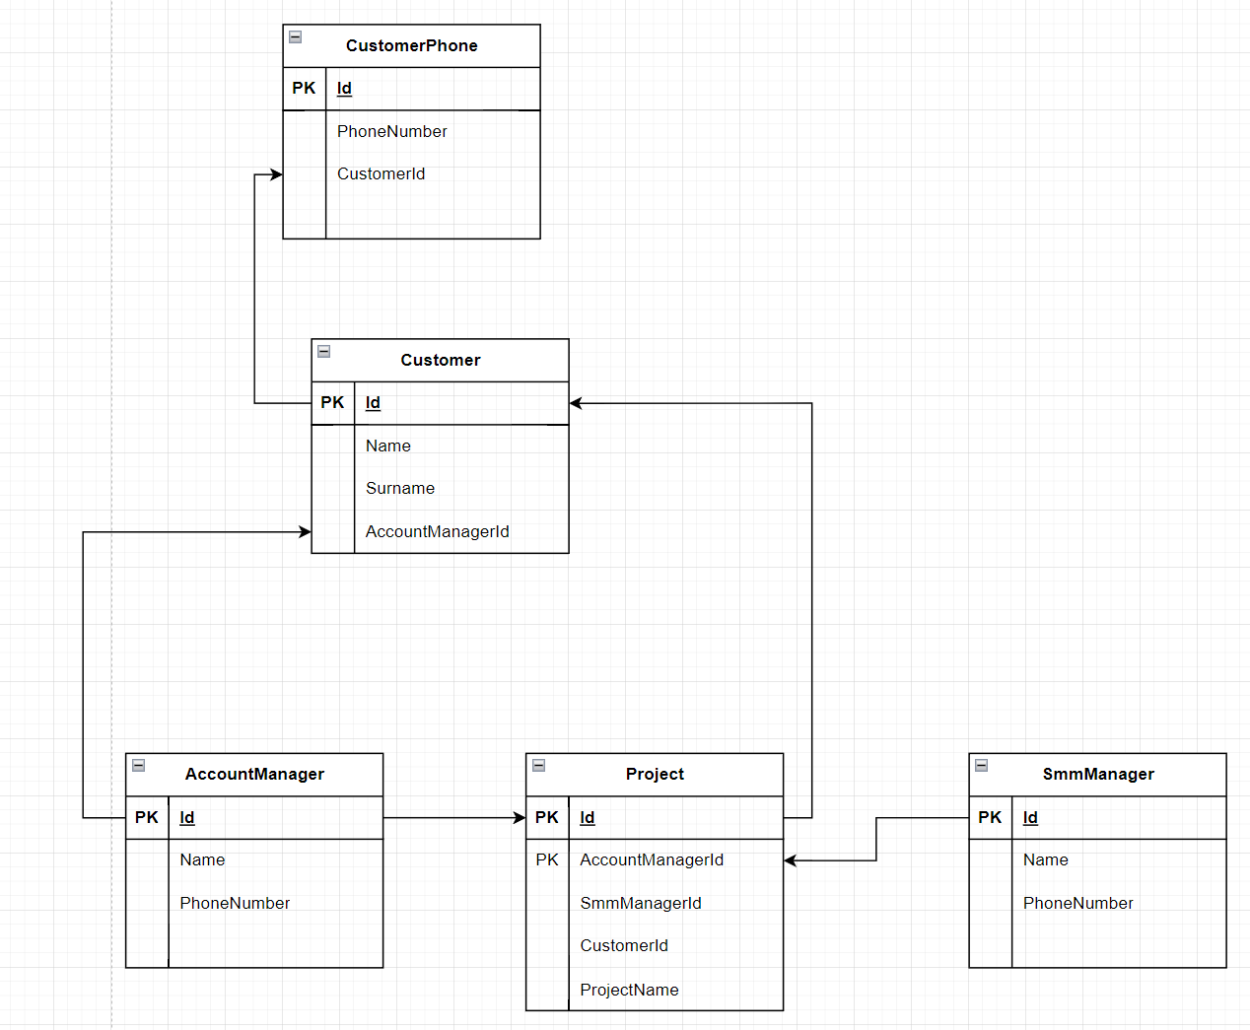

**Briefly about the ER diagram**. It shows entities like Customer, Manages and Projects. AccountManagers are seniors in the company and are able to distribute projects among smm managers. When customer contacts AccountManager the customer is assigned to one of them and always cooperates with only one manager. When details of the project are clarified, AccountManager initiates the project with all parties including Customer and SmmManager. As it can be seen from diagram the independent parties here are Account and Smm managers so they have to be created first.

**Briefly about WebAPI.** API includes basic operations of CRUD and does not include any advanced business logic or its validation. System supposes that user sends correct data and handles such situations using try/catch pattern.

Operations like Create and Update return the entity which was created or updated. Delete operation returns no message, only status code of successful deletion.