UI exaplained
1. Inventory
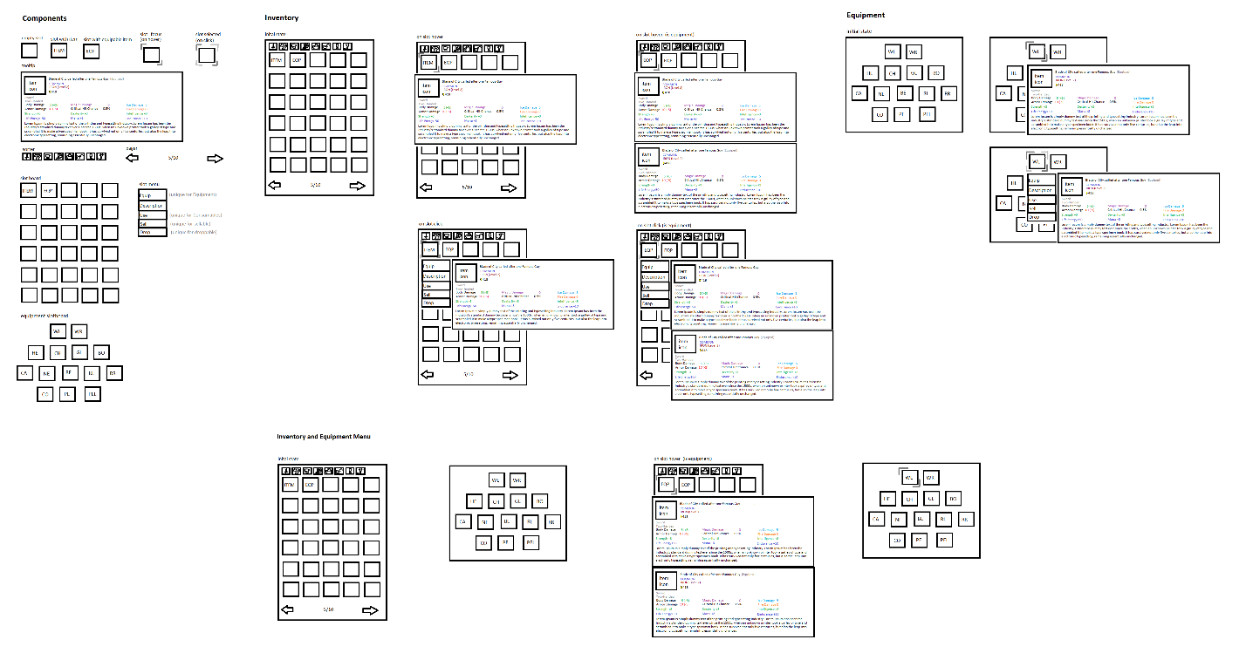
..\sketches\inventory_sketched_new.png

Components:
SlotComponent
ItemInfoTooltipComponent
ItemActionMenuComponent
SorterComponent
PagerComponent
InventoryComponent
EquipmentComponent
InventoryToEquipmentComponent
Changes Overview:

Inventory:
- Focusing the slots that are on hover or on click.
- Selecting the slots that are on click.
- Showing the item tooltip when slot on hover or on click.
- Showing the item menu when slot on click.
- The free layouting of the items in slots is deprecated.
- The dragNdrop of the items in slots is deprecated.
Equipment:
- Focusing the slots that are on hover or on click.
- Selecting the slots that are on click.
- Showing the item tooltip when slot on hover or on click.
- Showing the item menu when slot on click.
- The dragNdrop of the items in slots is deprecated.

InventoryToEquipment:
- The action “Equip” appears in the ItemActionMenu if the selected inventory item is equipment, and the suitable slot item in the equipment is null.
- The action “Swap Equipment” appears in the ItemActionMenu if the selected inventory item is equipment and the suitable item in the equipment slot is NOT null.
- The action “Drop” appears in the ItemActionMenu if the item is not questitem.
- The action “Sell” appears in the ItemActionMenu if the item has a price.
- The action “Description” appears in the ItemActionMenu always.
- Showing additional item tooltip when slot on hover or on click, and if the item is equipment, and if there is suitable slot in the equipment for item, and if the suitable slot in the equipment is NOT empty.
- The dragNdrop of the items in slots is deprecated.

- After clicking the “Equip” or “Swap Equipment” action, the suitable slot in equipment item sets to the selected slot in the inventory item, and the selected slot in the inventory item sets to null.
- After clicking the “Drop” action, the InteractiveItemEntity is being created at the player world position with the selected slot in the inventory item, the selected slot in the inventory item is set to null.
- After clicking the “Sell” action, the ….
- After clicking the “Description” action, the…

