Project Management

Name: Ottor Mills

The estimated duration for each task depends on the type of project; however, based on personal observation, the ratios of timespans for each task or milestone across all types of project projects are usually close if not identical. This paper aims to confirm observation based on the randomly chosen samples below. This confirmation can be used to determine if the timespan of each project is realistic. Please note, the project samples provided are not based real scenarios.

Sample 1

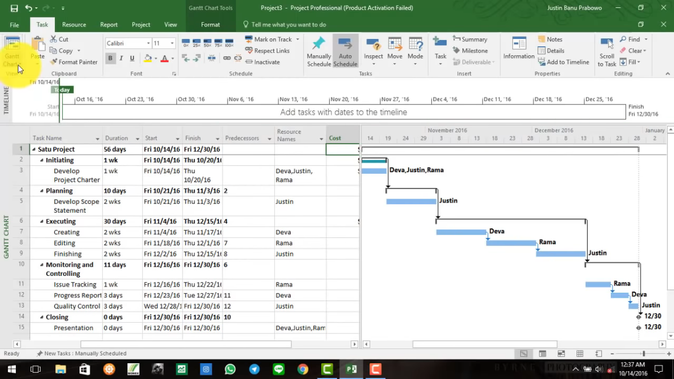

In the sample above we see that the executing phase is around three times as long as the planning phase

Sample 2

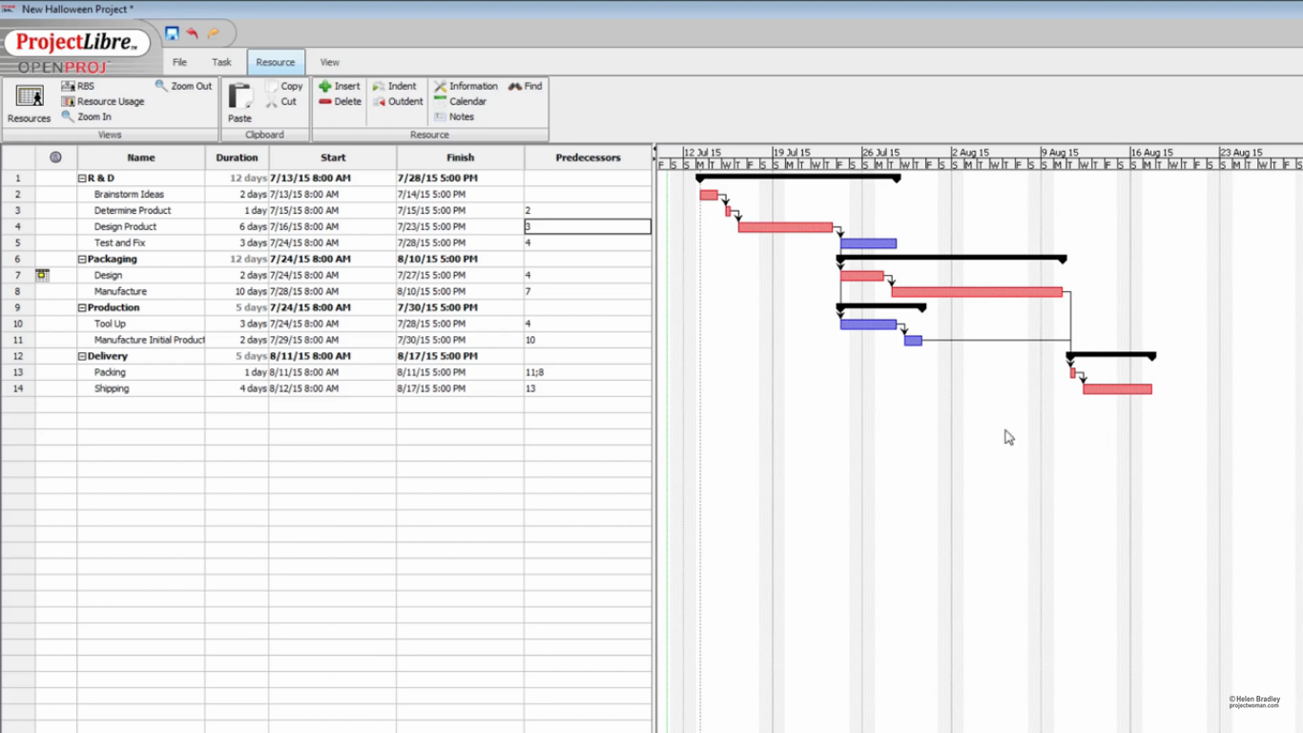

In the sample above we see that the milestones are structured differently. The well-known planning and execution milestones are combined into a single milestone called research and development (R&D). Breaking this milestone down, brainstorming ideas and determine product would fall under planning with an estimated time of 3 days whereas the design product and test and fix tasks would fall under execution with a total estimated time of 9. The ratio of planning to execution is 1:3 in other words the execution phase is also around three times as long.

Sample 3

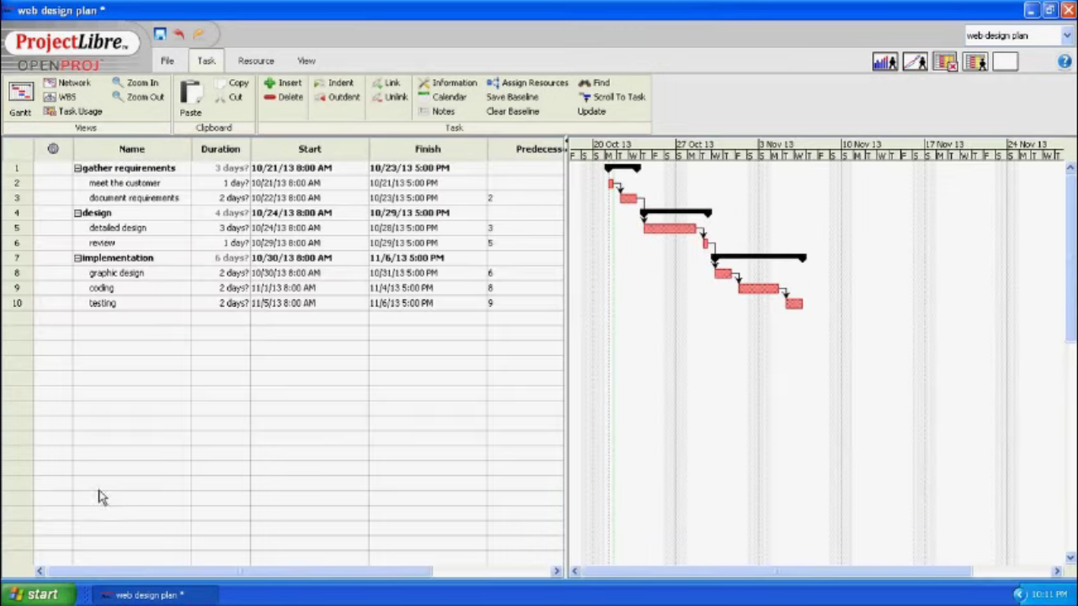

The final sample is rather rudimentary. As with previous two samples, there is not well defined planning or execution phases, further analysis is required. Gathering requirements would fall under the planning phase with a total estimated duration of 3 days, whereas the design and implementation phases would fall under the execution phase with a total estimated duration of 10 days. The ratio of estimated duration of the planning to the execution phase is 1:3.33, therefore it can be said that the execution phase is approximately 3 times as long as the planning phase.

The planning phase and execution phases are the most crucial phases of a project. Based on the results above it can be concluded that the schedule of each sample is realistic due to the fact that the ratios of the planning and execution tasks are similar.

References

Sample 1

<https://www.youtube.com/watch?v=zgWePRrWN-Q>

Sample 2

<https://www.youtube.com/watch?v=oiVnWX-J5Mo>

Sample 3

<https://www.youtube.com/watch?v=oPVbZ_XNGdA>