Supplementary information: Five chronological-age transcriptomic directions fail a locked portability benchmark across partial-reprogramming interventions
Oğuzcan Ünver
30 September 2026

Contents
- Extended study design and temporal firewall
- Dataset and biological-unit audit
- Frozen framework and deviations
- Primary and secondary results
- Adaptive Benchmark B1
- Post-review Extension C1
- Supplementary figures and tables
- Reproducibility and rights boundary

1. Extended study design and temporal firewall
The discovery eligibility cutoff was 31 December 2024 at 23:59:59 UTC. Eligibility concerned the exact data and annotations used, not merely an article date. The protocol, model definition, validation endpoints, known-target list and analysis configuration were committed as tag protocol-v1.0 at commit 8be128cc5ab5f2cfc3147a0ee569fa59ff256b79. The aggregate protocol manifest SHA-256 is c41ab8c013582925d1cd10c81513b4ee3c2a133da8eaafdc32bb8ea9f94c7d18.
Nine discovery files (6.6 GB) were acquired and recorded in a manifest with aggregate SHA-256 c7a5ddeadd7b15806313b82265b22e9508cd0fb83fe991f15a9058953d9a589a. Protocol-v1 failed its Y-axis construction. Adaptive Amendment A1 was then defined and tagged at commit b7109948380cfd14acba5cad26f98b5acce7a897 before any intervention score was inspected.
The full discovery output, including all candidate ranks, was frozen as tag discovery-a1-v1 at commit cdece0dec297800e7e3ab1aa1688f7f6d8a9d6b9. Its 63-file release manifest has SHA-256 73c7dc5c37d1b7f3170371d0bb7bb629ebbf0b70f07a8b1ac4a0aa266d29d0a7. Only after this release were target ranks inspected and validation matrices obtained. The conclusions of the source papers and the five target names were known throughout; the design is not described as blinded or prospective.
After the positive framework failed, Adaptive Benchmark B1 was specified and hashed before any comparator model was fitted or applied. Its lock is tag adaptive-benchmark-b1 at commit 8ca3859e4118cbc86f6440069cf8dd697ab56e37. The first complete benchmark run and every defect found during audit were preserved. The corrected benchmark is committed at c05439da2e9bba4897b9fa312b46ad199afde2f0 [abbreviated in prose as c05439d].

2. Dataset and biological-unit audit
Supplementary Table 1 lists all registered datasets. GEO SuperSeries sample totals were never used as replicate counts. Inference used the independent donor, animal, culture or independently prepared experimental pool. Single cells and technical/culture replicates nested within the same source unit were not counted as independent observations.
The two chronological-age references contain 133 and 82 healthy human donors. Ten Hutchinson–Gilford progeria samples in GSE113957 were excluded from the normal-age reference. GSE297984 contains 24 RNA-seq profiles but only two aged donor lines (56 and 83 years); repeated cultures are nested within donor, day and treatment. GSE297234 contains one 22-year and one 96-year donor in the analysed trajectory and is descriptive. GSE300625 contains 20 mouse tissue profiles split between liver and kidney. Exact sample-to-unit mappings are retained in receipts/sample-metadata.tsv and the analysis code.
GSE276656 was preregistered as a secondary sensitivity but was not needed to adjudicate any primary gate once the positive framework had failed. It was not added selectively to improve the benchmark. Its omission is explicit rather than being presented as a missing result.

3. Frozen framework and deviations

3.1 Protocol-v1 failure
Protocol-v1 required concordant age-effect signs and Benjamini–Hochberg q<=0.10 in each human age reference. It selected zero genes. GSE226189’s minimum adjusted value was approximately 0.132. The rule and zero-gene output were preserved.

3.2 Adaptive Amendment A1
A1 used 10,532 common protein-coding genes, within-sample percentile ranks, and ridge regression on within-cohort standardized age. The final penalty was 3.1622776601683795. Corrected outer-CV Spearman correlations were −0.846594 in GSE113957, −0.457697 in GSE226189 and −0.730162 pooled. Higher Y_A1 was defined as more youth-associated by negating predicted standardized age. The score has no unit and was not converted to years.

3.3 State axes
- I measures expression of a frozen somatic-identity programme, not complete cell function.
- P measures an endogenous late-pluripotency programme after removing the introduced Yamanaka symbols and vector features; it is not a tumorigenicity score.
- D averages response to oxidative stress, cellular response to DNA damage, endoplasmic-reticulum stress and cellular senescence programmes. It does not measure every form of damage.
The guarded-youthward call required all four axes to be available and their bootstrap intervals to pass the frozen margins. An unavailable axis forced “not evaluable,” never “pass.”

3.4 Complete deviation register relevant to the manuscript
- Protocol-v1 Y failed with zero genes. A1 was defined before intervention scores were viewed.
- An early GSE176206 identity implementation admitted genes not detected across every control pool. It was repaired before the discovery release. All released discovery results use the corrected rule.
- Two of five known targets were outside the immutable candidate universe. They were left missing, not replaced.
- Frozen positive validation failed. No threshold, endpoint or model was changed to restore it.
- B1 was defined after the primary outcomes were visible; it is adaptive and cannot rescue the original claim.
- B1 r1 outer CV used full-cohort age-standardization moments. r1 was preserved, and r2 recomputed developmental CV using training-fold moments. Final models, intervention scores, contrasts, family summaries, gene-effect vectors and gates were unaffected.
- B1’s selected elastic-net model had zero non-zero coefficients and constant outputs. It was retained as an implementation failure and not replaced after results were visible.
The full dated register is results-and-deviations.md.

4. Primary and secondary results

4.1 Discovery-stage MPTR separation
Thirteen matched successful MPTR contrasts spanned three donors. Donor-level mean changes and percentile-bootstrap intervals were:
Axis | Mean change | 95% interval
Y_A1 | 0.43696 | 0.16285 to 0.61004
Identity | -0.00356 | -0.00815 to 0.00017
Endogenous pluripotency | 0.00256 | -0.00130 to 0.00507
Aggregate measured damage | -0.00310 | -0.00392 to -0.00263
Twenty-one failed-to-reprogram matched contrasts were retained as a negative comparator, but they do not constitute 21 independent donors. Their mean ΔY_A1 was 0.06866.
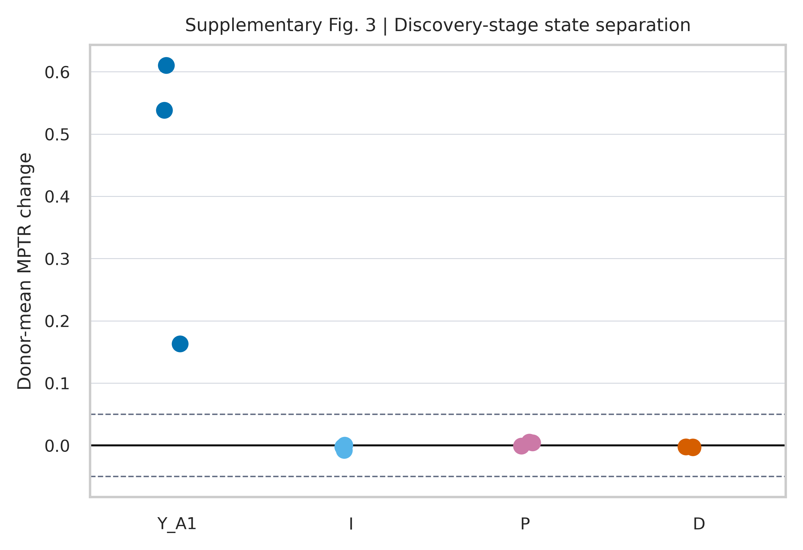
Discovery-stage donor-level changes for all four state axes. Dashed lines show the fixed ±0.05 identity/pluripotency margins.

4.2 Chemical discovery study
The untreated young-minus-old contrast in GSE246954 was positive (ΔY_A1=0.24545, interval 0.20114 to 0.29638). In contrast, old-cell 2c and 7c changes were −0.39583 and −0.46266; all four matched replicates were negative for both cocktails. This discordance was visible before the temporal validation release and already limited a universal interpretation.

4.3 Frozen temporal endpoints
In GSE297984, the eight donor-line/day/cocktail effects were:
Donor age | Day | 2c ΔY_A1 | 7c ΔY_A1
56 | 6 | -0.2533 | -0.5561
56 | 14 | -0.5629 | -0.6454
83 | 6 | 0.0204 | -0.3880
83 | 14 | 0.1522 | -0.2202
Neither cocktail was positive across both donor lines with consistent day-level aggregate direction. No population p-value was computed from the two donor lines.
In GSE297234, the young-minus-old day-0 control was +0.85559. Old-donor day changes relative to day 0 were:
Day | ΔY_A1 | ΔI | ΔP | ΔD
3 | 0.30763 | -0.08229 | 0.09387 | 0.01129
7 | 0.56112 | -0.05797 | 0.09974 | 0.00311
10 | -0.91965 | -0.02668 | 0.04488 | 0.00368
Day 3 was simultaneously the first youthward point and the first point at which both fixed risk margins were exceeded.
GSE300625 liver and kidney ΔY_A1 values were −0.11742 (interval −0.19121 to −0.04130) and −0.07520 (−0.17313 to 0.02494). Tissue identity was not available, making the guarded-state endpoint structurally non-evaluable. For GSE304043, GSTA4 ΔY_A1 was 0.03244 (−0.63759 to 0.55661) and aggregate ΔD was 0.00419 (−0.00089 to 0.00859).

4.4 Known-target rank
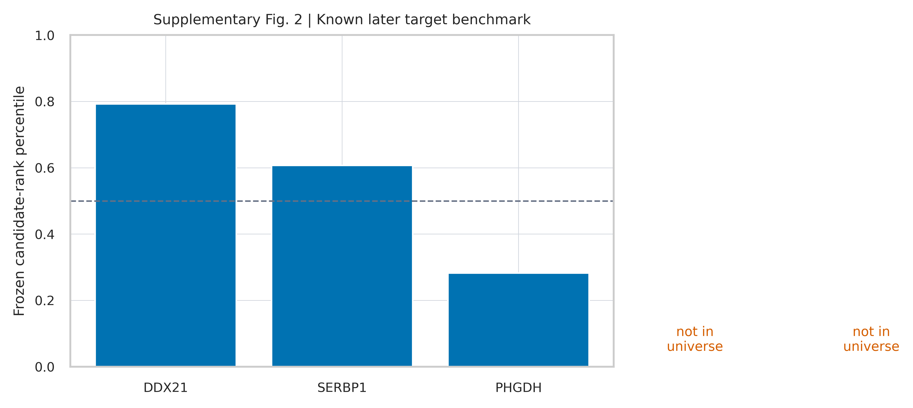
Frozen percentile ranks for the five known later targets. Missing genes were not assigned a replacement or artificial low rank.
The evaluable-target mean percentile was 0.56091. In 100,000 expression-decile-matched three-gene sets, the null mean was 0.48699 and its 95% interval was 0.17238 to 0.80345. The one-sided empirical P value was 0.33237. This analysis is evaluable-only because two targets were missing; the complete five-target endpoint failed by construction.

5. Adaptive Benchmark B1

5.1 Model panel and developmental performance
The five evaluable methods and pooled corrected outer-CV correlations were ridge-rank (−0.73016), PCA50-ridge (−0.71304), meta-effect projection (−0.31406), GSE113957-only ridge (−0.61047), and GSE226189-only ridge (−0.36476). All five correctly oriented both independent age controls. Final hyperparameters and cohort-specific correlations are in Supplementary Table 3.
The corrected A1 predictions reproduce the independently generated A1 outer predictions to maximum absolute difference 1.56e-15. Fifteen repository tests passed at the B1-r2 checkpoint.

5.2 Complete contrast set
The complete method-by-contrast table is distributed as tables/supplementary-table-5-contrast-matrix.csv. It contains all 184 declared contrasts, including favourable-labelled, negative, trajectory, exploratory, adverse and age-control categories. Source-unit labels are replaced by stable contrast codes in the redistribution-safe table. No contrast was removed because its sign was unexpected.
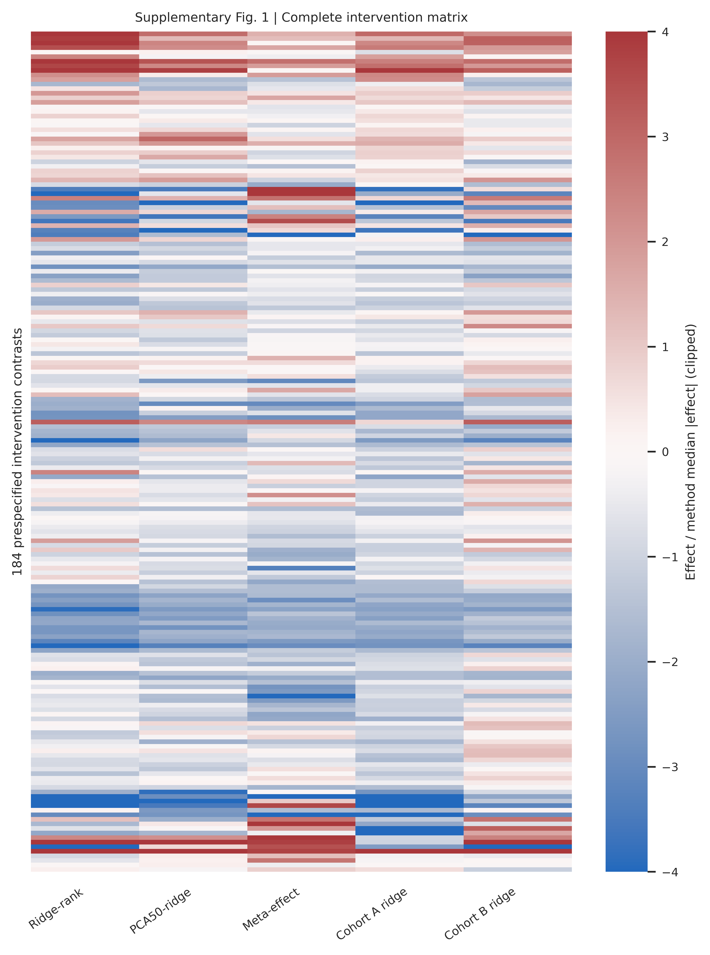
All 184 contrasts. Each method is divided by its own median absolute effect for visualization; values are clipped to ±4. This scaling is visual only and is not used by any endpoint.
Across the five evaluable methods, the pairwise sign-agreement values were:
 | Ridge-rank | PCA50-ridge | Meta-effect | Cohort A | Cohort B
Ridge-rank | 1.000 | 0.804 | 0.717 | 0.832 | 0.766
PCA50-ridge | 0.804 | 1.000 | 0.783 | 0.842 | 0.701
Meta-effect | 0.717 | 0.783 | 1.000 | 0.723 | 0.668
Cohort A | 0.832 | 0.842 | 0.723 | 1.000 | 0.620
Cohort B | 0.766 | 0.701 | 0.668 | 0.620 | 1.000
The upper-triangle median was 0.744565. Thus, the broad transportability gate failed despite all age controls being oriented correctly.

5.3 Family-level direction
Family-mean directions were positive in 3/8 families for ridge-rank, 3/8 for PCA50-ridge, 5/8 for meta-effect projection, 2/8 for cohort-A ridge and 3/8 for cohort-B ridge. Zero methods reached the locked 80% threshold. The source-labelled family set is a concordance audit, not a sensitivity and specificity analysis, because the source conclusions are heterogeneous and not a gold standard.

5.4 Gene-level effect concordance
There were 9,543 common genes in the complete family-effect matrix. The 28 off-diagonal family correlations had median 0.053812. Leave-one-family-out correlations were:
Held family | Spearman with seven-family consensus
MPTR | 0.06081
Mouse 2c/7c | 0.26497
SOKM screen | 0.16757
Human 2c/7c | 0.22642
Human OSK/O4YRSK | 0.33626
Human early OSKM | 0.23808
RPE OSK | 0.13868
RPE GSTA4 | 0.06008
The median was 0.196995. These are descriptive correlations over a fixed gene universe. Gene counts were not used as biological-replicate sample sizes.

6. Post-review Extension C1
C1 was frozen at commit 93c04d7 before its outcomes were calculated. Its Markdown and JSON lock files have SHA-256 values 7fdf1b4e27b0d16af3b0613cc011b0a91d8f5b80f9b9013430278b9a0166a9dd and 01420f7ebf81df459e022c7c87c49f300600da4f2ef1eabfaaae4bee1ec72ca0. It was requested after review of the complete manuscript, so every C1 result is explicitly outcome-aware and does not alter the historical locks.

6.1 Hierarchical agreement and gate sensitivity
The contrast-weighted median pairwise agreement of 0.744565 was reproduced. Giving each of 14 families equal weight yielded 0.622514. The family-cluster bootstrap estimate had median 0.630315 and 95% percentile interval 0.515200–0.737703. Leaving out one family at a time produced estimates from 0.593477 to 0.652182. Thus no single family or contrast-rich study accounts for the below-gate result.
The five model counts across the eight favourable-labelled families were 3, 3, 5, 2 and 3. One model met a four-of-eight threshold and one met five-of-eight; none met six-, seven- or eight-of-eight. Across agreement thresholds from 0.50 to 1.00, the observed contrast-weighted result passes only at thresholds up to 0.725 and the equal-family result only up to 0.600. These curves are descriptive and do not make any threshold biologically privileged.

6.2 Stratified summaries
Dimension | Stratum | Families | Median agreement | Pairwise range
Species | Human | 5 | 0.700 | 0.600–1.000
Species | Mouse | 3 | 0.667 | 0.333–1.000
Intervention | Chemical | 2 | 1.000 | 0.500–1.000
Intervention | Genetic | 6 | 0.667 | 0.500–0.833
Context | Fibroblast | 5 | 0.800 | 0.400–1.000
Context | Retinal pigment epithelium | 2 | 0.500 | 0.000–1.000
Small strata and wide method-pair ranges preclude attribution of heterogeneity to one biological or technical factor.

6.3 Gene-effect reliability
Only four favourable families had at least four contrast units. Their raw median split-half Spearman correlations were 0.558 (MPTR), 0.840 (mouse chemical), 0.323 (SOKM) and 0.678 (human chemical). Eight individual contrasts also supported independent arm splitting; raw correlations ranged from 0.188 to 0.912. These values establish a partial, heterogeneous noise ceiling. They do not support reliability correction for the four ineligible families, but show that the observed cross-family median of 0.054 is well below within-context reproducibility in several estimable settings.

6.4 Feature coverage
Historical-model coverage across ten expression matrices ranged from 0.8513 to 0.9999. Thresholds of 0.60, 0.70 and 0.80 retained all ten matrices, 184 contrasts and the same agreement statistics. A 0.90 threshold retained five matrices, 49 contrasts and eight total families; contrast-weighted and equal-family median agreement remained 0.734694 and 0.666123. A separate refit on the 8,427 features present in every matrix yielded 0.779891 and 0.648621.

6.5 Contemporary exploratory comparator
Pasta was pinned to official repository commit 58bcc7a69ee97f2dc9e3623ac86538c251ddd498. The three required model files had SHA-256 values:
- v_genes_model.rda: 42289278a0a0d5171af23b108b086deea7b413d287559a9ec39cf7c76269cb5f
- beta_Pasta.rda: b4a1891b7ed0737fbb784a89f6e00a9dfa07a15fa53359975f78f42fe92722e8
- cvfit_Pasta.rda: 158a9ec9d9e53786c85bfc8af3593bfa99ae4bc949c4ad3f2afb767c14befa56
The Python reconstruction reproduced the official three-sample example with maximum absolute error 4.73×10^-11. Pasta oriented the mouse and human age controls youthward by 18.195 and 52.184 units. Its favourable-family effects were negative for MPTR, SOKM, RPE OSK and RPE GSTA4 and positive for mouse chemical, human OSK/O4YRSK, early human OSKM and human chemical: four of eight positive. This result is exploratory, post-review and outcome-aware. No exact benchmark accession was found in the public article or packaged files, but the complete training sample list could not be audited.
The 2026 tAge model was not run. Its official public repository uses the MGB Open Access License 1.0 for non-commercial academic use and directs commercial users to obtain a separate agreement. The author’s commercial affiliation made exclusion the conservative rights-compliant choice.

7. Supplementary tables
- Supplementary Table 1: tables/supplementary-table-1-datasets.csv — dataset roles, species, modality, biological unit and public date.
- Supplementary Table 2: tables/supplementary-table-2-primary-scorecard.csv — complete frozen endpoint scorecard.
- Supplementary Table 3: tables/supplementary-table-3-benchmark-summary.csv — model hyperparameters, CV correlations, control orientation and family fractions.
- Supplementary Table 4: tables/supplementary-table-4-known-targets.csv — target evaluability and ranks.
- Supplementary Table 5: tables/supplementary-table-5-contrast-matrix.csv — all 184 contrasts and model effects, with source-unit labels replaced by stable codes.
- Supplementary Table 6: results/benchmark-b1/favourable-family-means.csv — family means.
- Supplementary Table 7: results/benchmark-b1/family-gene-effect-spearman.csv — complete gene-effect correlation matrix.
- Supplementary Table 8: results/benchmark-b1/leave-one-family-out-gene-consensus.csv — consensus transfer results.
- Supplementary Tables 9–22: results/post-review-c1/ — hierarchical agreement, cluster bootstrap, threshold sensitivity, strata, reliability, feature coverage, common-feature refit and Pasta outputs.

8. Reproducibility and rights boundary
The reproducibility package includes analysis and figure source code, configurations, exact input manifests, tests, aggregate result tables and audit receipts. It excludes raw public expression matrices, source H5AD/H5 files, participant-linked records and source content not licensed for redistribution. Users obtain raw data from the original repositories and verify them against the provided hashes.
The first B1 run and its corrected CV revision remain separately available. Historical outputs are never overwritten. The main manuscript uses outer-cv-correlations-r2.csv and summary-r2.json. Intervention results are the original B1 results because the repaired target scaling did not enter final model fitting or application.
The analysis package makes no claim of causal rejuvenation, direct biological age, clinical validity, therapeutic efficacy, safety, peptide efficacy or target causality. It also does not imply that transcriptomic non-concordance invalidates orthogonal functional or epigenetic findings in the source studies.

