Five chronological-age transcriptomic directions fail a locked portability benchmark across partial-reprogramming interventions
Oğuzcan Ünver
30 September 2026
Article type: Analysis Target journal: Nature Aging Affiliation: Metastate Bio Inc, Wilmington, Delaware, USA Corresponding author: Oğuzcan Ünver; can@metastate.bio; ORCID: 0009-0007-2023-5084

Abstract
Chronological-age models are used as scalar measures of cellular rejuvenation, although age prediction does not establish sensitivity to beneficial intervention. We constructed a temporally locked four-axis framework from public data available by 2024, challenged it against later studies without refitting, and compared five evaluable age directions across 184 partial-reprogramming contrasts. The frozen positive framework failed its human chemical and trajectory-order endpoints. All five benchmark models oriented two independent young–old controls correctly, but their median pairwise agreement on intervention direction was 0.745. Equal weighting across 14 study families reduced agreement to 0.623 (family-cluster bootstrap 95% interval 0.515–0.738). No model was youthward in more than five of eight source-labelled favourable families. Cross-family gene effects were weakly concordant relative to the within-family reproducibility estimable in four families. A post-review exploratory application of the contemporary Pasta model oriented both age controls but was positive in only four of eight favourable families. These results show that age prediction did not establish intervention portability for the evaluated directions. Rejuvenation claims require intervention-specific and orthogonal qualification.
Molecular clocks compress high-dimensional measurements into quantities associated with age, morbidity, mortality or the pace of ageing [1–3]. This compression is attractive for partial reprogramming, where transcription-factor or chemical interventions can induce broad and rapid state changes. A single scalar appears to offer a direct answer to a difficult question: did an old cell become younger? Yet chronological age is a training label, not an intervention outcome. A predictor can discriminate young from old samples while responding to perturbation-specific expression, changes in composition, stress, proliferation or loss of identity in ways that do not generalize across experiments.
This distinction is especially important for partial reprogramming. Transient expression of pluripotency factors has been reported to shift transcriptomic and epigenetic features towards younger states while retaining or reacquiring somatic identity [4–6]. Single-cell analyses also show that youthful expression can coincide with transient suppression of identity and activation of pluripotency programmes [7]. Chemical approaches produce extensive metabolic and transcriptional changes and clock responses [8,9], whereas later in-vivo work has exposed toxicity and an absence of detectable transcriptomic-age improvement in liver and kidney [10]. Later human trajectories and retinal studies add further experimental contexts [11,12]. These studies need not be mutually inconsistent: they interrogate different species, cell types, interventions, schedules, modalities and functional endpoints. They do, however, create a stringent test of whether a transcriptomic age-associated direction is a portable scalar measure of intervention-induced rejuvenation.
We therefore ran a failure-preserving computational study. First, we specified a four-axis state vector before opening the later expression matrices: a youth-associated chronological-age direction (Y), retained somatic identity (I), endogenous pluripotency or dedifferentiation (P), and four measured stress/damage programmes (D). Second, we froze discovery outputs before application to datasets released in 2025–2026. Publication conclusions were known, so the exercise was temporally external and outcome-informed rather than blinded or prospective. Third, after the positive framework failed, we locked an explicitly adaptive multi-model benchmark before computing comparator outputs. This design distinguishes prespecified failures from post-failure characterization and retains every unfavourable result (Fig. 1).
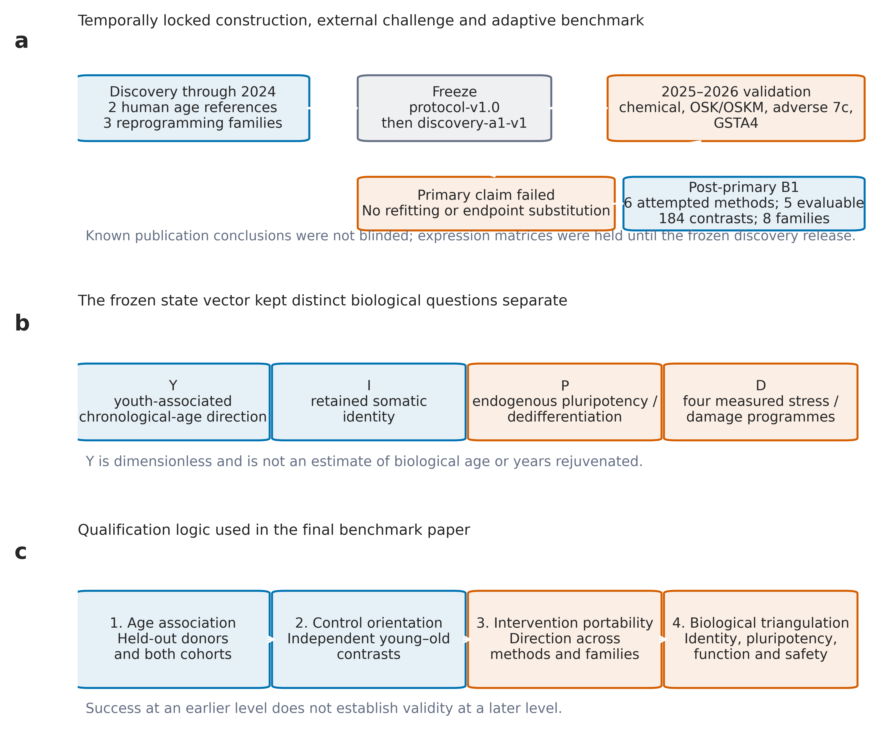
Study design and qualification logic. a, Discovery, locking, temporal validation and the post-primary benchmark. b, The four frozen state axes. c, The qualification ladder used for interpretation.

A frozen multidimensional framework fails its positive validation
The original protocol required genes to show concordant age effects at a false-discovery rate of 0.10 in each of two human fibroblast cohorts. No gene met that rule because the smaller cohort’s minimum adjusted value was 0.132. We preserved that failure and, before viewing any intervention outcome, defined Adaptive Amendment A1: within-sample percentile ranks for 10,532 common protein-coding genes and ridge regression against within-cohort standardized chronological age. The negative of the predicted standardized age was called Y_A1, such that higher scores were more youth-associated. In five-fold outer cross-validation, Spearman correlations between Y_A1 and age were −0.847 in GSE113957, −0.458 in GSE226189 and −0.730 pooled (Fig. 2a). These values establish an age association; they do not validate Y_A1 as biological age.
In discovery data, maturation-phase transient reprogramming (MPTR) provided the intended separation. Across three donors, the donor-mean change in Y_A1 was 0.437 (95% percentile-bootstrap interval 0.163 to 0.610), while mean changes in identity (−0.0036), endogenous pluripotency (0.0026) and aggregate measured damage (−0.0031) remained within the locked guardrails. However, chemical reprogramming already exposed context dependence: the untreated young-minus-old control was correctly oriented (ΔY_A1=0.245, interval 0.201 to 0.296), whereas old-mouse 2c and 7c effects were −0.396 and −0.463, respectively.
We hashed and committed the complete discovery release before obtaining the temporal-validation matrices. In the two-donor human chemical study, neither 2c nor 7c was positive across both donor lines and both assessed days; six of eight donor–day–cocktail effects were negative (Fig. 2c). In the 96-year donor OSKM trajectory, Y_A1 first increased at day 3 (Δ=0.308), but identity loss (ΔI=−0.082) and pluripotency gain (ΔP=0.094) crossed their locked margins on the same day (Fig. 2d). Thus, youth-associated movement did not precede the risk axes. The 22-year minus 96-year day-0 control remained correctly oriented (ΔY_A1=0.856).
The adverse in-vivo 7c challenge yielded negative mean Y_A1 changes in liver (−0.117; 95% interval −0.191 to −0.041) and kidney (−0.075; interval −0.173 to 0.025). It formally avoided a guarded-youthward call, but this endpoint was non-informative because a tissue-specific identity axis was unavailable. GSTA4 overexpression in aged retinal pigment epithelium produced ΔY_A1=0.032 (interval −0.638 to 0.557) and did not lower aggregate D. These expression results neither validate the frozen score nor negate functional findings in the source studies.
Finally, a complete candidate list had been frozen before five known later targets were looked up. GSTA4 and TOMM70A were absent from the immutable 9,131-gene intersection universe. DDX21, SERBP1 and PHGDH ranked at percentiles 0.793, 0.607 and 0.282. Their evaluable-only mean percentile was 0.561, with an expression-decile-matched empirical one-sided P=0.332 over 100,000 draws. The target endpoint was therefore negative and incomplete. Collectively, the frozen positive framework failed its chemical-validation and trajectory-order gates and did not recover the later target set (Fig. 2b).
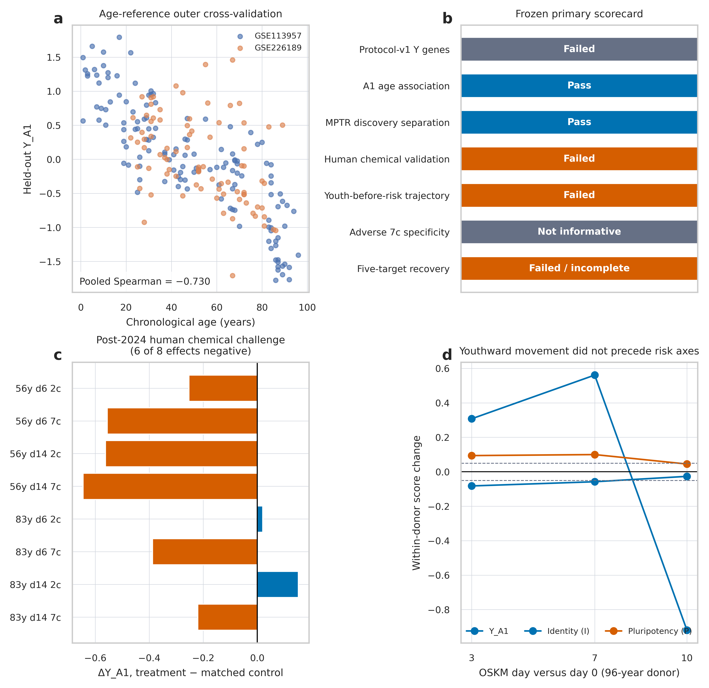
Frozen framework results. a, Held-out age association in the two reference cohorts. b, Complete primary scorecard. c, Human 2c/7c effects by donor line and day. d, Old-donor OSKM trajectory for the youth, identity and endogenous pluripotency axes.

Age models orient controls but disagree under intervention
One failed age direction cannot establish a general limitation. After closing the primary claim, we therefore specified Adaptive Benchmark B1 and fixed its models, contrasts, family units and descriptive gates before fitting any comparator. Six approaches were attempted: the existing ridge-rank model; PCA followed by ridge regression; a sign-concordant cross-cohort age-effect projection; ridge models fitted to each reference cohort separately; and elastic net. The selected elastic-net model had zero non-zero coefficients and constant outputs. We retained this failure and did not choose a replacement after seeing intervention results. Five methods remained evaluable.
All five models associated with chronological age in corrected outer cross-validation (pooled Spearman correlations −0.730 to −0.314; Fig. 3a). Moreover, all five correctly oriented two young-minus-old controls, one in mouse fibroblasts and one in human fibroblasts (Fig. 3b). These checks matter: the subsequent disagreement cannot be attributed simply to arbitrary reversal of score direction.
We next applied the fixed final models to 184 matched intervention contrasts spanning MPTR, Yamanaka-factor combinations, 2c/7c chemical treatments, human OSK/O4YRSK and OSKM trajectories, retinal OSK, GSTA4 and the adverse in-vivo study. For the locked broad-transportability gate, at least four of six attempted methods had to orient both age controls and median pairwise sign agreement across intervention contrasts had to reach 0.80. Restricting the summary to the five evaluable methods, median sign agreement was 0.745. The result remained below threshold; including the failed constant method would reduce interpretability rather than provide evidence for transportability.
Because the 184 contrasts are clustered within studies and families, we added an explicitly post-review, outcome-aware sensitivity under locked Amendment C1. Equal weighting of the 14 benchmark families lowered median pairwise agreement to 0.623. A 10,000-draw cluster bootstrap that resampled families gave a percentile interval of 0.515–0.738, and leave-one-family-out estimates ranged from 0.593 to 0.652 (Fig. 5a,b). The original contrast-weighted statistic is therefore not presented as 184 independent experiments; the family-weighted result is the more conservative summary.
The divergence was visible at the study-family level (Fig. 3c). MPTR was positive for every method, whereas the human chemical family was negative for every method. Other families split by model. For example, the meta-effect and cohort-B directions were positive for human OSK/O4YRSK while the other three models were negative. GSTA4 was positive under three directions and negative under two. We had defined a stringent universal-direction gate: at least four methods had to be positive in at least 80% of eight source-labelled favourable families. With eight families, that rule requires at least seven positive calls. The observed counts were two to five; only one method reached four or five, and none reached six, seven or eight. Thus the conclusion does not depend on treating 80% as a biologically privileged boundary (Fig. 3d). The labels describe favourable interpretations in source papers and are not ground-truth rejuvenation outcomes.
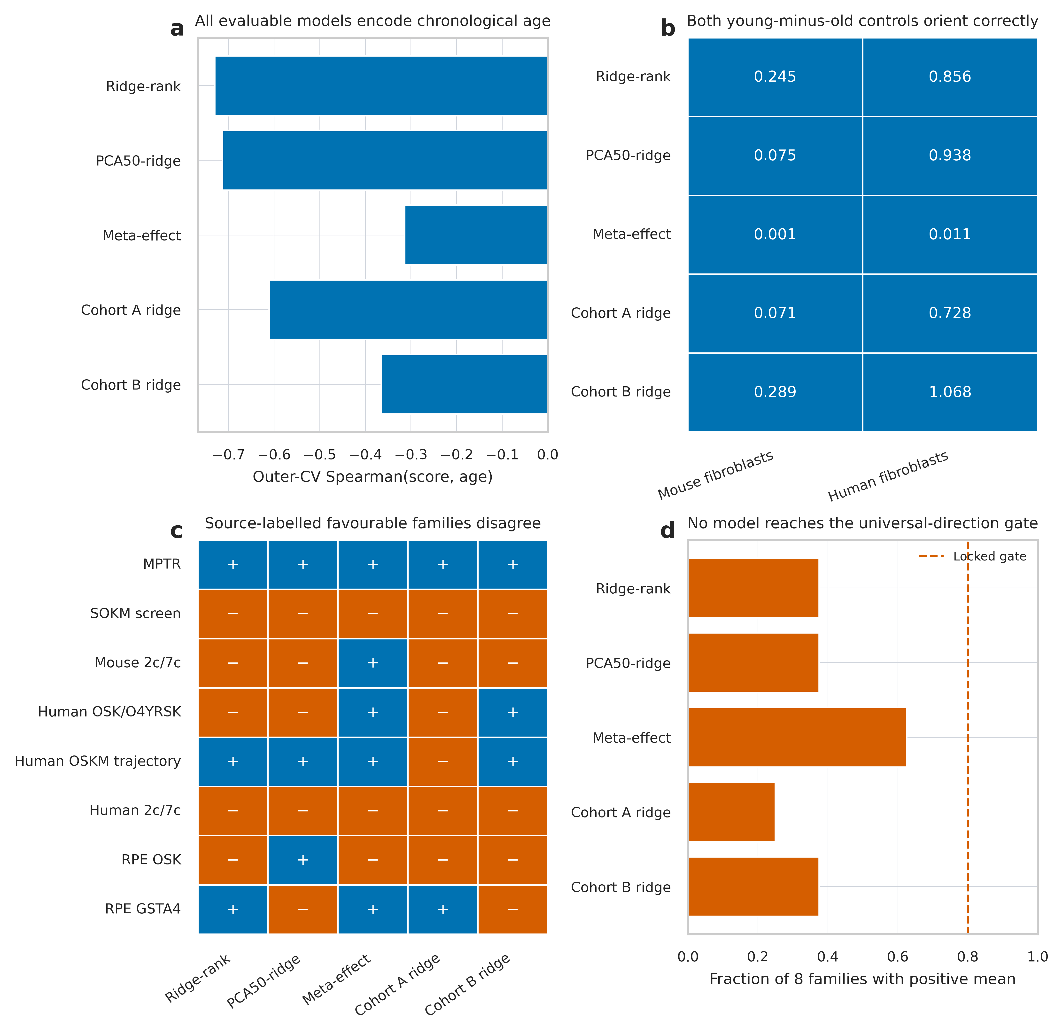
Adaptive multi-model benchmark. a, Corrected outer-CV age associations for five evaluable models. b, Independent young-minus-old controls. c, Signs of family-mean intervention effects. d, Fraction of source-labelled favourable families with positive mean effects.
Descriptive stratification did not identify a broadly consistent subset. Median method agreement was 0.700 across five human families, 0.667 across three mouse families and 0.667 across six genetic families. The five fibroblast families had a median of 0.800, but individual method pairs ranged from 0.400 to 1.000. The chemical and retinal strata each contained only two families and are too small for general conclusions. These analyses localize heterogeneity but do not attribute it to species, tissue or intervention class.

Intervention effects do not converge on a common gene direction
Model disagreement might arise even if interventions share a common gene-level programme that is weighted differently. We therefore compared family-mean expression-effect vectors on 9,543 common mapped genes. Pairwise Spearman correlations were low overall (median 0.054), ranging from −0.085 to 0.517 (Fig. 4b). The largest value linked the two related human OSK/OSKM families. This local agreement did not imply a universal programme across genetic, chemical, species and retinal contexts.
We also formed a leave-one-family-out consensus by averaging standardized expression effects from the other seven favourable-labelled families and correlating it with the held family. Correlations ranged from 0.060 to 0.336, with a median of 0.197 (Fig. 4c). Genes were not treated as biological replicates and these correlations are descriptive; no gene-count-based population inference is claimed.
We estimated a partial noise ceiling wherever the design permitted split-half comparisons. Four of eight favourable families had at least four contrast units; their median raw split-half correlations were 0.323, 0.558, 0.678 and 0.840. Eight individual contrasts supported arm-split estimates, ranging from 0.188 to 0.912. Reliability is therefore heterogeneous and unavailable for half the families, but in the estimable higher-reliability contexts it substantially exceeds the cross-family median of 0.054. The weak cross-family concordance cannot be assigned entirely to measurement noise, although the incomplete noise ceiling prevents a universal reliability-corrected claim. Together with the method sign matrix (Fig. 4a), these results support non-convergence in the evaluated data at both the scalar-score and gene-effect levels.
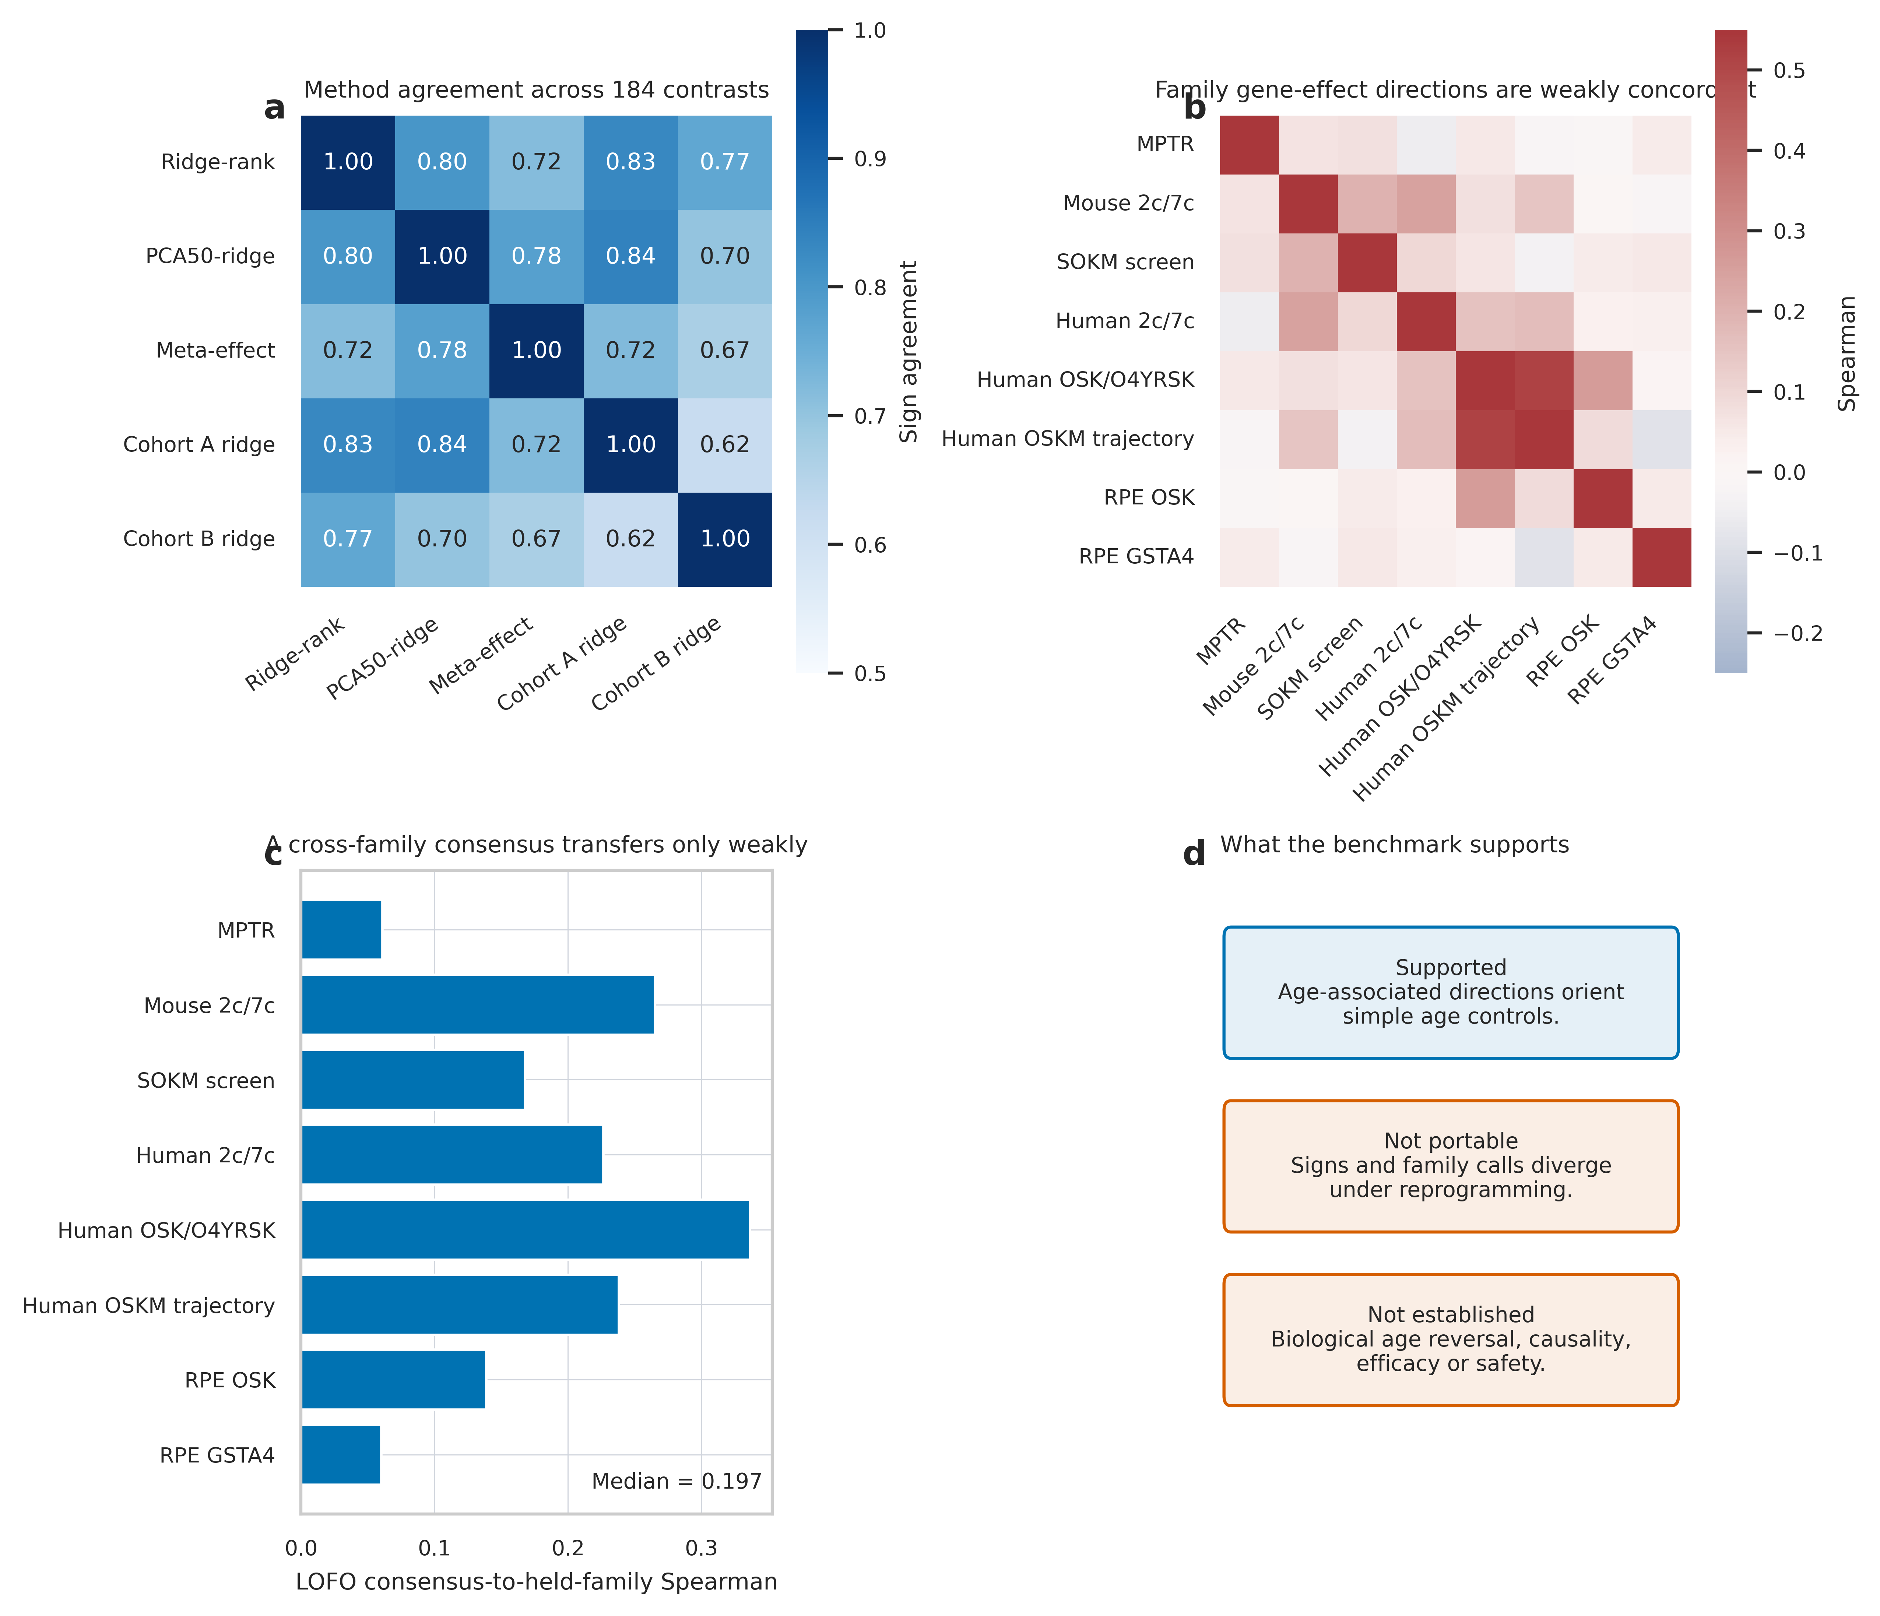
Cross-method and cross-family concordance. a, Pairwise method sign agreement across 184 contrasts. b, Spearman correlations between family-mean gene effects. c, Leave-one-family-out consensus correlations. d, Supported and unsupported interpretation.

Robustness and a contemporary exploratory comparator
Observed coverage of the 10,532 historical-model features ranged from 85.1% to 100.0%, rather than approaching the allowed 60% floor. Raising the eligibility threshold to 70% or 80% retained every dataset and result. At 90%, five expression matrices and 49 contrasts remained; contrast-weighted and equal-family agreements were 0.735 and 0.666. As a separate stress test, refitting all five historical methods on the 8,427 features present across every benchmark matrix yielded agreements of 0.780 and 0.649, still below 0.80 (Fig. 5c).
We also applied Pasta, a contemporary rank-based age-shift model released after the historical cutoff, as a post-review exploratory comparator [14]. A Python reconstruction reproduced the three bundled reference predictions to a maximum absolute error of 4.8×10^-11. Pasta oriented both young-minus-old controls correctly but was youthward in four of the eight favourable-labelled families (Fig. 5d). Its feature coverage was 83.3–99.5%. This analysis was not part of B1, was added after the historical outcomes were known, and does not constitute an independent prospective test. No exact benchmark accession overlap was identified in the public article or model package, but a complete sample-level audit of all 21 Pasta training datasets was not possible from the released materials. We excluded the contemporary tAge model from this commercial-affiliation release because its public licence is restricted to non-commercial academic use [13].
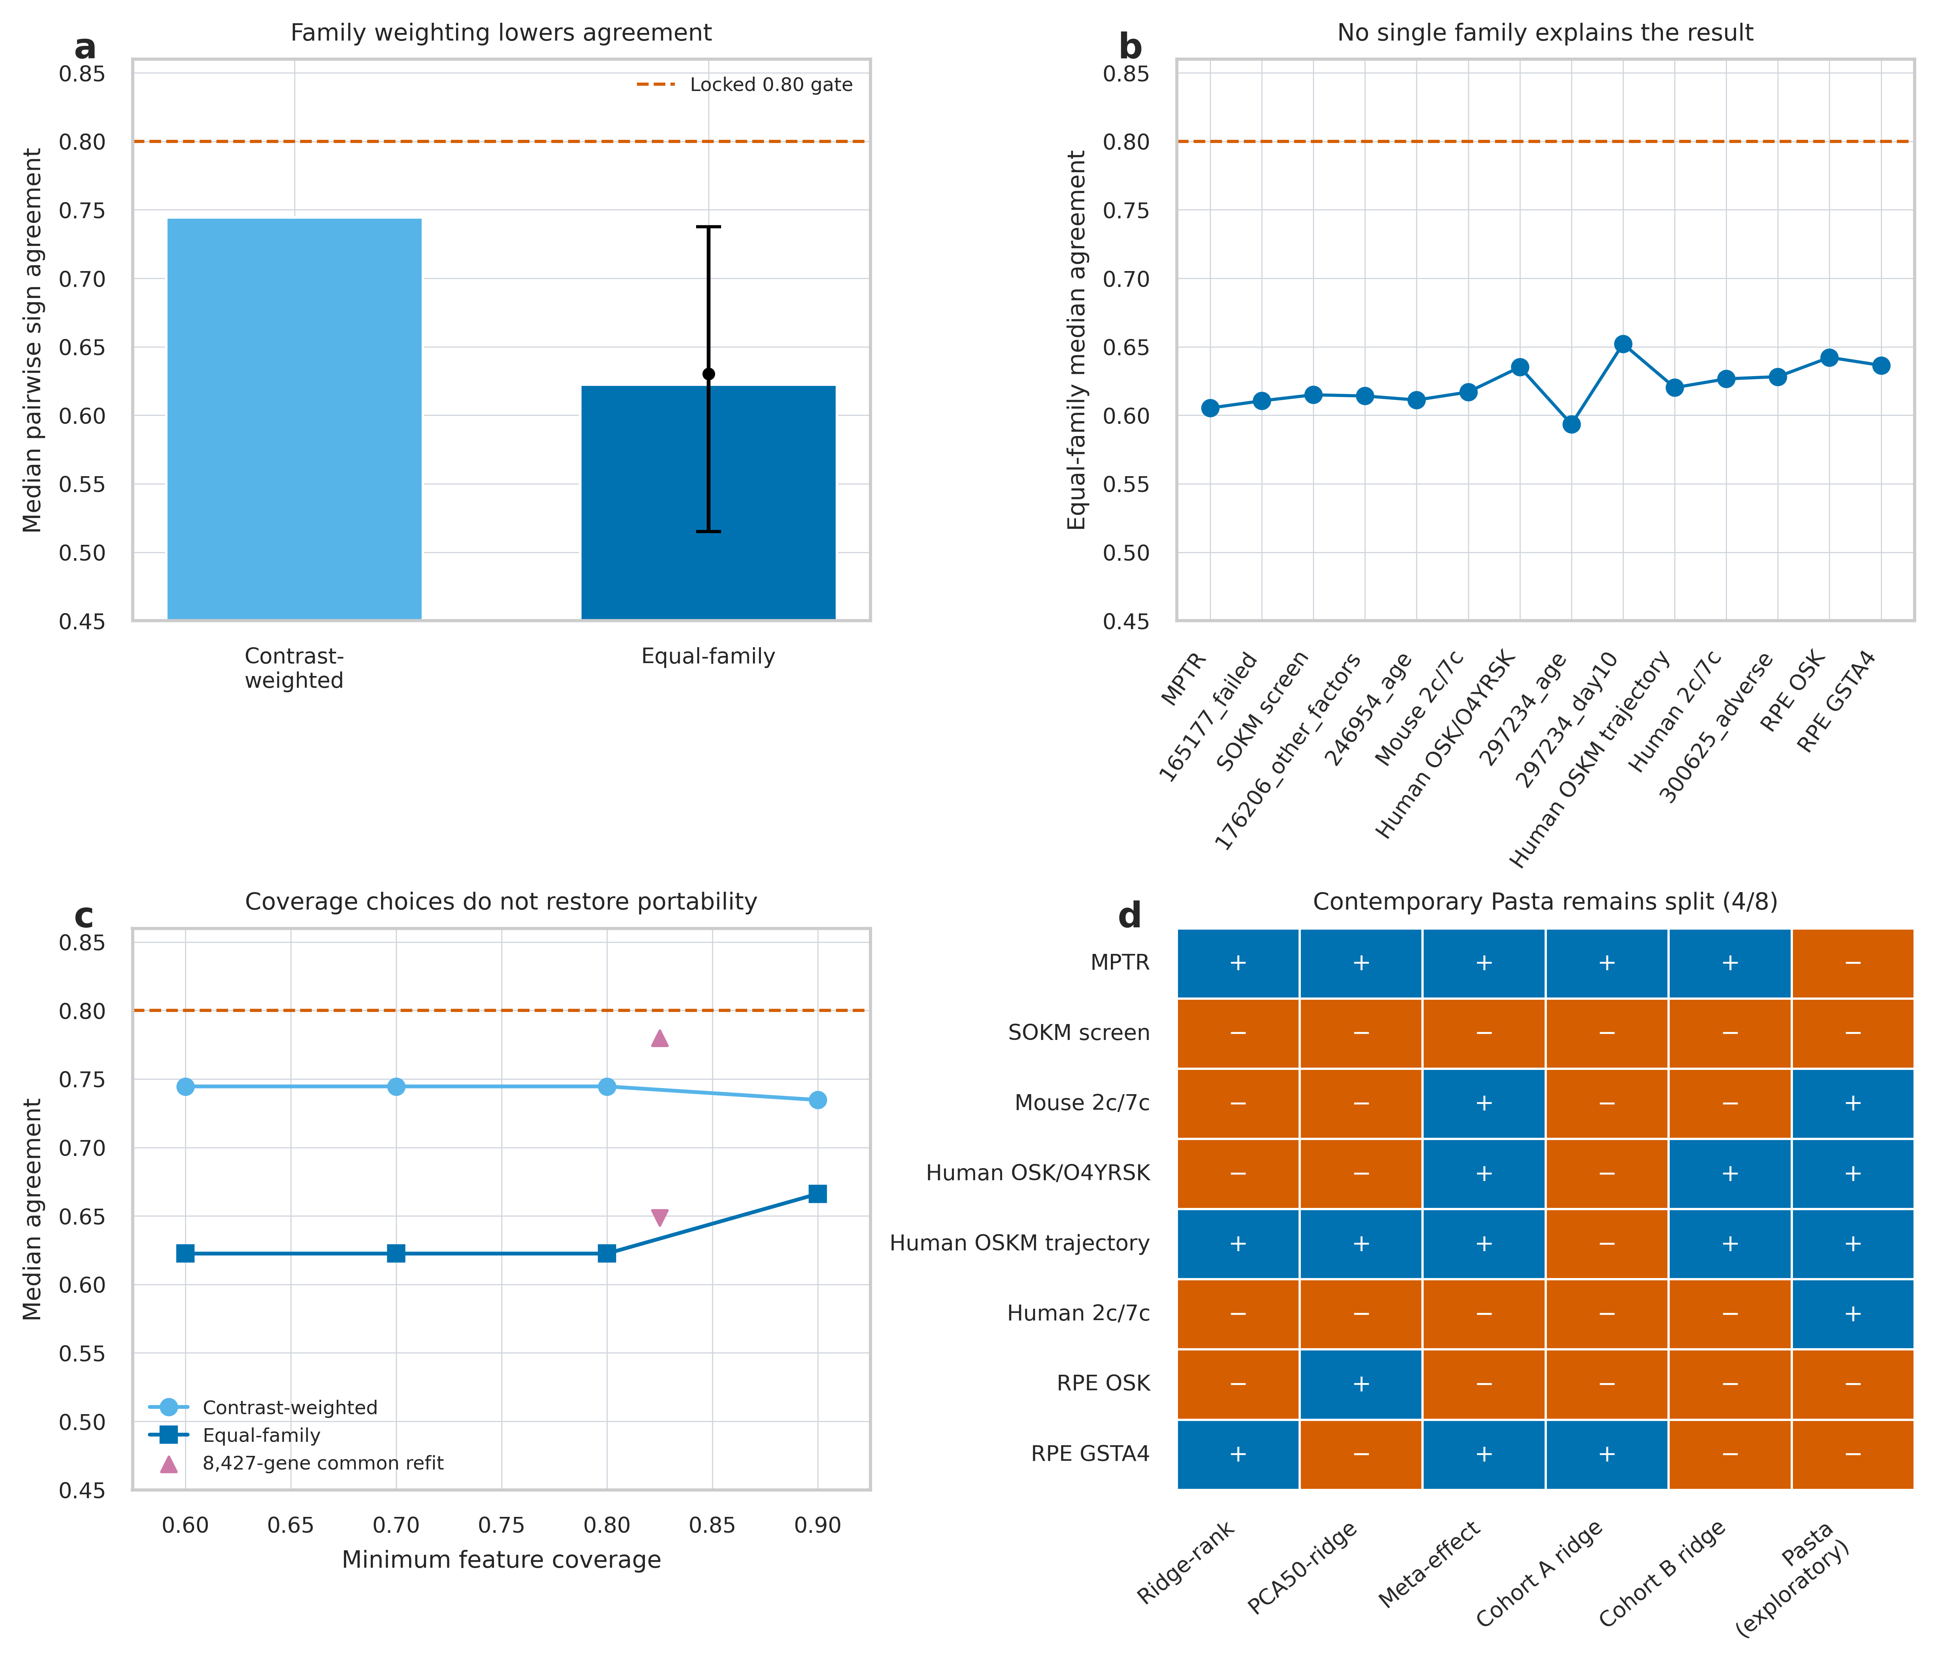
Post-review robustness analyses. a, Contrast-weighted and equal-family method agreement; the point and whisker show the family-cluster bootstrap median and 95% interval. b, Leave-one-family- out agreement. c, Feature-coverage thresholds and the common-feature refit. d, Historical models and exploratory Pasta signs across eight source-labelled favourable families. Blue denotes a positive youth-oriented effect and orange a negative effect; signs provide redundant encoding.

Discussion
Our central result is a qualification failure with a useful boundary: five transcriptomic chronological-age directions recognized young–old contrasts yet were not sufficiently portable across the evaluated partial-reprogramming interventions. This is not evidence that the source interventions lack biological or functional effects. It shows that age prediction and intervention measurement are different validation problems.
Recent large-scale work reaches a compatible conclusion from a different direction. Universal transcriptomic clocks trained on more than 11,000 samples found that chronological clocks correlated well with age but poorly with lifespan-modulating intervention effects, while mortality-oriented objectives performed better [13]. Pasta demonstrates that rank-based, multi-tissue transcriptomic models can generalize across platforms and recover experimental perturbations [14]. Our exploratory Pasta result shows that a stronger contemporary chronological model does not automatically resolve the present portability problem, but one model cannot represent the full modern clock class. The historical result and contemporary extension remain analytically separate. Our contribution is a partial-reprogramming-specific stress test with temporally separated data, identity and pluripotency axes, an adverse challenge, preserved failures and complete method-by-contrast disclosure.
The findings argue against treating “transcriptomically younger” as a self-sufficient rejuvenation claim. At minimum, a candidate score should demonstrate held-out age association, correct control orientation, portability to interventions that were not used to define it, and concordance with an outcome-relevant endpoint. Identity, pluripotency, stress, toxicity and function should remain separate measurements rather than being hidden inside a single scalar. This distinction also avoids the inverse error: a beneficial intervention need not reverse a chronological-age clock. For example, elamipretide improved cardiac and skeletal-muscle function in aged mice without detectable changes in tissue epigenetic or transcriptomic age [15].
Several limitations constrain the generality of our benchmark. The age references were cultured human fibroblasts, whereas interventions spanned species, cell types, platforms and tissues. That heterogeneity is the intended portability challenge, but it also prevents attribution of failure to one cause. Some validation studies had only one or two donor lines, and several contrasts are descriptive. Source-labelled favourable families are not a gold standard. Within-sample ranks reduce scale dependence but cannot remove composition and state confounding. The four D programmes cover selected transcriptional responses rather than total damage, and P is not a tumorigenicity score. The benchmark comparator was adaptive after primary failure, and its numerical gates are transparent engineering criteria rather than natural biological thresholds or population hypothesis tests. The post-review analyses were outcome-aware, Pasta’s complete training-sample overlap could not be audited from public materials, and the tAge licence did not permit inclusion under the present commercial affiliation. Newly published mortality- and outcome-trained clocks should therefore be evaluated in a prospectively locked future benchmark with compatible inputs and rights.
The practical implication is methodological. A rejuvenation biomarker should be qualified for its intended context, not promoted from chronological-age prediction by analogy. Public reprogramming data now permit a tiered evaluation in which construction, intervention transport, state preservation and orthogonal function are separately auditable. In the datasets assessed here, none of the five historical directions met the locked portability criteria, and the exploratory Pasta model remained split across favourable-labelled families. This does not establish that chronological transcriptomic clocks can never measure an outcome-relevant component of rejuvenation.

Methods

Study design and temporal firewall
The discovery cutoff was 31 December 2024. Discovery comprised human fibroblast age references GSE113957 (133 healthy donors, age 1–94 years) and GSE226189 (82 healthy donors, age 22–89 years), GSE165176/GSE165177 (human Sendai and MPTR trajectories), GSE176206 (mouse single-cell factor screens), and GSE246954/GSE247199 (mouse chemical reprogramming). Temporally external evaluation used GSE297984, GSE297233/GSE297234, GSE300625 and GSE304042/GSE304043/GSE304044. Exact source URLs, retrieval times, file sizes and SHA-256 hashes are recorded in the input manifests.
The protocol, code configuration and named-target list were committed and tagged before discovery expression matrices were opened. Protocol-v1 failed, after which A1 was defined and frozen before any intervention score was examined. Discovery results and the full 9,131-gene candidate rank were then hashed and committed before validation matrices were obtained. B1 was specified only after primary validation failed and is labelled adaptive throughout. Published study conclusions and named targets were known; “temporally external” does not mean prospective or blinded.
Reviewer-requested Extension C1 was locked before its outcomes were computed. It prespecified family weighting, cluster bootstrap, leave-one-family-out, threshold, stratum, reliability and feature- coverage analyses, plus one contemporary comparator. C1 is explicitly post-review and outcome-aware; it tests robustness but does not retroactively alter or rescue B1.

Expression representation and orthology
Gene identifiers were reduced to approved symbols using Ensembl release 111 annotations. Duplicate symbols were collapsed by median expression, except raw counts mapped before normalization were summed. Cross-species analyses used NCBI HomoloGene build 68 one-to-one human–mouse mappings; groups with ambiguous or one-to-many mappings were excluded. Counts were converted to log2 counts per million plus 0.5 after source-level filtering. Deposited normalized expression was used when a common raw matrix was unavailable. Within each sample, eligible genes were percentile-ranked. New datasets required at least 60% feature coverage; unobserved features were filled with frozen training-feature means. C1 reported actual coverage for every matrix, repeated eligibility at 70%, 80% and 90%, and refitted the historical models on the 8,427-feature intersection shared by all benchmark matrices.

Construction of Y_A1
We retained 10,532 protein-coding genes common to both age references. Chronological age was standardized within cohort using training-fold means and standard deviations. Ridge regression was fitted to within-sample rank features, with the penalty selected by generalized cross-validation from 17 values spanning 10^-2 to 10^6. Five outer folds were assigned within study, sex and age quintile with seed 1729. Feature transformation, age standardization and fitting were repeated inside each training fold. Y_A1 was the negative predicted standardized age so that higher values were youth-associated. Final model coefficients were fitted on both complete references. Scores are dimensionless and were never converted to years.

Identity, pluripotency and damage axes
The fibroblast identity and endogenous pluripotency programmes were derived from six donor lines in GSE165176 by paired baseline-to-late-state consistency rules. Identity genes decreased by at least one deposited log2-expression unit in at least five of six lines; pluripotency genes increased by the same criterion. POU5F1, SOX2, KLF4, MYC, vector features and non-standard identifiers were excluded from the primary pluripotency programme. Source-specific adipogenic and mesenchymal identity programmes were used only within GSE176206.
Damage components were Gene Ontology descendants of response to oxidative stress (GO:0006979), cellular response to DNA damage (GO:0006974), response to endoplasmic-reticulum stress (GO:0034976) and cellular senescence (GO:0090398), using the 17 January 2024 ontology and matching GOA/MGI annotations [16]. NOT and ND annotations were excluded. Each one-sided programme score was mean within-sample percentile rank minus 0.5; aggregate D was the unweighted mean of all four available components. Programme coverage required at least 15 genes and 50% of the frozen set.

Biological units and intervention contrasts
The donor, animal, culture or independently prepared experimental pool was the unit. Cells and technical replicates were nested and never counted as independent replicates. Treatment effects were treatment minus matched contemporaneous control. Primary intervals were percentile bootstrap intervals over biological units (10,000 draws, seed 1729) when each arm contained at least three units; smaller designs were descriptive. For GSE297984, culture replicates were collapsed within the 56- and 83-year donor lines, day and treatment. For GSE176206, cells were pseudobulked by source experimental pool and factor combination.
The frozen guarded-youthward rule required the 95% interval for ΔY to be above zero, the ΔI interval above −0.05, the ΔP interval below +0.05 and the ΔD interval below zero. If any axis was unavailable, guarded status was not evaluable. The human chemical gate required one cocktail to be positive in both donor lines with the same aggregate direction at both days. The trajectory gate required youthward movement before either identity loss below −0.05 or pluripotency gain above +0.05.

Candidate ranking and matched null
Candidates were one-to-one protein-coding orthologues detected in both age references, MPTR and the mouse chemical study. The frozen score combined age-effect magnitude, reversal of age direction in successful discovery contrasts, and reversal consistency relative to negative controls with weights 0.40, 0.40 and 0.20. The five known later targets were GSTA4, DDX21, TOMM70A, SERBP1 and PHGDH [12,17]. Their mean frozen-rank percentile was compared with 100,000 gene sets matched to discovery-reference expression deciles (seed 271828). Missing targets were reported and not replaced. This underpowered three-of-five evaluable analysis was treated as secondary corroboration, not as a major basis for the portability conclusion.

Adaptive Benchmark B1
B1 used the same 10,532 ranked features and age references. Its six attempted methods were:
- A1 ridge-rank;
- elastic-net rank regression over l1_ratio={0.1,0.5,0.9} and 25 penalties from 10^-4 to 10^1;
- 50-component PCA followed by ridge regression;
- a projection on the mean of cohort-specific standardized age effects, with weights set to zero when cohort signs differed;
- ridge-rank fitted only to GSE113957; and
- ridge-rank fitted only to GSE226189.
The final elastic-net model selected penalty 10 and l1_ratio=0.1, producing zero non-zero coefficients. It was retained as an implementation failure and excluded from evaluable-method summaries without replacement. Corrected outer CV standardized chronological age using training-fold moments. Final intervention scores, contrasts and gates were unaffected by that correction.
The complete benchmark contained 184 matched contrasts. Eight source-labelled favourable families were used for the family gate: MPTR, GSE176206 SOKM, mouse 2c/7c, human 2c/7c, human OSK/O4YRSK, early human OSKM, RPE OSK and RPE GSTA4. Source labels summarized authors’ interpretations and were not ground truth. Broad transportability required at least four of six attempted methods to orient both age controls and median pairwise sign agreement of at least 0.80. A universal direction additionally required at least four methods to have positive family means in at least 80% of the eight families. These are locked descriptive gates, not significance tests.
For gene-level concordance, family effects were mean treatment-minus-control log-expression vectors, standardized within family on 9,543 common mapped genes. We computed all pairwise Spearman correlations and leave-one-family-out correlations between each held family and the mean of the other seven. Genes were not treated as biological replicates.

Post-review Extension C1
For each method pair, sign agreement was first computed within each of the 14 benchmark families and then averaged across families; the reported statistic is the median across ten method pairs. The cluster bootstrap resampled 14 families with replacement 10,000 times (seed 3092026). The leave-one-family-out analysis recomputed the equal-family statistic after omitting each family. Gate sensitivity evaluated agreement thresholds from 0.50 to 1.00 in increments of 0.025 and favourable- family requirements from four to eight of eight.
Strata were fixed by species, intervention class and cellular context. Split-half reliability used balanced partitions of contrast units for families with at least four units. Where both treatment and control contained at least two biological units, a separate arm-split analysis reconstructed two independent effect vectors. Spearman–Brown values were recorded, but the manuscript reports raw split-half correlations to avoid implying full-study reliability.
Pasta was reconstructed from the authors’ MIT-licensed model package at commit 58bcc7a69ee97f2dc9e3623ac86538c251ddd498, using its 8,113-gene list, median imputation, within-sample ranks and frozen ridge coefficients [14]. Age-shift predictions were sign-reversed so that positive values denote a youth-associated direction. Package files and their SHA-256 hashes, implementation validation and the licensing decision for tAge are recorded in the release audit.

Software and reproducibility
Analyses used Python 3.12 with NumPy, pandas, SciPy, scikit-learn, h5py, anndata, rdata, matplotlib and seaborn in a frozen local environment. All stochastic procedures used recorded seeds. Tests cover metadata parsing, fold construction, rank scoring, orthology, normalization, contrasts, method orientation and the CV repair. The release bundle contains code, configurations, hashes, aggregate results, complete contrast tables and figure sources, but excludes raw public matrices and participant-linked records.

Data availability
All expression data are public under the GEO accessions listed above. The submission bundle includes exact source URLs, retrieval dates, file sizes and SHA-256 hashes. Raw matrices are not redistributed. The reviewed manuscript repository will be made publicly available at https://github.com/otcan/transcriptomic-reprogramming-portability. The immutable archival DOI will be inserted before submission: [ZENODO DOI — REQUIRED BEFORE SUBMISSION].

Code availability
The complete analysis and figure code, frozen configurations, tests and aggregate result tables will be made publicly available at https://github.com/otcan/transcriptomic-reprogramming-portability. Immutable commits and manifests are included. No language model or post-cutoff biological database was used as a model feature or to rank targets.

Acknowledgements
This research received no external funding. Computational resources were provided by Metastate Bio Inc.
OpenAI Codex was used under human direction to assist with code drafting, analysis orchestration, literature organization and manuscript drafting. The authors inspected the source data, code, computations, citations, figures and claims and retain full responsibility for the work and its conclusions.

Author contributions
O.Ü. conceived the study, defined the research questions and claim boundaries, directed the computational programme, provided resources, interpreted the results through iterative review, revised the manuscript and accepts responsibility for the integrity of the work. CRediT roles: Conceptualization, Methodology, Resources, Supervision, Project administration, and Writing – review & editing.

Competing interests
O.Ü. is the founder of Metastate and is affiliated with Metastate Bio Inc, which develops commercial computational biology, biomarker and modelling products and services that could benefit from the publication of this work. The author declares no other competing interests.

Ethics statement
This study reanalysed public, de-identified molecular datasets and involved no new human or animal recruitment or experimentation by the author. The original studies’ approvals govern source-data collection.

References
- López-Otín, C. et al. Hallmarks of aging: An expanding universe. Cell 186, 243–278 (2023). https://doi.org/10.1016/j.cell.2022.11.001
- Rutledge, J., Oh, H. & Wyss-Coray, T. Measuring biological age using omics data. Nature Reviews Genetics 23, 715–727 (2022). https://doi.org/10.1038/s41576-022-00511-7
- Teschendorff, A. E. & Horvath, S. Epigenetic ageing clocks: statistical methods and emerging computational challenges. Nature Reviews Genetics 26, 350–368 (2025). https://doi.org/10.1038/s41576-024-00807-w
- Fleischer, J. G. et al. Predicting age from the transcriptome of human dermal fibroblasts. Genome Biology 19, 221 (2018). https://doi.org/10.1186/s13059-018-1599-6
- Tsitsipatis, D. et al. Transcriptomes of human primary skin fibroblasts of healthy individuals reveal age-associated mRNAs and long noncoding RNAs. Aging Cell 22, e13915 (2023). https://doi.org/10.1111/acel.13915
- Gill, D. et al. Multi-omic rejuvenation of human cells by maturation phase transient reprogramming. eLife 11, e71624 (2022). https://doi.org/10.7554/eLife.71624
- Roux, A. E. et al. Diverse partial reprogramming strategies restore youthful gene expression and transiently suppress cell identity. Cell Systems 13, 574–587.e11 (2022). https://doi.org/10.1016/j.cels.2022.05.002
- Mitchell, W. et al. Multi-omics characterization of partial chemical reprogramming reveals evidence of cell rejuvenation. eLife 13, e90579 (2024). https://doi.org/10.7554/eLife.90579
- Schoenfeldt, L. et al. Chemical reprogramming ameliorates cellular hallmarks of aging and extends lifespan. EMBO Molecular Medicine 17, 9 (2025). https://doi.org/10.1038/s44321-025-00265-9
- Mitchell, W. et al. In vivo chemical reprogramming is associated with a toxic accumulation of lipid droplets hindering rejuvenation. Aging Cell 25, e70390 (2026). https://doi.org/10.1111/acel.70390
- Lu, A. T. et al. Prevalent mesenchymal drift in aging and disease is reversed by partial reprogramming. Cell 188, 5895–5911.e17 (2025). https://doi.org/10.1016/j.cell.2025.07.031
- Lu, Y. R. et al. Reprogramming factors activate a non-canonical oxidative resilience pathway that can rejuvenate RPEs and restore vision. bioRxiv (2025). https://doi.org/10.1101/2025.08.30.673239
- Tyshkovskiy, A. et al. Universal transcriptomic hallmarks of mammalian ageing and mortality. Nature 654, 173–188 (2026). https://doi.org/10.1038/s41586-026-10542-3
- Salignon, J. et al. Pasta, a versatile transcriptomic clock, maps the chemical and genetic determinants of aging and rejuvenation. Advanced Science, e76740 (2026). https://doi.org/10.1002/advs.76740
- Mitchell, W. et al. The mitochondria-targeted peptide therapeutic elamipretide improves cardiac and skeletal muscle function during aging without detectable changes in tissue epigenetic or transcriptomic age. Aging Cell 24, e70026 (2025). https://doi.org/10.1111/acel.70026
- Gene Ontology Consortium. The Gene Ontology knowledgebase in 2023. Genetics 224, iyad031 (2023). https://doi.org/10.1093/genetics/iyad031
- Min, B. et al. Rejuvenation potential of developmental genes downregulated in aging. International Journal of Stem Cells (2026). https://doi.org/10.15283/ijsc25144
- Benjamini, Y. & Hochberg, Y. Controlling the false discovery rate: a practical and powerful approach to multiple testing. Journal of the Royal Statistical Society B 57, 289–300 (1995). https://doi.org/10.1111/j.2517-6161.1995.tb02031.x
- Pedregosa, F. et al. Scikit-learn: machine learning in Python. Journal of Machine Learning Research 12, 2825–2830 (2011).
- de Lima Camillo, L. P. et al. pyaging: a Python-based compendium of GPU-optimized aging clocks. Bioinformatics 40, btae200 (2024). https://doi.org/10.1093/bioinformatics/btae200

