# Current Software Architecture

Our project is an online dress program that is easy to use for our customers. Our site is useful with clear guidance. While creating this project, Our goal is to deliver the clothes that our customers have chosen to their homes without using a credit card with the best possible service as soon as possible. You can choose any product on our site, our products only serve in İstanbul. We have categories for male and female customers on our website. After you have selected your products, you will be redirected to the payment page.

We are in the implemention part.

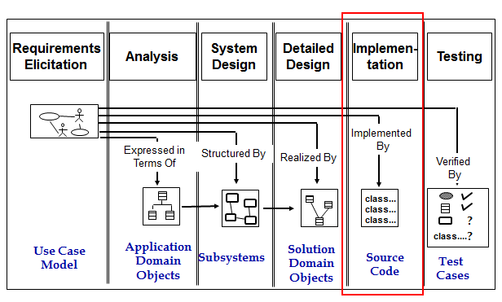

# Proposed Software Architecture

## Overview

Our system is divided into four subsystems. These are User, Visitor, Product Manager and Admin. The user have to sign up for any data related to clothes just for buying. The visitor can see the products but also need to sign up for shopping. The admin contains the acces of admin on the application. The admin can change primary and improtance activities. Admin has the ability for update any information about products. And last module is for product manager controls the biggest part of the system. All products, orders and sales. Our system is able to provide high cohesion low coupling condition so that the system can work efficiently. Because the more interconnection between items, the stronger the communication with each other. The external connection, ie, the coupling is kept to a minimum, the complexity is minimized. The whole system is adversely affected by connection confusion in the external system.

## Global Software Control

Users can purchase any product which they want in stock after enter the system. Address information is not requested in the payment process since the address information is received in the first user registration. The product will be shipped to the customer address with cargo. . And more than one user can access the system at the same time. Two customers can choose the same product. If there is one product in stock , deadlock will occur. Thread will be used for the deadlock that occurred. Therefore the product will be buy by selected first. Generally , threads are used in http.

## Boundary Conditions

Users can access the categories and products after logging into the system. They can choose the product that they want to buy from categories, products list or search. After you select a product, the purchase processing starts. If you want to purchase a product, you should log on to the website , if you’re a user, this is not necessary. If you make any mistakes, you can direct to main page. There is no credit limit check because there is no credit card payment.

## System Decomposition

According to hierarchy there are different interfaces for user login, admin login, and product manager login. Users will see and control their own page after they log in. And we have four subsystem.

Admin subsystem controls product manager subsystem and user subsystem. Product manager can be added and deleted and users can be deleted by the admin. Admin can view about products details but cannot control.

Product Manager subsystem contols all product, categories and orders. Product Manager can add, delete, update products and categories , and view users’ orders. Product Manager can view the sent products for delivery status.

Visitor subsystem can only view all products , categories and can search. Visitor can not buy any product.

User subsystem can view all products , categories and can search. User can add product to shopping box and delete product from shopping box and can give orders. User can view himself /herself user informations and can update. User can view his/her orders.

