Comparitive Analysis Threads and Twitter Reviews
*Note: Sub-titles are not captured in Xplore and should not be used

Sai Rachana Kandikattu
Data Science
GWU
Snehitha Tadapaneni
Data Science
GWU
Haeyeon Jeong
Data Science
GWU

Abstract: X formerly known as Twitter has been one of the most used social media platforms. Later Threads has been introduced by Meta with a similar objective as Twitter here people could share opinions on politics, current trends stc
Keywords—Natural Langauge Processing, Topic Modelling, Sentiment Analysis, Sentiment Classification

Introduction (Heading 1)
This template, modified in MS Word 2007 and saved as a “Word 97-2003 Document” for the PC, provides authors with most of the formatting specifications needed for preparing electronic versions of their papers. All standard paper components have been specified for three reasons: (1) ease of use when formatting individual papers, (2) automatic compliance to electronic requirements that facilitate the concurrent or later production of electronic products, and (3) conformity of style throughout a conference proceedings. Margins, column widths, line spacing, and type styles are built-in; examples of the type styles are provided throughout this document and are identified in italic type, within parentheses, following the example. Some components, such as multi-leveled equations, graphics, and tables are not prescribed, although the various table text styles are provided. The formatter will need to create these components, incorporating the applicable criteria that follow.

Data Prespocessing

Dataset Description
First, confirm that you have the correct template for your paper size. This template has been tailored for output on the A4 paper size. If you are using US letter-sized paper, please close this file and download the Microsoft Word, Letter file.

Data Cleaning
The template is used to format your paper and style the text.
- Lowercasing, Stop word removal, Lemmatization and
- Removing custom stop words.
- Addition of few words which could removed by stop words
Identify applicable funding agency here. If none, delete this text box.
- Removal of different langauges but written in english by analysing them manually and through lang detect.
- Text Normalisation for various names of social media platforms.

Feature engineering
Addition of unigrams, bigrams for more context.

Methodoly And Flow

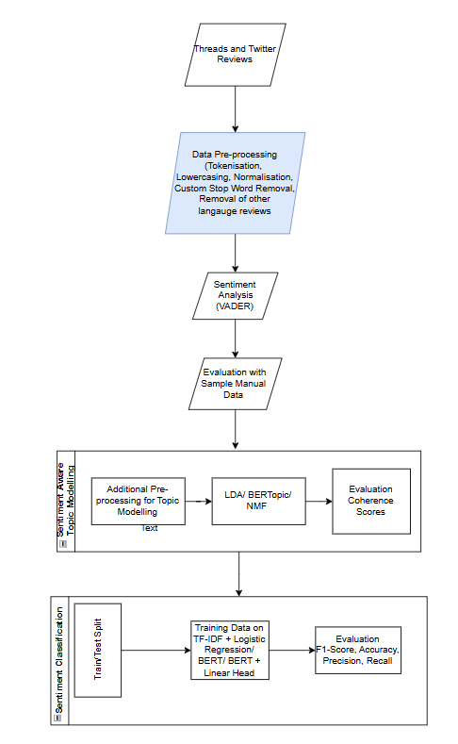

Sentiment analysis

VADER Based Sentiment
Define abbreviations and acronyms the first time they are used in the text, even after they have been defined in the abstract. Abbreviations such as IEEE, SI, MKS, CGS, sc, dc, and rms do not have to be defined. Do not use abbreviations in the title or heads unless they are unavoidable.

Zero Shot
- Use either SI (MKS) or CGS as primary units. (SI units are encouraged.) English units may be used as secondary units (in parentheses). An exception would be the use of English units as identifiers in trade, such as “3.5-inch disk drive”.
- Avoid combining SI and CGS units, such as current in amperes and magnetic field in oersteds. This often leads to confusion because equations do not balance dimensionally. If you must use mixed units, clearly state the units for each quantity that you use in an equation.
- Do not mix complete spellings and abbreviations of units: “Wb/m2” or “webers per square meter”, not “webers/m2”. Spell out units when they appear in text: “. . . a few henries”, not “. . . a few H”.
Identify applicable funding agency here. If none, delete this text box.
- Use a zero before decimal points: “0.25”, not “.25”. Use “cm3”, not “cc”. (bullet list)

Evaluation of self-supervised labels( Manual Labelling)
The equations are an exception to the prescribed specifications of this template. You will need to determine whether or not your equation should be typed using either the Times New Roman or the Symbol font (please no other font). To create multileveled equations, it may be necessary to treat the equation as a graphic and insert it into the text after your paper is styled.
“Eq. (1)” or “equation (1)”, except at the beginning of a sentence: “Equation (1) is . . .”

Comparision and Selection of Self-Supervised Models
- The word “data” is plural, not singular.
- The subscript for the permeability of vacuum μ₀, and other common scientific constants, is zero with subscript formatting, not a lowercase letter “o”.
- In American English, commas, semicolons, periods, question and exclamation marks are located within quotation marks only when a complete thought or name is cited, such as a title or full quotation. When quotation marks are used, instead of a bold or italic typeface, to highlight a word or phrase, punctuation should appear outside of the quotation marks. A parenthetical phrase or statement at the end of a sentence is punctuated outside of the closing parenthesis (like this). (A parenthetical sentence is punctuated within the parentheses.)

Sentiment Aware Topic Modelling
After the text edit has been completed, the paper is ready for the template. Duplicate the template file by using the Save As command, and use the naming convention prescribed by your conference for the name of your paper. In this newly created file, highlight all of the contents and import your prepared text file. You are now ready to style your paper; use the scroll down window on the left of the MS Word Formatting toolbar.

Pre-Processing for Topic Modelling
The template is designed for, but not limited to, six authors. A minimum of one author is required for all conference articles. Author names should be listed starting from left to right and then moving down to the next line. This is the author sequence that will be used in future citations and by indexing services. Names should not be listed in columns nor group by affiliation. Please keep your affiliations as succinct as possible (for example, do not differentiate among departments of the same organization).

For papers with more than six authors: Add author names horizontally, moving to a third row if needed for more than 8 authors.

For papers with less than six authors: To change the default, adjust the template as follows.

Selection: Highlight all author and affiliation lines.

Change number of columns: Select the Columns icon from the MS Word Standard toolbar and then select the correct number of columns from the selection palette.

Deletion: Delete the author and affiliation lines for the extra authors.

Topic Modelling Models
Headings, or heads, are organizational devices that guide the reader through your paper. There are two types: component heads and text heads.

LDA: Place figures and tables at the top and bottom of columns. Avoid placing them in the middle of columns. Large figures and tables may span across both columns. Figure captions should be below the figures; table heads should appear above the tables. Insert figures and tables after they are cited in the text. Use the abbreviation “Fig. 1”, even at the beginning of a sentence.

NMF: Place figures and tables at the top and bottom of columns. Avoid placing them in the middle of columns. Large figures and tables may span across both columns. Figure captions should be below the figures; table heads should appear above the tables. Insert figures and tables after they are cited in the text. Use the abbreviation “Fig. 1”, even at the beginning of a sentence.

BERTopic: Place figures and tables at the top and bottom of columns. Avoid placing them in the middle of columns. Large figures and tables may span across both columns. Figure captions should be below the figures; table heads should appear above the tables. Insert figures and tables after they are cited in the text. Use the abbreviation “Fig. 1”, even at the beginning of a sentence.

Comparision of Models and Insights

Coherence Scores Comparision: Place figures and tables at the top and bottom of columns. Avoid placing them in the middle of columns. Large figures and tables may span across both columns. Figure captions should be below the figures; table heads should appear above the tables. Insert figures and tables after they are cited in the text.
- Table Type Styles
Scores Comparision | Various Topic Modelling Techniques
Scores Comparision | Model | Coherence Scores | Topic Distribution
 | LDA
 | NMF
 | BERTopic
- Coherence Scores
- Example of a figure caption. (figure caption)
Figure Labels: Use 8 point Times New Roman for Figure labels. Use words rather than symbols or abbreviations when writing Figure axis labels to avoid confusing the reader. As an example, write the quantity “Magnetization”, or “Magnetization, M”, not just “M”. If including units in the label, present them within parentheses. Do not label axes only with units. In the example, write “Magnetization (A/m)” or “Magnetization {A[m(1)]}”, not just “A/m”. Do not label axes with a ratio of quantities and units. For example, write “Temperature (K)”, not “Temperature/K”.

Sentiment Classification

Logistic Regression

BERT

BERT + CNN head

Comparison OF models

Evaluation Metrics
Positivity score

Limitations
The preferred spelling of the word “acknowledgment” in America is without an “e” after the “g”. Avoid the stilted expression “one of us (R. B. G.) thanks ...”.

Conclusion
Instead, try “R. B. G. thanks...”. Put sponsor acknowledgments in the unnumbered footnote on the first page.

References
The template will number citations consecutively within brackets [1]. The sentence punctuation follows the bracket [2]. Refer simply to the reference number, as in [3]—do not use “Ref. [3]” or “reference [3]” except at the beginning of a sentence: “Reference [3] was the first ...”
Number footnotes separately in superscripts. Place the actual footnote at the bottom of the column in which it was cited. Do not put footnotes in the abstract or reference list. Use letters for table footnotes.
Unless there are six authors or more give all authors’ names; do not use “et al.”. Papers that have not been published, even if they have been submitted for publication, should be cited as “unpublished” [4]. Papers that have been accepted for publication should be cited as “in press” [5]. Capitalize only the first word in a paper title, except for proper nouns and element symbols.
For papers published in translation journals, please give the English citation first, followed by the original foreign-language citation [6].

- G. Eason, B. Noble, and I. N. Sneddon, “On certain integrals of Lipschitz-Hankel type involving products of Bessel functions,” Phil. Trans. Roy. Soc. London, vol. A247, pp. 529–551, April 1955. (references)
- J. Clerk Maxwell, A Treatise on Electricity and Magnetism, 3rd ed., vol. 2. Oxford: Clarendon, 1892, pp.68–73.
- I. S. Jacobs and C. P. Bean, “Fine particles, thin films and exchange anisotropy,” in Magnetism, vol. III, G. T. Rado and H. Suhl, Eds. New York: Academic, 1963, pp. 271–350.
- K. Elissa, “Title of paper if known,” unpublished.
- R. Nicole, “Title of paper with only first word capitalized,” J. Name Stand. Abbrev., in press.
- Y. Yorozu, M. Hirano, K. Oka, and Y. Tagawa, “Electron spectroscopy studies on magneto-optical media and plastic substrate interface,” IEEE Transl. J. Magn. Japan, vol. 2, pp. 740–741, August 1987 [Digests 9th Annual Conf. Magnetics Japan, p. 301, 1982].
- M. Young, The Technical Writer’s Handbook. Mill Valley, CA: University Science, 1989.
- K. Eves and J. Valasek, “Adaptive control for singularly perturbed systems examples,” Code Ocean, Aug. 2023. [Online]. Available: https://codeocean.com/capsule/4989235/tree
- D. P. Kingma and M. Welling, “Auto-encoding variational Bayes,” 2013, arXiv:1312.6114. [Online]. Available: https://arxiv.org/abs/1312.6114
- S. Liu, “Wi-Fi Energy Detection Testbed (12MTC),” 2023, gitHub repository. [Online]. Available: https://github.com/liustone99/Wi-Fi-Energy-Detection-Testbed-12MTC
- “Treatment episode data set: discharges (TEDS-D): concatenated, 2006 to 2009.” U.S. Department of Health and Human Services, Substance Abuse and Mental Health Services Administration, Office of Applied Studies, August, 2013, DOI:10.3886/ICPSR30122.v2

IEEE conference templates contain guidance text for composing and formatting conference papers. Please ensure that all template text is removed from your conference paper prior to submission to the conference. Failure to remove template text from your paper may result in your paper not being published.

