
FCE (T) Potiskum Staff Cooperative Society Limited
COOP Software
User Manual and System Documentation
Step-by-step instructions for members, officers and administrators
Document | Details
Version | 1.0
Date | October 2026
Applies to | COOP Software (web application)
Audience | Members, Treasurer, Chairman, Secretary, Auditor, Store Officer, Exco, Loan Officer, Super Admin

Contents
1. Introduction 6
1.1 About COOP Software 6
1.2 Who should read this manual 6
1.3 Conventions used in this manual 7
1.4 Key ideas you should know 7
2. User Roles and Responsibilities 8
2.1 Approval chains at a glance 8
3. Getting Started (All Users) 10
3.1 Opening the system 10
3.2 Logging in 10
3.3 First login: setting a new password 10
3.4 First login: completing your profile 11
3.5 Forgotten password 11
3.6 The Dashboard and the sidebar 11
3.7 Notifications 12
3.8 Announcements 12
3.9 Your account settings 12
3.10 Logging out 13
4. Member Guide 14
4.1 Applying for membership 14
4.2 Paying the application fee 15
4.3 Tracking your application 15
4.4 My Profile: viewing and updating your details 15
4.5 Changing your monthly contribution 15
4.6 My Savings and statements 16
4.7 Logging a voluntary deposit 16
4.8 Requesting a withdrawal 17
4.9 Requesting a complete withdrawal 17
4.10 Loans: how much can I borrow? 18
4.11 Applying for a loan 18
4.12 Responding to a guarantor request 19
4.13 Viewing your loans 19
4.14 Logging a repayment you paid directly 20
4.15 Repaying a loan from your savings 20
4.16 Excess repayments (over-payments) 21
4.17 Requesting commodities (commodity loans) 21
4.18 Share capital 22
4.19 Dividends and savings interest 23
4.20 Support tickets (complaints and enquiries) 23
4.21 Leaving the society (exit) 23
5. Treasurer Guide 24
5.1 Approving or rejecting membership applications 24
5.2 Bulk importing existing members 24
5.3 The members directory and member record 25
5.4 Posting monthly contributions 26
5.5 Confirming voluntary deposits 26
5.6 Contribution change requests 27
5.7 Reviewing and paying withdrawals 27
5.8 Withdrawal rules and voluntary deposit hold period 27
5.9 Correcting a mistake (reversals) 28
5.10 Share purchases and withdrawals 28
5.11 Dividends and savings interest 29
5.12 Budget and expenses 29
5.13 Welfare fund 29
5.14 Loan applications: review and disbursement 30
5.15 Posting monthly loan repayments (payroll deductions) 31
5.16 Confirming repayments logged by members 31
5.17 Loan repayments from savings 31
5.18 Excess repayment reversals 32
5.19 Importing existing (legacy) loans 33
5.20 Exit clearance 33
6. Chairman Guide 34
6.1 Authorizing withdrawals 34
6.2 Authorizing reversals 34
6.3 Authorizing loans 34
6.4 Loan interest rates 35
6.5 Authorizing share withdrawals and setting the share price 35
6.6 Declaring dividend rates 35
6.7 Budgets and expenses 36
6.8 Welfare fund settings and claims 36
6.9 Registration fee and its split 36
6.10 Commodity cycles: markup and authorization 37
6.11 Announcements and confidential complaints 37
7. Secretary Guide 38
7.1 Reviewing member change requests 38
7.2 Managing the commodity catalogue 38
7.3 Running a commodity cycle 38
7.4 Posting announcements 39
7.5 Handling complaints 39
7.6 Other Secretary tasks 39
8. Auditor Guide 41
8.1 Verifying commodity prices 41
8.2 Activity log 41
8.3 Reports available to the Auditor 42
9. Store Officer Guide 43
9.1 Verifying stock in the store 43
9.2 Releasing goods to members 43
10. Exco and Loan Officer Guide 45
10.1 Exco members 45
10.2 Loan Officer 45
11. Super Admin Guide 46
11.1 Resetting a user's password 46
11.2 Changing a member's status 46
11.3 Finalizing a member's exit 46
11.4 Editing locked member fields 46
11.5 Loan product rules and limits 46
12. Reports 48
13. Commodity Loan Cycle — End-to-End 50
Appendix A. CSV File Formats 51
A.1 Member import 51
A.2 Monthly contributions 51
A.3 Loan repayments 52
A.4 Legacy loan import 52
A.5 Welfare levy 52
Appendix B. Status Glossary 53
Appendix C. Automatic Daily Tasks 54
Appendix D. Installation and Deployment (Technical) 55
D.1 Requirements 55
D.2 First-time setup 55
D.3 Updating the software 55
D.4 Backups 55
Appendix E. Troubleshooting and FAQ 56

If page numbers are missing, right-click the table of contents and choose Update Field.

1. Introduction

1.1 About COOP Software
COOP Software is the web application used by the FCE (T) Potiskum Staff Cooperative Society Limited to run its day-to-day business online. It replaces paper registers and spreadsheets with one system that every member and officer of the society uses from a web browser.
The software covers the full life of a member and their money:
- Membership — online applications, application-fee payment, approval, profile changes, bulk import of existing members, exit and deceased-member handling.
- Savings — monthly contribution deductions, voluntary deposits, statements, partial and complete withdrawals, and corrections (reversals).
- Loans — cash loans with guarantors, commodity (foodstuff) loans, repayment by payroll deduction, cash or savings, and handling of over-payments.
- Share capital — buying and withdrawing shares at the current share price.
- Dividends and savings interest — calculated on time-weighted average balances and credited to members.
- Welfare (death benefit) fund, budgeting and expenses, support tickets, documents, announcements and notifications.
- Reports and financial statements, with CSV export.

1.2 Who should read this manual
Every user can read Chapters 1 to 3. After that, go to the chapter for your role:
If you are… | Read
A member, or applying to become one | Chapter 4 — Member Guide
The Treasurer | Chapter 5 — Treasurer Guide
The Chairman | Chapter 6 — Chairman Guide
The Secretary | Chapter 7 — Secretary Guide
The Auditor | Chapter 8 — Auditor Guide
The Store Officer | Chapter 9 — Store Officer Guide
An Exco member or Loan Officer | Chapter 10
The Super Admin (system administrator) | Chapter 11 — Super Admin Guide, and Appendix D
Anyone needing a report | Chapter 12 — Reports

1.3 Conventions used in this manual
- Menu paths are written with arrows: Loans › Loan Applications means open the Loans group in the left-hand sidebar, then click Loan Applications.
- Buttons, links and field names are written in bold, exactly as they appear on screen.
- Amounts are in Naira (₦). Dates are shown as day-month-year.
- Screenshots (figures) show fictional sample data — the names and amounts are made up. Your screens show your society's real data, and you only see the menu items your role allows.

Note: Notes give extra information that helps you understand a step.
Important: Important boxes warn about actions that cannot be undone or that affect money.

1.4 Key ideas you should know
Term | Meaning
Staff ID | Your college staff number. New applicants use SS/<number> (Senior Staff) or JS/<number> (Junior Staff). You can log in with your Staff ID or your email.
Application No. | Reference given when you apply, e.g. FCET/CSL/00012.
Membership No. | Given on approval, made from your Staff ID, e.g. FCET/CSL/SS/1234.
Regular Savings | Your main savings account. Monthly contributions and voluntary deposits go here. It is opened automatically when you are approved.
Approved monthly contribution | The amount deducted from your salary each month for savings, as approved by the Treasurer.
Two-signature control | Money going out (withdrawals, loans, share withdrawals, expenses, welfare claims) needs two officers: the Treasurer reviews and endorses, then the Chairman authorizes. The Treasurer then pays out and records it.
Ledger | Every money movement is recorded as a transaction that cannot be edited or deleted. Mistakes are corrected with a reversal (see 5.9), so the full history is always kept.
Usable (withdrawable) savings | Your savings balance minus money already promised to other pending requests and voluntary deposits still in their lock period.
Commodity cycle | A round of foodstuff/commodity purchasing. Members request items, the society prices and buys them, and each member repays what they received as a commodity loan.
Dividend period | A period (usually a financial year) over which share dividends and savings interest are calculated.

2. User Roles and Responsibilities
Each user account has one role. The role decides which menu items you see and which actions you can take. If you cannot find a menu item described in this manual, your role does not include it.
Role | Main responsibilities
Applicant | Someone who has applied but is not yet approved. Can only view their own application and pay the application fee.
Member | Views and manages their own profile, savings, loans, shares, dividends, commodity requests and support tickets.
Treasurer | Approves applications, imports members, posts contributions and loan repayments, reviews withdrawals, loans and share withdrawals, confirms deposits and repayments, runs dividends, manages budgets and expenses, posts welfare levies, and pays out approved money.
Chairman | Second signature: authorizes withdrawals, loans, share withdrawals, reversals, expenses and welfare claims. Approves budgets, declares dividend rates, sets interest rates, the registration fee and welfare amounts, posts announcements and handles confidential complaints.
Secretary | Reviews member profile change requests, manages the commodity catalogue and cycles (including pricing), posts announcements, manages member documents and logs complaints for members.
Auditor | Verifies commodity prices, and has read access to the activity log, financial statements and budget and welfare reports.
Store Officer | Verifies commodity stock in the store and releases goods to members.
Exco | Read-only access to the member list and most reports; can handle complaints.
Loan Officer | Can view the member list.
Super Admin | Has every permission. Also manages user passwords, member status (suspend, dormant, deceased, exit), locked member fields and loan product rules.

2.1 Approval chains at a glance
Operation | Started by | Reviewed by | Authorized by | Completed by
Membership application | Applicant | — | Treasurer approves | Automatic
Profile change | Member | — | Secretary approves | Automatic
Contribution change | Member | — | Treasurer approves | Automatic
Savings withdrawal | Member | Treasurer endorses | Chairman | Treasurer marks disbursed
Loan | Member + guarantors accept | Treasurer endorses | Chairman | Treasurer disburses
Share withdrawal | Member | Treasurer endorses | Chairman | Treasurer marks disbursed
Reversal (correction) | Treasurer | — | Chairman | Posted on authorization
Expense | Treasurer | — | Chairman | Treasurer marks paid
Welfare claim | Treasurer / Secretary | — | Chairman | Treasurer marks disbursed
Dividends | Treasurer opens period | Chairman declares rates | Treasurer calculates | Treasurer posts
Commodity cycle | Secretary | Auditor (prices), Store Officer (stock) | Chairman | Store Officer releases goods

3. Getting Started (All Users)

3.1 Opening the system
Open a modern web browser (Google Chrome, Microsoft Edge, Mozilla Firefox or Safari) on a computer or phone and go to the society's COOP Software web address. The pages adjust to phone screens.

3.2 Logging in
- Click Log in on the home page.
- In Staff ID or Email, type your Staff ID (for example SS/1234) or the email address on your account.
- Type your Password.
- Tick Remember me only on your own private device.
- Click Log in. You will be taken to your Dashboard.

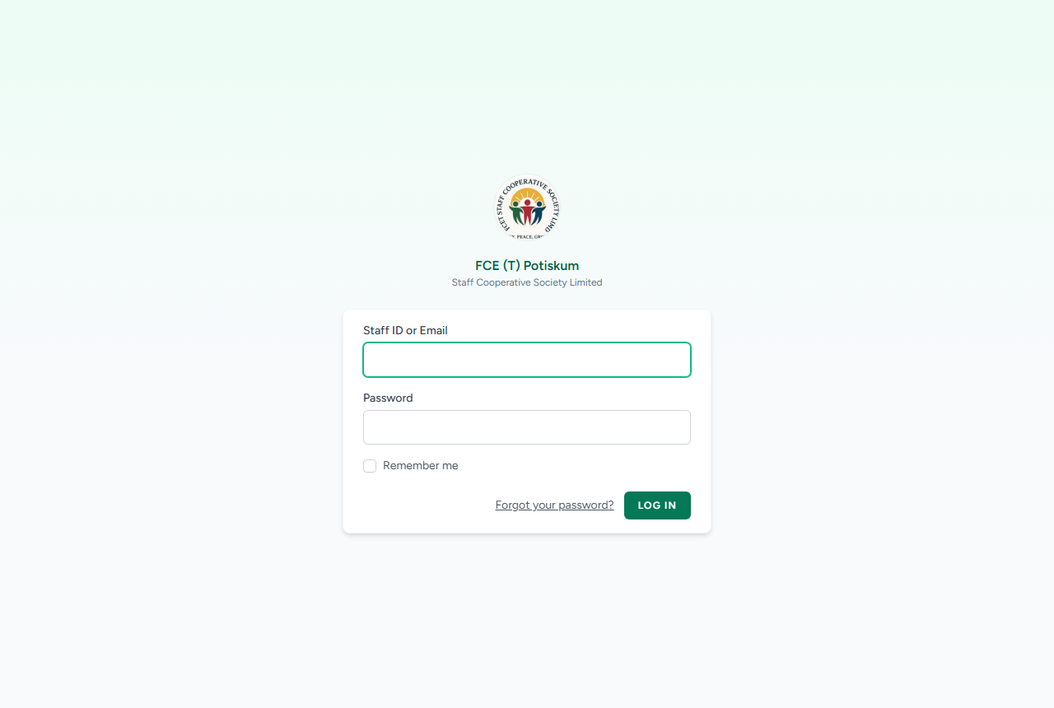
Figure 1: The login page
Note: After 5 wrong attempts the login is blocked for a short time. Wait a minute and try again, or use Forgot your password?.

3.3 First login: setting a new password
Accounts created by the society (imported members and staff accounts) start with a temporary password. Imported members' first password is their Staff ID. On first login you must choose a new password before you can do anything else.
- Log in with your Staff ID and temporary password.
- On the Set a New Password page, type a new password of at least 8 characters in New Password. It cannot be the same as your Staff ID.
- Type it again in Confirm New Password.
- Click Set Password & Continue.

3.4 First login: completing your profile
If you were added by bulk import and some of your details were not on file (phone, email, gender, date of birth, marital status, home address or next of kin), you will see Complete Your Profile after setting your password. You must fill these in before continuing.
- Fill in every field shown on the page. Only the missing details are shown.
- Under Next of Kin, enter the name, relationship and phone number of your next of kin, if asked.
- Click Save & Continue. Your details are saved straight away and you are taken to the Dashboard.

Note: Your department and rank/grade are set by the Super Admin, not on this page.

3.5 Forgotten password
- On the login page click Forgot your password?.
- Enter the email address on your account and click Email Password Reset Link.
- Open the email, click the link, enter a new password twice and click Reset Password.

Note: If your account has no real email address (for example, an imported member who has not completed their profile), ask the Super Admin to reset your password (see 11.1).

3.6 The Dashboard and the sidebar
The Dashboard is your home page. It shows cards for the tasks your role can do, latest announcements, and (for members) a summary of savings, loans and shares. Click any card to go to that screen.
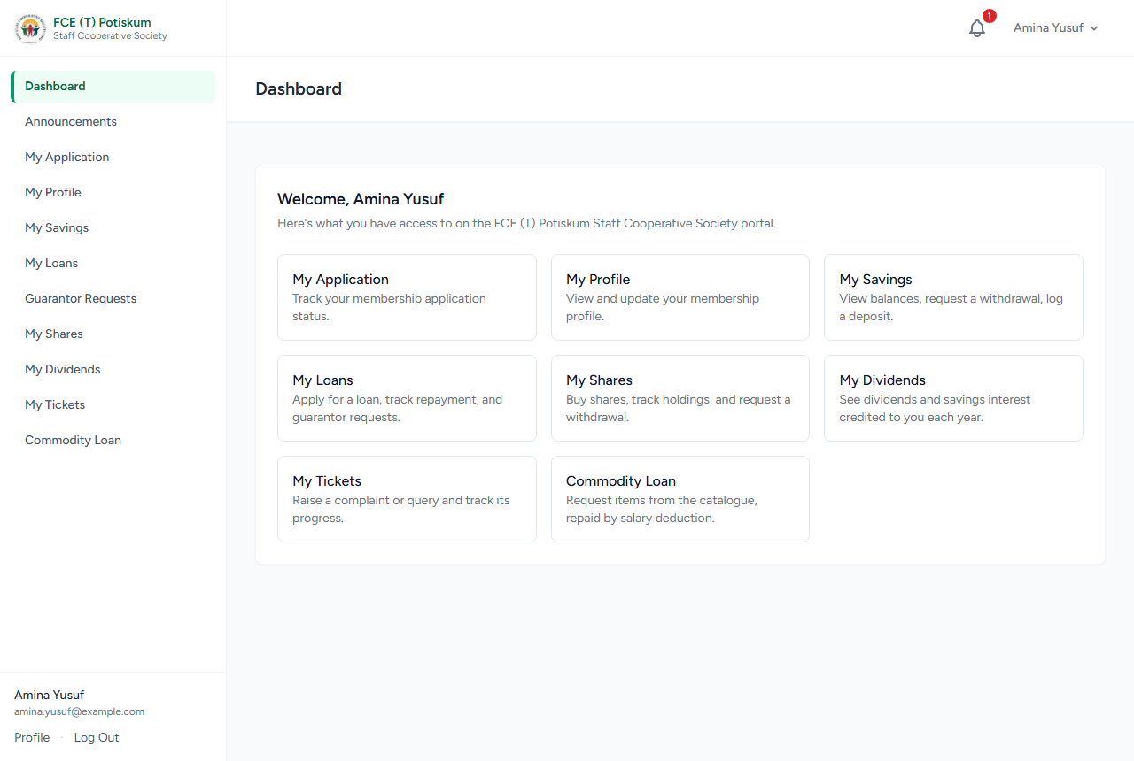
Figure 2: A member's Dashboard, with the sidebar on the left
The sidebar on the left lists everything you can open. Officers' items are grouped: Membership, Savings & Withdrawals, Share Capital, Dividends, Budgeting, Welfare Fund, Loans and Reports. Click a group name to open or close it. On a phone, tap the menu button at the top to show the sidebar.

3.7 Notifications
The bell icon at the top of every page shows how many unread notifications you have. You are notified, for example, when your application is approved, a loan is disbursed, a withdrawal is paid, an announcement is posted, a ticket gets a reply, or an excess loan repayment is recorded.
- Click the bell to see recent notifications. Click a notification to open the related page.
- Click Mark all read to clear the count.
- To see every notification, open My Notifications from the bell. Use Mark read on single items.

3.8 Announcements
Click Announcements in the sidebar to read notices from the society. Pinned announcements stay at the top. New announcements also appear on the Dashboard and as a notification.

3.9 Your account settings
Click your name at the top right, then Profile, to manage your login account:
- Profile Information — change your display name and login email, then click Save.
- Update Password — enter your Current Password, then the New Password twice, and click Save.

Note: This page changes your login account only. Members change their membership details (address, next of kin, etc.) on My Profile (see 4.4).

3.10 Logging out
Click your name at the top right and choose Log Out. Always log out on shared computers.

4. Member Guide

4.1 Applying for membership
Staff of the College who are not yet members apply online. Have your passport photograph (JPEG or PNG, max 2 MB) ready.
- Go to the COOP Software home page and click Register.
- Section A — Personal Information: enter your Full Name, Date of Birth, Gender, IPPIS Number (optional), Marital Status, Home Address, Phone Number 1 and optionally Phone Number 2.
- Enter your Email Address (this becomes your login), then Choose a Password and Confirm Password.
- Upload your Passport Photograph.
- Section B — Employment Information: enter your Department / Directorate / Unit, choose your Staff Category (Senior or Junior Staff), and enter your Staff ID Number in the right format: SS/<number> for Senior Staff or JS/<number> for Junior Staff. Then enter Date of First Appointment, Employment Status and Present Rank / Cadre / Grade Level.
- Section C — Membership Commitment: enter your Preferred Monthly Contribution (₦) (not below the society minimum shown) and choose the Mode of Deduction.
- Next of Kin: enter their Name, Relationship, Phone Number and optionally Address.
- Section D — Declaration: read the declaration, tick to accept it, and type your full name as your digital signature.
- Click Submit Application. You will see your application reference number.

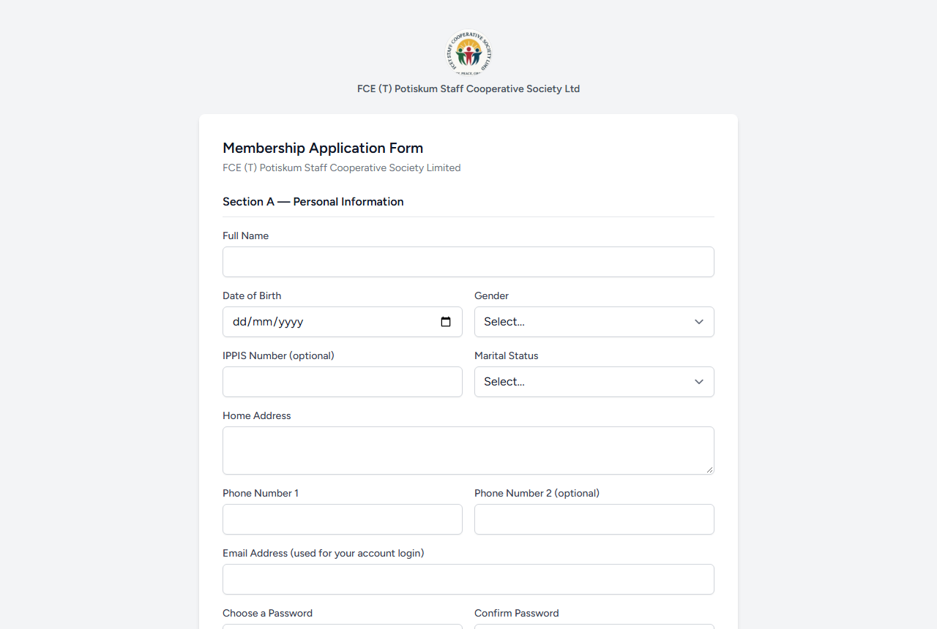
Figure 3: The membership application form (top of the page)
After submitting you can log in straight away as an applicant to pay the fee and track your application.

4.2 Paying the application fee
Your application cannot be approved until the application fee is paid. The current fee is shown on the payment page.
- Log in and click My Application in the sidebar.
- Click Pay Now next to the unpaid-fee notice.
- Click Pay with Paystack. You are taken to Paystack's secure page.
- Pay by card, bank transfer or another option offered by Paystack.
- You are returned to COOP Software. When the payment is confirmed, your fee shows as paid. Earlier attempts are listed under Payment Attempts.

Note: If online payment is not available, pay the society directly (cash or bank transfer). The Treasurer records it when approving your application.

4.3 Tracking your application
Click My Application to see your application details, fee status and the Status Timeline showing each step. When the Treasurer approves you, you are notified and given a Membership No., your Regular Savings account is opened, and your sidebar shows the full member menu.

4.4 My Profile: viewing and updating your details
Click My Profile to see your membership record.
- Membership Details (department, Staff ID, rank/grade, staff category, status) are locked. Contact the Super Admin to change them.
- Personal & Contact Information and Next of Kin can be changed by request.

To request a change:
- Open My Profile.
- Edit the fields you want to change in Personal & Contact Information or Next of Kin. To replace your photo, choose a file in Replace Passport Photograph.
- Click Save Changes.
- Your changes appear under Pending Change Requests (awaiting Secretary review). They take effect only when the Secretary approves them.

You can also upload documents (for example, an ID card or letter) in the Documents panel on My Profile: enter a Title, choose the File (PDF, image or Word document, max 10 MB) and click Upload.

4.5 Changing your monthly contribution
- Open My Profile and click Request Change next to your contribution.
- Enter the New Monthly Contribution (₦) (not below the society minimum) and an optional Reason.
- Click Submit. The Treasurer reviews it and may approve a different amount. Only one request can be pending at a time.

4.6 My Savings and statements
Click My Savings to see each savings account, its balance and recent transactions, and your withdrawal requests.
To get a statement:
- In My Savings, click Statement on the account.
- Choose the From and To dates.
- Click Download PDF to save or print the statement.

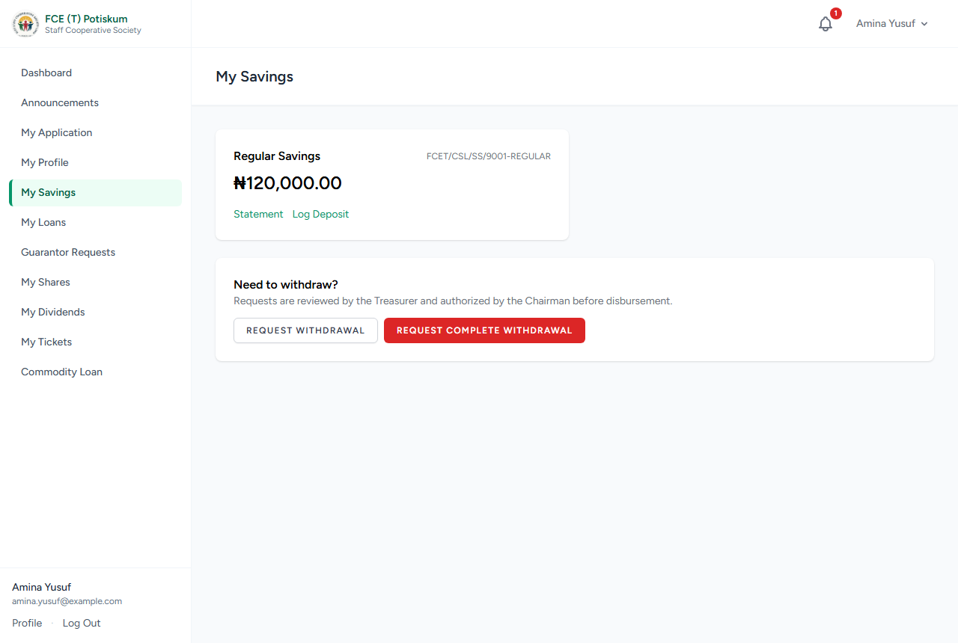
Figure 4: My Savings: balance, recent transactions and withdrawal requests

4.7 Logging a voluntary deposit
If you pay extra money into your savings (outside payroll deduction), log it so the Treasurer can confirm it.
- In My Savings, click Log Deposit on the account.
- Enter the Amount (₦), an optional Note (e.g. the bank and date) and optionally attach a Receipt (photo or PDF of the deposit slip).
- Click Submit. The deposit is added to your balance only when the Treasurer confirms it.

Important: Once confirmed, a voluntary deposit must stay in your account for the hold period set by the society (3 months by default) before it can be withdrawn.

4.8 Requesting a withdrawal
- In My Savings, click Request Withdrawal.
- Choose the Savings Account and enter the Amount to Withdraw (₦). The page shows the most you can withdraw.
- Enter the Bank Name, Account Number and Account Name to be paid into, and an optional Reason.
- Click Submit Request.
- Track progress under My Withdrawal Requests: Treasurer review, then Chairman authorization, then disbursement.

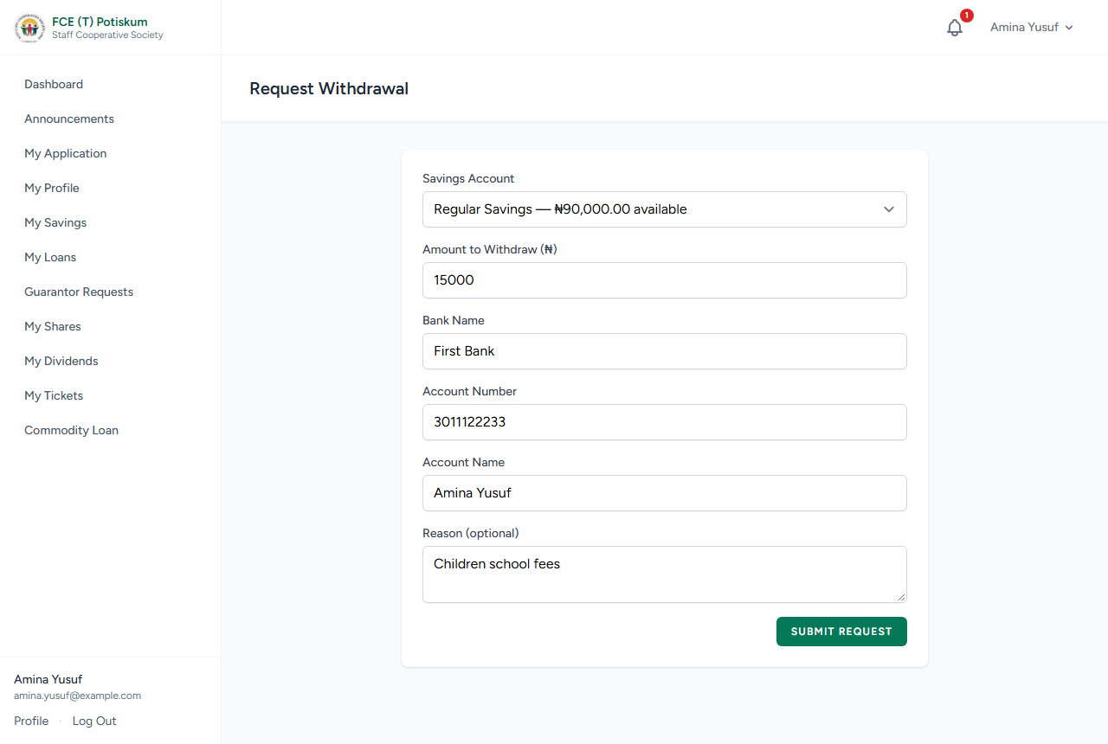
Figure 5: Requesting a withdrawal
Note: Society rules may limit withdrawals, for example a minimum balance that must remain, a minimum membership period, a maximum percentage of the balance, or a waiting period between withdrawals. You will see a warning if your request breaks a rule.

4.9 Requesting a complete withdrawal
A complete withdrawal pays out everything above the required minimum balance (excluding locked voluntary deposits).
- In My Savings, click Request Complete Withdrawal.
- Choose the Savings Account, enter your bank details and an optional Reason.
- Click Submit Complete Withdrawal Request.

Important: When a complete withdrawal is paid out, your membership is suspended.

4.10 Loans: how much can I borrow?
Each loan product (e.g. Regular/Ordinary Loan, Emergency/Special Loan) has rules set by the society:
- Loan limit — your savings balance times the product's multiplier (e.g. 3× savings).
- Minimum membership period and minimum savings balance before you can apply.
- Maximum tenure (number of months to repay).
- Guarantors — how many active members must guarantee the loan, and how much each pledges.

The Apply for a Loan page shows your limit and checks these rules as you fill the form.

4.11 Applying for a loan
- Click My Loans, then Apply for a Loan.
- Choose the Loan Product.
- Enter the Principal Amount (₦) and Tenure (months). Read the eligibility summary and the repayment estimate.
- If guarantors are required, enter Guarantor 1 — Staff ID and the Amount Pledged (₦), and Guarantor 2 if needed. Guarantors must be other active members.
- Click Submit Application. Your guarantors are notified.

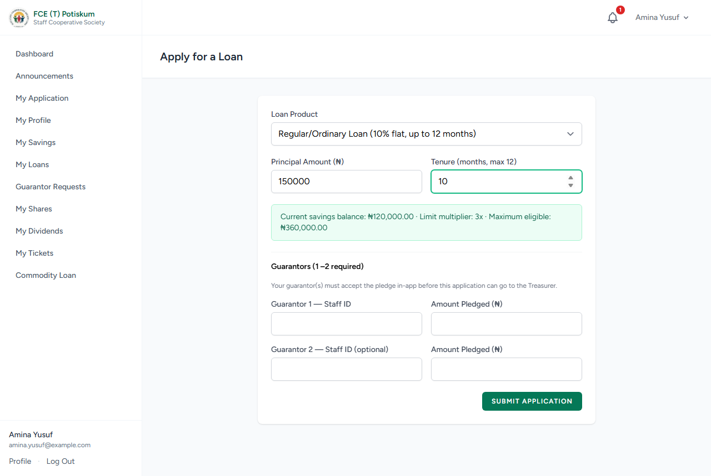
Figure 6: Applying for a loan — the eligibility summary shows the limit (savings × multiplier)
Your loan then moves through these stages, which you can see on My Loans: waiting for guarantors → Treasurer review → Chairman authorization → disbursed (active). If a guarantor declines, the application stops and you must apply again with another guarantor.

4.12 Responding to a guarantor request
- Click Guarantor Requests in the sidebar.
- Under Pending Invitations, read the applicant's name, loan amount and the amount you are asked to pledge.
- Click Accept to pledge that amount of your savings, or Decline.

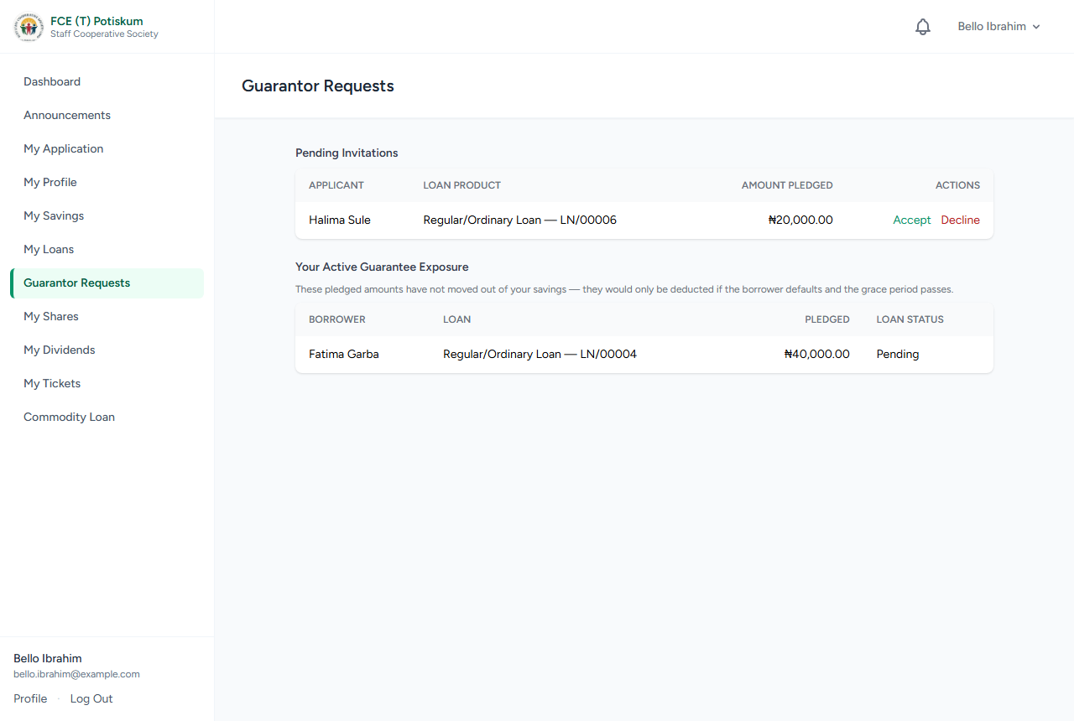
Figure 7: Guarantor Requests: accept or decline a pledge
Important: If the borrower defaults and the grace period passes, your pledged amount is taken from your savings to repay their loan. Your Active Guarantee Exposure shows what you currently guarantee.

4.13 Viewing your loans
On My Loans, each loan shows its principal, total repayable, total paid, outstanding balance and monthly installment.
- Click View repayment schedule to see each installment, its due date and how much has been paid.
- Click Details & documents to see the full loan record, guarantors and loan documents.

4.14 Logging a repayment you paid directly
Most repayments are deducted from salary. If you pay towards a loan yourself (cash or bank transfer), log it:
- On My Loans, click Make a repayment on the loan.
- Enter the Amount (₦), an optional Note and optionally attach a Receipt.
- Click Log Repayment.
- The repayment appears under Logged Repayments on the loan with status Awaiting Treasurer. It changes to Approved (and is taken off your balance) or Declined (with the Treasurer's reason).

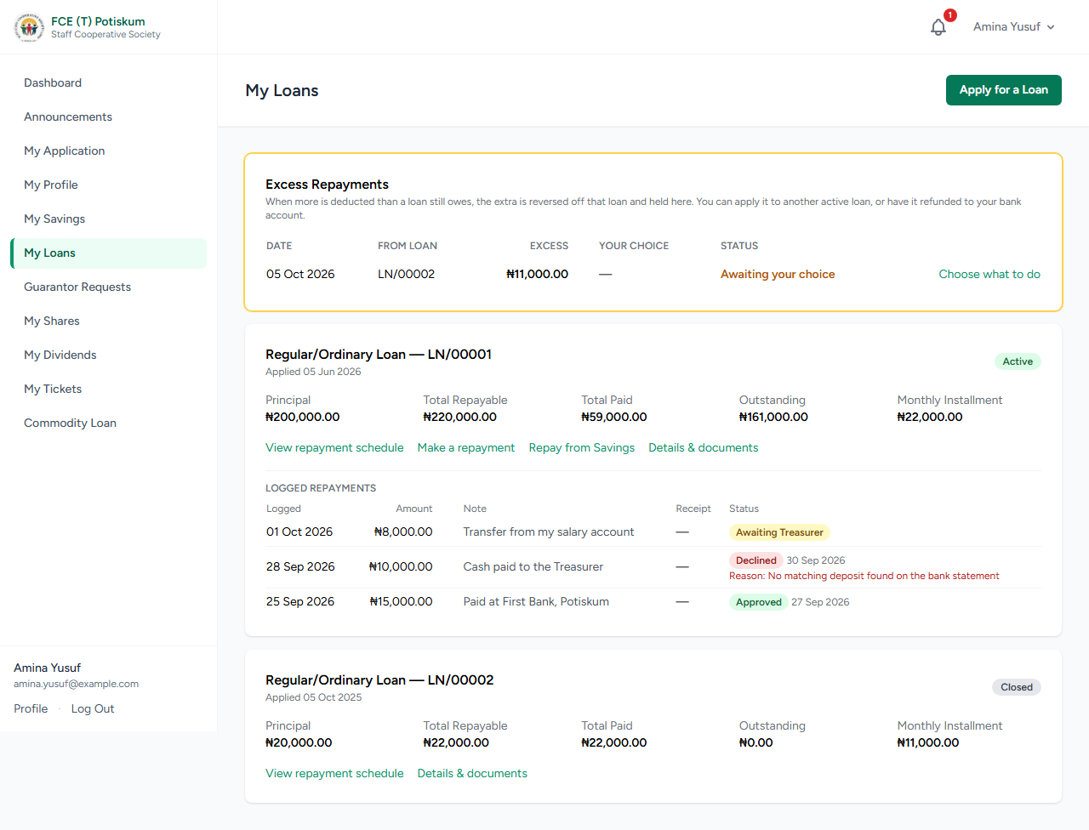
Figure 8: My Loans: an excess repayment awaiting the member's choice, and logged repayments with their status

4.15 Repaying a loan from your savings
- On My Loans, click Repay from Savings on the loan.
- Choose the Savings Account (the usable amount is shown) and enter the Amount (₦).
- Click Submit Request. You cannot ask for more than your usable savings or more than the loan still owes.
- The Treasurer approves it, and the money moves from your savings to the loan at once.

4.16 Excess repayments (over-payments)
If more is paid towards a loan than it owes (for example, payroll keeps deducting after the loan is cleared), the extra is held as an excess repayment. You are notified and it appears in the Excess Repayments panel at the top of My Loans.
- On My Loans, find the excess marked Awaiting your choice and click Choose what to do.
- Choose Apply it to another active loan and select the loan, or Refund it to my bank account and enter your Bank Name, Account Number and Account Name.
- Click Submit. The Treasurer processes your choice, and the status changes to Reversal completed. For refunds, the payment reference is shown.

4.17 Requesting commodities (commodity loans)
When the Secretary opens a commodity cycle, you can request foodstuff and other items to be repaid as a commodity loan.
- Click Commodity Loan in the sidebar.
- For each item, click the item box and type to search the catalogue, then choose the item. If it is not listed, describe it in the text box instead.
- Enter the Qty and choose the unit (e.g. bag, half bag, carton) if options are listed.
- Click Add Another Item for more items, or Remove to drop one.
- Tick the salary deduction authorization.
- Click Submit Request.

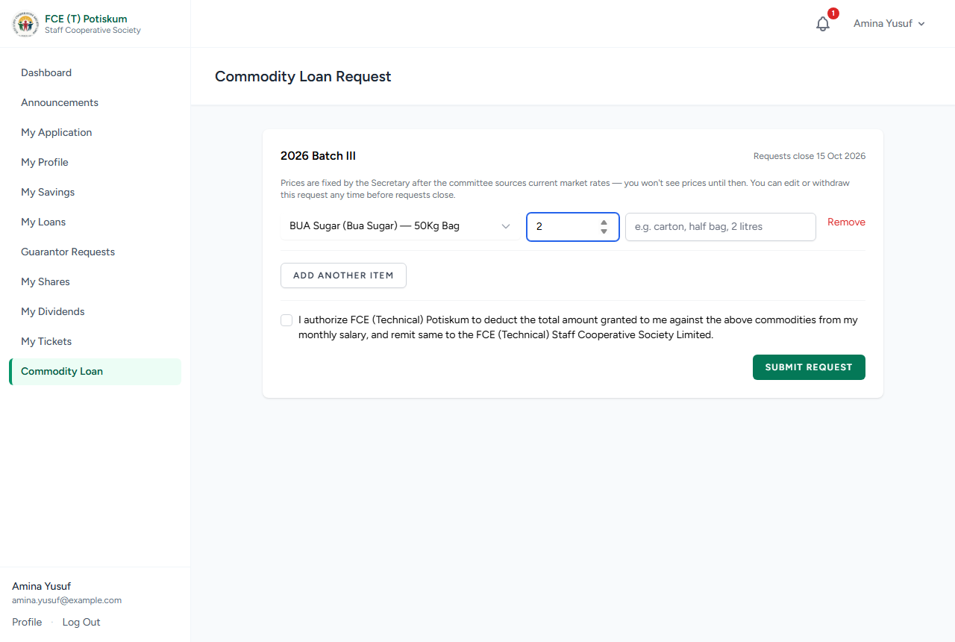
Figure 9: Requesting commodities: search the catalogue, enter the quantity
- You can change your request (Save Changes) or Withdraw Request until the request deadline.
- After the deadline, the Secretary prices the items and your totals appear on the same page.
- When goods are released you can see what you received. Items that were out of stock or damaged are marked and you are not charged for them. Your loan is created for the value received plus the cycle's markup.
- You cannot start a new commodity request while a previous commodity loan is still being repaid.

4.18 Share capital

Buying shares
- Click My Shares, then Buy Shares.
- Enter the Number of Shares and an optional Note. The cost at the current share price is shown.
- Click Log Purchase, then pay the society. Your shares are added when the Treasurer confirms payment, at the price on the day of confirmation.

Withdrawing shares
- On My Shares, click Withdraw Shares.
- Enter the Number of Shares to Withdraw (you must keep the society's minimum holding), your bank details and an optional Reason.
- Click Submit Request. It goes to the Treasurer, then the Chairman, and is then paid out.

4.19 Dividends and savings interest
Click My Dividends to see each dividend period: your share capital dividend, savings interest and the total credited to your Regular Savings account.

4.20 Support tickets (complaints and enquiries)
- Click My Tickets, then Raise a Ticket.
- Choose a Category (Loan, Savings, Share Capital, Dividend, Staff Conduct or General), enter a Subject and the Details.
- Tick the confidential option if the matter is sensitive. Only the Chairman can see confidential tickets.
- Click Submit. You are notified when an officer replies or resolves it. Open the ticket to read and reply.

4.21 Leaving the society (exit)
- Open My Profile and go to Exit / Withdrawal.
- Enter the Reason for exit and click Request Exit.
- The Treasurer checks you have no outstanding loans or guarantees and signs off. The Super Admin then finalizes your exit.

5. Treasurer Guide
The Treasurer runs most of the society's daily operations. Your Dashboard shows a card for each queue; cards with waiting items need your attention.

5.1 Approving or rejecting membership applications
- Go to Membership › Pending Applications.
- Review each applicant's details and fee status.
- To approve, click Approve. Check the Approved Monthly Contribution (₦). If you change it from what the applicant asked for, enter a Note explaining why.
- If the fee was not paid online, tick Application Fee to confirm it was paid another way, and note how and when (e.g. bank transfer reference).
- Click Confirm Approval. The member gets a Membership No. and a Regular Savings account, and is notified.
- To reject, click Reject, enter the Reason for rejection and click Confirm Rejection.

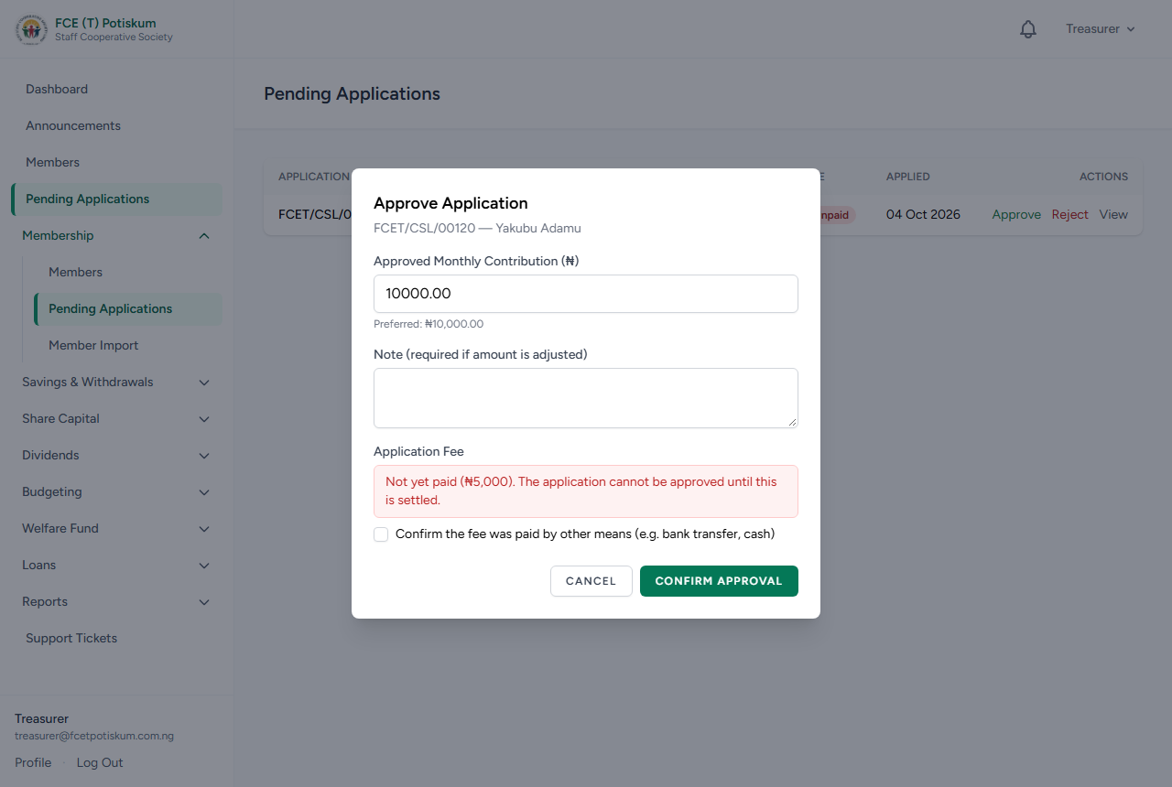
Figure 10: Approving an application — the fee must be paid or confirmed

5.2 Bulk importing existing members
Use this to bring existing (paper-record) members into the system in one go. See Appendix A.1 for the file format.
- Go to Membership › Member Import.
- Click Download CSV Template, fill it in Excel (one row per member) and save it as CSV.
- Click Choose file under Member Data File (CSV), select your file and click Upload & Validate.
- Review the batch page. Rows marked Ready are valid; flagged rows show the reason (e.g. Staff ID already exists, invalid date).
- To fix flagged rows, correct the file and use Re-upload Corrected File › Replace & Re-validate.
- Click Import N Member(s) and confirm.

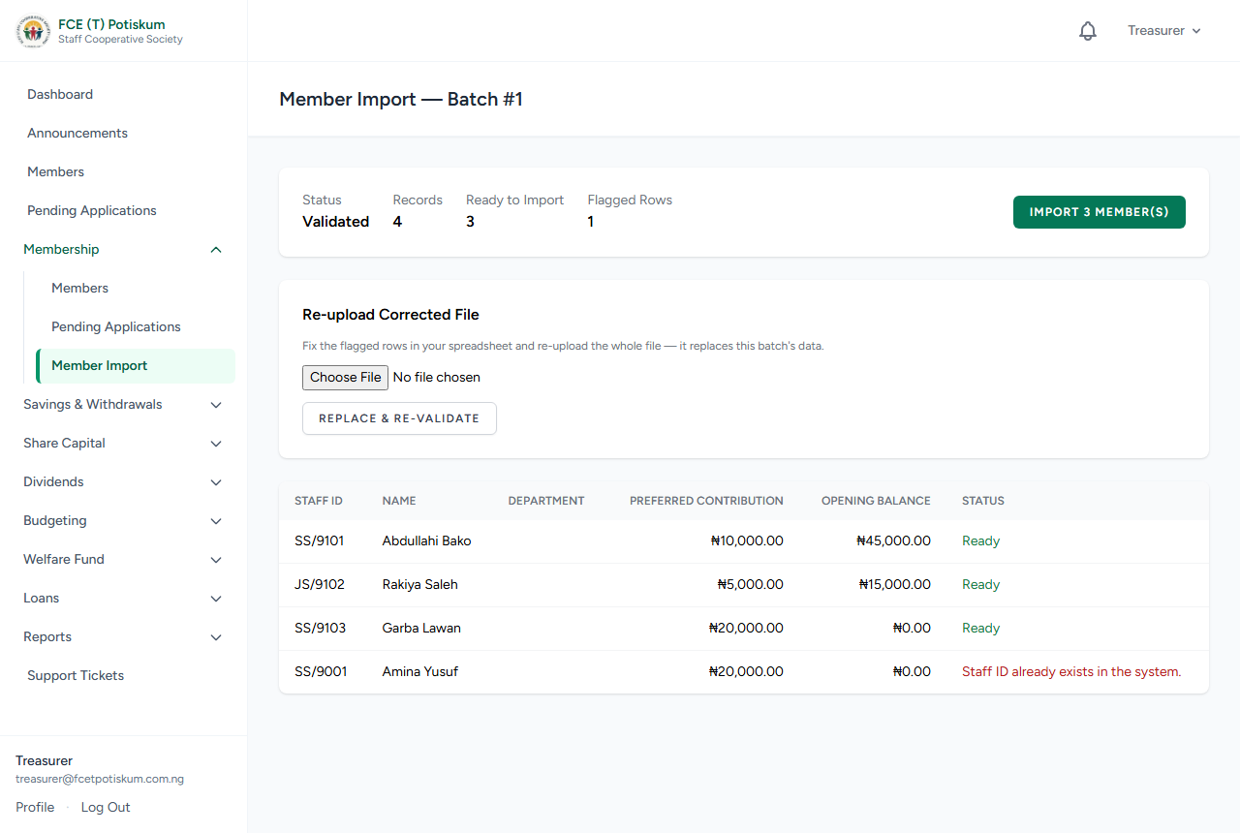
Figure 11: A validated member import batch: ready rows and a flagged duplicate
Each imported member becomes active, gets a login (password = their Staff ID, which they must change on first login), a Regular Savings account with any current_savings_balance as an opening balance, and a legacy application-fee record. Members with missing details are asked to complete them on first login.
Important: Only staff_id, full_name, employment_status and preferred_monthly_contribution are required. Dates may be written as DD/MM/YYYY (e.g. 01/07/2025 = 1 July 2025) or YYYY-MM-DD. Excel "CSV UTF-8" files are accepted.

5.3 The members directory and member record
- Go to Membership › Members.
- Use the status tabs, Search (name, Staff ID, membership or application no.) and Department filter to find members.
- Click Export CSV to download the filtered list.
- Click a member to open their full record: summary, Financial Summary, savings accounts, active loans, documents, change history and status history.

5.4 Posting monthly contributions
Each month, post the savings contributions deducted from salaries. See Appendix A.2 for the file format.
- Go to Savings & Withdrawals › Contributions.
- Click Download Template (Active Contributors). It lists every active member with their approved amount. Adjust amounts to match the payroll, and add a shares number for anyone buying shares through payroll.
- Enter the Period (YYYY-MM), choose the Contribution File (CSV) and click Upload & Validate.
- On the batch page, check the matched total and any flagged rows (e.g. no active member for a Staff ID). Fix and Replace & Re-validate if needed.
- Click Post Batch and confirm. Each matched amount is credited to the member's Regular Savings, and any shares are bought at the current price.

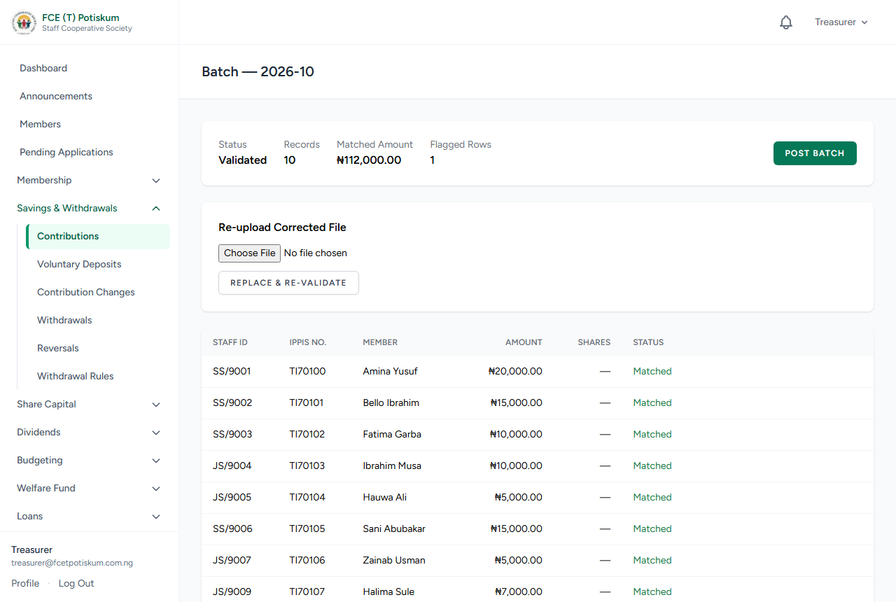
Figure 12: A validated contribution batch, ready to post
Important: A posted batch cannot be posted again or edited. Correct any mistakes with a reversal (5.9).

5.5 Confirming voluntary deposits
- Go to Savings & Withdrawals › Voluntary Deposits.
- Check each logged deposit against the bank statement. Open the receipt if one is attached.
- Click Confirm to post it to the member's savings, or Decline with a Reason.

5.6 Contribution change requests
- Go to Savings & Withdrawals › Contribution Changes.
- Click Approve, check the Approved Monthly Contribution (₦) (enter a Note if you change it) and click Confirm Approval.
- Or click Reject, enter a Reason and click Confirm Rejection.

5.7 Reviewing and paying withdrawals
- Go to Savings & Withdrawals › Withdrawals. Use the tabs to switch between stages.
- On a pending request, click Review. Check the rule checks shown (minimum balance, membership period, percentage limit, waiting period).
- Enter the Approved Amount (₦) and a Note (required if you approve a different amount or despite a rule warning), then click Endorse to Chairman.
- Or click Reject, enter a Reason and click Confirm Rejection.
- After the Chairman authorizes it, pay the member and click Mark Disbursed. The amount is taken from their savings and they are notified.

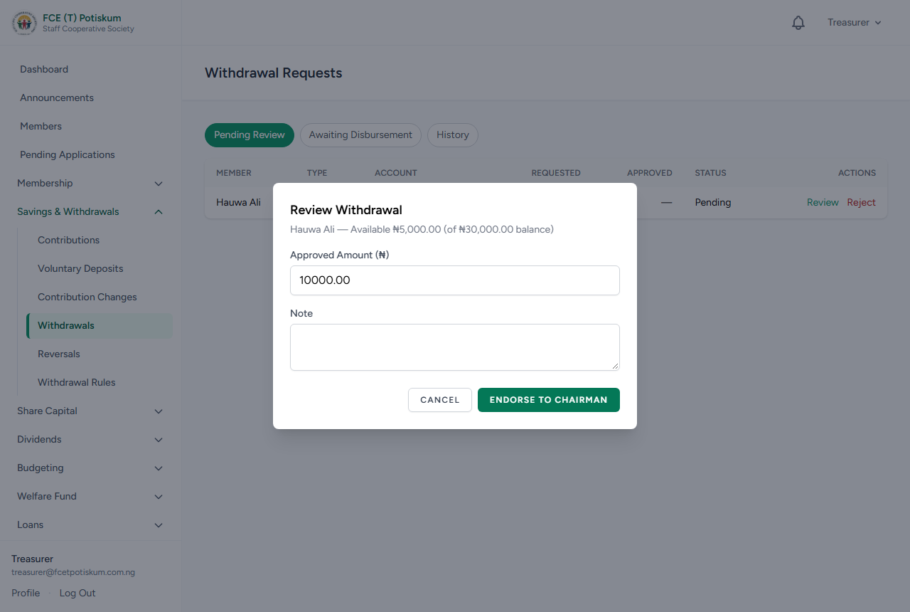
Figure 13: Reviewing a withdrawal before endorsing it to the Chairman

5.8 Withdrawal rules and voluntary deposit hold period
- Go to Savings & Withdrawals › Withdrawal Rules.
- Click Add Rule, choose the Product and Rule Type (minimum balance, minimum membership duration, maximum withdrawal % of balance, or cooling period between withdrawals), enter the Value and Description, and click Save Rule.
- Use Edit to change a rule, or Deactivate / Activate to switch it off or on.
- To change how long voluntary deposits are locked, edit Hold Period (months) under Voluntary Deposit Hold Period and click Save.

5.9 Correcting a mistake (reversals)
Ledger entries are never edited or deleted. A wrong entry is cancelled by a correcting (reversal) entry, which the Chairman must authorize.
- Find the transaction ID of the wrong entry (shown on the member's statement).
- Go to Savings & Withdrawals › Reversals.
- Under Initiate a Reversal, enter the Transaction ID to reverse and the Reason for reversal.
- Click Submit for Chairman Authorization. When the Chairman authorizes it, the correcting entry is posted.

5.10 Share purchases and withdrawals

Confirming share purchases
- Go to Share Capital › Share Purchase Confirmations.
- When the member's payment is received, click Confirm to post the shares at today's price, or Decline with a reason.

Share withdrawals
- Go to Share Capital › Share Withdrawals.
- Click Review, check or adjust the Approved Shares (the minimum holding must be kept), add a Note and click Endorse to Chairman. Or Reject with a reason.
- After the Chairman authorizes it, pay the member and click Mark Disbursed.

Share price and minimum holding
- Go to Share Capital › Share Price Settings.
- To change the price, click Set New Price, enter the Price per Share (₦) and Effective From date, and click Save. Past transactions keep the price that applied at the time.
- To change the minimum number of shares a member must keep, edit Minimum Shares and click Save.

5.11 Dividends and savings interest
- Go to Dividends › Dividend Periods and click Open New Period. Enter a Label (e.g. 2025 Financial Year), Start Date and End Date, and click Open Period.
- Wait for the Chairman to declare the rates (6.6).
- Click Calculate. The system works out each active member's time-weighted average share capital and savings over the period and their dividend and interest.
- Review the allocations. If rates or data change, click Recalculate.
- Click Post and confirm. The amounts are credited to members' Regular Savings accounts.

Important: Posting a dividend period cannot be undone.

5.12 Budget and expenses
- Go to Budgeting › Budget Manager and choose the Financial Year.
- If no budget exists, click Create Draft Budget. Enter the budgeted amount for each category and click Save Draft.
- Click Submit for Approval. The Chairman approves it or returns it for revision.
- To record spending, click Log Expense, choose the Category, enter the Description and Amount (₦), and click Log Expense. It waits for Chairman authorization.
- After the Chairman authorizes an expense and you pay it, click Mark Paid.

5.13 Welfare fund

Posting the welfare levy
- Go to Welfare Fund › Welfare Levy Batches.
- Click Download Template (Active Members), keep the rows of members who paid, and save as CSV (Appendix A.5).
- Enter the Period (YYYY-MM), choose the Levy Collection File (CSV) and click Upload & Validate.
- Review the batch and click Post Batch. Each member is charged the levy amount set by the Chairman. A member cannot be charged twice for the same period.

Death benefit claims
- When a member has died and the Super Admin has marked them deceased, open the member's record (Membership › Members).
- Under Welfare Death Benefit Claim, click File Welfare Claim.
- Enter the Date of Death, Beneficiary Name, Relationship to Member, Beneficiary Phone and the payout bank details, then click Submit for Chairman Authorization.
- After the Chairman authorizes it, pay the beneficiary, open the claim from Welfare Fund › Welfare Claims, enter the Payment Reference (optional) and click Mark Disbursed.

Paying a deceased member's savings to the next of kin
- Open the deceased member's record and click Initiate Disbursement to Next of Kin.
- Choose the Savings Account, enter the next of kin's bank details and an optional Note.
- Click Submit for Chairman Authorization. After authorization, pay it and mark it disbursed in Withdrawals.

5.14 Loan applications: review and disbursement
- Go to Loans › Loan Applications. Use the tabs to switch between stages.
- On an application waiting for you, click Review. Check the eligibility summary (limit, savings, membership period, guarantors).
- Adjust the Tenure if needed, enter a Note, and click Endorse to Chairman. If the loan no longer meets the savings-linked rules, you must explain why you are endorsing it anyway.
- Or click Reject, enter the Reason and click Confirm Rejection.
- After the Chairman authorizes the loan, pay the member and click Disburse. Choose the Method, enter an optional Reference and click Confirm Disbursement. The repayment schedule is created and the member is notified.

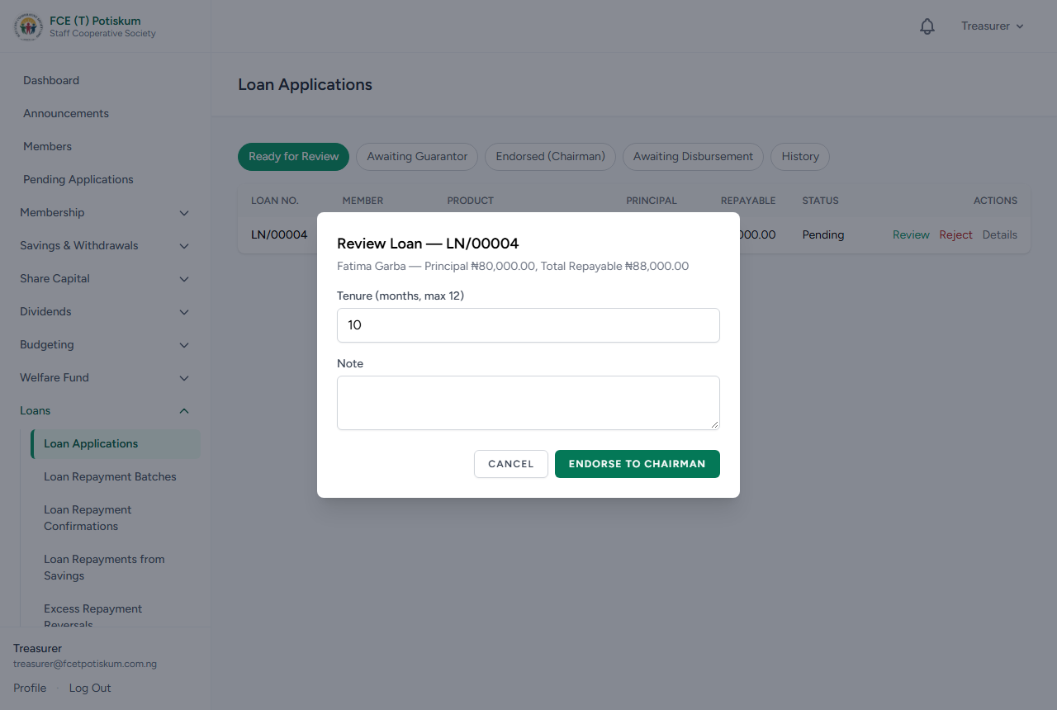
Figure 14: Reviewing a loan application

5.15 Posting monthly loan repayments (payroll deductions)
- Go to Loans › Loan Repayment Batches.
- Click Download Template (Active Loans), adjust the amounts to match the payroll deductions, and save as CSV (Appendix A.3).
- Enter the Period (YYYY-MM), choose the Repayment File (CSV) and click Upload & Validate.
- Review the batch. Rows where the amount is more than the loan owes, or the loan is already fully repaid, are marked in amber. The extra will be recorded as an excess repayment (5.18).
- Click Post Batch. Each repayment is applied to the oldest unpaid installments first.

5.16 Confirming repayments logged by members
- Go to Loans › Loan Repayment Confirmations.
- Check each logged repayment against the bank record (open the receipt if attached).
- Click Confirm to post it to the loan, or Decline, enter the Reason and click Confirm Decline. The member sees the result and the reason on My Loans.

5.17 Loan repayments from savings
- Go to Loans › Loan Repayments from Savings.
- Each request shows the member's Savings Balance, Usable Savings, the Loan Outstanding and the Requested Amount.
- If the request is within limits, click Approve. The money moves from savings to the loan at once.
- A request that is more than the usable savings or the loan balance is shown in red with the maximum allowed, and Approve is disabled. Click Decline, enter a reason and ask the member to submit a smaller amount.

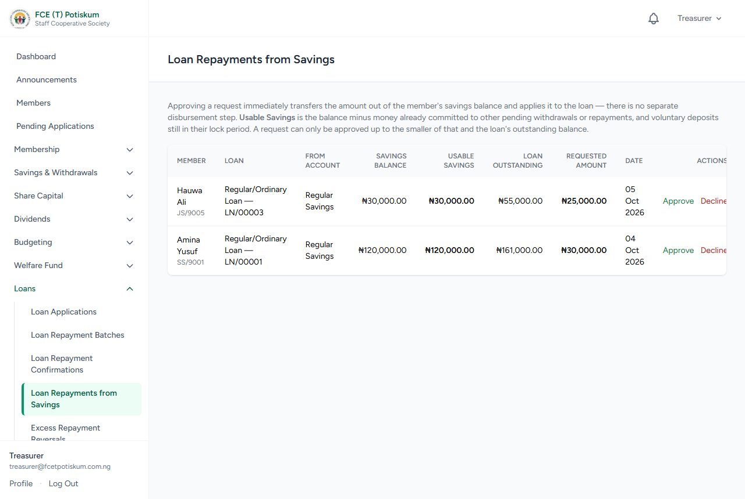
Figure 15: Loan Repayments from Savings — a request above the usable savings is flagged and cannot be approved
Note: Usable Savings already takes off money promised to the member's other pending requests, so two requests that each look fine can both be flagged together.

5.18 Excess repayment reversals
When a repayment is more than the loan owes, the extra is reversed off that loan and listed here. The member chooses to apply it to another loan or have it refunded.
- Go to Loans › Excess Repayment Reversals.
- Under Ready to Process, for an Apply to loan choice, click Apply to Loan and confirm. The amount is posted to the chosen loan. If it is more than that loan owes, the remainder becomes a new excess for the member.
- For a Refund, pay the member using the bank details shown, click Record Refund, enter the Payment Reference and click Mark Refunded.
- Waiting for Member's Choice lists excesses the member has not decided on yet. Recently Completed shows finished ones.

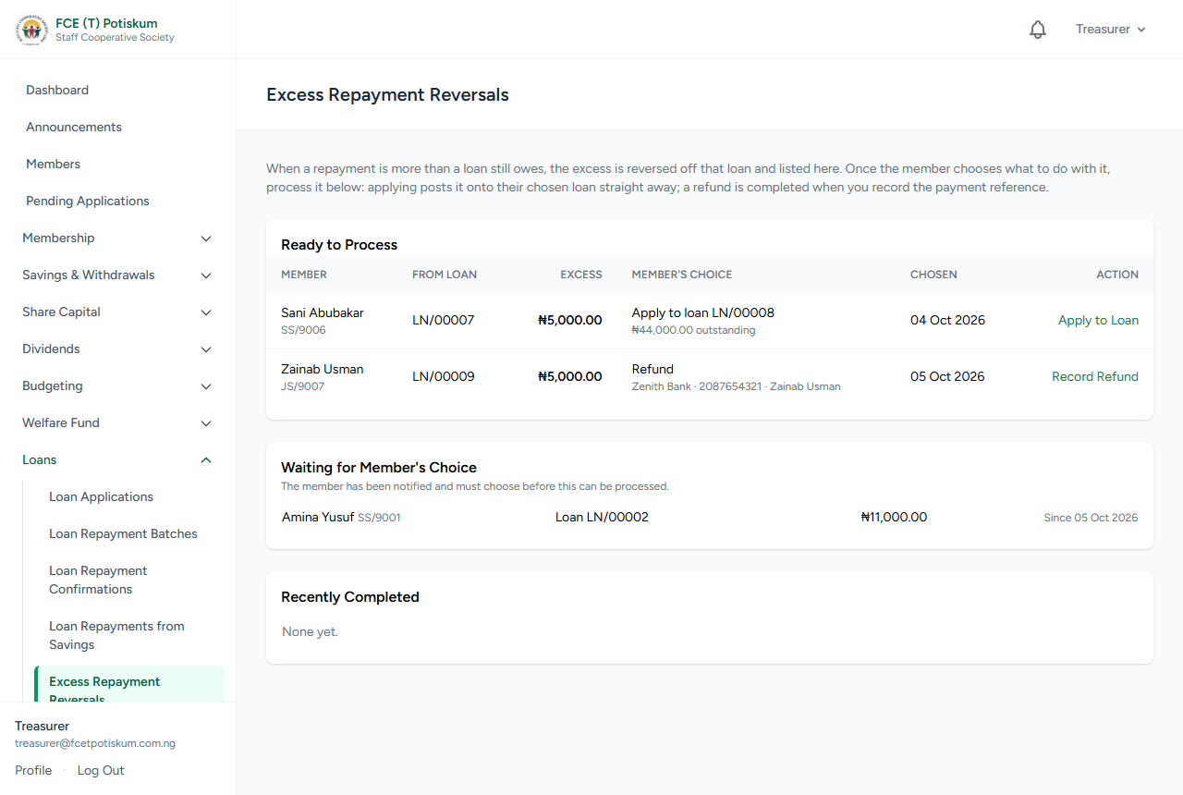
Figure 16: Excess Repayment Reversals: ready to process, waiting for the member, and completed

5.19 Importing existing (legacy) loans
- Go to Loans › Loan Import.
- Click Download CSV Template, fill in one row per existing loan (Appendix A.4) and save as CSV.
- Choose the Legacy Loan File (CSV) and click Upload & Validate. Fix any flagged rows and re-upload if needed.
- Click Import N Loan(s) and confirm. Each loan becomes active with its schedule; any amount already repaid is applied.

5.20 Exit clearance
- Open the member's record from Membership › Members.
- Under Exit / Withdrawal Clearance, check the checklist: no outstanding loans and no active guarantor obligations, plus the savings and share balance to be paid out.
- Click Treasurer Sign-Off. The Super Admin then finalizes the exit (11.3).

6. Chairman Guide
The Chairman gives the second signature on money going out and sets key rates and amounts. Your Dashboard shows what is waiting for authorization.

6.1 Authorizing withdrawals
- Go to Savings & Withdrawals › Withdrawal Authorization.
- Review each request endorsed by the Treasurer, including the approved amount, the Treasurer's note and any rule warnings.
- Click Authorize, add a Note (required if a rule warning applies) and click Authorize. The Treasurer can then pay it out.
- Or click Decline, enter the Reason and click Confirm Decline.

6.2 Authorizing reversals
- Go to Savings & Withdrawals › Reversals.
- Review the original transaction and the Treasurer's reason.
- Click Authorize › Authorize & Post to post the correcting entry, or Decline with a reason.

6.3 Authorizing loans
- Go to Loans › Loan Authorizations.
- Review each loan endorsed by the Treasurer: amount, tenure, guarantors and the Treasurer's note.
- Click Authorize, add an optional Note and click Authorize. The Treasurer can then disburse it.
- Or click Decline, enter the Reason and click Confirm Decline.

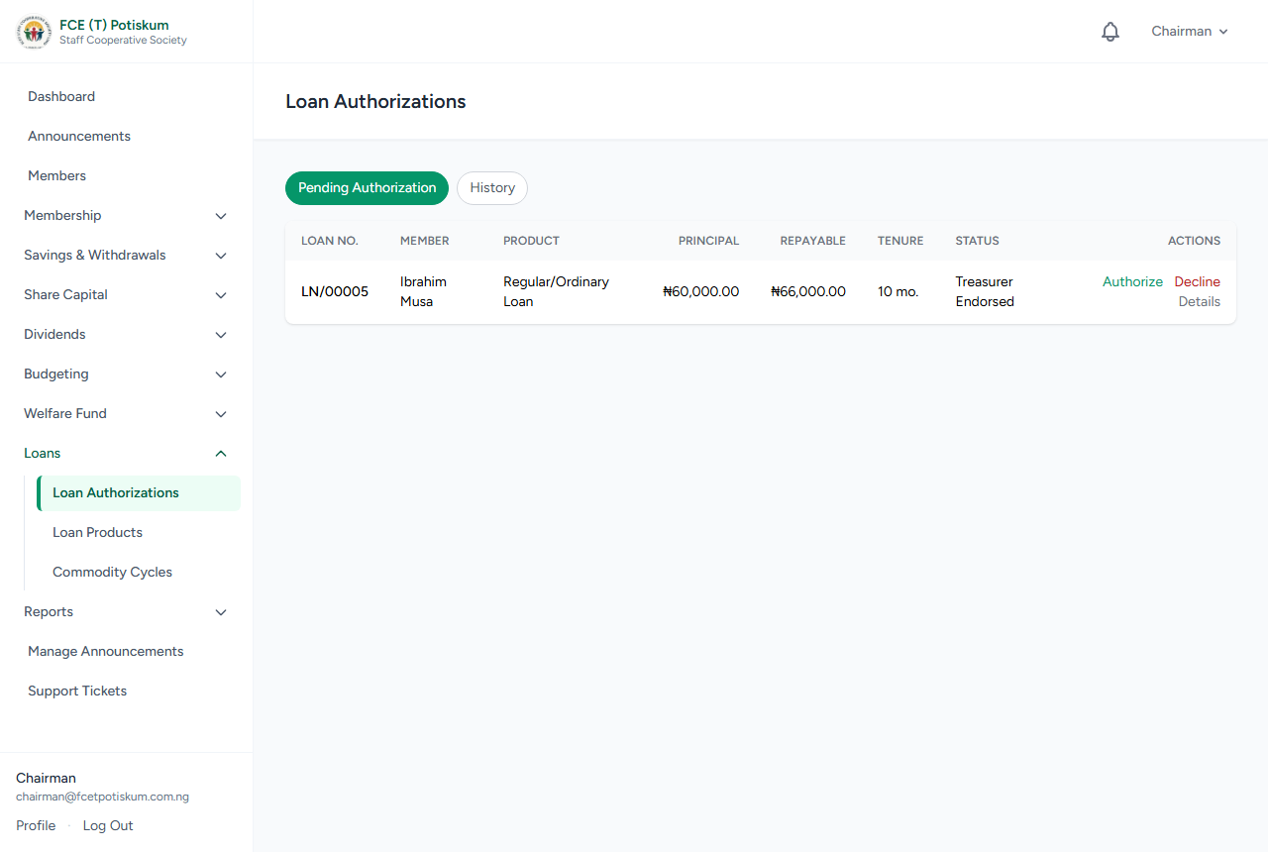
Figure 17: Loan Authorizations: loans endorsed by the Treasurer

6.4 Loan interest rates
- Go to Loans › Loan Products.
- On a product, click Edit Rates. Set the Administrative Charge (%) and Profit (accrues to dividends) (%).
- Click Save. New applications use the new rate; existing loans keep the rate they were approved with.

6.5 Authorizing share withdrawals and setting the share price
- Go to Share Capital › Share Withdrawal Authorization. Click Authorize (optional note) or Decline (reason) on each endorsed request.
- To change the share price or minimum holding, go to Share Capital › Share Price Settings (see 5.10).

6.6 Declaring dividend rates
- Go to Dividends › Dividend Declarations.
- On the period opened by the Treasurer, click Declare Rates.
- Enter the Share Capital Dividend Rate (%) and Savings Interest Rate (%). The estimated distributable profit for the period is shown to guide your decision.
- Click Declare Rates. The Treasurer then calculates and posts.
- To change when the financial year starts, set Start Month (1–12) and click Save. This affects periods opened from then on.

6.7 Budgets and expenses
- Go to Budgeting › Budget Approvals.
- Under Budgets Awaiting Approval, click Approve, or Return for Revision to send it back to the Treasurer.
- Under Expenses Awaiting Authorization, click Authorize, or Decline and enter a Reason.

6.8 Welfare fund settings and claims
- Go to Welfare Fund › Welfare Settings. Set the Levy per Member (₦) and the death benefit Payout Amount (₦), then click Save Settings. Existing records keep their original amounts.
- Go to Welfare Fund › Welfare Claims, open a pending claim, review the details and documents, and click Authorize or Decline (with a reason).

6.9 Registration fee and its split
- Go to Reports › Registration Fees.
- Click Edit Fee & Split.
- Enter the Registration Fee (₦) that new applicants pay, and the Admin Charge (%). The rest is profit, which counts towards dividends.
- Click Save. Only new registrations are affected; fees already paid keep their amount and split. The change is recorded in the activity log.

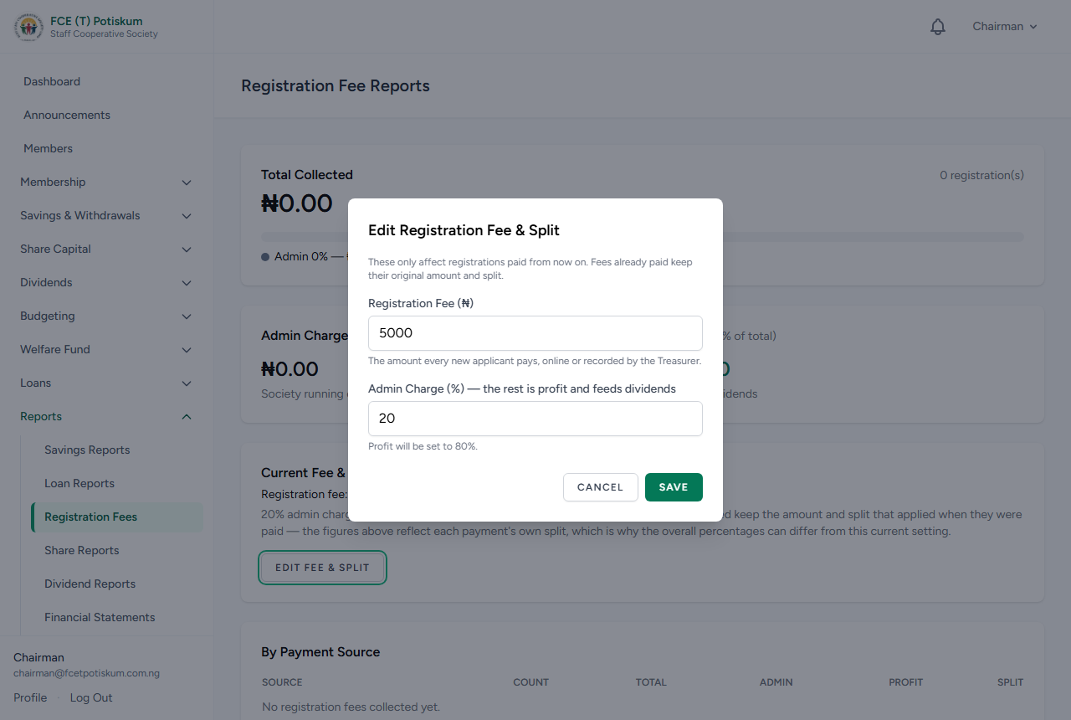
Figure 18: Editing the registration fee and its admin/profit split

6.10 Commodity cycles: markup and authorization
- Go to Loans › Commodity Cycles and open the cycle.
- While the cycle is open or its requests are closed, set the Markup Rate: Admin Charge (%) and Profit (%), then click Save Markup.
- When the Auditor and Store Officer have verified the cycle, click Chairman: Authorize Cycle. The Store Officer can then release goods.

6.11 Announcements and confidential complaints
- Post notices from Manage Announcements (see 7.4).
- Handle complaints from Support Tickets (see 7.5). Only the Chairman can see tickets marked confidential.

7. Secretary Guide

7.1 Reviewing member change requests
- Go to Membership › Change Requests.
- Each row shows the member, the field, the old value and the requested new value.
- Click Approve to apply the change to the member's record, or Reject, enter a Reason and click Confirm Rejection.

7.2 Managing the commodity catalogue
- Go to Loans › Commodity Catalogue. Use Search to find items.
- Click Add Item. Enter the Description, Type / Brand, Pack / Unit and, optionally, Request Unit Options: a comma-separated list such as "Full bag, Half bag, Quarter bag". Members must pick one of these when requesting the item.
- Click Save. Use Edit to change an item, or Deactivate to hide it from members.

7.3 Running a commodity cycle
- Go to Loans › Commodity Cycles and click Open New Cycle. Enter the Cycle Name and Request Deadline, then click Open Cycle. Members can now submit requests.
- The request window closes automatically at the deadline, or you can click Close Requests Now.
- Open the cycle. The Aggregated Demand table shows the total quantity of each item requested. Use it as your market sourcing sheet.
- If an item cannot be supplied at all, click Unavailable to remove it from every member's request.
- Enter the Tenure (months), Moratorium (months) (months before the first repayment) and a Unit Price for every item.
- Click Finalize Pricing. Each member's total and installment are calculated, and the cycle goes to the Auditor.

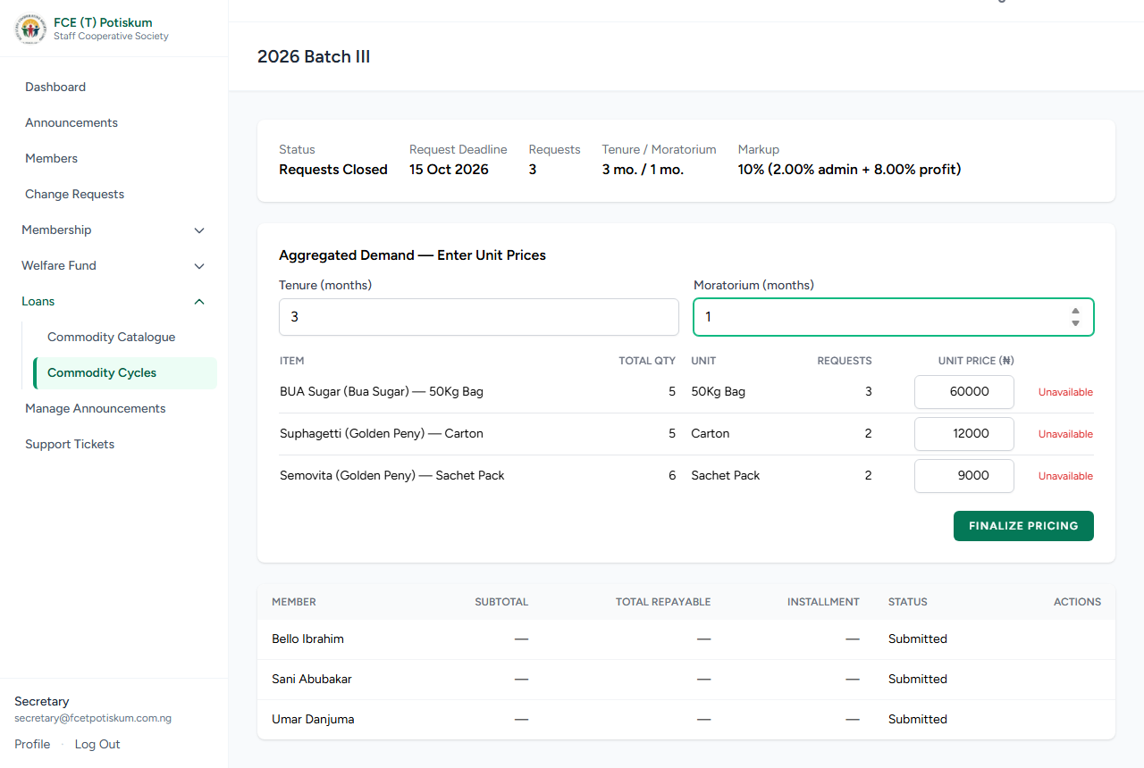
Figure 19: Pricing a commodity cycle after requests close
Note: Items members typed that are not in the catalogue are added to the catalogue automatically when you finalize pricing.

7.4 Posting announcements
- Click Manage Announcements in the sidebar, then Post Announcement.
- Enter the Title and Message. Tick Pin to the top of the board if it should stay at the top.
- Click Post. Every user is notified. Use Edit or Delete to change or remove it.

7.5 Handling complaints
- Click Support Tickets in the sidebar. Use the tabs to see open, in-progress and resolved tickets.
- To log a complaint for a member who cannot use the system, click Log a Complaint, search for the Member (name or Staff ID), choose the Category, enter the Subject and Details, and click Submit.
- Open a ticket and click Claim to take it on.
- Type a Reply and click Send Reply. The member is notified.
- When the matter is settled, click Resolve. If the member replies later, the ticket reopens.

7.6 Other Secretary tasks
- Upload and delete member documents on a member's record (Documents panel).
- File welfare death benefit claims (see 5.13).

8. Auditor Guide

8.1 Verifying commodity prices
After the Secretary finalizes pricing, the Auditor checks every price before the cycle can continue.
- Go to Loans › Commodity Cycles and open the cycle (status Priced).
- In Auditor: Verify Prices, each item shows the quantity requested, the Secretary's Price and a Verified Price box filled in with that price.
- If a price is wrong, type the correct one. The row turns amber and shows "Corrected".
- Click Verify Prices and confirm.

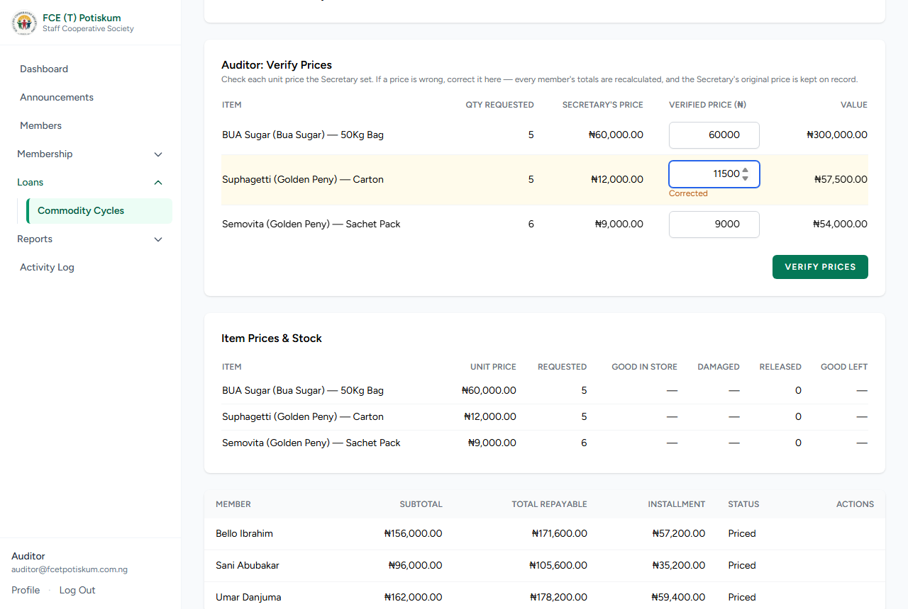
Figure 20: Auditor: correcting a price before verifying
Corrected prices update every affected member's totals straight away. The Secretary's original price is kept on record and shown as "Auditor corrected from ₦…" in the Item Prices & Stock table, and each change is written to the activity log. The cycle then goes to the Store Officer.

8.2 Activity log
- Click Activity Log in the sidebar.
- Filter by Module, Actor (who did it), From and To dates, or Search Description.
- Click Clear filters to start again.

Every important action — approvals, postings, rate changes, price corrections, releases — is recorded with who did it and when.

8.3 Reports available to the Auditor
Financial Statements, Budget Reports and Welfare Fund Reports (see Chapter 12).

9. Store Officer Guide

9.1 Verifying stock in the store
After the Auditor verifies prices, count the goods physically in the store.
- Go to Loans › Commodity Cycles and open the cycle (status Auditor Verified).
- In Store Officer: Verify Stock in Store, each item shows the Qty Requested. Good Condition is filled in with that quantity and Damaged with 0.
- If the count is correct, leave it. If not, enter how many are actually in good condition and how many are damaged. Short items turn amber and show "Short by …".
- Click Verify Stock and confirm. The cycle goes to the Chairman for authorization.

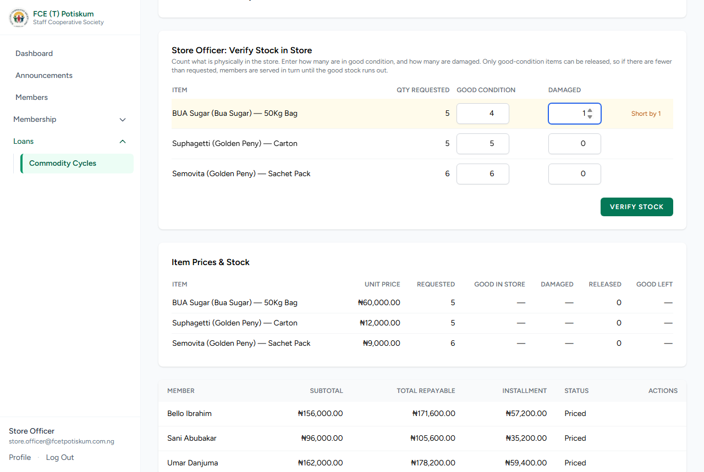
Figure 21: Store Officer: recording good-condition and damaged stock
Important: Only the good-condition quantity can ever be released. If there is less than members asked for, members are served in turn until the good stock runs out.

9.2 Releasing goods to members
After the Chairman authorizes the cycle, release each member's goods as they come to collect.
- Open the cycle. In the members table, click Release Goods for the member.
- The checklist shows each item with Requested, Good Stock Left, Unit Price and Qty Released. Qty Released starts at the requested quantity, or at the stock left if that is less.
- Check every item. Hand over only items that are available, undamaged and in good condition.
- If giving less than requested, enter the quantity actually given and choose the reason: Not in stock or Damaged / poor condition. Click Not in stock or Damaged to release none of an item.
- Check the summary: Requested, Released, the Loan (released value plus markup) and the Monthly Installment.
- Click Confirm Release and confirm. The member's commodity loan and repayment schedule start, for what they received only.

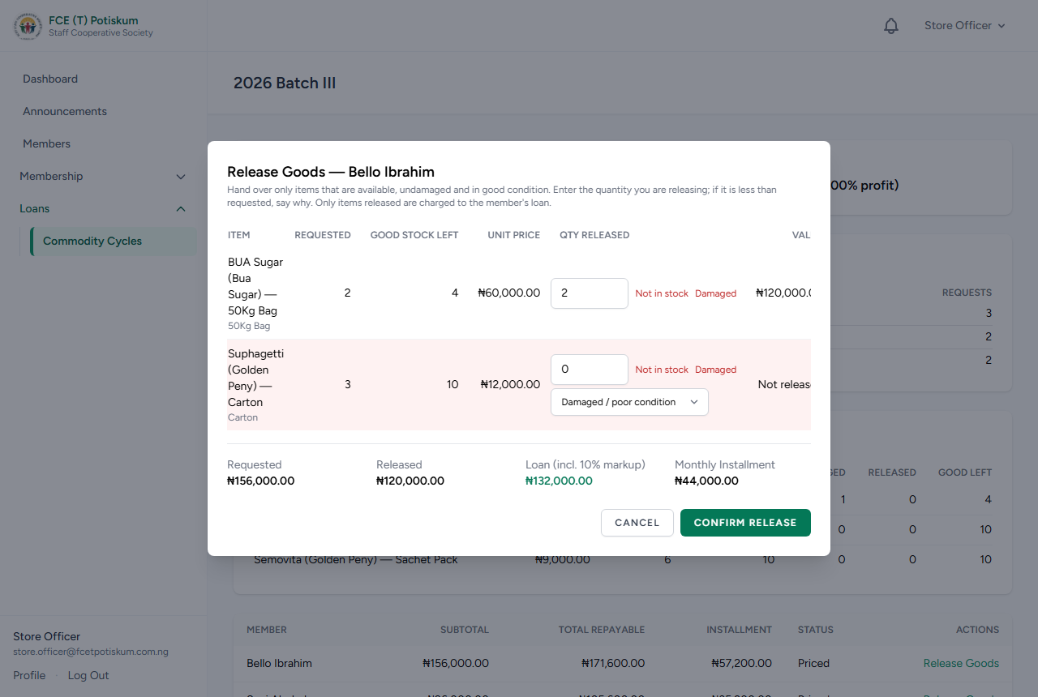
Figure 22: Releasing goods — a damaged item is withheld and not charged
- You cannot release more than was requested or more than the good stock left.
- Items found damaged at release are moved out of good stock automatically.
- If nothing at all can be given, the button becomes Close as Not Supplied. The request is closed and no loan is created.
- The Item Prices & Stock table shows good stock, damaged, released and good left for each item at any time.

10. Exco and Loan Officer Guide

10.1 Exco members
- View the members directory (Membership › Members) and export it.
- View Savings, Loan, Registration Fee, Share, Dividend, Budget and Welfare reports (Chapter 12).
- Handle non-confidential complaints in Support Tickets (7.5).

10.2 Loan Officer
The Loan Officer can view the members directory and member records to advise members on loans. Loan approval itself is done by the Treasurer and Chairman.

11. Super Admin Guide
The Super Admin has every permission in the system, so can do all the tasks in this manual. The tasks below are reserved for the Super Admin.

11.1 Resetting a user's password
- Click User Management in the sidebar.
- Find the user with Search (name, email, Staff ID) or the Role filter.
- Click Change Password, enter the New Password twice and leave Require this user to set their own password the next time they log in ticked.
- Click Update Password. The user is notified.

Note: Staff accounts (Treasurer, Chairman, etc.) are created when the system is set up (Appendix D). Members get accounts by applying online or through the member import.

11.2 Changing a member's status
Open the member's record (Membership › Members) and use Status Actions:
- Suspend — enter a reason and click Confirm Suspend. Use Reactivate to reinstate.
- Confirm Dormant — for members flagged as inactive (no contributions for the dormancy period). Use Reactivate when they resume.
- Mark Deceased — enter a reason and click Confirm Deceased. This allows the next-of-kin disbursement and welfare claim (5.13).

11.3 Finalizing a member's exit
After the member requests exit and the Treasurer signs off, open the member's record and click Finalize Exit under Exit / Withdrawal Clearance.

11.4 Editing locked member fields
- Open the member's record and find Locked Fields.
- Click Edit, change the Department, Staff ID, Rank / Grade or Staff Category, and click Save. The change is recorded in the member's history and the activity log.

11.5 Loan product rules and limits
- Go to Loans › Loan Products.
- Click Edit Rules to set Max Tenure (months), Min. Membership (months), Min. Savings Balance (₦), Requires Guarantor, Min. Guarantors, Max. Guarantors and Product Active. Click Save.
- Click Set Multiplier to set the Multiplier (x savings balance) and Effective From date. The Treasurer can also do this. Loans already approved keep their old multiplier.
- Interest rates are set by the Chairman (6.4).

12. Reports
Reports are under Reports in the sidebar. You see only the reports your role allows. Most sections have an Export CSV link that downloads the data for Excel.
Report | What it shows | Who can see it
Savings Reports | Total savings by department and product; top savers; low-balance alerts; all members' contributions (monthly amount, opening balance, total contributed, number of contributions, last month contributed, savings balance — searchable, with totals); contribution batch history; withdrawal activity; reversal log. | Treasurer, Chairman, Exco
Loan Reports | Interest collected; legacy vs. system loans; flagged loans; portfolio by product; overdue and defaulted loans; guarantor exposure; repayment batch history. | Treasurer, Chairman, Exco
Registration Fees | Total collected; admin vs. profit; by payment source; monthly breakdown; recent payments. The Chairman also sets the fee and split here. | Treasurer, Chairman, Exco
Share Reports | Total shares outstanding; total share capital; current price; top shareholders. | Treasurer, Chairman, Exco
Dividend Reports | Dividend periods and amounts; top recipients. | Treasurer, Chairman, Exco
Financial Statements | Trial balance, income statement and balance sheet for a chosen financial year. | Treasurer, Chairman, Auditor
Budget Reports | Budget vs. actual by category and expense lists for a financial year. | Treasurer, Chairman, Exco, Auditor
Welfare Fund Reports | Claims by status and fund transaction history. | Treasurer, Chairman, Exco, Auditor

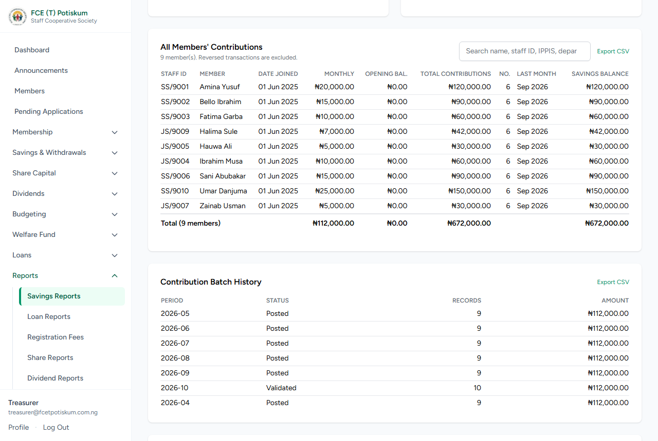
Figure 23: Savings Reports: All Members' Contributions, with totals and CSV export
To export, click Export CSV next to the section you want. The file opens in Excel.

13. Commodity Loan Cycle — End-to-End
This table summarizes the whole commodity process and who does each stage.
# | Stage | Who | Cycle status after
1 | Open a cycle with a request deadline | Secretary | Open
2 | Members submit, edit or withdraw requests | Members | Open
3 | Set the markup rate (any time before pricing) | Chairman | Open / Requests Closed
4 | Request window closes (deadline or Close Requests Now) | Automatic / Secretary | Requests Closed
5 | Enter unit prices, tenure and moratorium; Finalize Pricing | Secretary | Priced
6 | Check and correct prices; Verify Prices | Auditor | Auditor Verified
7 | Count stock (good and damaged); Verify Stock | Store Officer | Store Approved
8 | Authorize the cycle | Chairman | Chairman Authorized
9 | Release goods to each member (only good stock, in turn) | Store Officer | Active
10 | Members repay through payroll deductions | Treasurer posts repayment batches | —

Appendix A. CSV File Formats
All uploads are CSV files. Prepare them in Excel and use File › Save As › CSV UTF-8 or CSV (Comma delimited). The first row must contain the column names exactly as shown; column order does not matter. Always start from the Download Template button, which gives the right columns.

A.1 Member import
Column | Required? | Notes
staff_id | Yes | Must not already exist.
full_name | Yes
employment_status | Yes | permanent, contract or casual
preferred_monthly_contribution | Yes | Number greater than 0
approved_monthly_contribution | No | Defaults to the preferred amount
current_savings_balance | No | Opening savings balance; defaults to 0
membership_no | No | Defaults to FCET/CSL/<staff_id>
membership_date | No | Date the member joined the society (DD/MM/YYYY or YYYY-MM-DD)
gender | No | male or female
marital_status | No | single, married, divorced or widowed
email | No | Must be unique. If blank, a placeholder login is created and the member adds their email on first login.
phone_1, phone_2, home_address | No
ippis_number, department, rank_grade | No
date_of_first_appointment, date_of_birth | No | DD/MM/YYYY or YYYY-MM-DD
mode_of_deduction | No | Defaults to salary_deduction
nok_name, nok_relationship, nok_phone, nok_address | No | Next of kin

A.2 Monthly contributions
Column | Required? | Notes
staff_id | Yes | Must be an active member
amount | Yes | Savings contribution, greater than 0
shares | No | Whole number of shares to buy this month; 0 if none
ippis_number | No | For reference only; ignored on upload

A.3 Loan repayments
Column | Required? | Notes
staff_id | Yes | Must be an active member
loan_no | Yes | Must belong to that member; active or already closed loans accepted
amount | Yes | Amount deducted; anything above what the loan owes becomes an excess repayment
member_name | No | For reference only

A.4 Legacy loan import
Column | Required? | Notes
staff_id | Yes | Existing member
loan_product | Yes | Product code, e.g. regular or emergency
principal_amount | Yes | Greater than 0
total_interest | Yes | 0 or more
tenure_months | Yes | Whole number greater than 0
disbursed_date | Yes | DD/MM/YYYY or YYYY-MM-DD
amount_repaid | No | Amount already repaid; defaults to 0

A.5 Welfare levy
Column | Required? | Notes
staff_id | Yes | Active member, not already charged for the period
full_name, department | No | For reference only

Appendix B. Status Glossary
Item | Status | Meaning
Member | Pending | Applied, not yet approved (or rejected)
Member | Active | Full member
Member | Suspended | Suspended by Super Admin, or after a complete withdrawal
Member | Dormant | No contributions for the dormancy period (6 months by default), confirmed by Super Admin
Member | Exited / Deceased | Left the society / has died
Loan | Pending guarantors | Waiting for guarantors to accept
Loan | Pending | Waiting for Treasurer review
Loan | Treasurer Endorsed | Waiting for Chairman
Loan | Chairman Authorized | Waiting for Treasurer to disburse
Loan | Active / Overdue / Defaulted | Being repaid / an installment is late / long overdue (guarantors may be called)
Loan | Closed | Fully repaid
Loan | Guarantor Declined / Treasurer Rejected / Chairman Declined | Application stopped
Withdrawal | Pending → Treasurer Approved → Chairman Authorized → Disbursed | Normal path; can end as Treasurer Rejected or Chairman Declined
Logged repayment | Awaiting Treasurer / Approved / Declined | Status of a repayment the member logged
Excess repayment | Awaiting your choice → Awaiting Treasurer → Reversal completed | See 4.16 and 5.18
Commodity request | Submitted → Priced → Active (released) / Not supplied | Not supplied = nothing was in stock, no loan created
Dividend period | Open → Declared → Calculated → Posted | See 5.11
Budget | Draft → Pending Approval → Approved
Expense / Welfare claim | Pending → Chairman Authorized → Paid / Disbursed | Or Chairman Declined
Ticket | Open → In Progress → Resolved

Appendix C. Automatic Daily Tasks
The system runs these tasks automatically every night (when the server scheduler is set up, Appendix D):
Time | Task
01:00 | Flags active members with no contributions for the dormancy period, for Super Admin confirmation.
01:30 | Marks late loan installments overdue, moves long-overdue loans to defaulted, and calls guarantor pledges whose grace period has passed (capped at what the loan still owes).
01:45 | Closes the request window of commodity cycles whose deadline has passed.

Appendix D. Installation and Deployment (Technical)
This appendix is for the person who installs or maintains the server.

D.1 Requirements
- PHP 8.2 or newer, with the usual Laravel extensions (mbstring, openssl, pdo_mysql, bcmath, fileinfo, gd).
- MySQL 8 or MariaDB 10.4+.
- Composer, and Node.js (only to rebuild the front-end assets).
- A web server (Apache or Nginx) pointing to the public folder.

D.2 First-time setup
- Copy the application files to the server and run composer install --no-dev --optimize-autoloader.
- Copy .env.example to .env, set the database details, APP_URL, mail settings and the Paystack keys (PAYSTACK_SECRET_KEY, PAYSTACK_PUBLIC_KEY). Run php artisan key:generate.
- Create the database tables: php artisan migrate --force.
- Import database/sql/seed_staff_users.sql (with the mysql command or phpMyAdmin). It creates all roles and permissions, the savings products and the staff accounts. Edit the names and emails in the file first.
- Seed the reference data: php artisan db:seed --class=SettingsSeeder --force, then the same for ShareSeeder, LoanSeeder and CommodityCatalogueSeeder.
- Run php artisan storage:link and php artisan optimize.
- Add the scheduler to cron so the daily tasks run: *** * * * * php /path/to/artisan schedule:run**.
- Log in as each staff user and change the temporary password.

Important: Do not run plain php artisan db:seed. It also runs the demo data seeder and creates fake members.

D.3 Updating the software
- Back up the database.
- Upload the new files, then run composer install --no-dev, php artisan migrate --force and php artisan optimize:clear.

Note: If the database was created by importing an SQL dump, make sure the dump includes the migrations table, otherwise php artisan migrate will try to recreate existing tables.

D.4 Backups
Back up the MySQL database daily, and the storage/app folder (uploaded receipts, photos and documents) regularly. Keep copies off the server.

Appendix E. Troubleshooting and FAQ
Problem | Solution
I cannot log in. | Check you are using your Staff ID or the email on your account. Imported members' first password is their Staff ID. After 5 failed attempts, wait a minute. Use Forgot your password? or ask the Super Admin for a reset.
I do not see a menu item from this manual. | Your role does not include that task. Ask the Super Admin if you believe this is wrong.
An upload says "Staff ID is required" although the column is there. | Fixed in the current version (Excel "CSV UTF-8" files are accepted). Make sure the first row has the exact column names from the template.
A date imported as the wrong month. | Write dates as DD/MM/YYYY (01/07/2025 = 1 July 2025) or YYYY-MM-DD. Other formats are rejected.
Posting a contribution batch shows an error about the Regular Savings product. | The savings products were not set up. Import seed_staff_users.sql or run the SavingsSeeder (Appendix D).
A withdrawal shows a rule warning. | The request breaks a society rule (e.g. minimum balance). The Treasurer and Chairman can still proceed, but must write a note explaining why.
A Repay-from-Savings request cannot be approved. | It is more than the member's usable savings or the loan balance. Decline it and ask for a smaller amount.
A member was over-deducted for a loan. | The excess is tracked automatically. The member chooses to apply or refund it (4.16) and the Treasurer processes it (5.18).
A wrong amount was posted to savings. | Use a reversal (5.9). Ledger entries cannot be edited or deleted.
A member cannot request commodities. | There is no open cycle, the deadline has passed, or the member still has an unpaid commodity loan.

