MCMASTER UNIVERSITY

SFWRENG 4G06 / MECHTRON 4TB6

SOFTWARE ENGINEERING CAPSTONE

FITFORM: SYSTEM REQUIREMENTS DOCUMENT

|  |  |  |
| --- | --- | --- |
| **Name** | **Student Number** | **McMaster Email** |
| Othman Mullick | 001303421 | mullico@mcmaster.ca |
| Rohan Thakral | 400066207 | thakralr@mcmaster.ca |
| Jordan Levy | 400131067 | levyj1@mcmaster.ca |
| Hahd Khan | 001209974 | khanh27@mcmaster.ca |
| Cassandra Nicolak | 000971847 | nicolace@mcmaster.ca |
| Rohit Saily | 400144124 | sailyr1@mcmaster.ca |

**Table of Revisions**

|  |  |  |
| --- | --- | --- |
| **Revision** | **Date** | **Description** |
| 0 | November 1 2020 | Added System Requirements |

Table 1: Table of Revisions

**Contents**

1 Introduction

1.1 Purpose

1.2 Roadmap

2 Scope

3 Context Diagram

4 Monitored & Controlled Variables

4.1 Monitored Variables

4.2 Controlled Variables

5 Constants

6 Behaviour Overview

6.1 Formulas

7. Functional Decomposition

8. Functional Requirements

9. Non-Functional Requirements

10. Normal Operation

11. Undesired Event Handling

12. Requirements Likely to Change

13. Requirements Unlikely to Change

14. References

**1. Introduction**

This document seeks to specify the system requirements of FitForm to serve as a definition of FitForm's functionality. This is a deliverable for the Fall 2020 Software Engineering Capstone Course (SFWRENG 4G06) at McMaster University.

**1.1. Purpose**

FitForm seeks to provide an end-user with feedback that can be used to carry out strength-training-based exercises effectively. An attempt at an exercise is carried out more effectively than another if and only if the physical execution of it is closer to how it should be done as prescribed by professional fitness and scientific literature.

**1.1. Road Map**

The Gnatt chart will regularly be updated as we complete milestones and add tasks. All the dependencies will be attached.

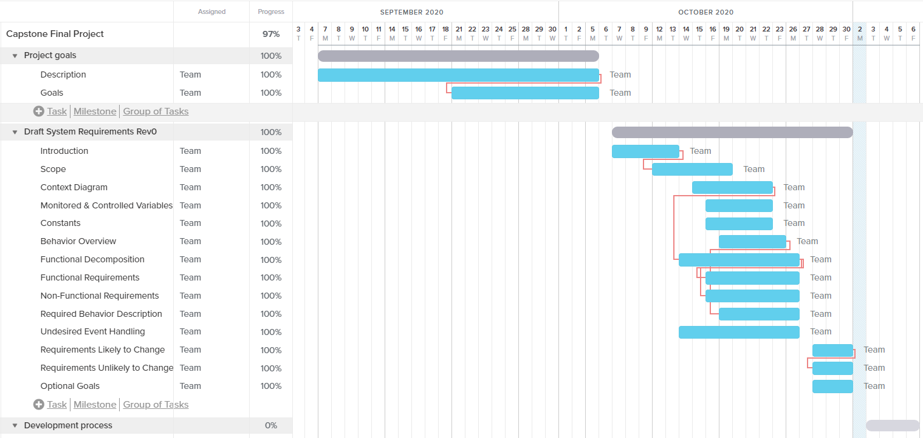

Figure 1: Gantt Chart

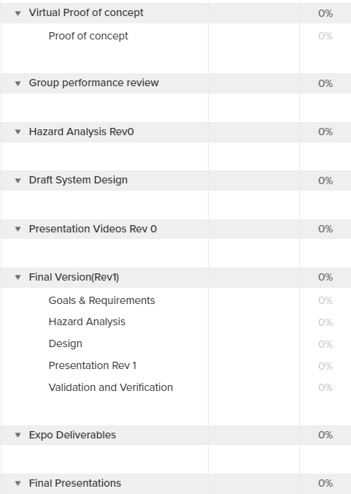

Figure 2: Schedule

**2. Scope**

The team has determined that the purpose is achievable through the following subsystems:

1. Data Acquisition: sensor(s) for measuring user movements.
   1. This subsystem shall receive input in the form of physical motion by the user.
   2. This subsystem shall output user movement data in real-time to the data processing subsystem.
2. Data Storage: holds data that describes the correct physical execution of exercises.
   1. This subsystem shall persistently store movement data of correct physical execution of exercises.
3. Data Processing: program(s) for evaluating user performance using acquired data and stored data.
   1. This subsystem shall periodically process received user movement data and stored movement data that reflects expected exercise movement.
   2. This subsystem shall output the user accuracy to the user interface.
4. User Interface: for exercise selection and feedback to the end-user.

**3. Context Diagram**

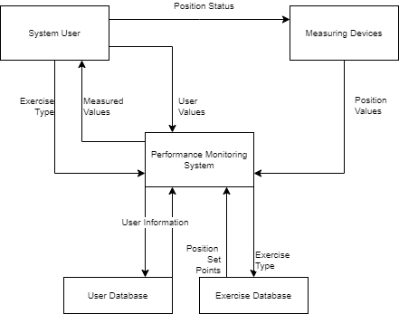

Figure 3: Context Diagram

**4. Monitored & Controlled Variables**

**4.1. Monitored Variables**

|  |  |
| --- | --- |
| **Variable** | **Description of variable** |
| User body position | A set of user’s limbs’ positions relative to each other |
| Exercise choice | User selected choice of exercise to determine correctness of body posture |
| Intensity | User defined intensity in repetitions per second to determine the minimum pace of the exercise |

Table 2: Monitored Variables

**4.2. Controlled Variables**

|  |  |
| --- | --- |
| **Variable** | **Description of variable** |
| Posture variance | Set of user’s limbs’ position displacement relative to correct posture |
| Posture feedback | Feedback determinant to relay audio messages to the user |

Table 3: Controlled Variables

**5. Constants**

|  |  |
| --- | --- |
| **Name** | **Description** |
| Number of users | 1 |
| Number of supported exercises | 3 basic exercises to measure and then we will expand upon them.   1. Pushups 2. Squats 3. Situps   Each of these give us a different dataset to work with which we will expand upon later.  Undecided at the moment. Will be constant. |
| Correct Postures | Posture information for the set of supported exercises |

Table 4: Constants

**6. Behaviour Overview**

**6.1 Formulae**

posture_variance = f(user_body_position, correct_postures, exercise_choice)

posture_feedback = f(posture_variance)

**7. Functional Decomposition**

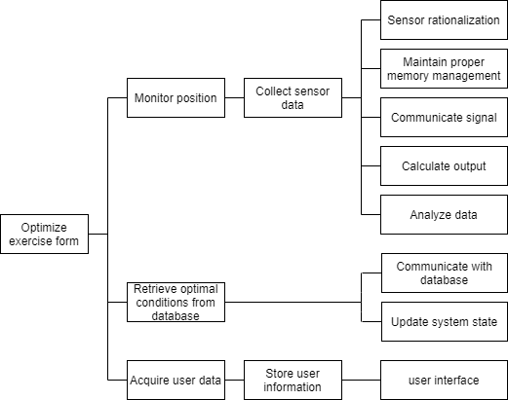

Figure 3: Functional Decomposition Diagram

**8. Functional Requirements**

|  |  |
| --- | --- |
| **Reference** | **Requirement** |
| FR01 | FitForm shall monitor user movement.  ***Rationale:*** *The positions of the user’s limbs need to be measured.* |
| FR02 | FitForm shall maintain a persistent store of data that describes ideal exercise movement. |
| FR03 | FitForm shall allow the user to select the ideal exercise movement to compare their exercise execution to. |
| FR04 | FitForm shall evaluate a comparison between monitored movement with ideal movement while the user performs the exercise.  ***Rationale:*** *The expected movement needs to be referenced and an accuracy value needs to be produced.* |
| FR05 | FitForm shall provide the user with end-of-exercise feedback via the GUI.  ***Rationale:*** *The GUI needs to specify the average of accuracy values determined during the exercise.* |
| FR06 | FitForm shall provide the user with live feedback via audio.  ***Rationale:*** *The user needs to be notified of how to correct their movements by specifying the limb and direction to move it.* |

**9. Non-Functional Requirements**

|  |  |
| --- | --- |
| **Reference** | **Usability Requirements** |
| NFR01 | The wearable devices must be comfortable for the user to wear for at least one hour. |

|  |  |
| --- | --- |
| **Reference** | **Performance Requirements** |
| NFR02 | The system will notify the user if a lost connection between the wearable devices occurs.  ***Rationale:*** *The user needs to be notified if the devices are no longer measuring their form.* |

|  |  |
| --- | --- |
| **Reference** | **Maintainability Requirements** |
| NFR03 | The wearable devices must be able to be cleaned with liquid. |
| NFR04 | The wearable devices must withstand wear and tear from exercise. |

|  |  |
| --- | --- |
| **Reference** | **Safety Requirements** |
| NFR05 | Wearable devices must not cause injury to the user. |
| NFR06 | Wearable devices must not impede the user’s range of motion. |

|  |  |
| --- | --- |
| **Reference** | **Legal Requirements** |
| NFR07 | The system shall not intentionally share the user’s data to any external person, company, or entity without the user’s consent. |

|  |  |
| --- | --- |
| **Reference** | **Internationalization and Localization Requirements** |
| NFR08 | The system shall provide audio feedback in English. |

**10. Normal Operation**

* System is turned on
  + The user will first manually turn on the system.
  + If the most recent system shut-off occurred during an exercise, the user will be given the option to either continue or abandon the exercise.
* System calibration
  + Before performing the exercise, the user will be asked to perform certain simple movements to calibrate the system. In the meantime, FitForm will measure readings from the sensors which it will take into account when scoring the user for the actual exercise. If there are inconsistent or nonsensical readings, FitForm will also inform the user to correctly set up the device before beginning the exercise.
* User chooses an exercise
  + The user will use the interface to select which exercise they would like to do. They may choose from a finite list of common exercises.
* User performs exercise
  + While the user is doing the exercise, the FitForm device will measure and store data received from the sensors.
  + User will be given real-time feedback on their performance of the exercise in the form of haptic and auditory stimuli
* User completes exercise
  + The user will be given a score to represent how well they performed the exercise, as well as tips in plain language to inform the user of ways in which they can improve their form for that exercise.
* System is turned off
  + System stops all operations immediately.
  + If the system was turned off during an exercise, the system will remember this for the next time the system is turned on.

**11. Undesired Event Handling**

* User improperly sets up the system
  + This would result in improper or non-meaningful readings. To decrease the likelihood of this undesired state being reached, FitForm will include a calibration period prior to the user performing the exercise. The system will inform the user to properly set it up before performing the exercise.
* System is not receiving readings during exercise
  + This could be due to either user error or system error, but the FitForm will pause the exercise and notify the user regardless. Once the issue is resolved, the user may proceed with the exercise as normal.
* System is turned off during exercise
  + This could be a result of the user manually turning off the system, or the system turning off due to system error. Prior to shut-off, the system will store the exercise that was currently being performed as well as any progress that the user has made on this exercise. When the system is turned back on, the interface will prompt the user to either continue or abandon the exercise.

**12. Requirements Likely to Change**

As we do further research and try different approaches, it is likely that the amount, placement, and type of the sensors that will be used will change. At the moment, this is too specific of a detail to know for sure.

Additionally, the list of exercises supported by the system is not yet finalized and is therefore subject to change.

Haptic feedback to inform the user whether they are performing the exercise correctly may be removed in the future depending on ease of implementation.

**13. Requirements Unlikely to Change**

At the moment, all requirements not included under the “List of Requirements that are Likely to Change” section of this document are not likely to change.

**14. References**

None.