Media vs. Public Opinion on GLP-1 Weight-Loss Drugs
A Comparative Text-Analytics Study of Ozempic & Wegovy
V. Christopoulos, H. Guideau, S. Khosla, M. Yousuf, O. Zizi — INSY 669 | McGill University | Winter 2026

1. Introduction
GLP-1 receptor agonists—Ozempic and Wegovy—have sparked extensive online patient discussion and media coverage. This study compares public discourse (3,246 Reddit posts + 102 WebMD reviews) with media discourse (634 Google News articles) from Jan–Nov 2024, asking: (1) How does sentiment differ? (2) What linguistic/thematic gaps exist? (3) Does either stream lead temporally?

2. Data & Methodology
Source | Type | n | Method
Reddit | Public | 3,246 | Arctic Shift API
WebMD | Public | 102 | Web scraping
Google News | Media | 634 | RSS + URL decode
We used a hybrid media-text strategy (full article body when available, snippet fallback otherwise). Preprocessing: tokenisation, stopword removal, lemmatisation. A length-normalised track (first 40 tokens) controls for document-length confounds. All ML pipelines use stratified k-fold CV to prevent leakage.

3. Results

3.1 Sentiment Analysis
VADER scores reveal a significant gap: public mean = +0.121, media = −0.137 (t = 9.43, p < 0.001, Cohen’s d = 0.44). Reddit is moderately positive (+0.135), WebMD strongly negative (−0.308), news negative (−0.137). All pairwise Mann–Whitney U tests significant (p < 0.001).
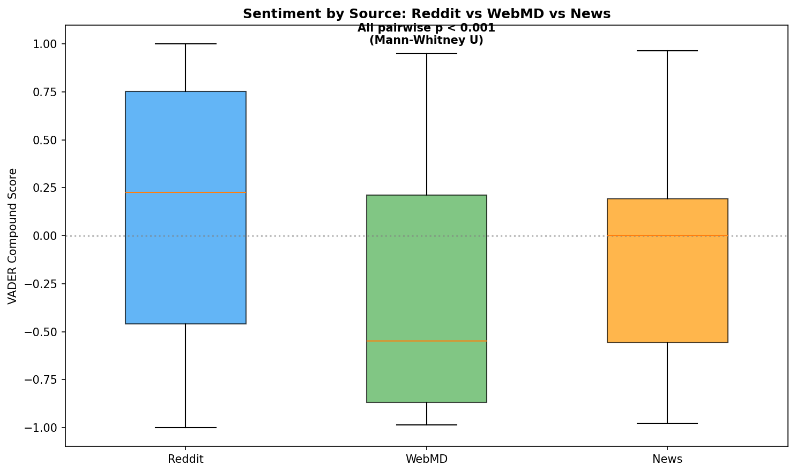  Sentiment by source | 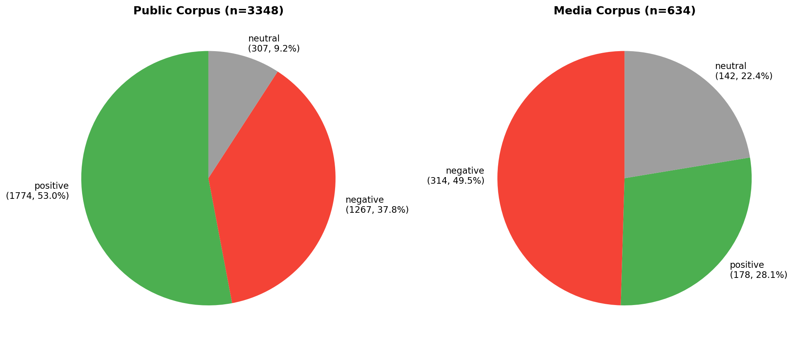  Label distribution

3.2 Corpus Comparison & Side Effects
TF-IDF confirms thematic divergence: public emphasises week, dose, lb, anyone; media foregrounds semaglutide, drug, weightloss drug. Cosine similarity: 0.346 (0.350 normalised). Public mentions nausea (3.38/1k tokens), diarrhea (1.22), constipation (1.16), anxiety (0.69) at rates far exceeding media, where most side effects have zero mentions. Gaps persist under normalisation.
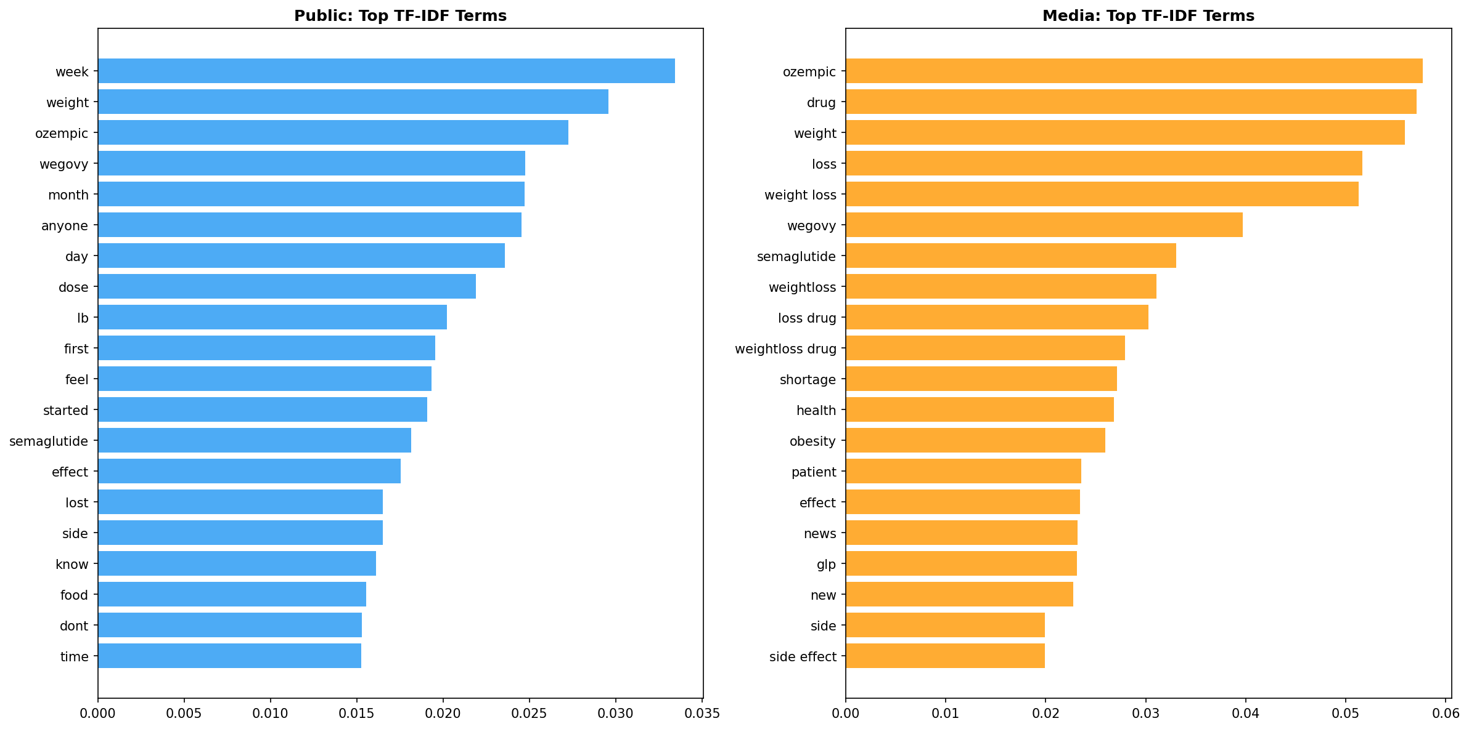  TF-IDF comparison | 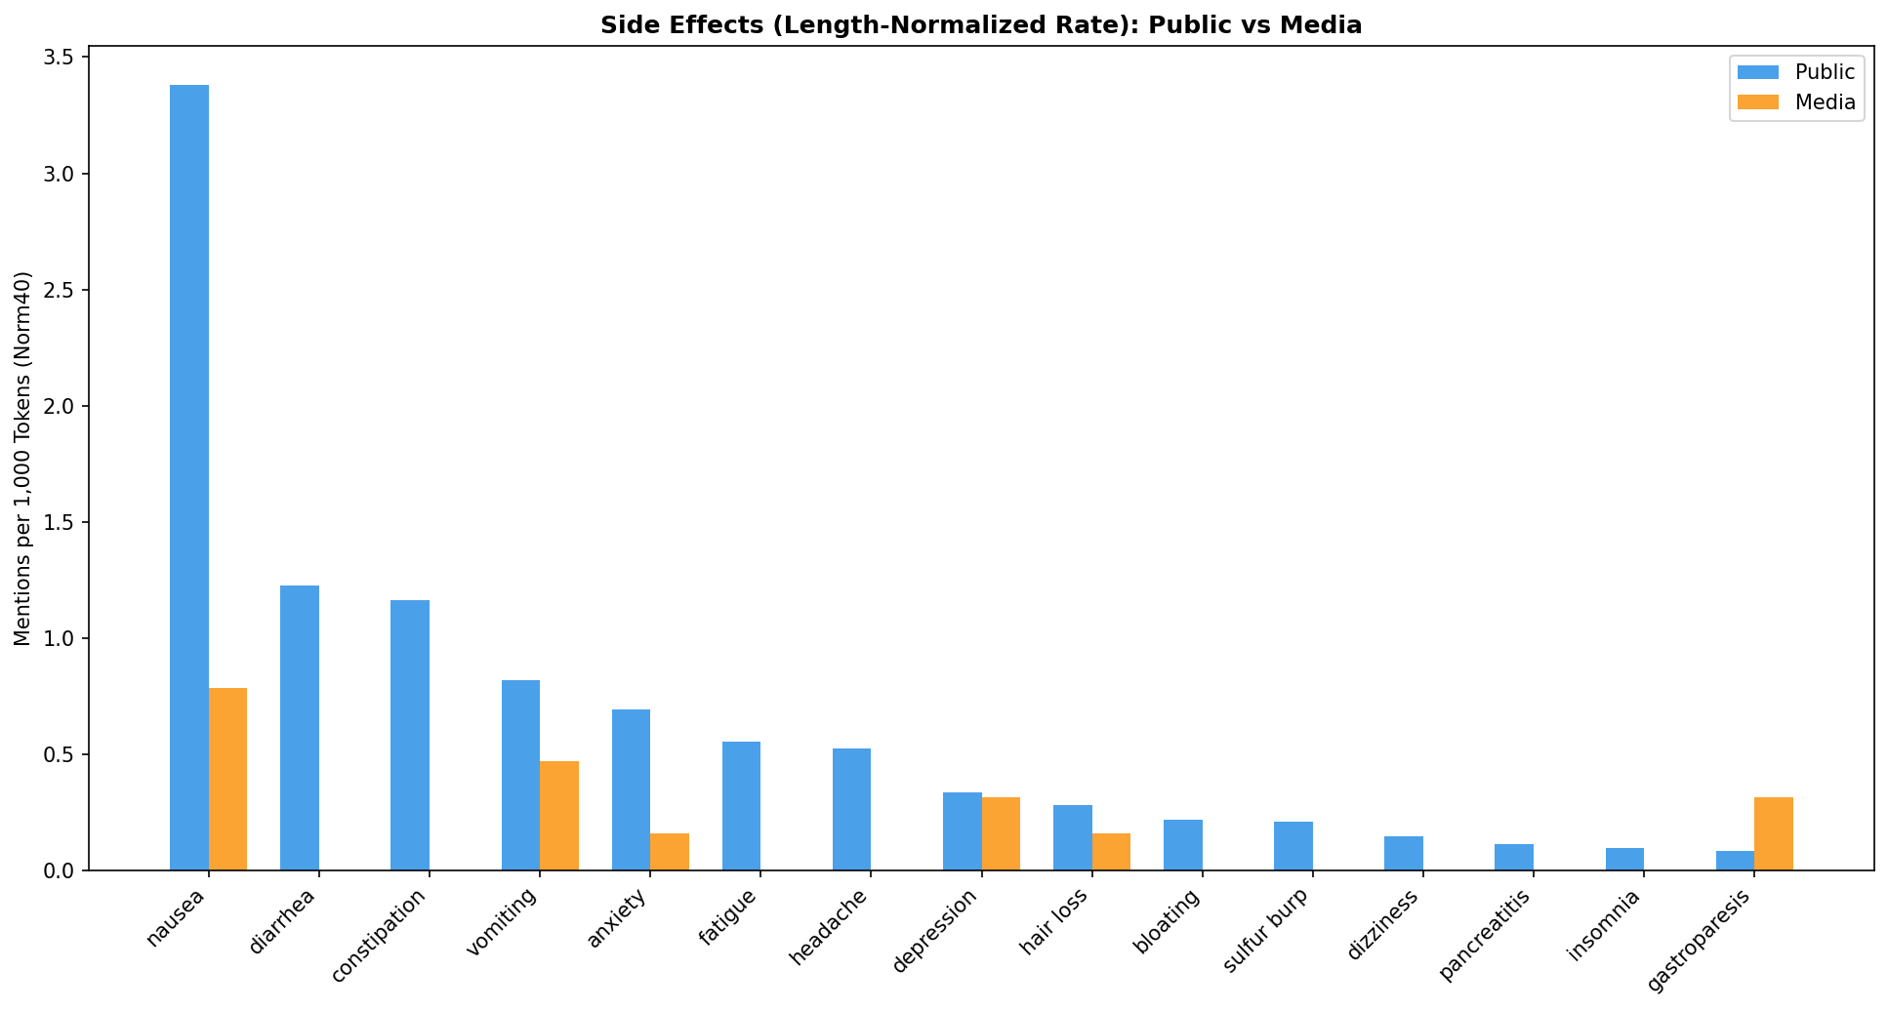  Side-effect rates per 1k tokens

3.3 Classification
Naïve Bayes (α=0.1): 97.6% CV accuracy. KNN (k=7): 96.7%. Normalised-track accuracy nearly identical (97.6%/96.4%), confirming separability is vocabulary-driven. Top public features: anyone, day, lb, feeling; top media: cnn, healthline, medscape, nbc.

3.4 Topic Modelling
LDA (5 topics/corpus): public topics centre on dosing, insurance, weight progress, compounding; media on clinical trials, FDA regulation, Medicare access. K-means (k=2) purity: 84.1%—strong unsupervised separation.

3.5 Aspect-Based Sentiment
Aspect | Public | Media | Gap | Sig.
Mental health | −0.10 | −0.74 | 0.63 | p=.040*
Access | +0.20 | −0.35 | 0.55 | p<.001*
Efficacy | +0.14 | −0.33 | 0.46 | p<.001*
Cost | +0.16 | −0.02 | 0.18 | p=.017*
Side effects | −0.03 | −0.20 | 0.16 | p=.666
Media is dramatically more negative on mental health (−0.74 vs. −0.10), likely driven by alarming headlines. Discrepancy classifier accuracy: 83.7%.

3.6 Temporal Lead-Lag
Granger causality (max lag 4 weeks, 45 obs.): no significant relationship (Media→Public p=0.37; Public→Media p=0.30). Cross-correlation peaks at lag −7 weeks (r=0.31). The streams respond to shared events rather than driving each other.
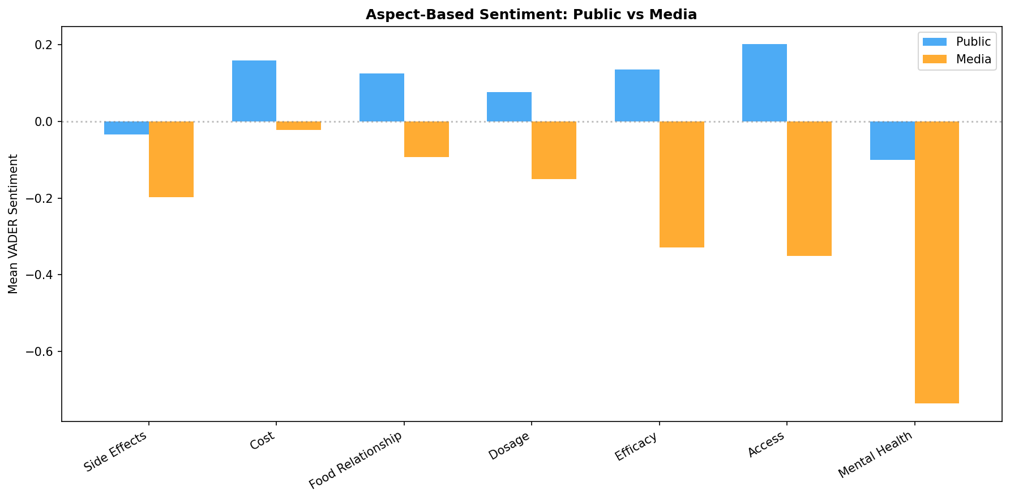  Aspect sentiment | 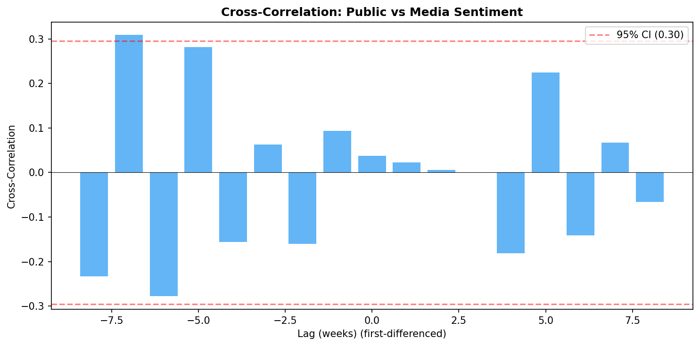  Cross-correlation

4. Discussion & Conclusion
The sentiment gap aligns with prior research: media defaults to cautionary framing while patients share mixed lived experiences. The 97.6% classification accuracy—stable under normalisation—confirms fundamentally different registers. The side-effect coverage gap has real-world implications: patients relying on media may underestimate everyday symptom burden, while providers could monitor patient communities for emerging signals. The mental-health discrepancy is striking: media amplifies alarm while patients report only mild negativity.
Limitations: hybrid mode used 100% snippet fallback; VADER may miss medical-domain nuance; 45 weekly observations limit Granger power; Reddit/WebMD are not representative of all patients.
Public and media discourse on GLP-1 drugs diverge significantly in sentiment, vocabulary, and thematic emphasis. These differences are robust across methods and length normalisation. Patients relying solely on media may form an incomplete picture; healthcare providers should monitor both discourse streams.
Reproducibility: python project_cli.py run-analysis --media-text-mode hybrid

